

# **SE 112**

**Introduction to Software Engineering**

**Spring 2023-2024**

**Driver Sleepiness Detection System**

**Group No:** 24

Zeynep Ünal

***ID:*** *23244710120*

Yağmur Balcılar

***ID:*** *23244710042*

Selen Yıldırım

***ID:*** *23244710069*

**Contents**

**Cover** 1

**Project Proposal** 3

**Project/ Problem Description** 3

**Gantt Chart** 4

**Risk Plan** 4

# **Project Proposal**

**Project/ Problem Description:** The aim of the project is to detect when drivers get sleepy, warn them about the danger and reduce the number of car crashes that occur due to attention loss or tiredness.

Of all car crashes and traffic accidents, 94% are caused by human error, and drowsy driving accounts for about 100,000 crashes annually on the roadway, which is a very high number. To solve this issue, a driver sleepiness detection system will be developed. Sleepy drivers usually don’t notice the signs of sleepiness until they become a danger, and with the application we will develop, we will make the detection of tiredness easier.

The application will be integrated into the digital system of the car, and it will be activated once the vehicle has been bought. It will scan all sides of the driver’s faces and store them in a database to remember them in the future. Users will be able to modify or delete the database of the faces.

Once it has been set up, the application will recognize and keep a record of the driver’s actions related to fatigue, such as yawning, stretching, or blinking slowly. If these actions exceed the normal limit, it will warn the driver with a signal and tell the driver to stop the car for a break. The face recognition system will be developed with the help of AI and machine learning. We will introduce faces of people from all ethnicities and colors to teach the system how to recognize faces. We wish to cover all face shapes, features and common accessories. Agile software development methodology will be used to develop the project.

## **Gantt Chart**

The Gantt chart for this project is as shown below. 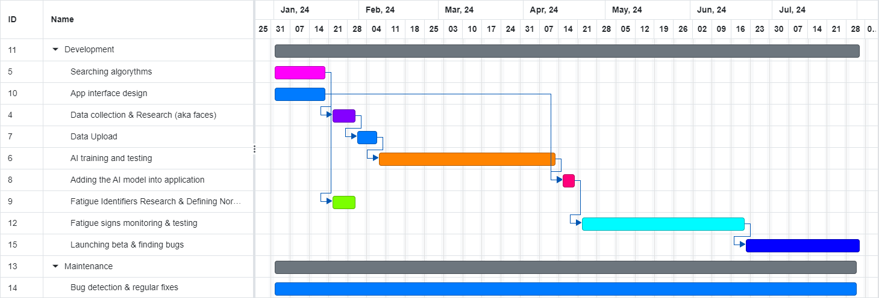

## **Risk Plan**

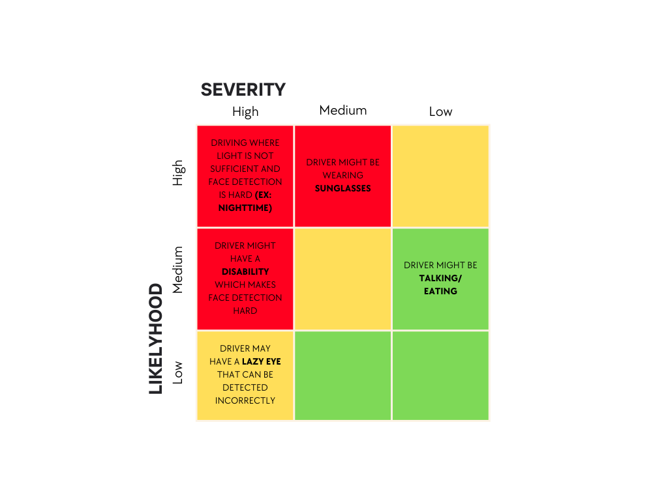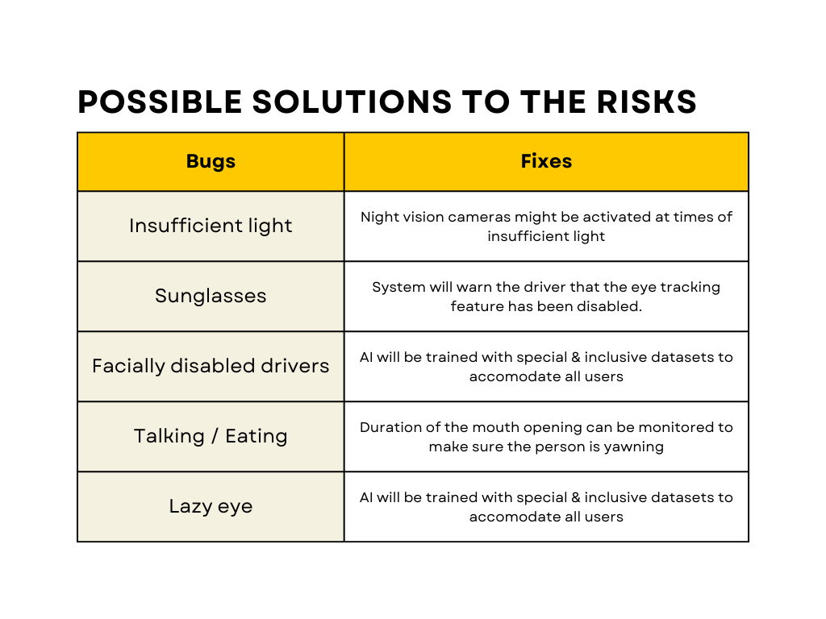There are potential risks with every project. Below are some of those risks and some possible solutions.