Patient Activity Monitoring System using RGBD Depth Camera and Skeletal Tracking with Rule-based Algorithm

Nattaphat Boonchumanee, Patchara Pitchayawetwongsa, Alongkorn Pimpin, Werayut Srituravanich and Nattapol Damrongplasit
Abstract— This study introduces a patient activity monitoring system, leveraging RGBD depth camera and skeletal tracking to automatically classify activities typically present in a healthcare setting: Sleeping, Falling, Sitting, Walking, and Standing. Employing a calibration process to establish threshold values and a rule-based algorithm to classify human activities, the system is designed to be accurate while requiring minimal computational resources and no additional training on a dataset. Activity classification results show a median error of 12.34% and 8.62% for a 5- and 10-second activity durations when compared to using human observers. Notably, the system excels at detecting falls with high precision (0.998) and recall (0.979) values. Classification errors primarily occur during transitions between activities. The software’s user-friendly interface provides real-time patient activity insights while maintaining patient privacy, demonstrating the system's potential as a reliable and efficient patient monitoring tool. The system provides real-time patient activity insights and preserves patient privacy by using a depth map instead of a color image as its primary visual output.
Index Terms— Patient Activity Monitoring, Human Activity Monitoring, HAR, Skeletal Tracking, RGBD camera, Depth Camera

I. INTRODUCTION
M
ANY countries are now experiencing a demographic shift towards aging society, driven by declining birthrates and increasing life expectancy [1]. Socio-economic factors, such as urbanization, education, and economic uncertainty, have contributed to couples choosing not to have children [2]. Concurrently, the advancement in healthcare and new breakthroughs in medicine have allowed people to live longer due to lower mortality rate from infectious diseases and better care for those living with chronic conditions. However, the aging population can present significant challenges to the current healthcare system. Elderly individuals often require close attention from healthcare professionals in terms of treatment and monitoring. It is expected that an increase in medical staff will be required in the future to accommodate the growing healthcare demands from the elderly, while ensuring the same quality of care and well-being. This not only places a financial burden on healthcare facilities by requiring them to hire more workers, but it also places strain on the available supply of medical staff, which is already experiencing a shortage [2].
One solution to the aging population problem is to replace routine yet important tasks, usually performed by a medical staff, with an automated system. An example of such task is the patient activity monitoring, which involves the tracking and analyzing of patient’s movements within a hospital or in a healthcare setting. The process often requires a trained medical staff to closely monitor the behavior and activity that a patient performs throughout the day. The information gathered can serve multiple purposes. First, by analyzing the patterns in patient activity, early sign of behavioral change or deterioration in health condition can be identified, allowing doctors to intervene in a timely manner. In addition, this information is vital for a successful rehabilitation process. Patient’s recovery progress can be precisely tracked and assessed to determine if a patient is making a steady improvement as scheduled, or if adjustment to the therapy is needed for a better outcome. Furthermore, patient activity monitoring can be used to help prevent a fall, which is one of the leading causes of injury among the elderly [3]. By observing the patient’s behavior, medical staff can identify patients with greater risk of falling and implement any necessary preventive measures, such as bed alarms or assistive walking devices. And in an event of a fall, medical staff can provide immediate care or seek additional medical assistance for the patient.
Patient activity monitoring performed by a human is an important task, but it is highly labor-intensive. Being able to offload such task to an automated system will help alleviate the strain on human resources, potentially reducing the healthcare cost in the long run. An automated system can also provide several advantages over using a human. For example, the system can provide a continuous patient monitoring without requiring breaks, or the need to implement different work shifts among staffs. Human error associated with fatigues and bias will also be reduced, leading to a more consistent and reliable data monitoring. The large amount of data can then be analyzed by an algorithm for subtle pattern changes or anomaly in behavior which might not be obvious to a human observer.
This study proposes the implementation of a patient monitoring system using a single RGBD depth camera and a skeletal tracking for human activity recognition. Combining skeletal tracking with depth information allows key joint positions to be mapped onto a real three-dimensional space to improve the prediction of human activity. Through the proposed calibration process and a rule-based human activity recognition (HAR) algorithm, the classification of activities within a confined space occupied by a single individual can be achieved with good accuracy without additional training of dataset or performing complex point cloud processing steps. The system is designed to be low-cost, open-source, privacy-preserving, and easy to implement inside a hospital room.

II. Background and Related Work

A. Human Activity Recognition (HAR)
The process of automatically identifying and categorizing human actions or activities is known as human activity recognition. Research involving HAR has spanned across many fields and applications. For instance, it can be used in hospitals to track patient activity [4], in nursing home to monitor well-being of elderly [5], in retail store to gather insights on customer purchasing behavior [6], in sport science to evaluate the performance of an athlete [7], in densely populated cities to monitor criminal activities [8], and in office buildings to track occupancy [9]. The growing use of HAR can be attributed to the lower cost and widely available sensors that are capable of collecting data associated with human activities. In addition, the computation required for processing and analyzing data obtained from sensors is becoming more accessible due to the growth of computational power and advancement in machine learning algorithms. The implementation of HAR system can be broadly categorized into wearable and non-wearable systems based on the type of sensors and methods used to capture the data. Each type of system has its own advantages and limitations. The selection between them, or a combination thereof, will depend on the specific application requirements.

B. Wearable HAR Systems
Wearable HAR systems are characterized by the use of sensors in a form of wearable devices that are worn by an individual. These devices include fitness trackers, smart watches, smart rings, smart phones, or other custom-made wearable devices [10-15]. The typical sensors embedded in these devices often include sensors that can detect motion based on physical movement, such as an accelerometer, gyroscope, magnetometer, or a global positioning (GPS) module [10-12, 14]. In addition to the motion data being collected, modern wearable devices are also equipped with sensors that can measure basic vital signs such as heart rate, blood oxygen level, and temperature [16]. Data obtained from different types of sensors can be integrated and analyzed using statistical methods and machine learning techniques to enhance activity monitoring accuracy and deliver highly personalized healthcare for individuals. Not only can these wearable devices work as a standalone-device, but they can also be used in combination with external cameras. This setup is commonly employed in a motion tracking system known as “outside-in” [17]. In this system, cameras positioned around the capture area detect and track markers attached to the subject’s body, allowing the captured motion to be reconstructed on a computer.
The main disadvantage of a wearable approach is that the individual needs to wear one or more devices on the body. While this requirement might not be a major issue for typical consumer electronic applications, it can become a critical concern for certain specialized applications such as healthcare. For some patients, having to wear a monitoring device constantly for a long period of time may cause discomfort which can interfere with their daily activity. In extreme cases, patients can develop undesirable side effects such as rashes or other allergic skin reactions due to prolonged usage of the wearable devices [18]. Additionally, the wearable device itself will need to be cleaned and sterilized regularly to reduce the risk of infections, requiring additional human resources and increasing overall costs.

C. Non-wearable HAR Systems
Owing to some of the drawbacks of wearable HAR systems, some have decided to adopt non-wearable HAR systems, which do not require an individual to wear or attach sensor devices on the body. Instead, the system relies on using external sensors, such as cameras, microphones, or motion detectors installed inside the environment to capture human activity, which can then be analyzed manually by a trained medical staff or automatically by a computer [4]. Non-wearable HAR systems offer the advantage of non-intrusiveness and scalability, as they can monitor multiple individuals simultaneously and cover larger areas without the need for individual sensors to be worn.
One example of such systems is a vision-based system that uses an RGB camera to capture the information in the scene and reproduce it in a form of 2D color images [19-22]. Multiple cameras can be employed, at an increased cost and complexity to the system, to simultaneously gather more information from different vantage points and help to mitigate occlusion problems that may arise in a single-camera setup [23].
While color images contain valuable information that can be used for activity tracking, they inherently lack the spatial information of the actual scene, which is three-dimensional in nature. Therefore, an alternative type of camera, called a RGBD depth camera, can be used instead of a regular RGB camera. Depth cameras can capture not only the 2D color image of an environment, but also how far an object is away relative to the camera sensor. Moreover, many new depth cameras have also incorporated infrared sensor or LiDAR, allowing the camera to function in the dark or low-light condition. The additional depth information provided by the camera can be used alongside RGB information to make the activity recognition more accurate, especially when attempting to segment out human from the rest of the background [24-27].

D. Skeleton Tracking
Computer vision can be applied to automatically monitor the activity of an individual in a vision-based system without the need for human assistance. One method is the use of a skeleton tracking, which is capable of identifying key joint positions of a human body from an image or a video [28-33]. The positions of these joints can be tracked over time to infer and predict the movement of an individual. Skeleton tracking is particularly useful in HAR application because it provides a concise description of human movement. Rather than analyzing the original image or video directly, the movement is summarized into a set of joint positions, which reduces the amount of data that needs to be processed and enables faster computation. Skeleton tracking algorithms can be built using traditional image processing techniques and predefined rules, but many recent algorithms have relied on machine learning to make the prediction more accurate and more robust to occlusions or poor lighting [32]. Nowadays, there are many open-source and closed-source skeletal tracking algorithms available that can be used without the need to train one’s own data. Some examples include MediaPipe Pose Landmarker [34], Azure Kinect Body Tracking [35], YOLOv7 [36], Detectron2 [37], and OpenPose [38].

III. Methodology
Our proposed system uses an RGBD depth camera, a skeletal tracking, and a rule-based algorithm to classify human activities into five categories: Sleeping, Falling, Sitting, Walking, and Standing. A pre-trained model from MediaPipe Pose is employed for skeletal tracking to obtain body joint positions in pixel coordinates from a real-time video feed or from a recorded video. Out of the 33 acquired joint positions, 11 joint positions are selected for the classification process as shown in Fig. 1. The pixel coordinate of the selected joints is transformed into the X-Y-Z coordinate of the real world with respect to the camera’s axis by aligning the RGB frame to the depth frame. The position of the camera, which is mounted on a tripod, is setup such that the X- and Y-axis correspond to the horizontal and vertical direction, respectively, as indicated in Fig. 1.
The proposed system utilizes a single RGBD depth camera, skeletal tracking, and a rule-based algorithm to classify five common human activities in a healthcare setting: Sleeping, Falling, Sitting, Walking, and Standing. A pre-trained model from MediaPipe Pose is employed for skeletal tracking to obtain body joint positions from a real-time video feed. Out of the 33 acquired joint positions, 11 key positions as shown in Fig. 1. —including the nose, shoulders, hips, knees, heels, and feet—are selected for the classification process. These specific joints were chosen as they provide a concise and effective representation of the human posture and movement essential for distinguishing the five target activities, thereby reducing the amount of data that needs to be processed and enabling faster computation.
The pixel coordinates of the selected joints are transformed into real-world X-Y-Z coordinates by aligning the RGB frame to the depth frame. The camera, an Intel RealSense D435, is mounted on a tripod such that the X- and Y-axes correspond to the horizontal and vertical directions, respectively. The D435 camera has a depth resolution of 1280x720 pixels and an RGB resolution of 1920x1080 pixels, which is sufficient for accurately capturing joint displacements within the experimental area.
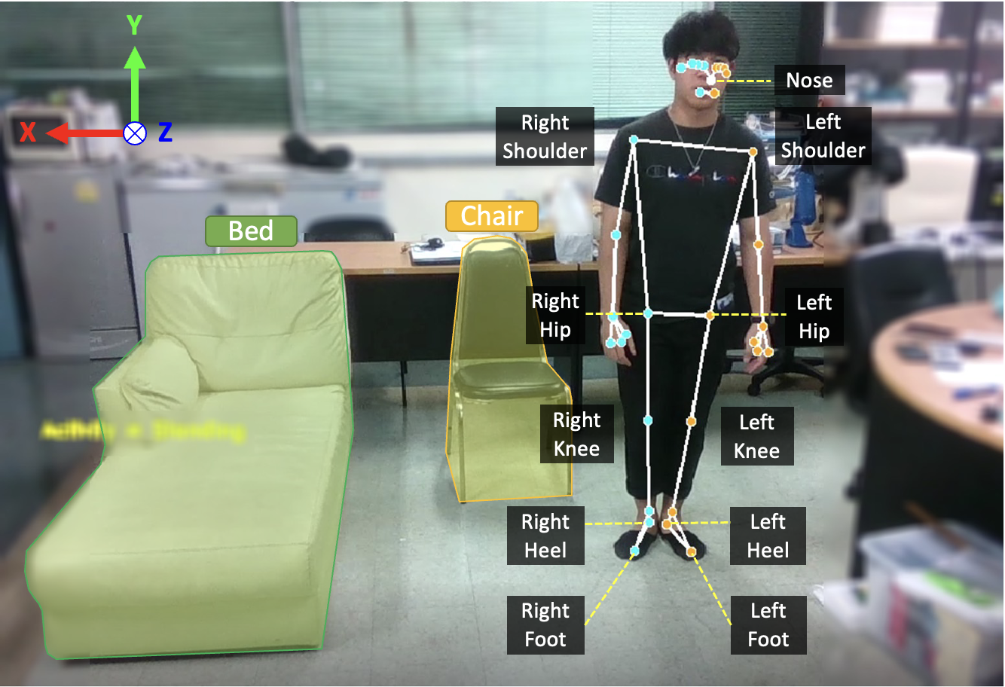
Fig. 1. An RGB video frame with an overlaid of a skeletal tracking result from MediaPipe. The 11 joint positions used in the rule-based algorithm are labeled.
The workflow of the proposed patient activity monitoring system is summarized in Fig. 2, which consists of two main phases: Calibration and HAR.

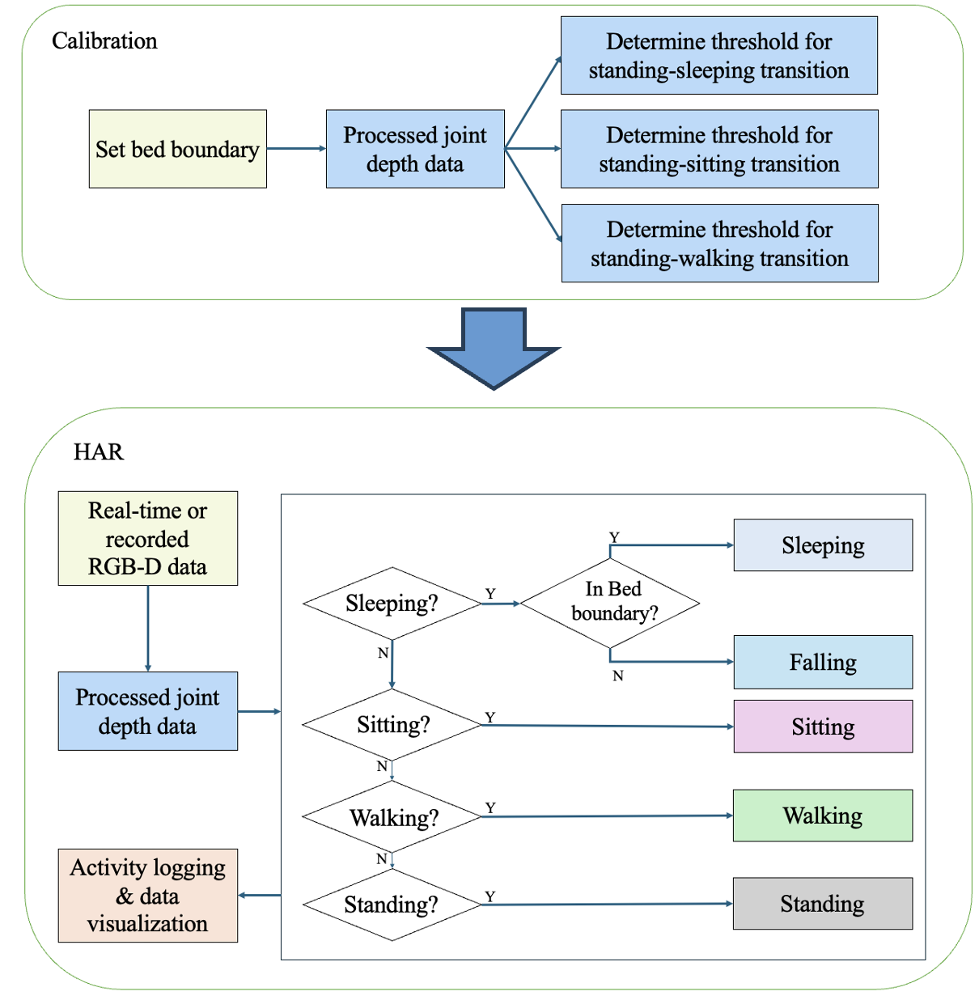
Fig. 2. System workflow diagram for the proposed patient monitoring system, consisting of Calibration and HAR phases.

A. Calibration
To obtain the best result for each user, it is recommended that a calibration process is performed once, or whenever the camera position or the patient’s bed is changed. This process consists of two main steps: setting the bed boundary and calculating personalized activity transition thresholds.

1) Bed Boundary Setup
Our calibration software requires the user to identify the boundary of the bed manually. During a bed boundary setup, a live view from a camera is displayed on the screen. The bed boundary can be defined by clicking on the four corners of the bed using a computer mouse. The program correlates the pixel coordinates of these four points with the depth information, resulting in real-world coordinates. These coordinates are then projected onto the floor plane (X-Z plane) to establish the bed boundary. While an instance segmentation method could automatically extract the bed from an image frame, we opt for a manual approach in this work to keep the algorithm as light weight as possible. Moreover, considering that the bed inside a hospital room is not frequently moved, this manual approach satisfies our requirement.

2) Skeletal Joint Data Preprocessing
Before we can use joint depth data to determine the threshold in the rule-based algorithm, the raw data need to be processed to improve the signal quality and reduce noise. The two main signal processing methods employed are simple moving average and downsampling, as shown in Fig. 3.
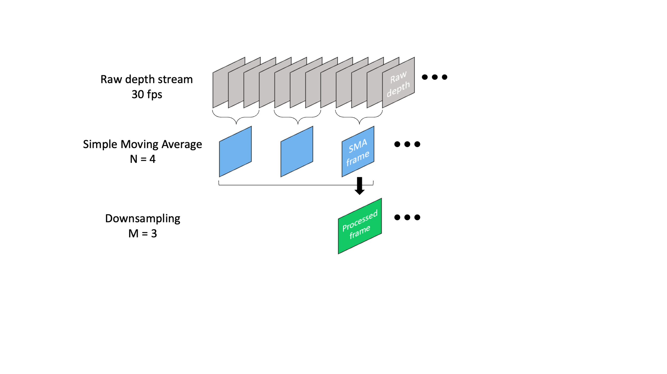
Fig. 3. Data processing steps which consist of a simple moving average and a downsampling of raw depth stream.

a) Simple Moving Average (SMA)
The depth camera streams RGB and depth data at a frame rate of 30 fps. The skeletal tracking algorithm operates on RGB frame to determine the pixel coordinates of the joints, which are then mapped onto the corresponding depth data. Subsequently, we apply a simple moving average to the joint depth data to reduce noise. This acts as a low-pass filter, smoothing out the high fluctuation signals typically present in the raw output of skeleton tracking algorithms. The simple moving average with a window size of n = 4 is applied to raw depth frames, according to Eq. (1). The chosen window size provides the necessary smoothing of the data without introducing excessive delay.

$SMA=\frac{A_{1}+A_{2}+⋯+A_{n}}{n}$, (1)

where
A_{i} is the raw depth data from the i^{th} frame
n is the window size

b) Downsampling
After computing the simple moving average, the resulting SMA frame undergoes downsampling to minimize noise further and enhance accuracy of activity classification. Downsampling is accomplished by retaining every m-th frame of the SMA frames, where m represents downsampling factor. These downsampled frames are denoted as processed frame, and they are used for the threshold calculation as well as during the activity classification. For example, to distinguish between standing and walking activities, the position of the individual in the current frame is compared to the previous frame. By tracking the net displacement of the joints between frames, it can be determined if a person is standing still or has moved to a new position. Figure 4 shows the displacement of a nose joint over a time using two different downsampling factors (m = 2 and m = 3). The joint displacement between standing and walking is more pronounced with 3-frame downsampling compared to 2-frame downsampling, making it easier to establish a threshold between these two activities. This occurs because a larger downsampling factor results in a longer elapsed time, during which the individual may have moved a greater distance. Consequently, such displacement will be amplified when using a larger downsampling factor. However, it is important not to set the downsampling factor too high because it will not be able to capture a fast-changing activity. In our testing, a 3-frame downsampling provides the optimal result for the classification, while still being able to capture real-time events related to typical patient’s activity. With the use of n = 4 for simple moving average and m = 3 for downsampling, the time difference between two consecutive processed frames are approximately 0.27 seconds apart.

Fig. 4. Displacement of nose joint depth data when transitioning from standing to walking. 3-frame downsampling results in a larger displacement when compared to using 2-frame downsampling.
Through internal testing, a downsampling factor of m=3 was found to provide the optimal result for classification. This choice amplifies joint displacement over a longer elapsed time, making it easier to establish a clear threshold between activities like standing and walking. While a larger factor would amplify displacement further, it might fail to capture fast-changing activities. The combination of n=4 and m=3 results in a time difference of approximately 0.27 seconds between consecutive processed frames, which is sufficient for capturing typical patient activities in real time.

3) Calculation of Activity Transition Threshold
To classify the 5 activities previously outlined, we need to determine activity transition thresholds that can detect a change of one activity to the next. According to the decision tree of the system workflow diagram, there are 3 activity thresholds that need to be established for HAR: standing-sleeping, standing-sitting, and standing-walking. To accomplish this, the user will need to perform these three pairs of activities following an on-screen instruction. The software will display a text prompt guiding the individual to perform the first activity for a duration of 5 seconds. After this, it will prompt the individual to transition to the second activity within a 4 second transition period. Then, the individual should continue to perform the second activity for another 5 sec. The joint depth data recorded during the first and second activities, are used in the threshold calculation.
An example of the data collected during the calibration process is shown in Fig. 5, where the displacement of a particular joint is tracked as the individual performs the activity transition. The salient characteristic of the data is the clear transition from a lower value to a higher value, or vice versa, indicating a change in activities. This allows the use of a threshold to detect if changes in activity have occurred. To establish the threshold values, the algorithm finds all the relative maximum points of the lower value data and the relative minimum points of the higher value data. Then, outliers in each set of data are filtered out by eliminating the points which do not lie between the 1st and 3rd quartile of their distributions. Lastly, the global maximum point of the lower data set (Low) and the global minimum point of the higher data set (High) are selected for the threshold calculation according to Eq. (2). The reason the threshold is set closer to the lower value is because the characteristic associated with the lower values in our HAR tends to be more stable and shows less fluctuations as compared to the higher value data. Therefore, placing the threshold closer to the lower value allows the detection to be less prone to false classification due to noise and local fluctuations.

$Threshold=Low+\frac{High-Low}{4}$ , (2)

where $Low$ is the global maximum of the lower data and
$High$ is the global minimum of the higher data.

Fig. 5. A plot of joint depth displacement vs. processed frame, showing how the threshold value can be calculated from the global maximum and global minimum points.

B. HAR
During the HAR phase, real-time RGBD data captured from the camera or from previous recordings are preprocessed using the same procedure used during Calibration phase. The processed joint data are inputted into a rule-based algorithm, which uses a decision tree to classify the activities according to the established thresholds. The details of each activity recognition will be discussed in this section.
Let us define the real-world coordinates in 3D Cartesian space of a joint depth data as P. The component along a specific axis for a particular joint depth data can denoted as $P_{j,s}^{u}$ , where u represents one of the three major axes (x, y, z), j denotes the name of a joint on the human body (nose, shoulder, hip, knee, heel, foot) and s indicates the side of the body to which the joint belongs, whether it be the right (r) or the left (l) side.

1) Sleeping recognition
To detect sleeping activity, the shoulder, hip, and heel joints are the key skeletal joints used for detection. In particular, the vertical coordinate (Y-coordinate) of these joints will have values that are close to one another. Therefore, the vertical distance between these pairs of joints will be small when a person is lying flat on a bed. Based on these observations, a set of Boolean expressions can be formed, as in Eq. (3) and Eq. (4), to determine if a person has entered sleeping.

${| P}_{shoulder,r}^{y}- P_{hip,r }^{y}|<{ T}_{shoulder-hip dist,r} ∨$
${| P}_{shoulder,l}^{y}- P_{hip,l}^{y} | <{ T}_{shoulder-hip dist,l} ,$ (3)

where ${ T}_{shoulder-hip dist, r/l}$ represents the threshold distance between the shoulder and hip for the right and left sides, respectively.

${| P}_{hip,r}^{y}- P_{heel,r }^{y}| <{ T}_{hip-heel dist,r} ∨$
${| P}_{hip,l}^{y}- P_{heel,l}^{y} | < { T}_{hip-heel dist,l} ,$ (4)

where ${ T}_{hip-heel dist,r/l}$ represents the threshold distance between the hip and heel for the right and left sides, respectively.
According to Eq. (3), the vertical distances between the shoulder and hip for the right and left sides of the body are compared against their respective threshold values obtained during calibration. If the vertical distance from either side, or both sides, falls below the threshold value, the condition will evaluate to true due to the logical OR operator ($∨)$. This consideration of both the right and left side information is necessary because skeletal tracking may occasionally fail to detect a joint from one side due to occlusion, or when a person is turned sideways to the camera. Similarly, Eq. (4) verifies whether the vertical distance between the hip and heel is below the threshold value.
The vertical distances between the shoulder and hip, as well as between the hip and heel, during the transition from standing to sleeping, are shown in Fig. 6. It can be seen that the vertical distances start off at a high value when a person is standing and drop to a lower value when a person is sleeping. This difference in the observed values allows the system to set a threshold that can be used for classification. For a person to be classified as sleeping, both Eq. (3) and Eq. (4) must evaluate to true. Additionally, the projection of these key skeletal joints in the X-Z plane must lie within the bed boundary defined during calibration.

Fig. 6. Vertical distances of shoulder to hip and heel to hip from one side of the body as a person transitions from standing to sleeping.

2) Falling recognition
The logic used to detect if a person has fallen is nearly identical to that of a sleeping recognition, with the only difference being the location of the skeletal joints. If all the conditions for sleeping are met and the projections of the skeletal joints in the X-Z plane are located outside the bed boundary, the system will classify such activity as falling down.

3) Sitting recognition
The extracted feature used for sitting recognition is the vertical distance between the hip and knee joints. When a person sits in a chair, this vertical distance will be minimal since the hip and the knee are approximately on the same plane. A Boolean expression according to Eq. (5) can be used to check for sitting condition. When the distance from the hip to knee on either side of the body falls below the thresholds, the sitting condition is met.

${| P}_{hip,r}^{y}- P_{knee,r }^{y} | <{ T}_{hip-knee dist,r} ∨$
${| P}_{hip,l}^{y}- P_{knee,l }^{y} | <{ T}_{hip-knee dist,l} ,$ (5)

where${ T}_{hip-knee dist,r/l}$ represents the threshold distance between the hip and knee for the right and left sides, respectively.

Figure 7 shows the vertical distance between the hip and knee joints as the person transitions from standing to sitting. The distance value associated with sitting tends to be more stable as compared to standing, and hence the threshold is placed closer to the lower value as previously mentioned.


Fig. 7. Vertical distance between the hip and knee joints on one side of the body during the transition from standing to sitting.

4) Walking recognition
To determine if a person is walking, the positions of the nose, foot, and shoulder joints are monitored over time. Specifically, the net displacements of these joints between the current and past frames are calculated and compared if they exceed the thresholds. The conditions used to detect walking are expressed in Eq. (6), Eq. (7), and Eq. (8).

$\sqrt{{{(P}_{nose }^{x}\left[i\right]- P_{nose }^{x}\left[i-1\right])}^{2}+{{(P}_{nose }^{z}\left[i\right]-P_{nose }^{z}\left[i-1\right])}^{2}} >$ ${ T}_{nose displacement} ,$ (6)

where ${ T}_{nose displacement}$ represents the threshold displacement of the nose joint between previous and current processed frame. The index i is used to indicate the i^{th} processed frame.

$\sqrt{{{(P}_{foot,r }^{x}\left[i\right]- P_{foot,r }^{x}\left[i-1\right])}^{2}+{{(P}_{foot,r }^{z}\left[i\right]-P_{foot,r }^{z}\left[i-1\right])}^{2}}> { T}_{foot displacement,r} ∨$

$\sqrt{{{(P}_{foot,l }^{x}\left[i\right]- P_{foot,l }^{x}\left[i-1\right])}^{2}+{{(P}_{foot,l }^{z}\left[i\right]-P_{foot,l }^{z}\left[i-1\right])}^{2}}> { T}_{foot displacement,l} ,$ (7)

where ${ T}_{foot displacement,r/l}$ represents the threshold displacement of the foot joint between previous and current processed frame for the right and left sides, respectively.

$\sqrt{{{(P}_{shldr,r }^{x}\left[i\right]- P_{shldr,r }^{x}\left[i-1\right])}^{2}+{{(P}_{shldr,r }^{z}\left[i\right]-P_{shldr,r }^{z}\left[i-1\right])}^{2}}> { T}_{shoulder displacement,r} ∨$

$\sqrt{{{(P}_{shldr,l }^{x}\left[i\right]- P_{shldr,l }^{x}\left[i-1\right])}^{2}+{{(P}_{shldr,l }^{z}\left[i\right]-P_{shldr,l }^{z}\left[i-1\right])}^{2}}> { T}_{shoulder displacement,l} ,$ (8)

where ${ T}_{shoulder displacement,r/l}$represents the threshold displacement of the shoulder joint between previous and current processed frame for the right and left sides, respectively.

Figure 8 shows the displacement between frames as a person transitions from standing to walking. To classify that a person is walking, two conditions must be satisfied. The first condition is the threshold condition for the nose joint as in Eq. (6). The nose joint serves as a primary skeletal joint for referencing a person’s position since it is relatively stable compared to the rest of the joints. The second condition is the threshold condition of either the foot joints in Eq. (7), or the shoulder joints in Eq. (8). This additional requirement helps to improve the accuracy and reliability of the activity recognition in an event that the skeletal tracking algorithm can detect the nose joint, but fails to detect either the foot or the shoulder joints.


Fig. 8. Displacement of the nose, shoulder, and foot joints between frames during the transition from standing to walking.

5) Standing recognition
According to decision tree of the rule-based algorithm, if the activity does not satisfy the criteria for sleeping, falling, sitting, and walking, it will be classified as standing by default. This condition holds true as long as the system can still detect the presence of a human in its field of view.

C. Experimental Setup
The experiment is conducted inside a room with controlled lighting. An Intel RealSense D435 depth camera is set up on a tripod and it is connected via a USB-C cable to a laptop. The camera angle is adjusted to provide a field of view (FOV) of the floor area measuring approximately 2.4 meters by 2.25 meters, which closely mimics the dimensions of a typical patient's area in a hospital setting. Inside the room, there are one chair and one bed within the camera’s FOV to facilitate activities such as sitting and sleeping. An illustration of the experimental area with approximate dimensions is shown in Fig. 9.
This study was approved by the research ethics review committee for research involving human research participants, Group I, Chulalongkorn University, Study Title No. 660006. Four participants were recruited for the experiment. Prior to the experiment, each participant underwent a calibration process to establish personalized threshold values for activity recognition. During HAR phase, participants were instructed to perform a sequence of activities, including standing, sitting, sleeping, walking, and falling, respectively. An audio cue is provided to the participants to inform them when to transition from one activity to the next. Two separate sets of experiments were conducted: in one set, participants were instructed to perform each activity for 5 seconds, while in the other set, each activity lasted 10 seconds. Each participant repeated the experiment 5 times for each set.
Two human observers independently reviewed the recorded video clips of the participants performing the activities and manually labeled the activities at every 1 second interval. The results from the two human observers are used to compare against the predicted output by the proposed patient activity monitoring system.
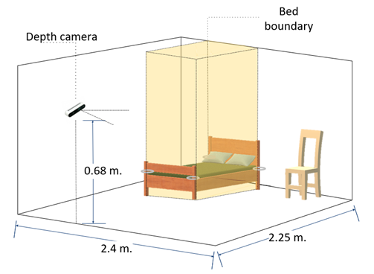
Fig. 9. Approximate layout and dimensions of the experimental area.

IV. Results and Discussion

A. Activity Classification Results
An example of an activity sequence performed by a participant over a time period is represented in a Gantt chart according to Fig. 10. The system’s predicted activity recognition result is shown alongside the results provided by the two human observers. Qualitatively, it can be seen that the result predicted by the system and the two human observers are similar, especially when the participant has settled into a particular activity. The most notable discrepancies occur during transitions between activities. For example, when the participant transitions from standing to sitting around the 7-second mark, the system predicts such transition happens one second later than human observers do. Similarly, during the transition from walking to falling at around the 35-second mark, the system predicts that the participant briefly enters a standing phase, returns to walking, and then finally transitions to falling.
To quantify the accuracy of our proposed patient activity monitoring system, the system’s predictions are compared to those of two human observers at every 1 second. For each activity sequence, a percentage error is calculated by tallying the seconds during which the system’s predicted output differ from that of each of human observers. The analysis includes data from four participants, each performing two sets of activity duration experiment (5 and 10 seconds), with each experiment repeated five times. It is important to note that while the guideline intended each activity to last precisely 5 and 10 seconds, the actual time spent in each activity by the participants may vary. The data collected from the participants show that, on average, it takes participants approximately 42 seconds and 65 seconds to complete the entire sequence for the 5-second and 10-second activity duration experiments, respectively. The longer time to complete the sequence, as compared to the expected time duration of 25 seconds and 50 seconds, are due to the delay in the participant’s movement upon hearing the audio cue to transition into the next activity.
The percentage errors for the activity duration of 5-second and 10-second are summarized in Fig. 11. The results show median percentage errors of 12.34% and 8.62%, for a 5-second and 10-second activity duration, respectively. The smaller percentage error in the case of 10-second activity duration is consistent with the qualitative observation that most the errors between the system and human observers happen during the transition between activities. Therefore, when there are fewer transitions in the activity sequence, or equivalently, when an individual remains in a given activity for a longer time, the overall percentage error for the entire activity will also be reduced. This is because the time associated with transitions will represent a smaller portion of the total time spent in the entire activity sequence.
To quantify the accuracy of our proposed patient activity monitoring system, the system's predictions were compared to those of two human observers at every 1-second interval. The analysis includes data from four participants, each performing two sets of experiments with activity durations of 5 and 10 seconds, and each experiment repeated five times.
The core results show median percentage errors of 12.34% for a 5-second activity duration and 8.62% for a 10-second activity duration, as shown in Fig. 11. The smaller error for the longer duration is a key finding, as it is consistent with our observation that most classification errors occur during activity transitions. When an individual remains in an activity for a longer period, the time spent in transitions makes up a smaller portion of the total time, which reduces the overall error rate.

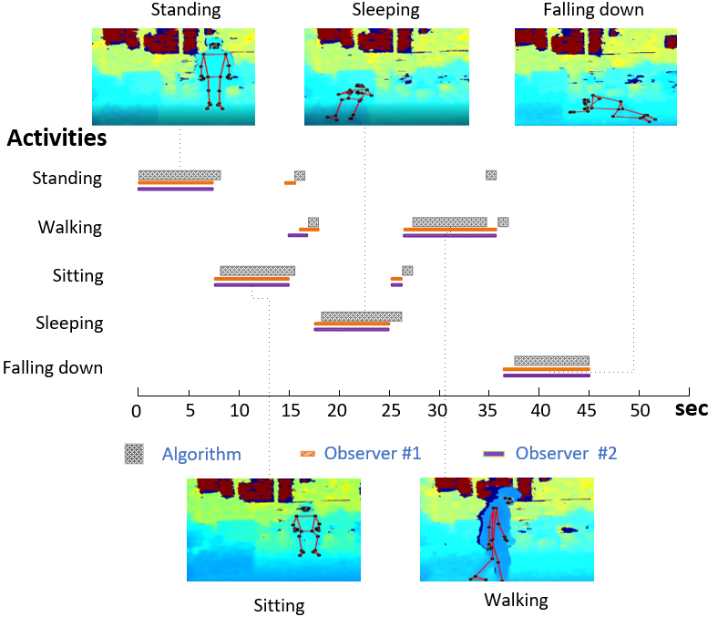
Fig. 10. Gantt chart depicting a participant performing sequences of activities. The activity classifications predicted by the algorithm are shown alongside those labeled by the two human observers.
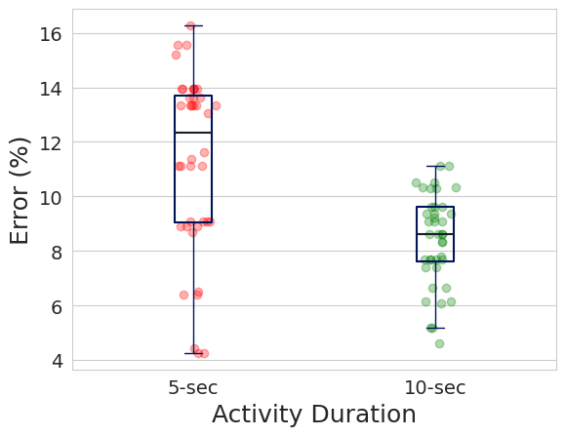
Fig. 11. Distribution of percentage error for the patient activity monitoring system between 5-second and 10-second activity duration.
To further evaluate the performance of the classification system, a confusion matrix for the 5- and 10-second activity duration are shown in Fig. 12(a) and 12(b), respectively. The precision and recall values for each class of activity, which can be calculated according to Eq. (9) and Eq. (10), are summarized in Table I. Comparing between the 5- and 10-second activity durations, it can be seen that there is a general improvement in both the precision and recall values for the longer activity duration, which is consistent with the previous analysis of the system’s error rate. The detection of a fall shows the best precision and recall values. When a person falls down, the event is characterized by a sudden and abrupt movement, resulting in a clear transition in activity that the rule-based algorithm can effectively determines if the threshold has been crossed.
Standing has the lowest precision value among all activities. From the confusion matrix, it can be seen that the system most often misclassifies walking as standing, resulting in lower precision. Such instance often occurs when a participant starts to transition from walking into other activities. As the walking pace of the participant slows down, the joint displacement between frames that is used for walking recognition may fall below the threshold value. This causes the algorithm to assume that the person has stopped walking and come to a standing, even though the participant is actually in the process of transitioning from walking to sleeping or sitting. Another instance occurs when the participant makes frequent turns or changes direction while walking. In such cases, the algorithm can mistakenly interpret the turn as a brief period of standing. These misclassifications between standing and walking also explain why walking has a low recall value compared to the other activities.
Sitting can be misclassified as standing, walking, and sleeping. Errors often occur during the transitioning in and out of sitting. As the participant sits down or gets up from a chair, the activity can be mistaken for standing or walking. Additionally, when the participant momentarily sits on the bed before going to sleep or after waking up, these instances can be perceived as sleeping by the algorithm.
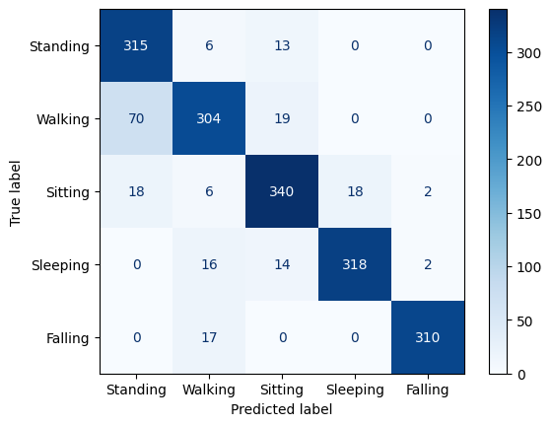
(a)

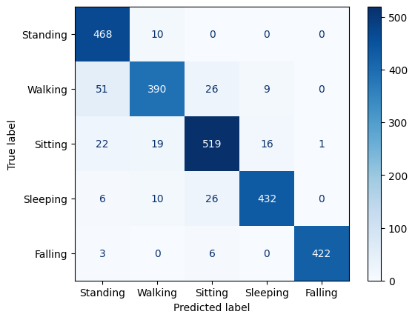
(b)
Fig.12. Confusion matrix of (a) 5-second and (b) 10-second activity duration.
${Precision}_{Class i}=\frac{{TP}_{Class i}}{{TP}_{Class i}+{FP}_{Class i}}$ (9)

${Recall}_{Class i}=\frac{{TP}_{Class i}}{{TP}_{Class i}+{FN}_{Class i}}$ , (10)

where i represents a single instance of activity among the entire set of activities. TP = True positive, FP = False positive, and FN = False negative

TABLE I
Precision and Recall for 5- AND 10-SECOND activity duration
Activity | 5-sec |  | 10-sec
 | Precision | Recall | Precision | Recall
Standing | 0.782 | 0.943 | 0.851 | 0.979
Walking | 0.871 | 0.774 | 0.909 | 0.819
Sitting | 0.881 | 0.885 | 0.899 | 0.899
Sleeping | 0.946 | 0.909 | 0.945 | 0.911
Falling | 0.987 | 0.948 | 0.998 | 0.979
A qualitative review of the activity sequences, illustrated in the Gantt chart as shown in Fig. 10, visually supports these quantitative findings. The chart shows that while the system's classifications generally align with human observers, the most notable discrepancies occur precisely during transitions between activities. For example, as a participant transitions from standing to sitting around the 7-second mark, the system's prediction is delayed by one second compared to the human observers. Similarly, during the transition from walking to falling at around the 35-second mark, the system incorrectly classifies the participant as briefly standing and then returning to walking before finally classifying the fall. These examples provide concrete evidence of the transition errors observed in the quantitative data.

B. Observer Discrepancy
The activity classification result performed by the two human observers are compared to see if there is any variability or bias between them. For each activity sequence, the discrepancy in the activity classification among human observers is summed up and expressed as a percentage error relative to the total time spent in the sequence, as shown in Fig. 13. The result shows that the discrepancy between observers has a median value of 2% or less. However, in the case of a 5-second activity duration, there is a larger variation and more outliers. This indicates that even among human observers, the classification during the transition between activities may not be straightforward. But if these transitions make up only a small portion of the entire activities, which is likely the case of a continuous daily monitoring, the agreement in human observation should improve considerably.
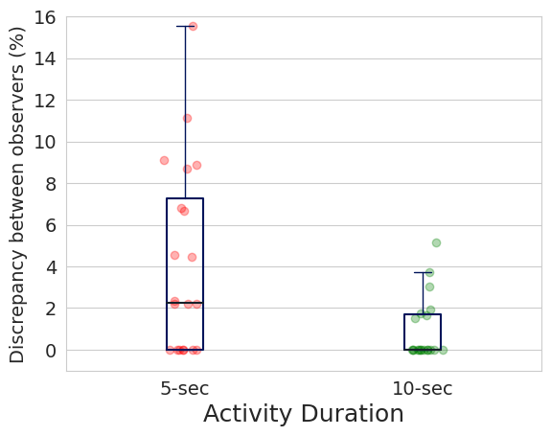
Fig.13. Discrepancy in activity classification between two human observers.

C. Software Interface
The Graphical User Interface (GUI) for the software is created using open-source libraries such as Tkinter [39] and OpenCV2 [40]. When the software is launched, users are presented with an initial screen where they can choose between initiating a Calibration process or starting a real-time Human Activity Recognition (HAR) monitoring. An example screenshot during HAR mode is shown in Fig. 14. The display consists of several key components: a real-time depth map with overlaid skeletal tracking, a predicted classification of the current activity, and a cumulative summary indicating the percentage of time spent in each activity. The use of depth map instead of a color image (RGB) as a default visual output is intended to safeguard the patient’s privacy while still providing valuable insights into their activity and subtle movements.

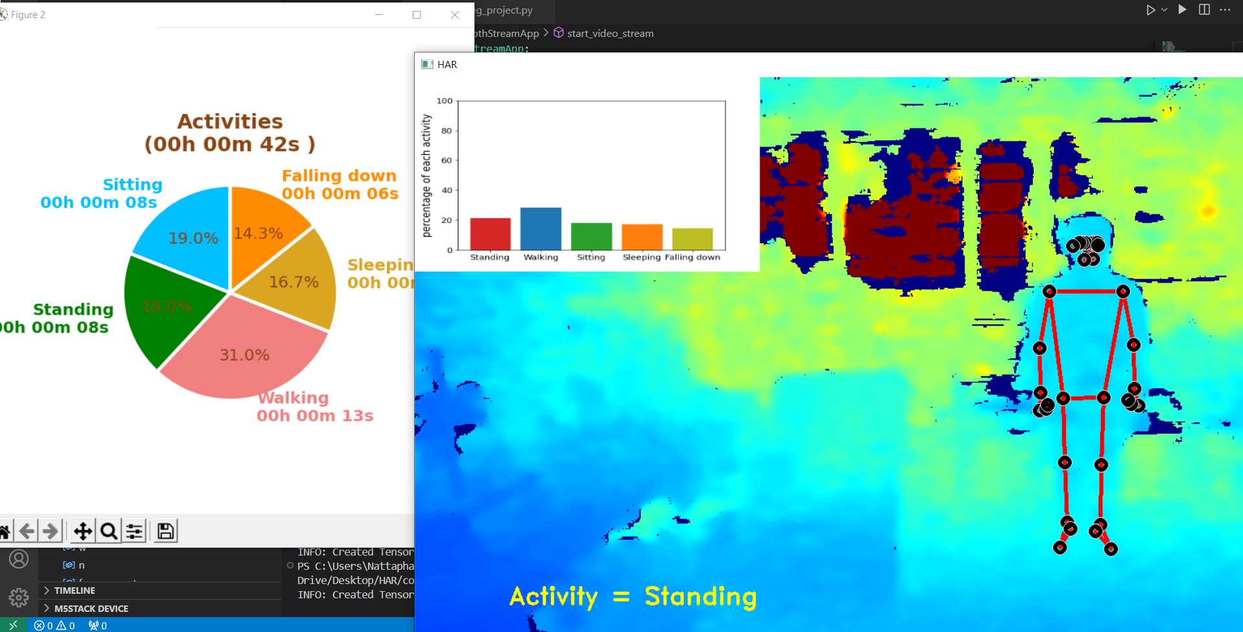
Fig.14. Real-time display of patient activity monitoring system. Depth map of the scene along with overlaid skeletal tracking is shown. The classification of current activity is displayed in the lower left-hand corner and the cumulative statistic of each is activity shown in the upper left-hand corner.
Upon completion of the HAR process, a dashboard will summarize the activity breakdown for that session, featuring a pie chart and a time log, as shown in Fig. 15. Additionally, the time log table can be exported to a Comma-Separated Values (CSV) file for further detailed analysis.
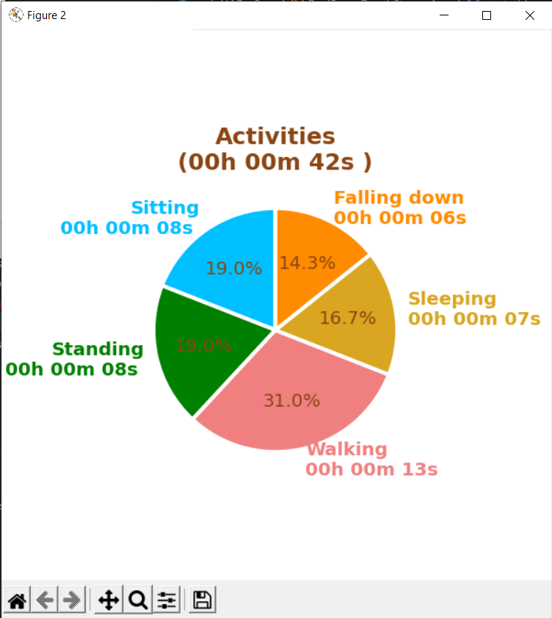
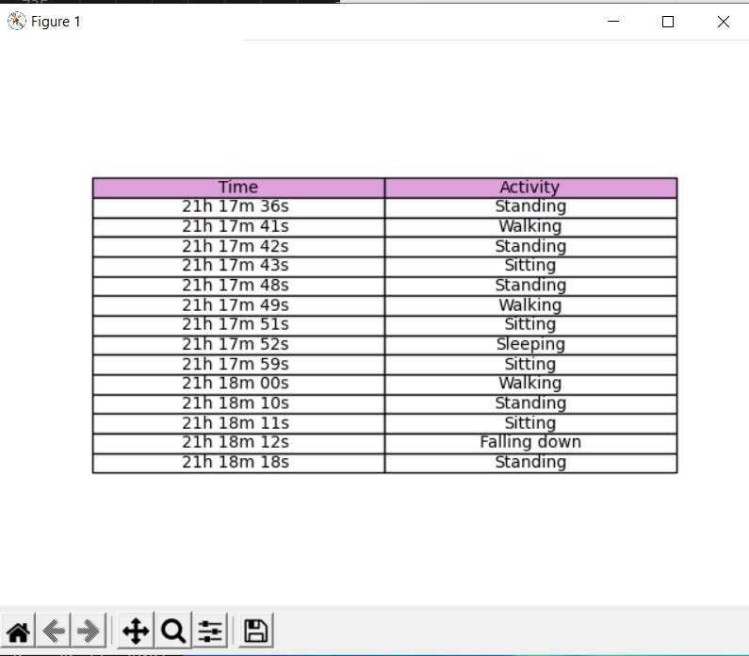

Fig.15. Summary dashboard showing activity summary and time log.

C. STUDY LIMITATIONS
This study serves as a proof of concept and has several important limitations. The system's performance relies heavily on the accuracy of the pre-trained MediaPipe Pose model for joint position estimation. A direct comparison with state-of-the-art models was not feasible due to the lack of a standardized dataset and controlled conditions across different studies. Therefore, our evaluation against human observers serves as the most appropriate benchmark for this work.
Furthermore, the empirical evaluation was conducted in a controlled laboratory setting with a limited sample size of only four participants, which restricts the generalizability of the findings to a broader, more diverse patient population. While the system is designed to be cost-effective, open-source, and privacy-preserving, these factors require formal empirical evaluation to fully substantiate the claims. The manual calibration process, while effective for personalization, may not be robust for dynamic clinical environments where conditions are constantly changing. Finally, the software’s interface usability was not formally evaluated via user experience methods such as interviews or surveys.

V. Conclusion
This study proposes the use of a patient activity monitoring system capable of automatically classifying 5 common activities in real-time, including sleeping, falling, sitting, walking, and standing. The system uses an RGBD depth camera to capture both color and depth information from the scene. The software employs skeletal tracking and rule-based algorithm that operates on joint skeletal depth data for activity classification. A calibration step is necessary to personalize the threshold values used in the algorithm to improve the accuracy for each individual patient. Without the need for additional training on the dataset or complex point cloud processing, the system achieves good accuracy with an error rate of approximately 10%, depending on the duration of the activity. Most classification errors occur during transitions between activities, which are also not trivial even for human observer to classify. Future improvements to the system can streamline the calibration process by eliminating the need for patients to physically perform the prescribed sets of activities during calibration. Instead, dynamic modeling based solely on the captured body dimensions of a patient may be sufficient to derive the threshold values for the HAR.

VI. References
- UN. Population Division, Ed., World Population Prospects: 2022: summary of results. New York: UN, 2022.
- H. T. A. Khan, “Population ageing in a globalized world: Risks and dilemmas?,” Journal of Evaluation in Clinical Practice, vol. 25, no. 5, pp. 754–760, 2019, doi: 10.1111/jep.13071.
- K. J. Jones, G. Haynatzki, and L. Sabalka, “Evaluation of Automated Video Monitoring to Decrease the Risk of Unattended Bed Exits in Small Rural Hospitals,” J Patient Saf, vol. 17, no. 8, pp. e716–e726, Dec. 2021, doi: 10.1097/PTS.0000000000000789.
- S. Yeung et al., “A computer vision system for deep learning-based detection of patient mobilization activities in the ICU,” npj Digit. Med., vol. 2, no. 1, pp. 1–5, Mar. 2019, doi: 10.1038/s41746-019-0087-z.
- A. Jalal, S. Kamal, and D. Kim, “A Depth Video Sensor-Based Life-Logging Human Activity Recognition System for Elderly Care in Smart Indoor Environments,” Sensors, vol. 14, no. 7, Art. no. 7, Jul. 2014, doi: 10.3390/s140711735.
- K. Wankhede, B. Wukkadada and V. Nadar, "Just Walk-Out Technology and its Challenges: A Case of Amazon Go," 2018 International Conference on Inventive Research in Computing Applications (ICIRCA), Coimbatore, India, 2018, pp. 254-257, doi: 10.1109/ICIRCA.2018.8597403.
- K. Host and M. Ivašić-Kos, “An overview of Human Action Recognition in sports based on Computer Vision,” Heliyon, vol. 8, no. 6, p. e09633, Jun. 2022, doi: 10.1016/j.heliyon.2022.e09633.
- C. Jobanputra, J. Bavishi, and N. Doshi, “Human Activity Recognition: A Survey,” Procedia Computer Science, vol. 155, pp. 698–703, Jan. 2019, doi: 10.1016/j.procs.2019.08.100.
- A. Menache, “1 - Motion Capture Primer,” in Understanding Motion Capture for Computer Animation (Second Edition), A. Menache, Ed., in The Morgan Kaufmann Series in Computer Graphics. , Boston: Morgan Kaufmann, 2011, pp. 1–46. doi: 10.1016/B978-0-12-381496-8.00001-9.
- Y. Liang, K. Feng and Z. Ren, "Human Activity Recognition Based on Transformer via Smart-phone Sensors," 2023 IEEE 3rd International Conference on Computer Communication and Artificial Intelligence (CCAI), Taiyuan, China, 2023, pp. 267-271, doi: 10.1109/CCAI57533.2023.10201297.
- S. Al Farshi Oman, M. N. Jamil and S. M. T. U. Raju, "BCL: A Branched CNN-LSTM Architecture for Human Activity Recognition Using Smartphone Sensors," 2023 International Conference on Next-Generation Computing, IoT and Machine Learning (NCIM), Gazipur, Bangladesh, 2023, pp. 1-5, doi: 10.1109/NCIM59001.2023.10212972.
- S. Mekruksavanich and A. Jitpattanakul, "Smartwatch-based Human Activity Recognition Using Hybrid LSTM Network," 2020 IEEE SENSORS, Rotterdam, Netherlands, 2020, pp. 1-4, doi: 10.1109/SENSORS47125.2020.9278630.
- S. Mekruksavanich and A. Jitpattanakul, "Sensor-based Complex Human Activity Recognition from Smartwatch Data using Hybrid Deep Learning Network," 2021 36th International Technical Conference on Circuits/Systems, Computers and Communications (ITC-CSCC), Jeju, Korea (South), 2021, pp. 1-4, doi: 10.1109/ITC-CSCC52171.2021.9501477.
- M. -C. Kwon, H. You, J. Kim and S. Choi, "Classification of Various Daily Activities using Convolution Neural Network and Smartwatch," 2018 IEEE International Conference on Big Data (Big Data), Seattle, WA, USA, 2018, pp. 4948-4951, doi: 10.1109/BigData.2018.8621893.
- N. A. Choudhury, S. Moulik and D. S. Roy, "Physique-Based Human Activity Recognition Using Ensemble Learning and Smartphone Sensors," in IEEE Sensors Journal, vol. 21, no. 15, pp. 16852-16860, 1 Aug.1, 2021, doi: 10.1109/JSEN.2021.3077563.
- S. Balli, E. A. Sağbaş, and M. Peker, “Human activity recognition from smart watch sensor data using a hybrid of principal component analysis and random forest algorithm,” Measurement and Control, vol. 52, no. 1–2, pp. 37–45, Jan. 2019, doi: 10.1177/0020294018813692.
- S. Mekruksavanich, N. Hnoohom and A. Jitpattanakul, "Smartwatch-based sitting detection with human activity recognition for office workers syndrome," 2018 International ECTI Northern Section Conference on Electrical, Electronics, Computer and Telecommunications Engineering (ECTI-NCON), Chiang Rai, Thailand, 2018, pp. 160-164, doi: 10.1109/ECTI-NCON.2018.8378302.
- K. Khatsenko, Y. Khin, and H. Maibach, “Allergic Contact Dermatitis to Components of Wearable Adhesive Health Devices,” Dermatitis, vol. 31, no. 5, pp. 283–286, 2020, doi: 10.1097/DER.0000000000000575.
- J. Geng, D. Huang, and F. De la Torre, “DensePose From WiFi.” arXiv, Dec. 31, 2022. doi: 10.48550/arXiv.2301.00250.
- R. A. Güler, N. Neverova, and I. Kokkinos, “DensePose: Dense Human Pose Estimation In The Wild.” arXiv, Feb. 01, 2018. doi: 10.48550/arXiv.1802.00434.
- J. Gall, C. Stoll, E. de Aguiar, C. Theobalt, B. Rosenhahn and H. -P. Seidel, "Motion capture using joint skeleton tracking and surface estimation," 2009 IEEE Conference on Computer Vision and Pattern Recognition, Miami, FL, USA, 2009, pp. 1746-1753, doi: 10.1109/CVPR.2009.5206755.
- N. U. R. Malik, S. A. R. Abu Bakar and U. U. Sheikh, "A Simplified Skeleton Joints Based Approach For Human Action Recognition," 2021 IEEE International Conference on Signal and Image Processing Applications (ICSIPA), Kuala Terengganu, Malaysia, 2021, pp. 72-76, doi: 10.1109/ICSIPA52582.2021.9576770.
- C. Zhu, Q. Cheng and W. Sheng, "Human activity recognition via motion and vision data fusion," 2010 Conference Record of the Forty Fourth Asilomar Conference on Signals, Systems and Computers, Pacific Grove, CA, USA, 2010, pp. 332-336, doi: 10.1109/ACSSC.2010.5757529.
- J. Rajasegaran, G. Pavlakos, A. Kanazawa, C. Feichtenhofer, and J. Malik, “On the Benefits of 3D Pose and Tracking for Human Action Recognition,” in 2023 IEEE/CVF Conference on Computer Vision and Pattern Recognition (CVPR), Jun. 2023, pp. 640–649. doi: 10.1109/CVPR52729.2023.00069.
- P. S. Sase and S. H. Bhandari, "Human Fall Detection using Depth Videos," 2018 5th International Conference on Signal Processing and Integrated Networks (SPIN), Noida, India, 2018, pp. 546-549, doi: 10.1109/SPIN.2018.8474181.
- A. Dubois and F. Charpillet, "Human activities recognition with RGB-Depth camera using HMM," 2013 35th Annual International Conference of the IEEE Engineering in Medicine and Biology Society (EMBC), Osaka, Japan, 2013, pp. 4666-4669, doi: 10.1109/EMBC.2013.6610588.
- L. Piyathilaka and S. Kodagoda, "Gaussian mixture based HMM for human daily activity recognition using 3D skeleton features," 2013 IEEE 8th Conference on Industrial Electronics and Applications (ICIEA), Melbourne, VIC, Australia, 2013, pp. 567-572, doi: 10.1109/ICIEA.2013.6566433.
- D. S. Alexiadis, P. Kelly, P. Daras, N. E. O’Connor, T. Boubekeur, and M. B. Moussa, “Evaluating a dancer’s performance using kinect-based skeleton tracking,” in Proceedings of the 19th ACM international conference on Multimedia, in MM ’11. New York, NY, USA: Association for Computing Machinery, Nov. 2011, pp. 659–662. doi: 10.1145/2072298.2072412.
- T. Hachaj and M. R. Ogiela, “Rule-based approach to recognizing human body poses and gestures in real time,” Multimedia Systems, vol. 20, no. 1, pp. 81–99, Feb. 2014, doi: 10.1007/s00530-013-0332-2.
- H. Ramirez, S. A. Velastin, I. Meza, E. Fabregas, D. Makris and G. Farias, "Fall Detection and Activity Recognition Using Human Skeleton Features," in IEEE Access, vol. 9, pp. 33532-33542, 2021, doi: 10.1109/ACCESS.2021.3061626.
- G. Th. Papadopoulos, A. Axenopoulos, and P. Daras, “Real-Time Skeleton-Tracking-Based Human Action Recognition Using Kinect Data,” in MultiMedia Modeling, C. Gurrin, F. Hopfgartner, W. Hurst, H. Johansen, H. Lee, and N. O’Connor, Eds., Cham: Springer International Publishing, 2014, pp. 473–483. doi: 10.1007/978-3-319-04114-8_40.
- A. Manzi, P. Dario, and F. Cavallo, “A Human Activity Recognition System Based on Dynamic Clustering of Skeleton Data,” Sensors, vol. 17, no. 5, Art. no. 5, May 2017, doi: 10.3390/s17051100.
- N. Varshney, B. Bakariya, A. K. S. Kushwaha, and M. Khare, “Rule-based multi-view human activity recognition system in real time using skeleton data from RGB-D sensor,” Soft Computing, vol. 27, no. 1, pp. 405–421, Jan. 2023, doi: 10.1007/s00500-021-05649-w.
- “On-device, Real-time Body Pose Tracking with MediaPipe BlazePose.” Accessed: Jun. 03, 2024. [Online]. Available: http://research.google/blog/on-device-real-time-body-pose-tracking-with-mediapipe-blazepose/
- tesych, “About Azure Kinect DK.” Accessed: Jun. 03, 2024. [Online]. Available: https://learn.microsoft.com/en-us/azure/kinect-dk/about-azure-kinect-dk
- Ultralytics, “YOLOv7.” Accessed: Jun. 03, 2024. [Online]. Available: https://docs.ultralytics.com/models/yolov7
- “Detectron2.” Accessed: Jun. 03, 2024. [Online]. Available: https://ai.meta.com/tools/detectron2
- “OpenPose: Main Page.” Accessed: Jun. 03, 2024. [Online]. Available: https://cmu-perceptual-computing-lab.github.io/openpose/web/html/doc/index.html
- Python Software Foundation. 2024. "Tkinter: Python's Standard GUI Library." Accessed Jun 03, 2024. [Online]. Available: https://docs.python.org/3/library/tkinter.html.
- G. Bradski, “The OpenCV Library,” Dr. Dobb’s Journal of Software Tools, 2000.

Corresponding author: Nattapol Damrongplasit Nattaphat Boonchumanee and Patchara Pitchayawetwongsa are with the Department of Mechanical Engineering, Faculty of Engineering, Chulalongkorn University, Bangkok, Thailand. These authors contributed equally to this work. Nattapol Damrongplasit, Werayut Srituravanich, Alongkorn Pimpin are with the Department of Mechanical Engineering and Micro/Nano Electromechanical Integrated Device Research Unit, Faculty of Engineering, Chulalongkorn University, Bangkok, Thailand. (e-mail: Nattapol.D@chula.ac.th;Werayut.S@chula.ac.th;Alongkorn.P@chula.ac.th). This work involved human subjects or animals in its research. This study was approved by the research ethics review committee for research involving human research participants, Group I, Chulalongkorn University, Study Title No. 660006.

