**Phase 2 (Task 04)**

Here are the Steps (Commands) used to perform the task.

**sudo apt update**

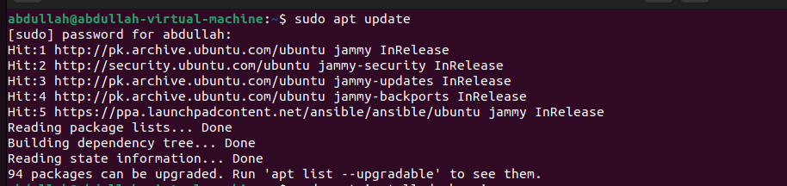

**sudo apt install docker.io**

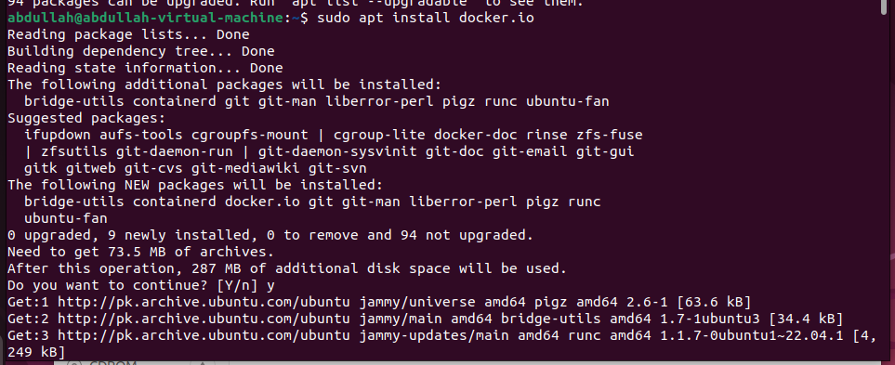

**sudo apt install docker-compose**

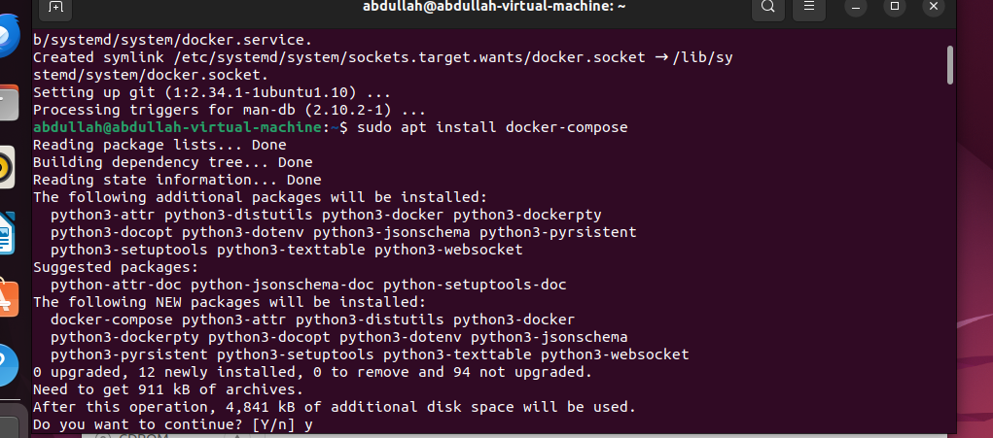

**touch docker-compose11.yml**

**touch Dockerfile**

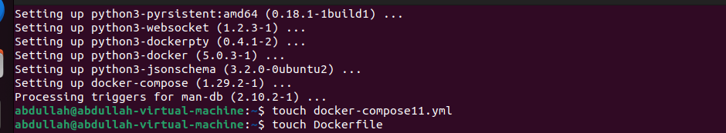

**sudo apt-get install docker-ce**

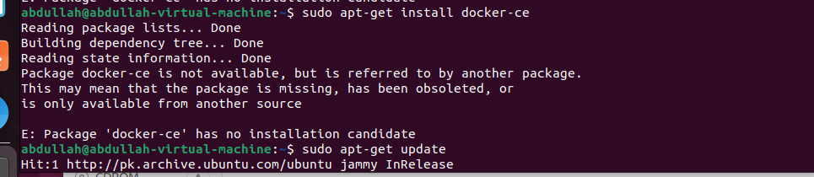

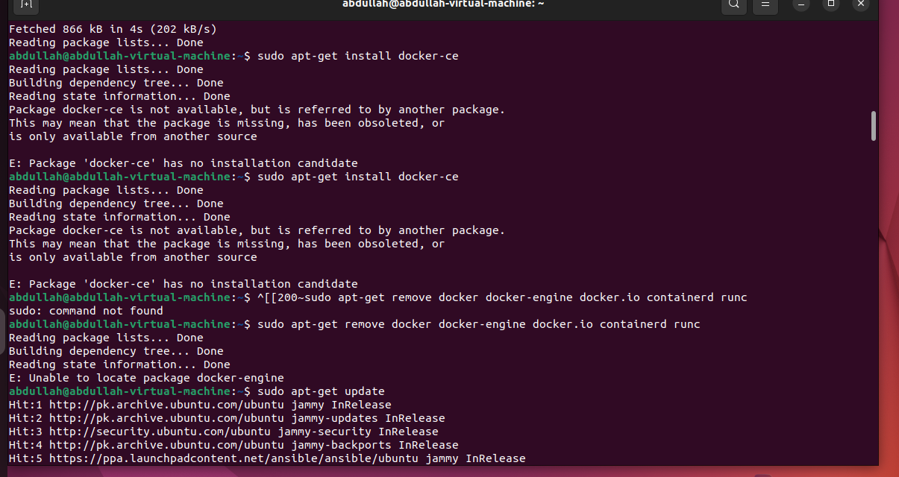

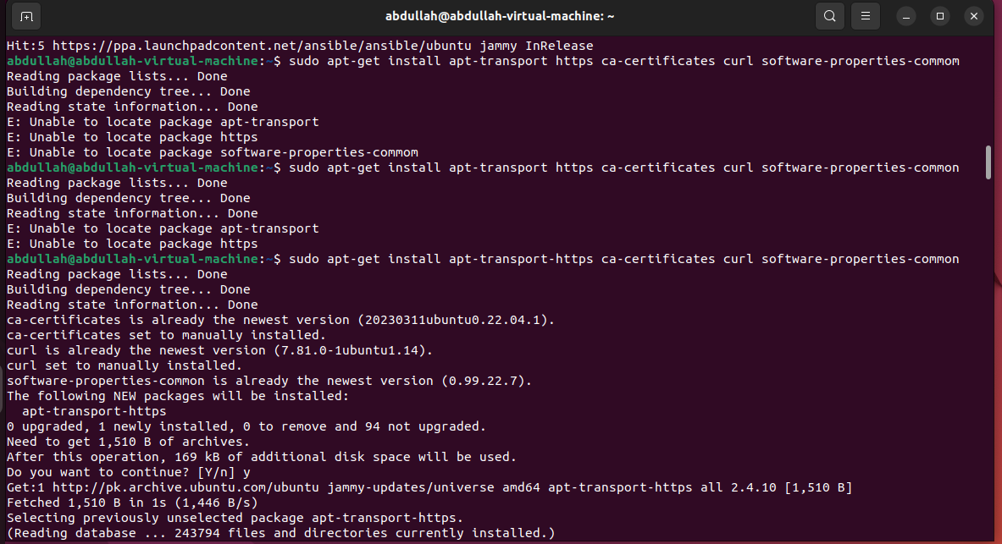

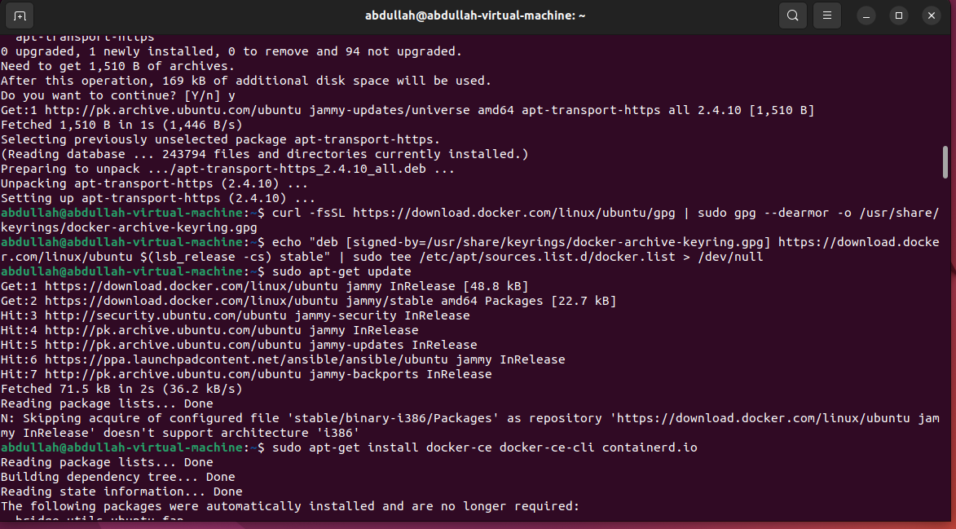

**sudo docker**

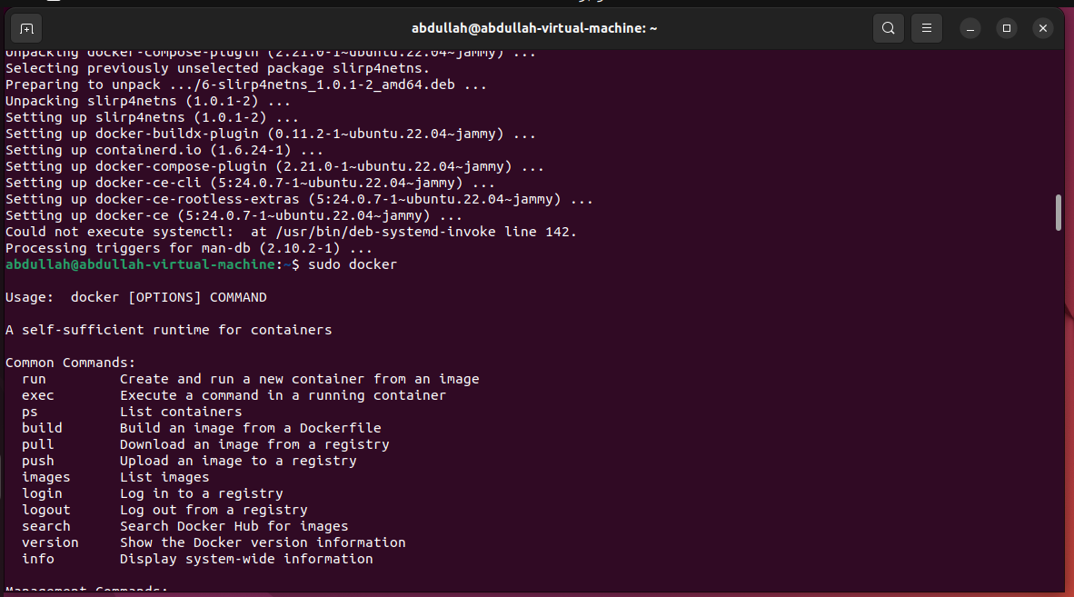

**sudo snap install docker**

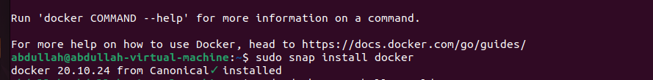

**sudo docker run hello-world**

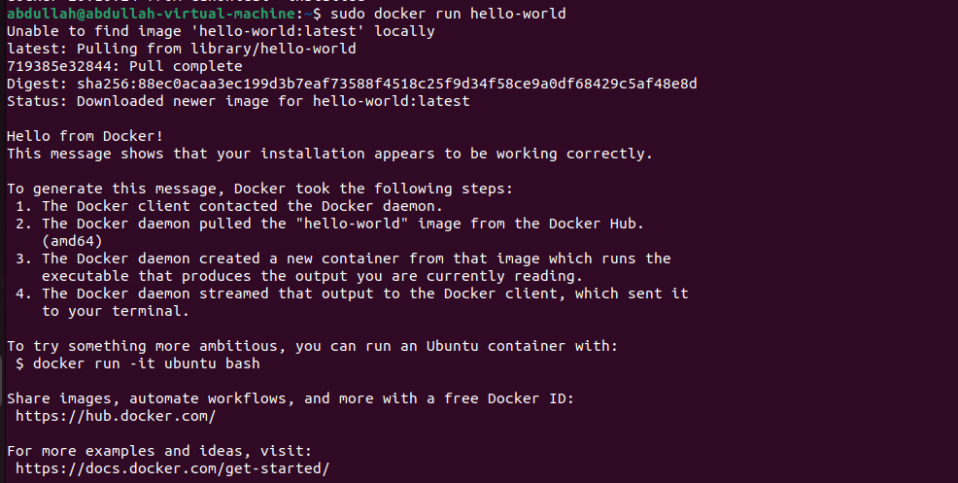

**sudo groupadd docker**



**sudo usermod –aG docker $USER**

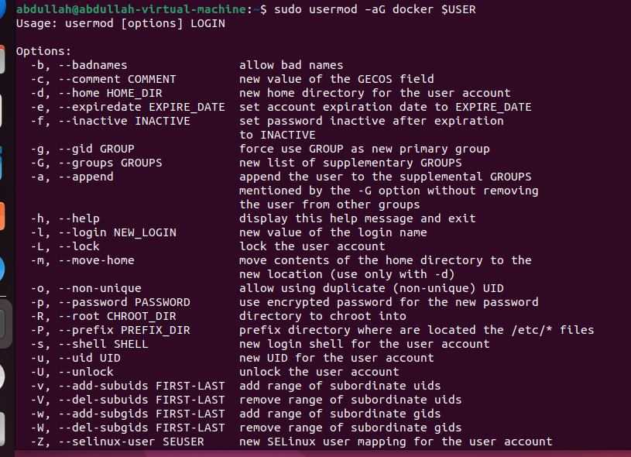

**sudo systemctl status docker**

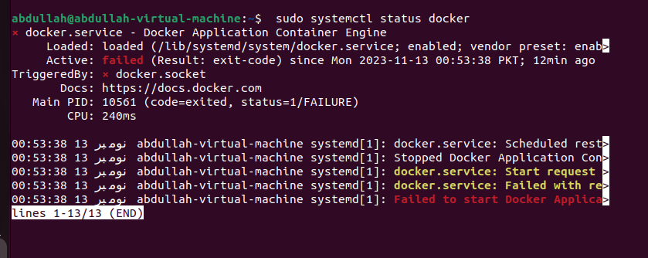

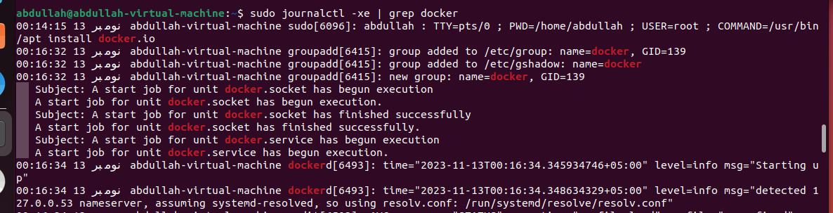

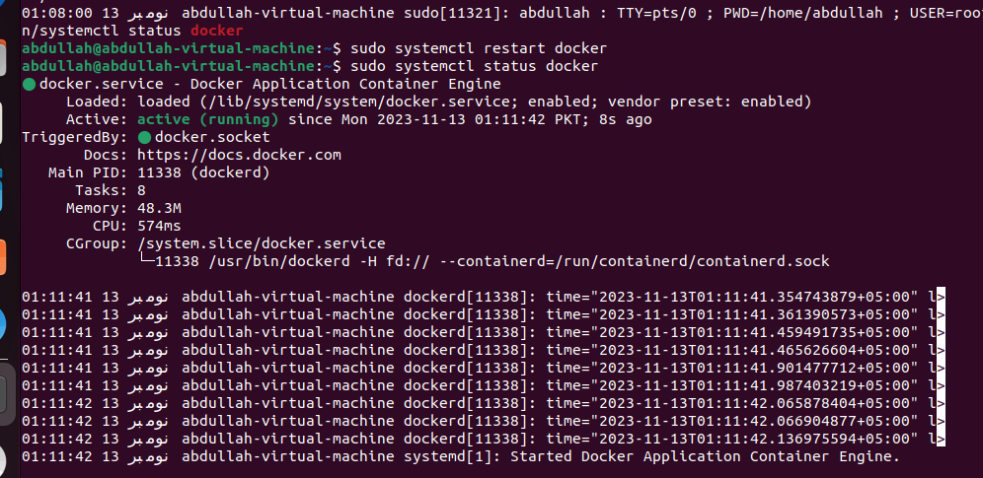

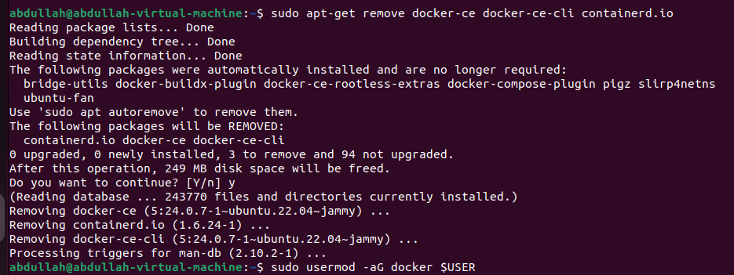

**sudo curl -SL https://github.com/docker/compose/releases/download/v2.23.0/docker-compose-linux-x86_64 -o /usr/local/bin/docker-compose**

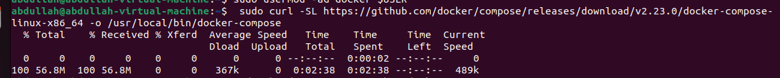

**sudo chmod +x /usr/local/bin/docker-compose**



**sudo ln -s /usr/local/bin/docker-compose /use/bin/docker-compose**

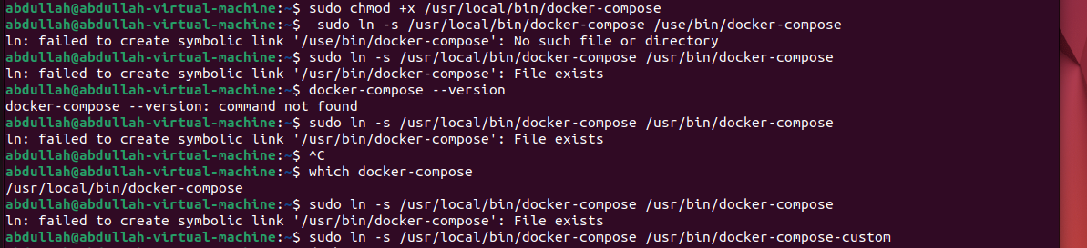

**docker-compose –version**

