昨日复习
自主Socket (客户端程序/java对 TCP/IP的实现)/开源 Xmpp
知识点/模块 | 概念/方法 | 开发步骤
消息对象 | 消息对象:content +附加信息(time from to)  ProtocalObj:基类 | IM接口文档:1.字段 2.格式(xml/json)  Xstream:java对象与xml互转的开发库  Xstream 核心类  fromXml xml-->java对象  toXml java对象-->xml  Gson :java与json互转的开发库  Gson 核心类  fromJson json-->java对象  toJson java对象-->json
消息通道 | 传输消息对象 1.发送 2.接收 | Socket:java对象TCP/IP的实现  - 插头:客户端程序  ServerSockete:插座:服务端程序  配置HOST PORT
消息发送 | 将消息对象转xml/json 通过流写到服务端 | writeUTF  |--OutputStream  |--DataOutputStream
消息接收 | 创建等待消息的线程.  监听器:接口.  IM软件:消息的接收对象. | readUTF  |--InputStream  |--DataInputStream
消息转发 | 服务端根据to查找出对应的消息通道 | 不要求会实现.IM服务器必须有该功能
启动 | 布局 .线程等待3000
登录 | 提交账号密码等待验证结果  - 通道  - 消息对象
好友 | 显示好友信息  把服务端转回的好友信息解析  提取 List集合  IM软件:受上线/上线好友影响 | 使用适配  BaseAdapter 4  |--ArrayAdapter 1  getView  notifyDatasetChanged 刷新
聊天 | 消息通道中消息的来回转输 | - 静态UI (假数据)  - ListView的多种行视图显示  - getViewTypeCount 返回行视图的种类  - getItemViewType判断指定下标的数据使用哪种类型的视图  - 优化 ViewHolder  - 假数据换真数据  - 消息发送  - 消息接收

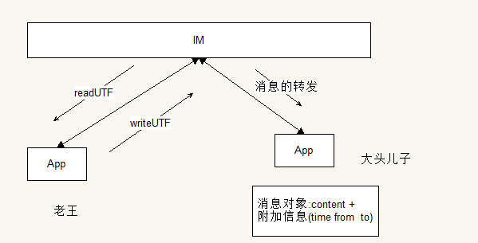
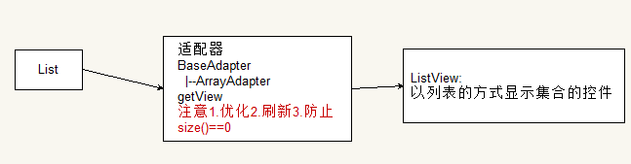

Xmpp基础

学习要点
消息对象
消息通道
消息发送
消息接收 | 通过监听器接收消息的
消息转发 | IM服务器

xmpp | 以xml消息转输格式  写在IM接口文档  行业的标准 msn gtalk
smack | 按照文档编写基于xmpp实现的开发库
asmack | a即是Android  专用
jabber | xmpp的前身就jabber
openfire | 基于xmpp 开源的im通讯服务器
spark | 基于xmpp开源im客户端软件

Spark安装配置
- next -->finish
- 配置 HOST ip 服务器名称
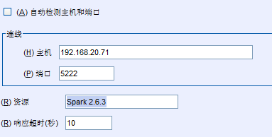

OpenFire搭建
>>1.next-->finish
>>2.mysql 初始化数据库 CREATE DATABASE openfire3 DEFAULT CHARACTER SET utf8;
>>3.在Openfire\resources\database取出脚本执行
>>4.配置数据库被使用

项目实战

Asmack搭建Client
- 创建工程
- 添加jar
- 绑定源代码

模块:欢迎

模块:登录
XMPPConnection | asmack实现的消息通道 xmpp  - 发送消息  - 接收消息  - login(账号,密码)
SSH xml  通过对象配置参数  ConnectionConfiguration | 参数配置对象  HOST  PORT  SERVICE_NAME itheima.com

开发步骤
- 静态UI TableLayout TableRow
- 登录逻辑
// 192.168.20.71 5222
// 1.创建通道
ConnectionConfiguration configuration = new ConnectionConfiguration(MyApp.HOST, MyApp.PORT);
// Debug信息
configuration.setDebuggerEnabled(true);
// 使用明文
configuration.setSecurityMode(SecurityMode.disabled);//
conn = new XMPPConnection(configuration);
conn.connect();
// 2.配置参数

try {
conn.login(username, password);
flag = true;
} catch (XMPPException e) {
// TODO Auto-generated catch block
e.printStackTrace();
flag = false;
}

模块:主页
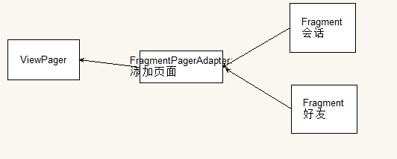

页面搭建ViewPager(重点!)
ViewPager | android-support-v4.jar  页面集合，以左右滑动的方式完成切换
Fragment | 包含视图的对象
PagerAdapter (需要)页面View  |--FragmentPagerAdapter (需要)页面Fragment | 适配器 装载页面的集合
FragmentActivity | Activity  |--FragmentActivity 添加Framgent到当前页面

$$$$开发步骤
- 必须是FreagmentActivity
- 使用Fragment创建两个页面
- 创建FragmetnPagerAdapter(其实已经是集合的两者的,那么所在类不必继承FragementActivity,说的是第一条)
- 布局ViewPager
- 设置给ViewPager

final List<Fragment> pages = new ArrayList<Fragment>();
pages.add(new SessionFragment());
pages.add(new ContactFragment());
FragmentPagerAdapter adapter = new FragmentPagerAdapter(getSupportFragmentManager()) {
// 返回页面数量
@Override
public int getCount() {
return pages.size();
}

// 指定下标 返回页面
@Override
public Fragment getItem(int position) {
return pages.get(position);
}
};
// ④ 布局ViewPager
// ⑤ 设置给ViewPager
viewpager.setAdapter(adapter);

页面指示器
指定当前第几个的控件
TabHost+TabWidget
RadioGroup +RadioButton
TextView两个
viewpager.setOnPageChangeListener(new ViewPager.OnPageChangeListener() {

// 监听页面切换完成
@Override
public void onPageSelected(int index) {

// index
if (index == 0) {
title.setText("会话");
session.setEnabled(false);
contact.setEnabled(true);
} else {
title.setText("好友");
session.setEnabled(true);
contact.setEnabled(false);// 高亮
}
}

private View.OnClickListener listener = new View.OnClickListener() {
@Override
public void onClick(View v) {
switch (v.getId()) {
case R.id.session:
viewpager.setCurrentItem(0);
break;
case R.id.contact:
viewpager.setCurrentItem(1);
break;
}

}

};

Fix Fragment的BUG
- 控件上的数据丢失
public abstract class BaseFragment extends Fragment {
private View view = null;
// 一个View只能被 添加布局里面ViewPager一次
@Override
public View onCreateView(LayoutInflater inflater, ViewGroup container, Bundle savedInstanceState) {
if (view == null) {
view = createView(inflater, container, savedInstanceState);
} else {
// has parent
ViewGroup parent = (ViewGroup) view.getParent();
if (parent != null) {
parent.removeView(view);
}
}
return view;

}

protected abstract View createView(LayoutInflater inflater, ViewGroup container, Bundle savedInstanceState);
}

模块:联系人--Roster
RosterEntry | 一个联系人 =好友  账号 昵称 头像
RosterGroup | 一组联系人 好集合
Roster | 所有联系人 分组的集合
RosterListener | 监听器:接收消息 名单修改消息

Roster对象
// 组数
// int count = roster.getGroupCount();
Collection<RosterGroup> groups = roster.getGroups();
for (RosterGroup group : groups) {
System.out.println("组名" + group.getName());
Collection<RosterEntry> list = group.getEntries();
for (RosterEntry entry : list) {
System.out.println("----" + entry.getUser() + " " + entry.getName());
}

}

RosterListener监听Roster修改操作
private RosterListener listener=new RosterListener() {
@Override
public void presenceChanged(Presence presence) {

}

//重命名好友
@Override
public void entriesUpdated(Collection<String> addresses) {
System.out.println("有人重命名好友了...");
printLn(addresses);
}
//删除
@Override
public void entriesDeleted(Collection<String> addresses) {
System.out.println("有人删除好友了...");
printLn(addresses);
}

private void printLn(Collection<String> addresses)
{
for(String address:addresses)
{
System.out.println(address);
}

}
//添加
@Override
public void entriesAdded(Collection<String> addresses) {
System.out.println("有人添加新好友了...");
printLn(addresses);
}
};

同步联系人

- 创建Provider
- 循环 Roster 同步 1.存在就更新 2.不存在就添加
- 查询Cusor
- 创建CursorAdapter游标适配器
- 设置给ListView

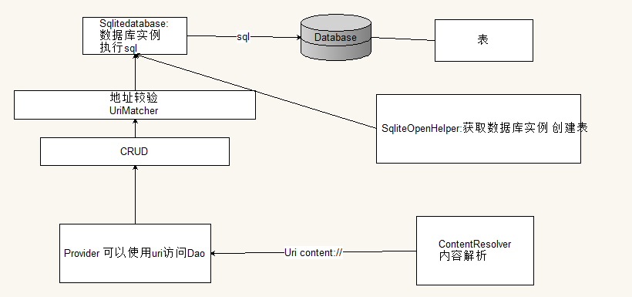

public class ContactProvider extends ContentProvider {
private static final String authority = "com.itheima.im3.provider.ContactProvider";
public static final Uri CONTACT_URI = Uri.parse("content://" + authority + "/contacts");
// 表结构
// BaseColumns _id
public static class CONTACT implements BaseColumns {
public static final String ACCOUNT = "account";
public static final String NICK = "nick";
public static final String AVATAR = "avatar";
public static final String SORT = "sort";// 拼音
}

private static final String TABLE = "contacts";
private static final String DB = "contact3.db";
private String sql = "create table contacts(_id integer primary key autoincrement,account text,nick text,avatar integer,sort Text)";

private MyHelper mMyHelper = null;

private class MyHelper extends SQLiteOpenHelper {

public MyHelper(Context context) {
super(context, DB, null, 1);
}

@Override
public void onCreate(SQLiteDatabase db) {
db.execSQL(sql);
}

@Override
public void onUpgrade(SQLiteDatabase db, int oldVersion, int newVersion) {
// TODO Auto-generated method stub

}

}

private SQLiteDatabase db = null;

@Override
public boolean onCreate() {
mMyHelper = new MyHelper(getContext());
return mMyHelper == null ? false : true;
}

@Override
public String getType(Uri uri) {
// TODO Auto-generated method stub
return null;
}

// content://contact/contacts
// content://contact/contacts/1
// ContentUris 1.+id 2. id
private static UriMatcher uris = null;

private static final int CONTACT_CODE = 0;
static {
uris = new UriMatcher(UriMatcher.NO_MATCH);
uris.addURI(authority, TABLE, CONTACT_CODE);
}

// 添加一个联系人
@Override
public Uri insert(Uri uri, ContentValues values) {
switch (uris.match(uri)) {
case CONTACT_CODE:
System.out.println("insert---");
db = mMyHelper.getWritableDatabase();
long id = db.insert(TABLE, "", values);
if (id != -1) {
uri = ContentUris.withAppendedId(uri, id);
}
break;
}
return uri;
}

// 删除 返回删除的记录数
@Override
public int delete(Uri uri, String selection, String[] selectionArgs) {
int count = 0;
switch (uris.match(uri)) {
case CONTACT_CODE:
System.out.println("delete---");
db = mMyHelper.getWritableDatabase();
count = db.delete(TABLE, selection, selectionArgs);
break;
}
return count;
}

// 更新 修改一条记录 昵称
@Override
public int update(Uri uri, ContentValues values, String selection, String[] selectionArgs) {
int count = 0;
switch (uris.match(uri)) {
case CONTACT_CODE:
System.out.println("update---");
db = mMyHelper.getWritableDatabase();
count = db.update(TABLE, values, selection, selectionArgs);
break;
}
return count;
}
// projection返回 select nick from contacts
@Override
public Cursor query(Uri uri, String[] projection, String selection, String[] selectionArgs, String sortOrder) {
Cursor c = null;
switch (uris.match(uri)) {
case CONTACT_CODE:
db = mMyHelper.getReadableDatabase();
System.out.println("query---");
c = db.query(TABLE, projection, selection, selectionArgs, null, null, sortOrder);
break;
}
return c;
}

}

完善保存逻辑
private RosterListener listener = new RosterListener() {
@Override
public void presenceChanged(Presence presence) {

}

// 重命名好友
@Override
public void entriesUpdated(Collection<String> addresses) {
System.out.println("有人重命名好友了...");
// printLn(addresses);
for (String address : addresses) {
RosterEntry person = roster.getEntry(address);
saveOrUpdateRosterEntry(person);
}
}

// 删除
@Override
public void entriesDeleted(Collection<String> addresses) {
System.out.println("有人删除好友了...");
printLn(addresses);
for (String address : addresses) {
getActivity().getContentResolver().delete(ContactProvider.CONTACT_URI, CONTACT.ACCOUNT + "=?", new String[] { address });
}
}

private void printLn(Collection<String> addresses) {
for (String address : addresses) {
System.out.println(address);
}

}

// 添加
@Override
public void entriesAdded(Collection<String> addresses) {
System.out.println("有人添加新好友了...");
printLn(addresses);
for (String address : addresses) {
RosterEntry person = roster.getEntry(address);
saveOrUpdateRosterEntry(person);
}
}
};

CursorAdapter显示联系人
private CursorAdapter adapter = null;

private void setAdapterOrNotify() {

if (adapter == null) {
final Cursor c = getActivity().getContentResolver().query(ContactProvider.CONTACT_URI, null, null, null, CONTACT.SORT + " ASC");// A-->Z
if (c.getCount() < 1) {
return;
}

adapter = new CursorAdapter(getActivity(), c,true) {

@Override
public View getView(int position, View convertView, ViewGroup parent) {
ViewHolder holder = null;

if (convertView == null) {
convertView = View.inflate(getActivity(), R.layout.item_buddy, null);
holder = new ViewHolder(convertView);
convertView.setTag(holder);
} else {
holder = (ViewHolder) convertView.getTag();
}
// 优化
c.moveToPosition(position);// list.get(position)

String account = c.getString(c.getColumnIndex(CONTACT.ACCOUNT));
String nick = c.getString(c.getColumnIndex(CONTACT.NICK));

holder.account.setText(account);
holder.nick.setText(nick);
return convertView;

}

// converView==null; 产生inflate
@Override
public View newView(Context arg0, Cursor arg1, ViewGroup arg2) {
return null;
}

// convertView!=null findViewById set
@Override
public void bindView(View arg0, Context arg1, Cursor arg2) {

}
};
contactlistview.setAdapter(adapter);
} else {
// adapter.notifyDataSetChanged();
// c.requery();
adapter.getCursor().requery();
}

注册ContentObserver自动更新UI
Provider发出信号
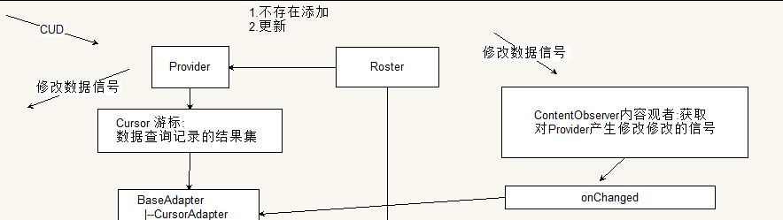
getContext().getContentResolver().notifyChange(uri, null);//null所有的观察者
ContentObserver接收信号
// FragmentActivity被删除了
@Override
public void onDestroy() {
super.onDestroy();
roster.removeRosterListener(listener);
getActivity().getContentResolver().unregisterContentObserver(mMyObserver);
}

ListView contactlistview;

private MyObserver mMyObserver = new MyObserver(new Handler());

private class MyObserver extends ContentObserver {

public MyObserver(Handler handler) {
super(handler);
}

// 低版本 2.2
@Override
public void onChange(boolean selfChange) {
System.out.println("----低版本 2.2---");
setAdapterOrNotify();
}

// 高版本 4.0
@Override
public void onChange(boolean selfChange, Uri uri) {
System.out.println("----高版本 4.0---");
setAdapterOrNotify();
}

}

使用Service开发后台服务
Activity /Fragment | Service
返回 关闭同步程序 | 后台运行的 隐蔽(没有Layout)  长期运行在后台
Service来同步数据
Activity/Fragment只负责显示数据

模块:聊天
消息对象必须在消息通道传输.Im服务器转发消息。
Message | 消息对象  from to type content
Chat | 消息的发送工具 sendMessage
ChatManager | Chat管理者 获取chat对象
MessageListener | 接收聊天消息的监听器
ChatManagerListener | 监听Chat创建  1.进入聊天 Chat 2.别人发起聊天 也会创建Chat

Chat与MessageListener
开发步骤
- 创建Chat工具(是长连接的消息通道,而httpurlconnection是一次性的是一种短连接)
- 创建ChatManager
- 创建Message
- 发送Chat sendmessage
- 创建监听器设置给Chat
// ① 创建Chat工具
if (currChat == null) {
// ② 创建ChatManager
ChatManager cm = MyApp.conn.getChatManager();
// currChat=cm.createChat(账号, 消息监听器);
currChat = cm.createChat(toAccount, listener);
}

private MessageListener listener = new MessageListener() {

// 接收消息
@Override
public void processMessage(Chat chat, final Message message) {

if (Message.Type.chat.equals(message.getType())) {

ThreadUtils.runUIThread(new Runnable() {

@Override
public void run() {
Toast.makeText(getBaseContext(), message.getBody(), 0).show();

}
});
}

}
};

ChatManagerListener监听Chat创建
ChatManager cm;
ChatManagerListener listener = new ChatManagerListener() {

// 监听聊天 createdLocally true 本程序发起聊天 createChat false 别人过来找聊天
@Override
public void chatCreated(Chat chat, final boolean createdLocally) {
System.out.println("---chatCreated--" + createdLocally);
if (!createdLocally) {
chat.addMessageListener(messagelistener);
}
// ThreadUtils.runUIThread(new Runnable() {
// @Override
// public void run() {
// Toast.makeText(getBaseContext(), "chatCreated..."+createdLocally,
// 0).show();
//
// }
// });
}
};
private MessageListener messagelistener = new MessageListener() {

@Override
public void processMessage(Chat chat, final Message message) {
ThreadUtils.runUIThread(new Runnable() {
@Override
public void run() {
Toast.makeText(getBaseContext(), message.getBody(), 0).show();
}
});
}
};

@Override
public void onDestroy() {
super.onDestroy();
if (cm != null) {
cm.removeChatListener(listener);
}
}

Provider保存消息
session_id:可以按照某人的账号 过滤出 某人与自己的聊天记录
public class SmsDao {
private Context context;
public SmsDao(Context context) {
this.context = context;
}

public void saveSendMessage(Message msg) {
ContentValues values=new ContentValues();
String account=msg.getFrom();
values.put(SMS.FROM_ID, account);
String nick=NickUtil.getNick(context, account);
String sessionName=NickUtil.getNick(context, msg.getTo());
values.put(SMS.FROM_NICK, nick);
values.put(SMS.FROM_AVATAR, 0);
values.put(SMS.BODY, msg.getBody());
values.put(SMS.TIME, System.currentTimeMillis());
values.put(SMS.TYPE, Message.Type.chat.toString());
values.put(SMS.STATUS, "");
values.put(SMS.UNREAD, 0);
values.put(SMS.SESSION_ID, msg.getTo());
values.put(SMS.SESSION_NAME, sessionName);
this.context.getContentResolver().insert(SmsProvider.SMS_URI, values);

}
public void saveReceiverMessage(Message msg) {
//小头@itheima.com-->老王@itheima.com
String from=NickUtil.filterAccount(msg.getFrom());
ContentValues values=new ContentValues();
values.put(SMS.FROM_ID, from);
String nick=NickUtil.getNick(context, from);
values.put(SMS.FROM_NICK, nick);
values.put(SMS.FROM_AVATAR, 0);
values.put(SMS.BODY, msg.getBody());
values.put(SMS.TIME, System.currentTimeMillis());
values.put(SMS.TYPE, Message.Type.chat.toString());
values.put(SMS.STATUS, "");
values.put(SMS.UNREAD, 0);
values.put(SMS.SESSION_ID, from);
values.put(SMS.SESSION_NAME, nick);
this.context.getContentResolver().insert(SmsProvider.SMS_URI, values);
}
}

使用CusorAdapter显示聊天内容
private CursorAdapter adapter = null;

private void setAdapterOrNotify() {
// TODO Auto-generated method stub
if (adapter == null) {

final Cursor c = getContentResolver().query(SmsProvider.SMS_URI, null, null, null, SMS.TIME + " ASC");
if (c.getCount() < 1) {
return;
}
adapter = new CursorAdapter(this, c) {

// 返回视图种类 0 1
@Override
public int getViewTypeCount() {
return 2;
}

// 根据 position返回类型 0发送 from=me 1 接收 from !=me
@Override
public int getItemViewType(int position) {
c.moveToPosition(position);
String fromId = c.getString(c.getColumnIndex(SMS.FROM_ID));
if (MyApp.account.equals(fromId)) {
return 0;
}
return 1;
}

// 返回行视图 显示指定下标的数据
@Override
public View getView(int position, View convertView, ViewGroup parent) {
int type = getItemViewType(position);
if (type == 0) {// 发送视图
ViewHolder holder1 = null;
if (convertView == null) {
convertView = View.inflate(getBaseContext(), R.layout.item_chat_send, null);
holder1 = new ViewHolder(convertView);
convertView.setTag(holder1);
} else {
holder1 = (ViewHolder) convertView.getTag();
}

c.moveToPosition(position);
long time = c.getLong(c.getColumnIndex(SMS.TIME));
String timeStr = MyTime.getTime(time);
String body = c.getString(c.getColumnIndex(SMS.BODY));
holder1.time.setText(timeStr);
holder1.content.setText(body);
return convertView;

} else if (type == 1) {// 接收
ViewHolder holder2 = null;
if (convertView == null) {
convertView = View.inflate(getBaseContext(), R.layout.item_chat_receive, null);
holder2 = new ViewHolder(convertView);
convertView.setTag(holder2);
} else {
holder2 = (ViewHolder) convertView.getTag();
}
c.moveToPosition(position);
long time = c.getLong(c.getColumnIndex(SMS.TIME));
String timeStr = MyTime.getTime(time);
String body = c.getString(c.getColumnIndex(SMS.BODY));
holder2.time.setText(timeStr);
holder2.content.setText(body);
return convertView;
}
return convertView;
}

@Override
public View newView(Context context, Cursor cursor, ViewGroup parent) {
return null;
}

@Override
public void bindView(View view, Context context, Cursor cursor) {

}
};

chatlistview.setAdapter(adapter);
} else {
adapter.getCursor().requery();
}

// 行数设置
if (adapter.getCursor().getCount() >= 1) {
chatlistview.setSelection(adapter.getCursor().getCount() - 1);
}

}

通过注册ContnetObserver自动更新UI
getContentResolver().registerContentObserver(SmsProvider.SMS_URI, true, mMyObserver);
getContentResolver().unregisterContentObserver(mMyObserver);
private MyObserver mMyObserver=new MyObserver(new Handler());
private class MyObserver extends ContentObserver {

public MyObserver(Handler handler) {
super(handler);
}

@Override
public void onChange(boolean selfChange) {
setAdapterOrNotify();
}

@Override
public void onChange(boolean selfChange, Uri uri) {
setAdapterOrNotify();
}

}

模块:会话列表
概念
聊天记录 按照session_id分组排序( time DESC ).显示最新的一条记录 列表.

CursorAdapter显示会话列表
参考其它页面 好友 聊天

注册ContentObserver自动更新UI
参考其它页面 好友 聊天

进入ChatActivity
sessionlistview.setOnItemClickListener(new ListView.OnItemClickListener() {

@Override
public void onItemClick(AdapterView<?> parent, View view, int position, long id) {

Cursor cursor=adapter.getCursor();
cursor.moveToPosition(position);// list.get(position)

String session_id = cursor.getString(cursor.getColumnIndex(SMS.SESSION_ID));
String nick=NickUtil.getNick(getActivity(), session_id);
Intent intent=new Intent(getActivity(),ChatActivity.class);
intent.putExtra("account", session_id);
intent.putExtra("nick", nick);
startActivity(intent);

}

消息推送
Packet:推送数据包
|---Message from to

聊天 与消息推送 集成 最主流应用
即时获取服务端更新敏感数据
保存消息通道 有效，服务端有新数据可以通过通道 发送消息。
轮询 | 循环线程每隔1000取得服务端新数据  - 流量  - 电量  假推送
Asmack xmpp | PacketListener  拦截底层数据包

// MyApp.conn.addPacketListener(包监听器 , 类型 );
MyApp.conn.addPacketListener(new PacketListener() {
@Override
public void processPacket(final Packet packet) {
System.out.println(packet.toXML());
if ("itheima.com".equals(packet.getFrom())) {
ThreadUtils.runUIThread(new Runnable() {
@Override
public void run() {
Message msg = (Message) packet;
// TODO Auto-generated method stub
Toast.makeText(getBaseContext(), "商城:" + msg.getBody(), 0).show();
}
});
}
// ??-?? ??:??:??.???: INFO/<unknown>(<unknown>): <message
// from="itheima.com"><body>ddd</body><thread>B312Y0</thread></message>

}
}, null);

