电路图：

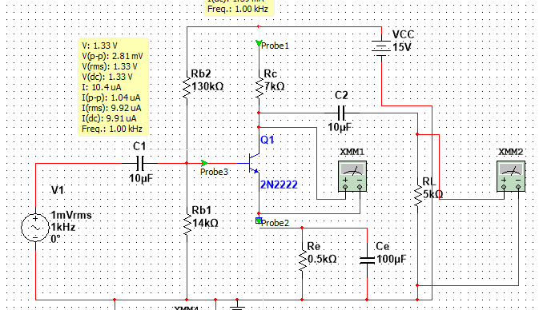

表1

|  |  |  |  |  |  |
| --- | --- | --- | --- | --- | --- |
|  | ***I*BQ** | **Rc** | **Re** | **Rb1** | **Rb2** |
| 计算初始值 | 10uA | 7kΩ | 0.5kΩ | 14kΩ | 136kΩ |
| 调试最终值 | 10uA | 7kΩ | 0.5kΩ | 14kΩ | 130kΩ |

表2

|  |  |  |  |
| --- | --- | --- | --- |
| ***I*BQ** | ***I*CQ** | ***U*CEQ** | ***U*BEQ** |
| 10.2uA | 1.4mA | 4.575V | 1.333V |

表3

|  |  |  |  |  |  |  |
| --- | --- | --- | --- | --- | --- | --- |
| **Ri测试数据** | | | **Ro测试数据** | | | **Av测试数据** |
| 输入电压（无取样电阻） | 输入电压（取样电阻为2k） | 输入电阻 | 输出电压（有负载） | 输出电压（负载开路） | 输出电阻 | 放大倍数 |
| 1mV | 523mV | 2.2kΩ | 123mV | 213mV | 3.7kΩ | 123 |

输入输出波形（蓝色为输入，红色为输出）

