1. OCL电路波形失真测量

图1

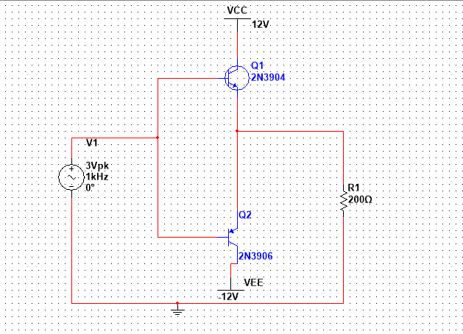

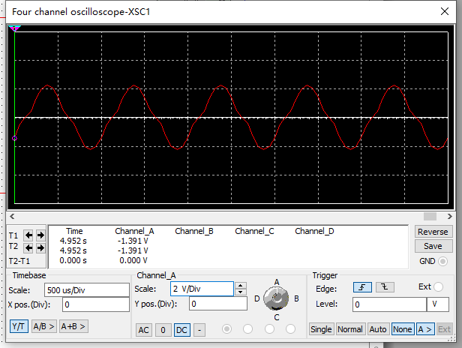

图2

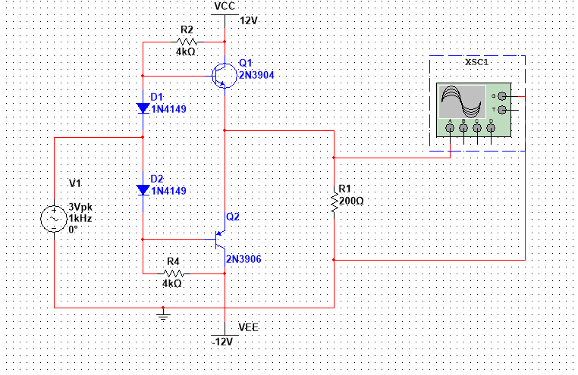

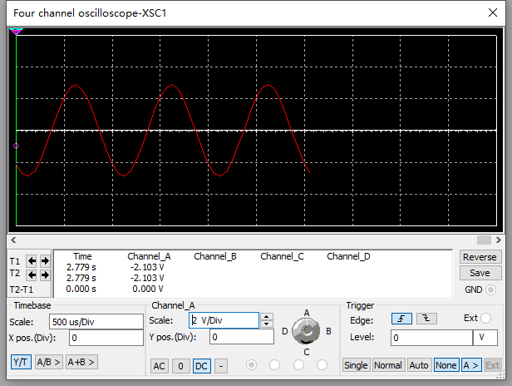

1. OCL甲乙类放大电路测量

表1

|  |  |  |  |  |  |
| --- | --- | --- | --- | --- | --- |
| **IB1（uA）** | **IE1**  **(mA)** | **IB2**  **(uA)** | **IE2**  **(mA)** | **UB1B2**  **(mV)** | **URL**  **(mV)** |
| 2.48uA | 321uA | -881nA | 256uA | 1.29V | 13mV |

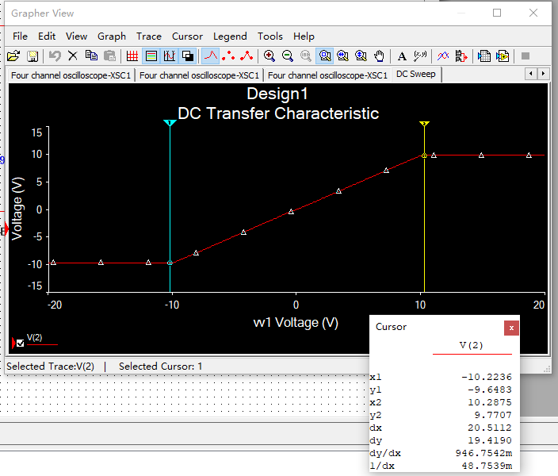

表2

|  |  |  |  |  |  |
| --- | --- | --- | --- | --- | --- |
| **v1**  **（V）** | **I+Vcc（mA）** | **I-Vcc**  **(mA)** | **PV**  **(W)** | **PO**  **(W)** | **效率(%)** |
| v1max=10.3 | 25.6 | 25.4 | 0.612 | 0.248 | 40.5% |
| 3 | 8.95 | 8.87 | 0.214 | 0.0204 | 9.5% |

1. 音频功率放大器仿真分析

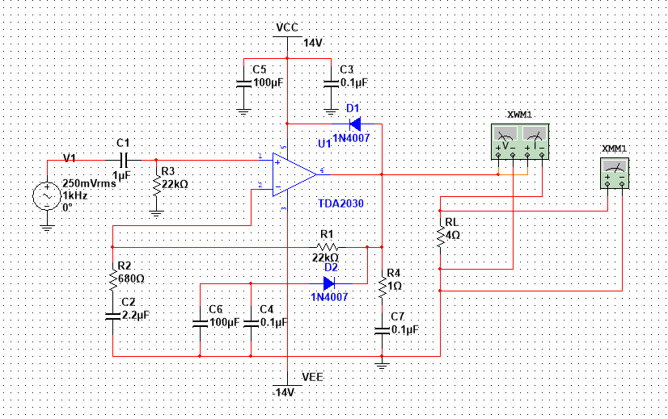

表3

|  |  |  |  |
| --- | --- | --- | --- |
| **Po（W）** | **10** | **15** | **20** |
| THD（%） | 0.014% | 0.027% | 0.524% |
| R1（kΩ） | 16.51 | 20.42 | 23.67 |
| 电压放大倍数 | 25.268 | 30.988 | 35.768 |

功率20w时波形图：

