1.

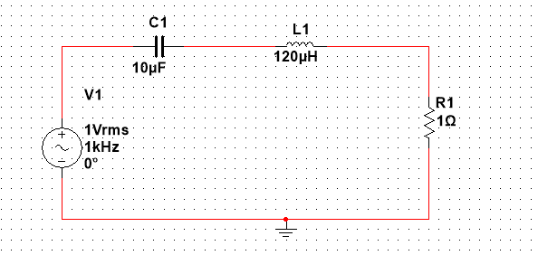

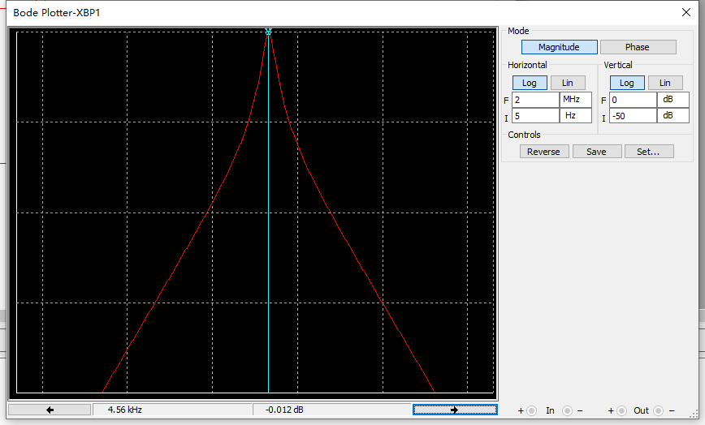

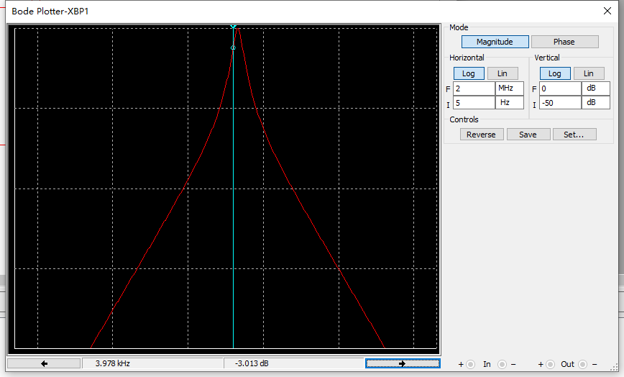

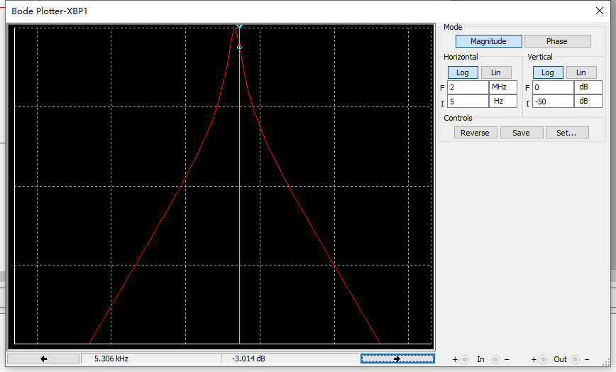

|  |  |  |  |  |  |  |  |  |
| --- | --- | --- | --- | --- | --- | --- | --- | --- |
| ***f*-3dB下** | ***f*-3dB上** | | ***f*0** | | ***Δf*** | | ***Q*** | |
| 3.978kHz | 5.306kHz | | 4.571kHz | | 1.325 | | 3.45 | |
| **VC** | | ***V*L** | | ***V*R** | | ***Vi*** | |
| 3.432mV | | 3.486mV | | 1mV | | 1mV | |

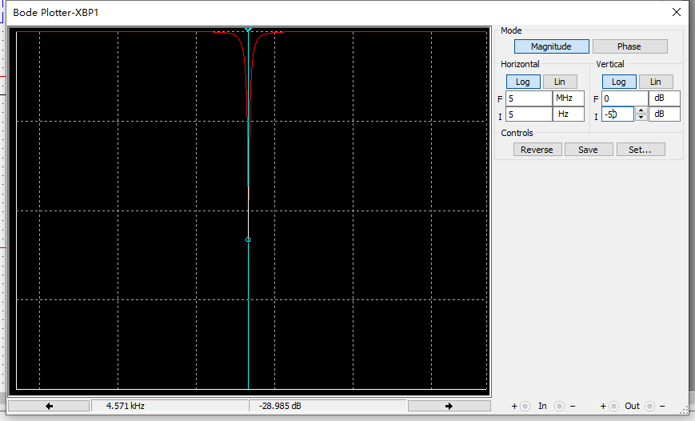

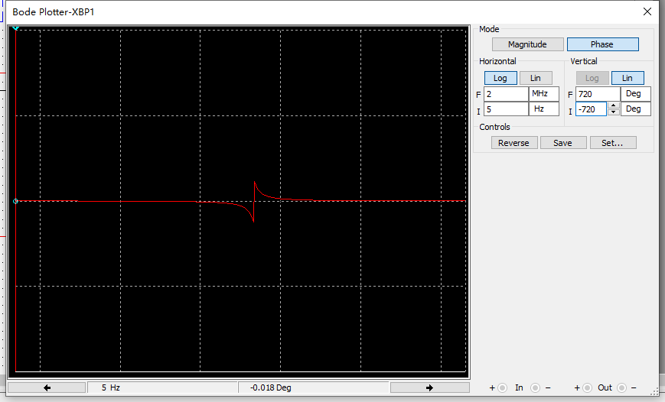

2.

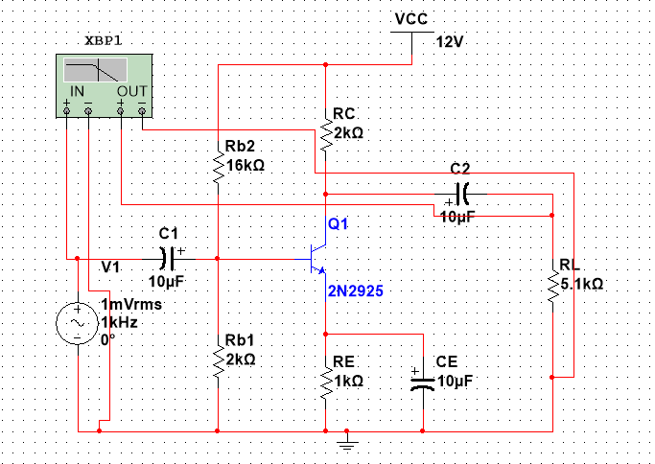

|  |  |  |  |  |  |  |
| --- | --- | --- | --- | --- | --- | --- |
| ***C*1**  **(μF)** | ***C*2**  **(μF)** | ***C*E**  **(μF)** | ***f*L**  **(Hz)** | ***f*H**  **(Hz)** | ***Δf***  **(Hz)** | **中频放大倍数*AV*（dB）** |
| 10 | 10 | 10 | 433.57 | 34.718M | 34.718M | 31.467 |
| 10 | 500 | 500 | 14.749 | 34.718M | 34.718M |
| 500 | 10 | 500 | 9.224 | 34.718M | 34.718M |
| 500 | 500 | 10 | 432.429 | 34.718M | 34.718M |

10 10 10

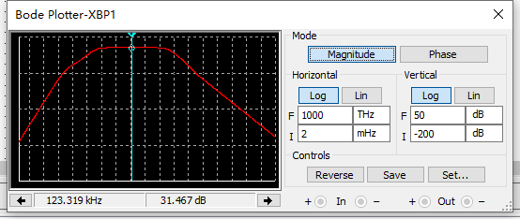

10 500 500

500 10 500

500 500 10

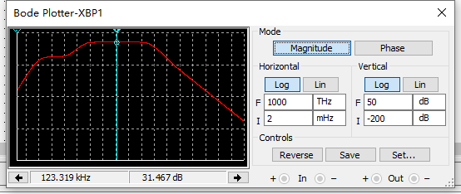

3.

|  |  |  |  |
| --- | --- | --- | --- |
| ***C*3**  **(pF)** | ***f*L**  **(Hz)** | ***f*H**  **(Hz)** | ***Δf***  **(Hz)** |
| 1 | 433.481 | 26.667M | 26.667M |
| 10 | 433.491 | 8.56M | 8.56M |
| 100 | 433.063 | 1.096M | 1.096M |

1pF

