1. 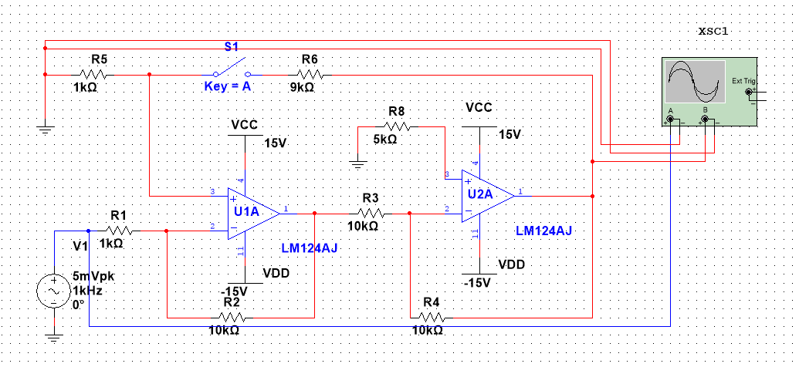

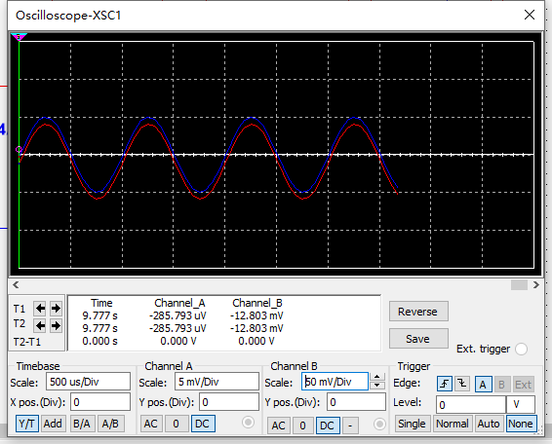

|  |  |  |  |
| --- | --- | --- | --- |
| R2（kΩ） | **10**  **（S1断开）** | **10**  **（S1闭合）** | **1000**  **（S1闭合）** |
| Au | 10 | 4.76 | 9.9 |
| Ri（kΩ） | 1 | 1.47 | 46.7 |

2. 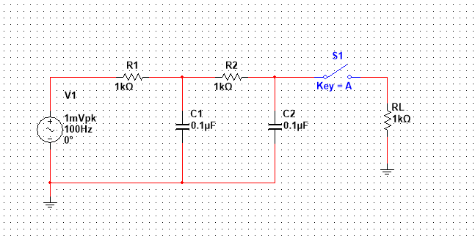

|  |  |  |  |
| --- | --- | --- | --- |
| **滤波器状态** | **无源空载** | **无源帶载** | **有源** |
| 通带电压增益  20lg|Aup| (dB) | 0 | -9.534 | 6.021 |
| 截止频率*f*p（kHz） | 0.594 | 1.448 | 0.594 |
| 特征频率*f*0（kHz） | 1.59 | 1.59 | 1.59 |

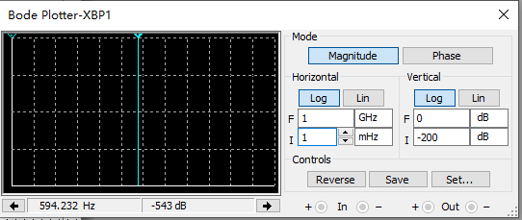

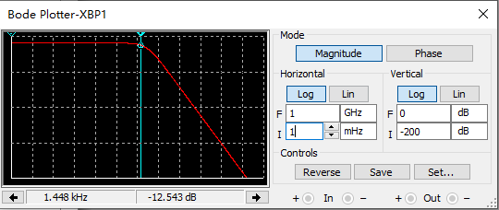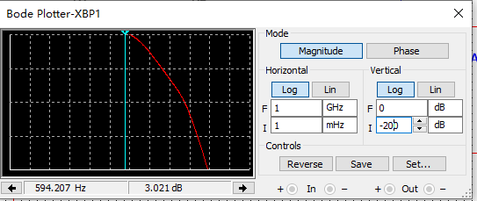

|  |  |  |  |  |  |  |
| --- | --- | --- | --- | --- | --- | --- |
| **Rf（kΩ）** | **特征频率*f*0（kHz）** | **通带电压增益**  **20lg|Aup| (dB)** | **通带电压放大倍数Aup** | ***f*=*f*0电压增益20lg|Au| （dB）** | ***f*=*f*0电压放大倍数Au** | **品质因数**  ***Q*=|Au/Aup|** |
| 5 | 1.59 | 3.5221 | 1.5 | 14.3716 | 5.2310 | 3.4873 |
| 10 | 1.59 | 6.0209 | 2 | 6.5055 | 2.1155 | 1.0578 |
| 15 | 1.59 | 7.9590 | 2.5 | 0.5006 | 1.0592 | 0.4237 |

3.

