同济大学计算机系

数字逻辑课程实验报告



学 号
姓 名
专 业 | 计算机科学与技术
授课老师

目录
一、 实验内容 2
二、 数据通路设计图 2
R 型指令 2
通路类型1 2
通路类型2 8
通路类型3 10
通路类型4 13
通路类型5 16
I 型指令 17
通路类型6 17
通路类型7 22
通路类型8 23
通路类型9 24
通路类型10 27
通路类型11 29
J 型指令 30
通路类型12 30
通路类型13 31
三、 模块建模 32
顶层sccomp_dataflow.v模块 32
寄存器堆REGFILES.v 33
PC.v 35
MUX.v 35
IMEM.v 36
II.v 36
EXT.v 37
DMEM.v 37
DIVIDER.v 38
DECODER.v 38
CU.v 42
CPU31.v 44
ALU.v 48
ADD.v 50
四、 测试模块建模 50
Tb_cpu顶层测试模块 50
五、 实验结果 53

- 实验内容
- 使用verilog建模,实现31条MIPS指令的CPU 的设计仿真和测试,验证结果
- 数据通路设计图

R 型指令

通路类型1

1.ADD
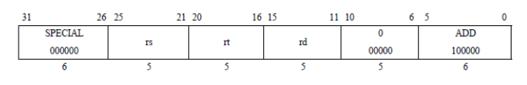
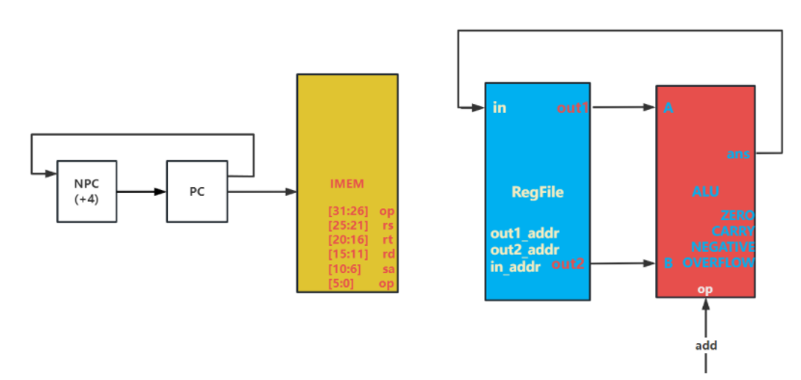
PC -> IMEM
PC + 4 -> NPC
NPC -> PC
out1 -> A , out2 -> B
(A + B -> RES)
ans -> in

2.ADDU
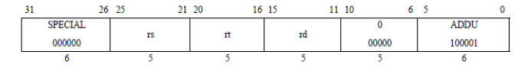
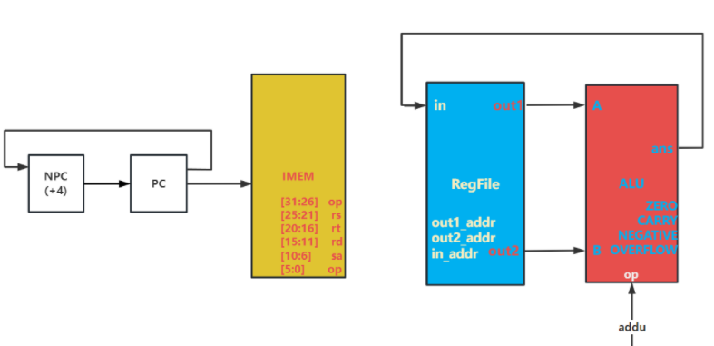
PC -> IMEM
PC + 4 -> NPC
NPC -> PC
out1 -> A , out2 -> B
(A + B -> RES)
ans -> in

3.SUB
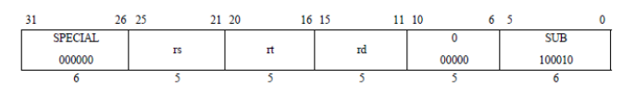
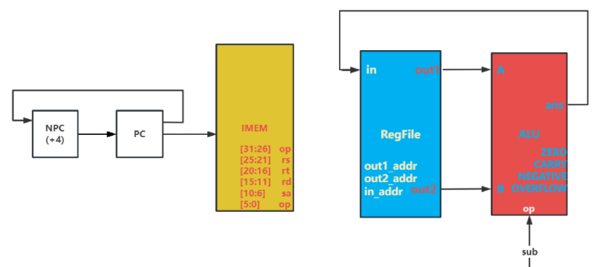
PC -> IMEM
PC + 4 -> NPC
NPC -> PC
out1 -> A , out2 -> B
(A - B -> RES)
ans -> in

4.SUBU
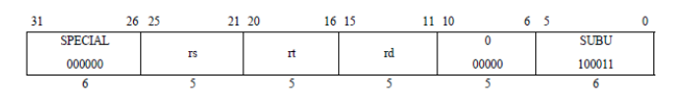
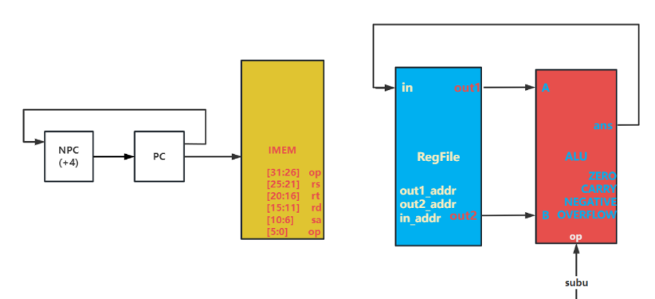
PC -> IMEM
PC + 4 -> NPC
NPC -> PC
out1 -> A , out2 -> B
(A - B -> RES)
ans -> in

5.AND
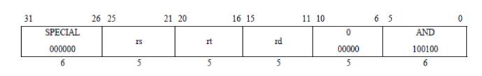
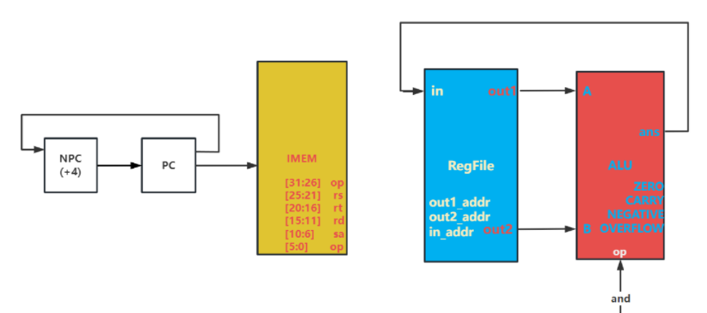
PC -> IMEM
PC + 4 -> NPC
NPC -> PC
out1 -> A , out2 -> B
(A & B -> RES)
ans -> in

6.OR
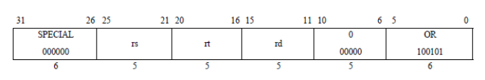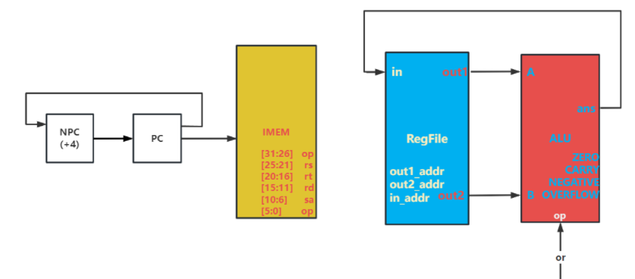
PC -> IMEM
PC + 4 -> NPC
NPC -> PC
out1 -> A , out2 -> B
(A | B -> RES)
ans -> in

7.XOR
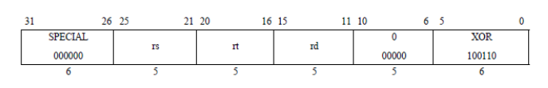
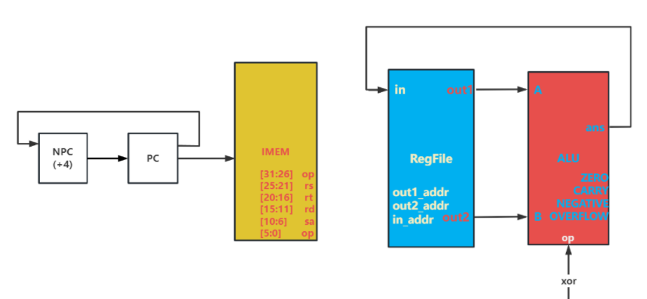
PC -> IMEM
PC + 4 -> NPC
NPC -> PC
out1 -> A , out2 -> B
(A ⊕ B -> RES)
ans -> in

8. NOR
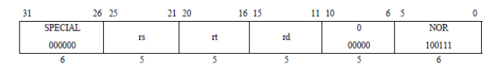
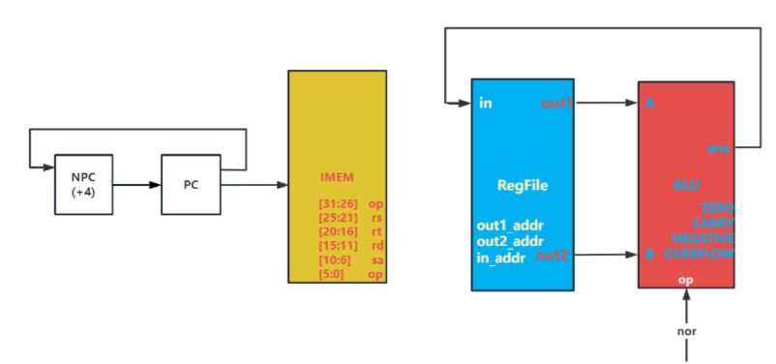
PC -> IMEM
PC + 4 -> NPC
NPC -> PC
out1 -> A , out2 -> B
(A ⊙ B -> RES)
ans -> in

通路类型2

9.SLT
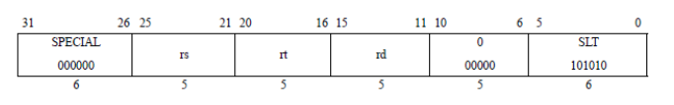
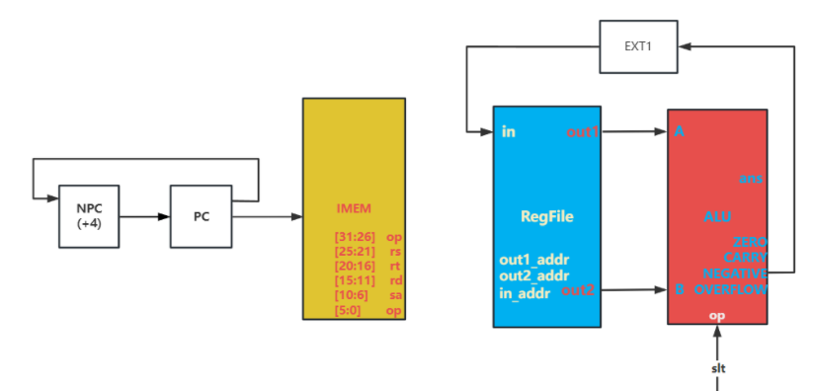
PC -> IMEM
PC + 4 -> NPC
NPC -> PC
out1 -> A , out2 -> B
(A - B -> ans) //相减判断，负数则为Rs中数小
negative -> EXT1 //注意要做扩展
EXT1 -> in

10.SLTU
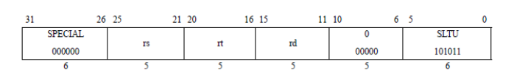
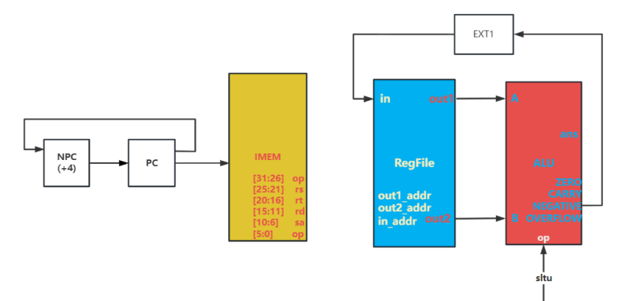
PC -> IMEM
PC + 4 -> NPC
NPC -> PC
out1 -> A , out2 -> B
(A - B -> ans) //相减判断，负数则为Rs中数小
negative -> EXT1 //注意要做扩展
EXT1 -> in

通路类型3

11.SLL
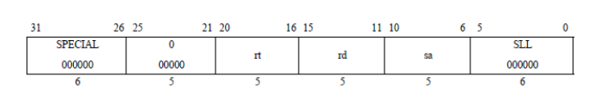
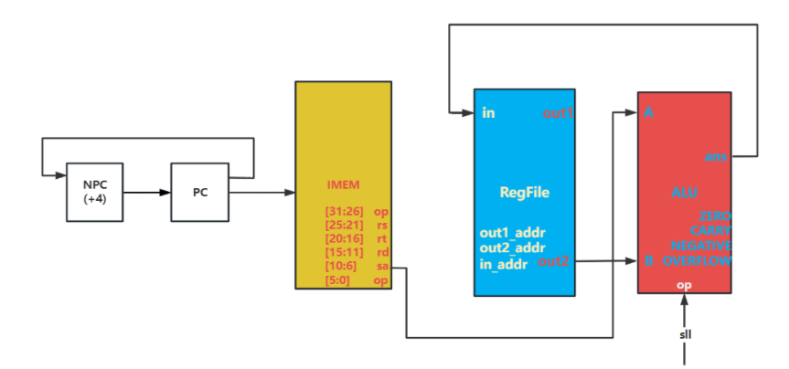
PC -> IMEM
PC + 4 -> NPC
NPC -> PC
IMEM[10:6] -> EXT5
EXT5 -> A
out2 -> B
(B<<A -> ans)
ans -> in

12.SRL
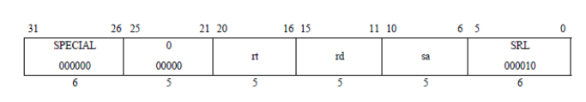
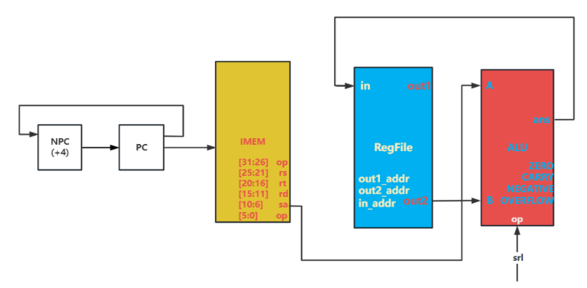
PC -> IMEM
PC + 4 -> NPC
NPC -> PC
IMEM[10:6] -> EXT5
EXT5 -> A
out2 -> B
(B>>A -> ans)
ans -> in

13.SRA
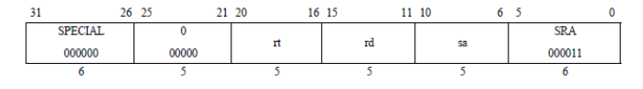
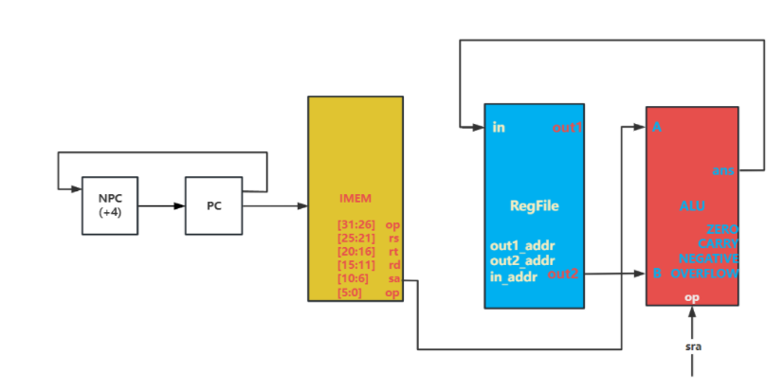
PC -> IMEM
PC + 4 -> NPC
NPC -> PC
IMEM[10:6] -> EXT5
EXT5 -> A
out2 -> B
(B>>A -> ans)
ans -> in

通路类型4

14.SLLV
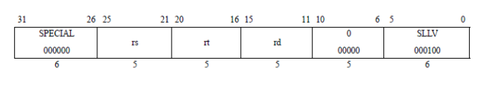
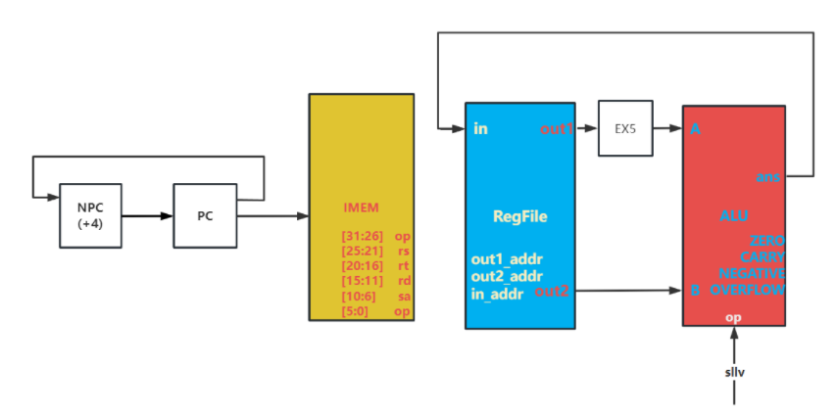
PC -> IMEM
PC + 4 -> NPC
NPC -> PC
out1[4:0] -> EXT5
EXT5 -> A
out2 -> B
(A<<B -> ans)
ans -> in

15.SRLV
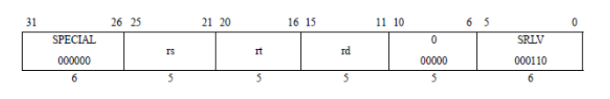
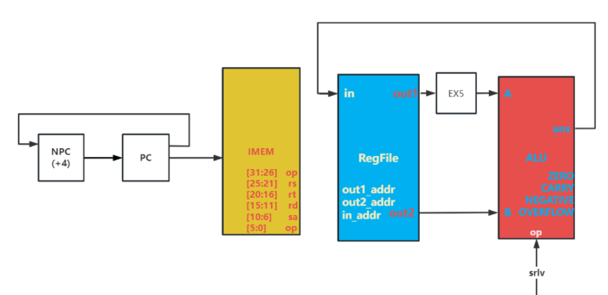
PC -> IMEM
PC + 4 -> NPC
NPC -> PC
out1[4:0] -> EXT5
EXT5 -> A
out2 -> B
(A >> B -> ans)
ans -> in

16.SRAV
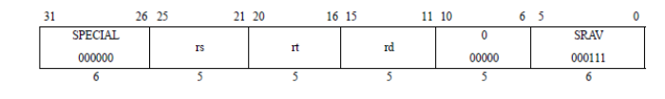
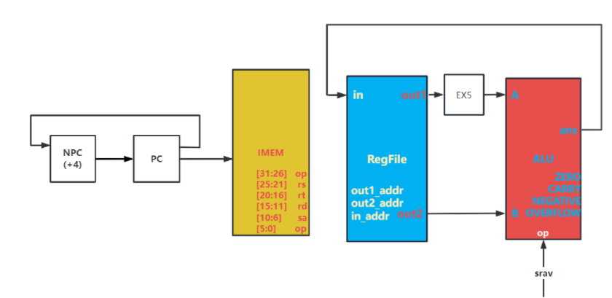
PC -> IMEM
PC + 4 -> NPC
NPC -> PC
out1[4:0] -> EXT5
EXT5 -> A
out2 -> B
(A >> B -> ans)
ans -> in

通路类型5

17.JR
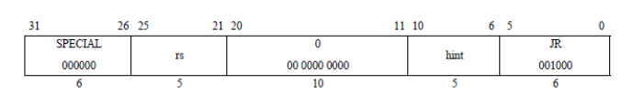
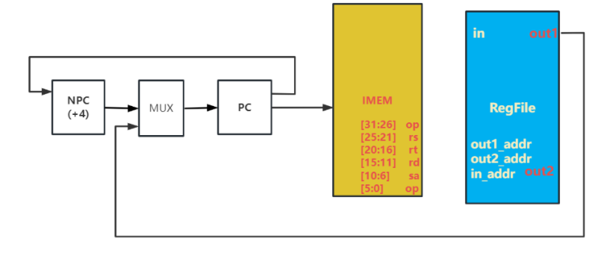
PC -> IMEM
PC + 4 -> NPC //无关指令
out1 -> MUX
MUX_OUT -> PC
NPC -> MUX //无关指令

I 型指令

通路类型6

18. ADDI
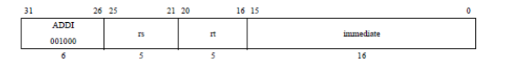
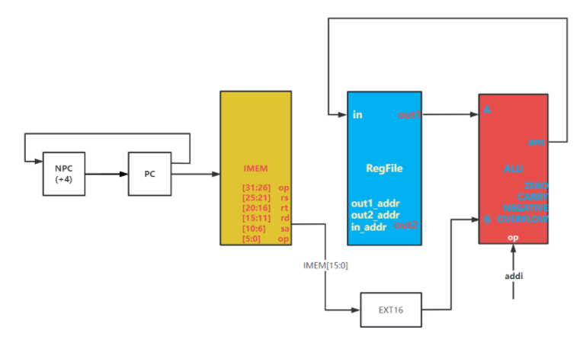
PC -> IMEM
PC + 4 -> NPC
NPC -> PC
IMEM[15:0] -> EXT16
EXT16-> B
out1 -> A
(A + B -> RES)
ans -> Rd

19.addiu
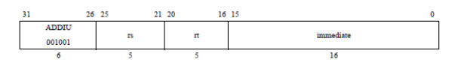
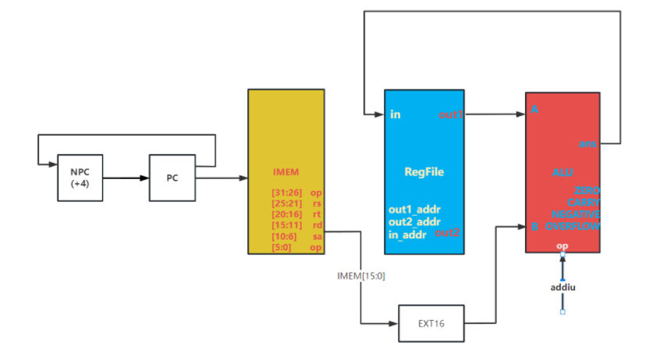
PC -> IMEM
PC + 4 -> NPC
NPC -> PC
IMEM[15:0] -> EXT16
EXT16-> B
out1 -> A
(A + B -> RES)
ans -> Rd

20.andi
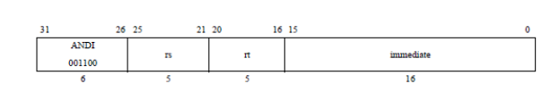
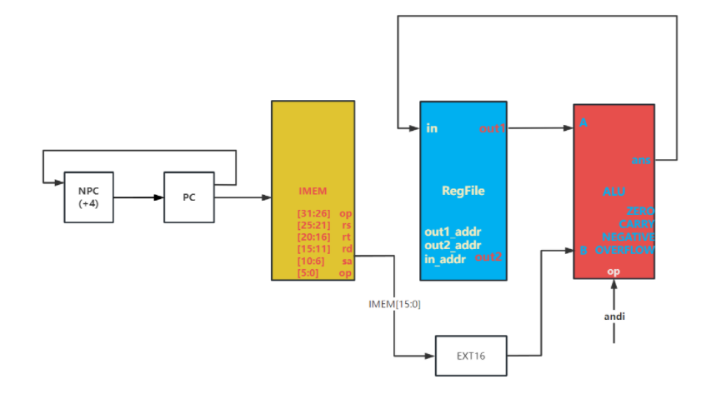
PC -> IMEM
PC + 4 -> NPC
NPC -> PC
IMEM[15:0] -> EXT16
EXT16-> B
out1 -> A
(A & B -> RES)
ans -> Rd

21.ori
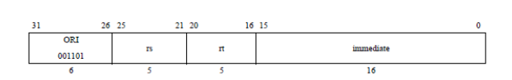
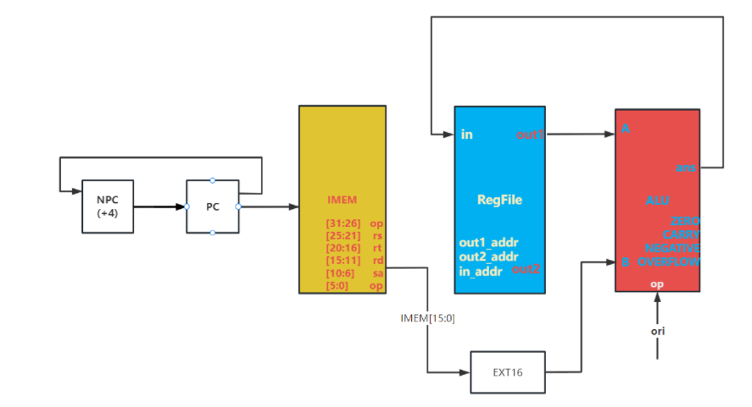
PC -> IMEM
PC + 4 -> NPC
NPC -> PC
IMEM[15:0] -> EXT16
EXT16-> B
out1 -> A
(A | B -> RES)
ans -> Rd

22.xori
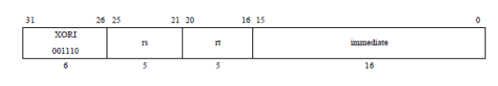
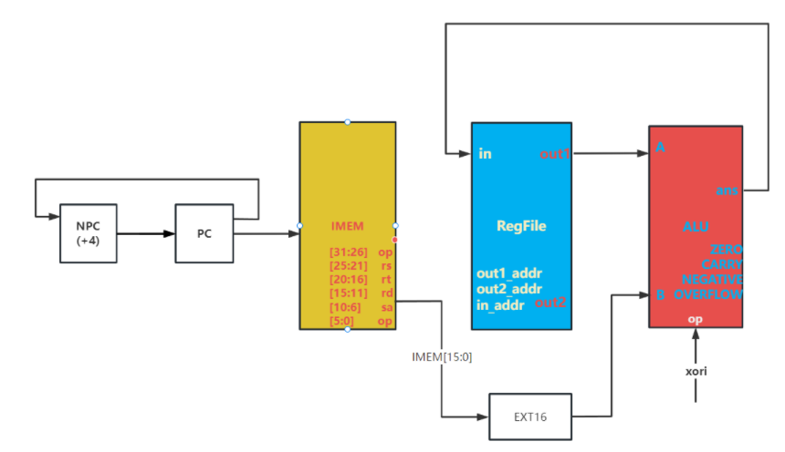
PC -> IMEM
PC + 4 -> NPC
NPC -> PC
IMEM[15:0] -> EXT16
EXT16-> B
out1 -> A
(A ⊕ B -> RES)
ans -> Rd

通路类型7

23.lw
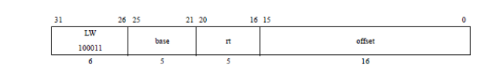
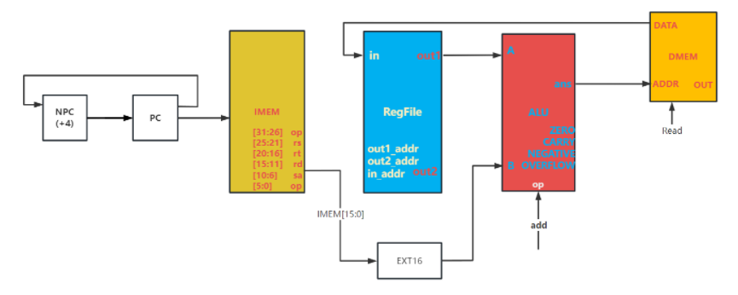
PC -> IMEM
PC + 4 -> NPC
NPC -> PC
IMEM[15:0] -> EXT16
EXT16 -> B
out1 -> A
(A + B -> ans)
ans -> DMEM_ADDR
data -> in

通路类型8

24.sw
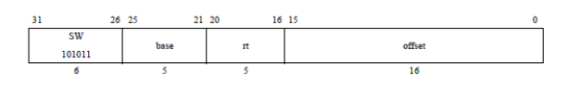
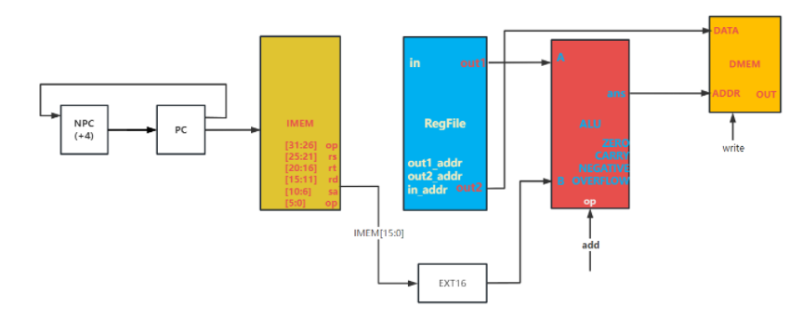
PC -> IMEM
PC + 4 -> NPC
NPC -> PC
IMEM[15:0] -> EXT16
EXT16_OUT -> B
out1 -> A
(A + B -> ans)
out2 -> DMEM
ans -> DMEM_ADDR

通路类型9

25.beq
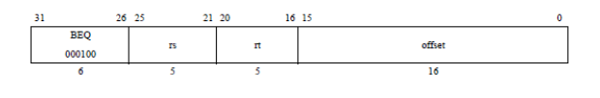
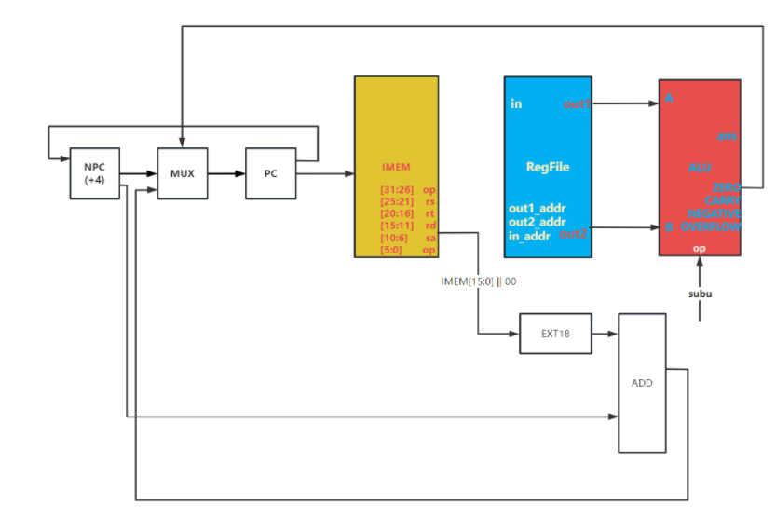
PC -> IMEM
PC + 4 -> NPC
NPC -> MUX
IMEM[15:0] || 02 -> EXT18
EXT18_OUT -> ADD_A
NPC -> ADD_B
(ADD_A + ADD_B -> ADD_OUT)
ADD_OUT -> MUX
out1 -> A
out2 -> B
(A - B -> RES)
zero -> MUX
MUX -> PC

26.bne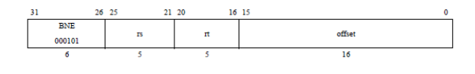
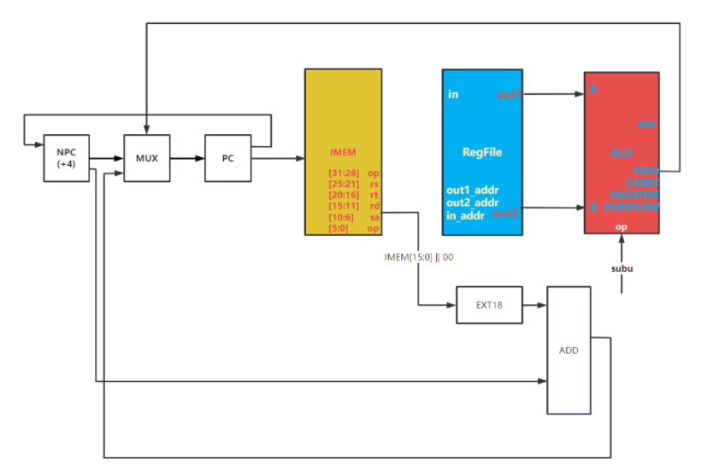
PC -> IMEM
PC + 4 -> NPC
NPC -> MUX
IMEM[15:0] || 02 -> EXT18
EXT18_OUT -> ADD_A
NPC -> ADD_B
(ADD_A + ADD_B -> ADD_OUT)
ADD_OUT -> MUX
out1 -> A
out2 -> B
(A - B -> RES)
zero -> MUX
MUX -> PC

通路类型10

27.slti
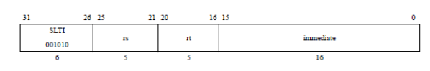
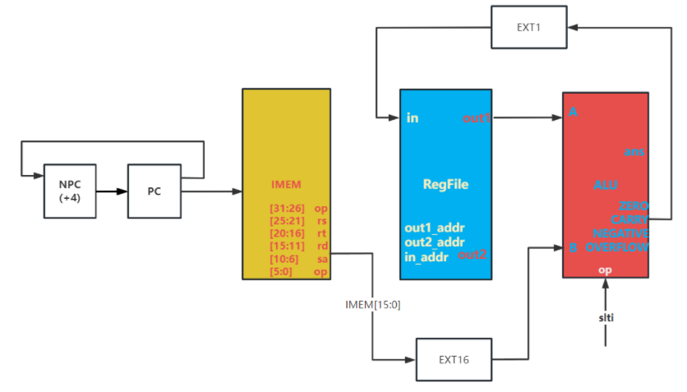
PC -> IMEM
PC + 4 -> NPC
NPC -> PC
IMEM[15:0] -> EXT16
EXT16 -> B
out1 -> A
(A - B -> RES)
Carry -> EXT1
EXT1 -> in

28.sltiu
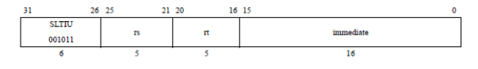
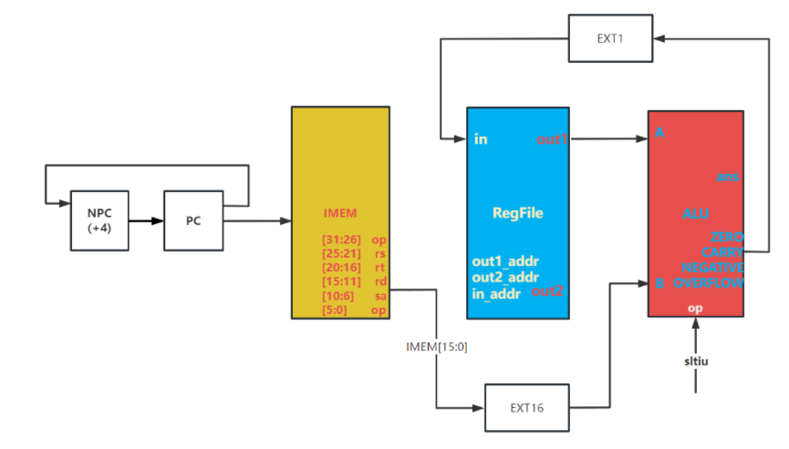
PC -> IMEM
PC + 4 -> NPC
NPC -> PC
IMEM[15:0] -> EXT16
EXT16 -> B
out1 -> A
(A - B -> ans)
Carry -> EXT1
EXT1 -> in

通路类型11

29.lui
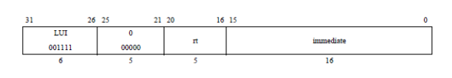
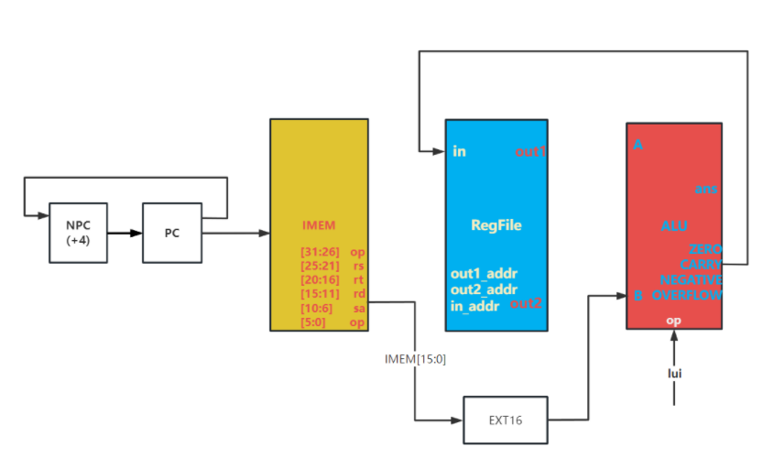
PC -> IMEM
PC + 4 -> NPC
NPC -> PC
IMEM[15:0] -> EXT16
EXT16 -> B
ans -> in(!!!!!!上面画错了!!!!!!)

J 型指令

通路类型12

30.j
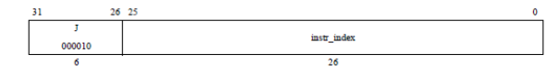
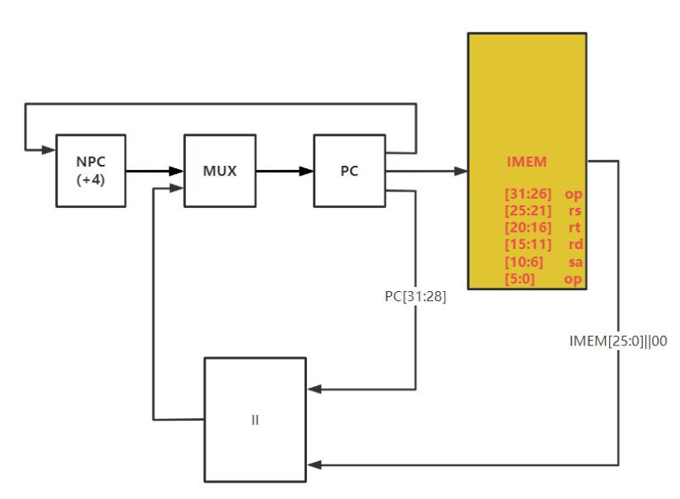
PC -> IMEM
PC + 4 -> NPC
NPC -> MUX
PC[31:28] -> ||_A
IMEM[25,0] || 00 -> ||_B
||_OUT -> MUX
MUX_OUT -> PC

通路类型13

31.jal
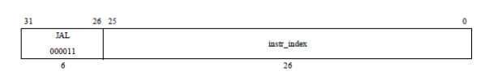
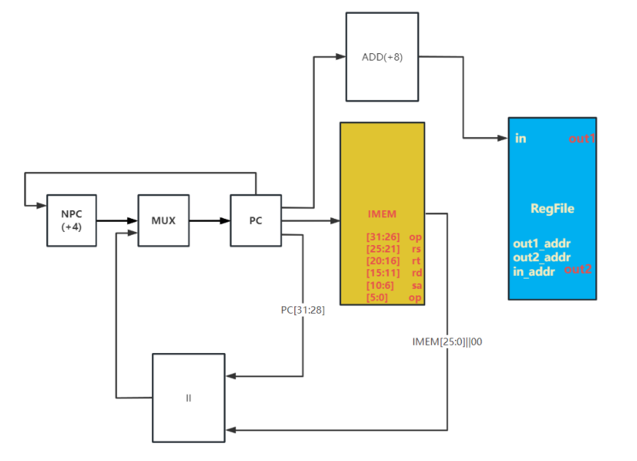
PC -> IMEM
PC + 4 -> NPC
NPC -> MUX
8 -> ADD_A
PC -> ADD_B
(ADD_A + ADD_B -> ADD_OUT)
ADD_OUT -> Rd
PC[31:28] -> ||_A
IMEM[25,0] || 02 -> ||_B
||_OUT -> MUX
MUX_OUT -> PC

数据通路总图
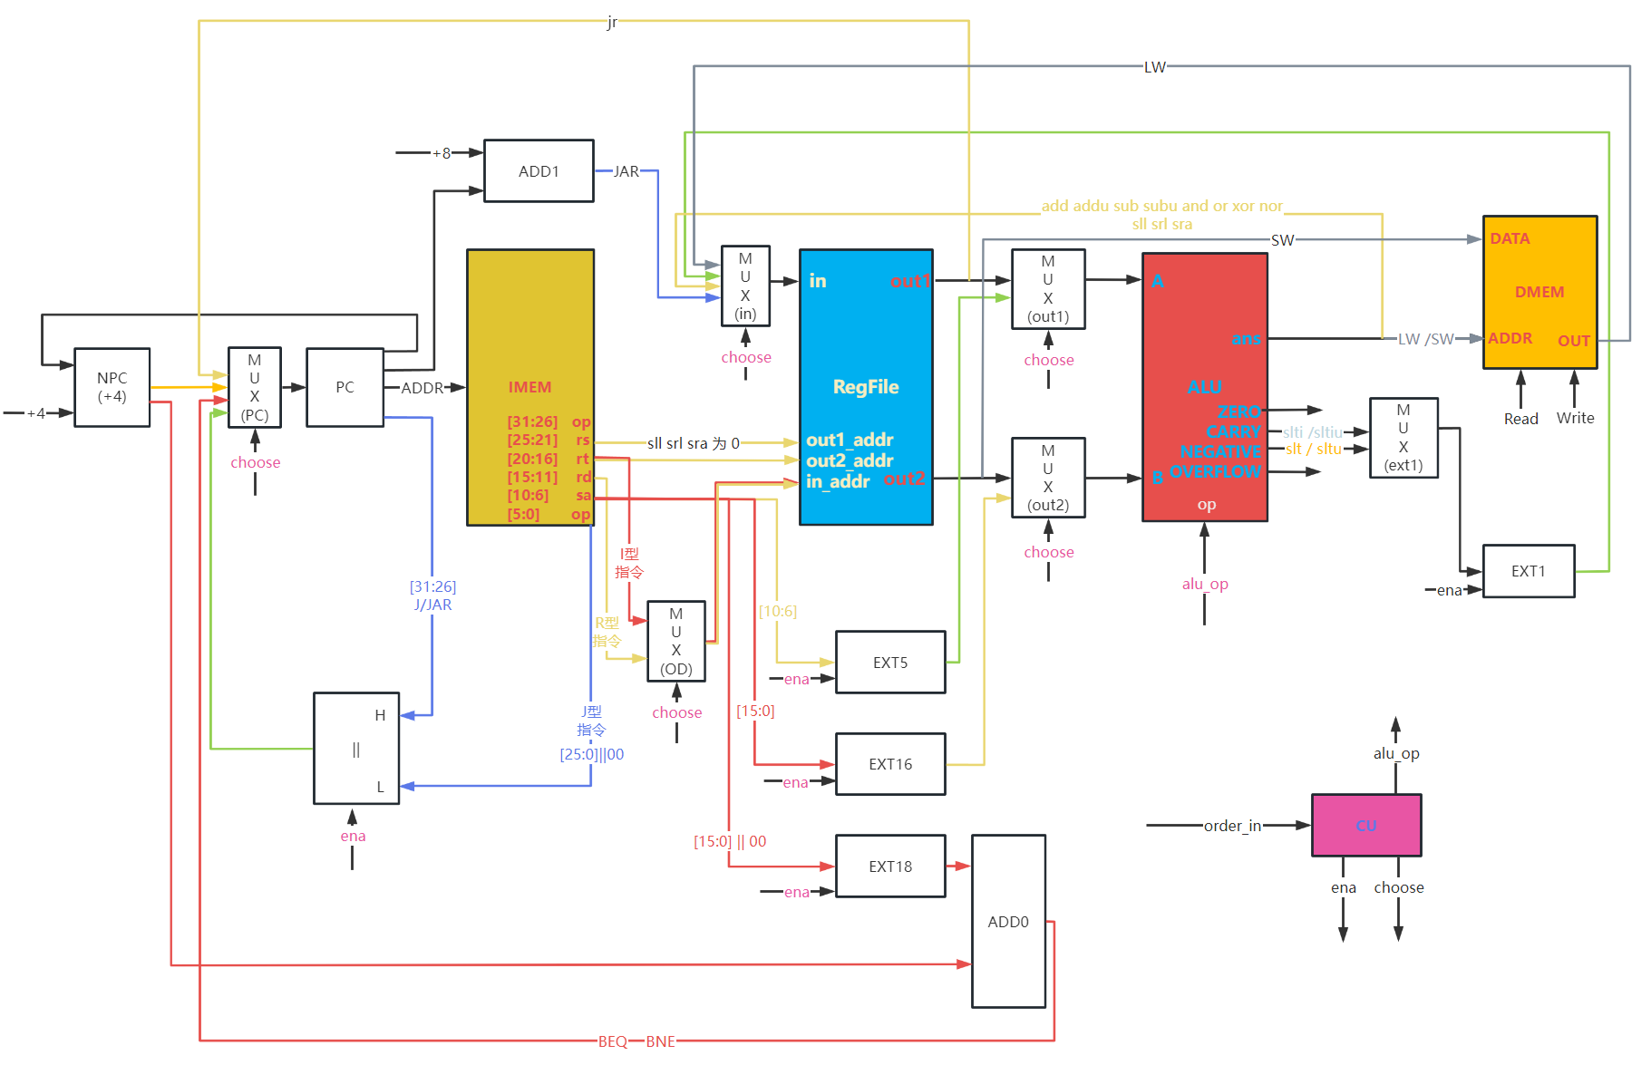
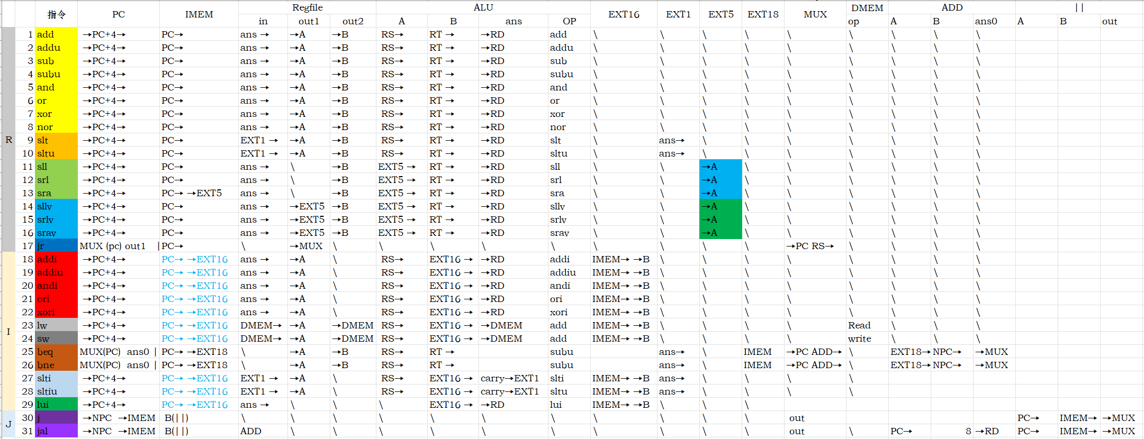
- 模块建模
（该部分要求对实验中建模的所有模块进行功能描述，并列出各模块建模的verilog代码）

顶层sccomp_dataflow.v模块
用Verilog代码进行描述数据流型描述如下：
`timescale 1ns/1ps
module sccomp_dataflow(
input clk_in, //别改,提交就是这个规则
input reset,
output [31:0] inst, //测试用,检测是什么指令
output [31:0] pc // 测试用,检测pc有没有正常前进

/******数码管显示接口*******/
// input cs,
// output [7:0] o_seg,
// output [7:0] o_sel

);
wire dmem_ena,dmem_read,dmem_write;
wire [31:0]dmem_addr,dmem_addr_temp,dmem_read_data,dmem_write_data;
assign dmem_addr = (dmem_addr_temp - 32'h1001_0000) /4;
wire [31:0]imem_addr;
/*****************下板时使用慢时钟*********************/
wire slow_clk;
DIVIDER #(.div(1)) divide_clk(.clk(clk_in),.rst(reset),.new_clk(slow_clk));

/* DMEM */
DMEM dmem(
.clk(slow_clk),
.ena(1'b1),
.write(dmem_write),
.read(dmem_read),

.addr(dmem_addr[10:0]),
.in(dmem_write_data),
.out(dmem_read_data)
);
/* CPU */
CPU31 sccpu(
.clk(slow_clk), .ena(1'b1),.rst(reset),

.imem_out(inst),
.imem_addr(imem_addr),

//.alu_ans() 不接

.dmem_addr(dmem_addr_temp),
.dmem_out(dmem_read_data),
.dmem_in(dmem_write_data),

.dmem_write(dmem_write),
.dmem_read(dmem_read)
);
/* IMEM */
assign pc = imem_addr;

IMEM imem(
.in(imem_addr[12:2]),
.out(inst)
);

/*********数码管接口**********/
// seg7x16 show_pc (
// .clk(slow_clk),
// .reset(reset),
// .cs(cs),
// .i_data(pc),
// .o_seg(o_seg),
// .o_sel(o_sel)
// );

endmodule

寄存器堆REGFILES.v
用Verilog代码进行描述数据流型描述如下：
`timescale 1ns/1ps
module REGFILES(
input ena,
input rst,
input clk,
input [4:0]in_addr,
input [4:0]out1_addr,
input [4:0]out2_addr,

input write,

input [31:0] in,
output [31:0] out1,
output [31:0] out2

);
reg [31:0] array_reg[31:0];
always @(posedge clk or posedge rst)
begin
if(ena)
begin
if(rst)
begin
array_reg[0] <= 32'b0;
array_reg[1] <= 32'b0;
array_reg[2] <= 32'b0;
array_reg[3] <= 32'b0;
array_reg[4] <= 32'b0;
array_reg[5] <= 32'b0;
array_reg[6] <= 32'b0;
array_reg[7] <= 32'b0;
array_reg[8] <= 32'b0;
array_reg[9] <= 32'b0;
array_reg[10] <= 32'b0;
array_reg[11] <= 32'b0;
array_reg[12] <= 32'b0;
array_reg[13] <= 32'b0;
array_reg[14] <= 32'b0;
array_reg[15] <= 32'b0;
array_reg[16] <= 32'b0;
array_reg[17] <= 32'b0;
array_reg[18] <= 32'b0;
array_reg[19] <= 32'b0;
array_reg[20] <= 32'b0;
array_reg[21] <= 32'b0;
array_reg[22] <= 32'b0;
array_reg[23] <= 32'b0;
array_reg[24] <= 32'b0;
array_reg[25] <= 32'b0;
array_reg[26] <= 32'b0;
array_reg[27] <= 32'b0;
array_reg[28] <= 32'b0;
array_reg[29] <= 32'b0;
array_reg[30] <= 32'b0;
array_reg[31] <= 32'b0;
end
else
if(write && in_addr!=0)
array_reg[in_addr] <= in;
end
end
assign out1 = ena? array_reg[out1_addr] : 32'bz;
assign out2 = ena? array_reg[out2_addr] : 32'bz;
endmodule

PC.v
用Verilog代码进行描述数据流型描述如下：
`timescale 1ns/1ps
module PC(
input clk,
input rst,
input ena,
input [31:0] in,
output [31:0] out
);

reg [31:0] register;
always @(negedge clk) begin
if (ena)
begin
if(rst)
register <= 32'h0040_0000;
else
register <= in;
end
end
assign out = rst ? 32'h0040_0000:(ena ? register :32'bz);
endmodule

MUX.v
用Verilog代码进行描述数据流型描述如下：
`timescale 1ns / 1ps
module MUX #(parameter WIDTH = 32)
(
input [WIDTH-1:0] in0,
input [WIDTH-1:0] in1,
input [WIDTH-1:0] in2,
input [WIDTH-1:0] in3,
input [1:0] choose,
output reg[WIDTH-1:0] out
);

always@(*)
begin
case(choose)
2'b00:out <=in0;
2'b01:out <=in1;
2'b10:out <=in2;
2'b11:out <=in3;
endcase
end
endmodule

IMEM.v
用Verilog代码进行描述数据流型描述如下：
`timescale 1ns/1ps
module IMEM(
input [10:0] in,
output [31:0] out

);
/*ip核*/
dist_mem_gen_0 imem(
.a(in),
.spo(out)
);
endmodule

II.v
用Verilog代码进行描述数据流型描述如下：
`timescale 1ns / 1ps
module II(
input [3:0]H,
input [25:0]L,
input ena,
output [31:0] out_d
);
assign out_d = ena? {{H},{L},2'b00}:32'bz;
endmodule

EXT.v
用Verilog代码进行描述数据流型描述如下：
`timescale 1ns/1ps
module EXT #(parameter WIDTH = 16)(
input [WIDTH-1:0] in,
input sign,
input ena,
output [31:0] out
);
assign out=ena?(sign? {{(32-WIDTH){in[WIDTH-1]}},in} : {{(32-WIDTH){1'b0}},in}) : 32'bz;
endmodule

DMEM.v
用Verilog代码进行描述数据流型描述如下：
`timescale 1ns / 1ps
module DMEM(
input clk,
input ena,
input write,
input read,

input [10:0] addr,
input [31:0] in,
output [31:0] out
);

reg [31:0] memory [0:31];
always@(posedge clk)
begin
if(ena)begin
if(write)
memory[addr] <= in;
end
end
assign out = (read && ena)? memory[addr] : 32'bz;
endmodule

DIVIDER.v
用Verilog代码进行描述数据流型描述如下：
`timescale 1ns/1ps
module DIVIDER
#(parameter div = 32'd20)//分频为原来频率的1/n
(
input clk,//要分频的时钟
input rst,//高电平复位信号
output reg new_clk//分频后的时钟
);
localparam T = div / 2;
reg [31:0] cnt = 0;
initial
begin
new_clk <= 0;
end
always @(posedge clk)
begin
if(rst == 1)
begin
cnt <= 0;
new_clk <= 0;
end
else
begin
if(cnt == T)
begin
cnt <= 1;
new_clk <= ~new_clk;
end
else
cnt <= cnt + 1;
end
end
endmodule

DECODER.v
用Verilog代码进行描述数据流型描述如下：
`timescale 1ns / 1ps
module DECODER(
input [31:0] order, //需要译码的指令，也就是当前要执行的指令

output [31:0] which_order,//哪一个指令

output [4:0] Rs, //Rs对应的寄存器的地址
output [4:0] Rt, //Rt对应的寄存器的地址
output [4:0] Rd, //Rd对应的寄存器的地址
output [4:0] Sa, //位移偏移量（SLL，SRL，SRA用）
output [15:0] i_immediate, //立即数（I型指令用）
output [25:0] j_immediate //跳转地址（J型指令用）
);

/* R型指令 */
parameter ADD = 6'b100000;
parameter ADDU = 6'b100001;
parameter SUB = 6'b100010;
parameter SUBU = 6'b100011;
parameter AND = 6'b100100;
parameter OR = 6'b100101;
parameter XOR = 6'b100110;
parameter NOR = 6'b100111;
parameter SLT = 6'b101010;
parameter SLTU = 6'b101011;
parameter SLL = 6'b000000;
parameter SRL = 6'b000010;
parameter SRA = 6'b000011;
parameter SLLV = 6'b000100;
parameter SRLV = 6'b000110;
parameter SRAV = 6'b000111;
parameter JR = 6'b001000;
/* I型指令 */
parameter ADDI = 6'b001000;
parameter ADDIU = 6'b001001;
parameter ANDI = 6'b001100;
parameter ORI = 6'b001101;
parameter XORI = 6'b001110;
parameter LW = 6'b100011;
parameter SW = 6'b101011;
parameter BEQ = 6'b000100;
parameter BNE = 6'b000101;
parameter SLTI = 6'b001010;
parameter SLTIU = 6'b001011;
parameter LUI = 6'b001111;
/* J型指令*/
parameter J = 6'b000010;
parameter JAL = 6'b000011;
/************************************R**********************************************/
wire add_ = ((order[31:26] == 6'h0) && (order[5:0] == ADD )) ? 1'b1 : 1'b0;
wire addu_ = ((order[31:26] == 6'h0) && (order[5:0] == ADDU )) ? 1'b1 : 1'b0;
wire sub_ = ((order[31:26] == 6'h0) && (order[5:0] == SUB )) ? 1'b1 : 1'b0;
wire subu_ = ((order[31:26] == 6'h0) && (order[5:0] == SUBU )) ? 1'b1 : 1'b0;
wire and_ = ((order[31:26] == 6'h0) && (order[5:0] == AND )) ? 1'b1 : 1'b0;
wire or_ = ((order[31:26] == 6'h0) && (order[5:0] == OR )) ? 1'b1 : 1'b0;
wire xor_ = ((order[31:26] == 6'h0) && (order[5:0] == XOR )) ? 1'b1 : 1'b0;
wire nor_ = ((order[31:26] == 6'h0) && (order[5:0] == NOR )) ? 1'b1 : 1'b0;

wire slt_ = ((order[31:26] == 6'h0) && (order[5:0] == SLT )) ? 1'b1 : 1'b0;
wire sltu_ = ((order[31:26] == 6'h0) && (order[5:0] == SLTU )) ? 1'b1 : 1'b0;

wire sll_ = ((order[31:26] == 6'h0) && (order[5:0] == SLL )) ? 1'b1 : 1'b0;
wire srl_ = ((order[31:26] == 6'h0) && (order[5:0] == SRL )) ? 1'b1 : 1'b0;
wire sra_ = ((order[31:26] == 6'h0) && (order[5:0] == SRA )) ? 1'b1 : 1'b0;

wire sllv_ = ((order[31:26] == 6'h0) && (order[5:0] == SLLV )) ? 1'b1 : 1'b0;
wire srlv_ = ((order[31:26] == 6'h0) && (order[5:0] == SRLV )) ? 1'b1 : 1'b0;
wire srav_ = ((order[31:26] == 6'h0) && (order[5:0] == SRAV )) ? 1'b1 : 1'b0;

wire jr_ = ((order[31:26] == 6'h0) && (order[5:0] == JR )) ? 1'b1 : 1'b0;
/*************************************I************************************************/
wire addi_ = (order[31:26] == ADDI ) ? 1'b1 : 1'b0;
wire addiu_ = (order[31:26] == ADDIU ) ? 1'b1 : 1'b0;
wire andi_ = (order[31:26] == ANDI ) ? 1'b1 : 1'b0;
wire ori_ = (order[31:26] == ORI ) ? 1'b1 : 1'b0;
wire xori_ = (order[31:26] == XORI ) ? 1'b1 : 1'b0;

wire lw_ = (order[31:26] == LW ) ? 1'b1 : 1'b0;

wire sw_ = (order[31:26] == SW ) ? 1'b1 : 1'b0;

wire beq_ = (order[31:26] == BEQ ) ? 1'b1 : 1'b0;
wire bne_ = (order[31:26] == BNE ) ? 1'b1 : 1'b0;

wire slti_ = (order[31:26] == SLTI ) ? 1'b1 : 1'b0;
wire sltiu_ = (order[31:26] == SLTIU ) ? 1'b1 : 1'b0;

wire lui_ = (order[31:26] == LUI ) ? 1'b1 : 1'b0;
/*************************************J*************************************************/
wire j_ = (order[31:26] == J ) ? 1'b1 : 1'b0;

wire jal_ = (order[31:26] == JAL ) ? 1'b1 : 1'b0;
/***************************************************************************************/
assign which_order [1] = add_ ; //ADD
assign which_order [2] = addu_ ; //ADDU
assign which_order [3] = sub_ ; //SUB
assign which_order [4] = subu_; //SUBU
assign which_order [5] = and_ ; //AND
assign which_order [6] = or_ ; //OR
assign which_order [7] = xor_ ; //XOR
assign which_order [8] = nor_ ; //NOR
assign which_order [9] = slt_ ; //SLT
assign which_order [10] = sltu_ ; //SLTU
assign which_order [11] = sll_ ; //SLL
assign which_order [12] = srl_ ; //SRL
assign which_order [13] = sra_ ; //SRA
assign which_order [14] = sllv_ ; //SLLV
assign which_order [15] = srlv_ ; //SRLV
assign which_order [16] = srav_ ; //SRAV
assign which_order [17] = jr_ ; //JR
assign which_order [18] = addi_ ; //ADDI
assign which_order [19] = addiu_; //ADDIU
assign which_order [20] = andi_ ; //ANDI
assign which_order [21] = ori_ ; //ORI
assign which_order [22] = xori_ ; //XORI
assign which_order [23] = lw_ ; //LW
assign which_order [24] = sw_ ; //SW
assign which_order [25] = beq_ ; //BEQ
assign which_order [26] = bne_ ; //BNE
assign which_order [27] = slti_ ; //SLTI
assign which_order [28] = sltiu_; //SLTIU
assign which_order [29] = lui_ ; //LUI
assign which_order [30] = j_ ; //J
assign which_order [31] = jal_ ; //JAL
/* 取出指令中各部分的值 */
assign Rs = (sll_|srl_|sra_|lui_|j_|jal_) ? 5'hz :order[25:21];

assign Rt = (jr_|j_|jal_) ? 5'hz : order[20:16];

assign Rd = (jr_|addi_|addiu_|andi_|ori_|xori_|lw_|sw_|beq_|bne_|slti_|sltiu_|lui_|j_|jal_) ? 5'bz : order[15:11];

assign Sa = (sll_ | srl_ | sra_) ? order[10:6] : 5'hz;

assign i_immediate = (addi_ | addiu_ | andi_ | ori_ |
xori_ | lw_ | sw_ | beq_ |
bne_ | slti_ | sltiu_ | lui_) ? order[15:0] : 16'hz;

assign j_immediate = (j_ | jal_) ? order[25:0] : 26'hz;

endmodule

CU.v
用Verilog代码进行描述数据流型描述如下：
`timescale 1ns/1ps
module CU(
input [31:0]order_flag,
input zero,
input overflow,

output regfile_write,

output dmem_write,
output dmem_read,

output [18:0] ext_ena,
output ext16_sign,
output II_ena,
output [4:0] alu_op,

output [1:0] choose_mux_pc,
output [1:0] choose_mux_od,
output [1:0] choose_mux_in,

output choose_mux_out1,
output choose_mux_out2,
output choose_mux_ext1

);
wire add_ = order_flag [1] ; //ADD
wire addu_ = order_flag [2] ; //ADDU
wire sub_ = order_flag [3] ; //SUB
wire subu_ = order_flag [4] ; //SUBU
wire and_ = order_flag [5] ; //AND
wire or_ = order_flag [6] ; //OR
wire xor_ = order_flag [7] ; //XOR
wire nor_ = order_flag [8] ; //NOR
wire slt_ = order_flag [9] ; //SLT
wire sltu_ = order_flag [10]; //SLTU
wire sll_ = order_flag [11]; //SLL
wire srl_ = order_flag [12]; //SRL
wire sra_ = order_flag [13]; //SRA
wire sllv_ = order_flag [14]; //SLLV
wire srlv_ = order_flag [15]; //SRLV
wire srav_ = order_flag [16]; //SRAV
wire jr_ = order_flag [17]; //JR
wire addi_ = order_flag [18]; //ADDI
wire addiu_= order_flag [19]; //ADDIU
wire andi_ = order_flag [20]; //ANDI
wire ori_ = order_flag [21]; //ORI
wire xori_ = order_flag [22]; //XORI
wire lw_ = order_flag [23]; //LW
wire sw_ = order_flag [24]; //SW
wire beq_ = order_flag [25]; //BEQ
wire bne_ = order_flag [26]; //BNE
wire slti_ = order_flag [27]; //SLTI
wire sltiu_= order_flag [28]; //SLTIU
wire lui_ = order_flag [29]; //LUI
wire j_ = order_flag [30]; //J
wire jal_ = order_flag [31]; //JAL

assign choose_mux_out1 = (sll_|srl_|sra_) ? 1 : 0;
assign choose_mux_out2 = (addi_|addiu_ | andi_|ori_|xori_|lw_|sw_|slti_|sltiu_|lui_)?1:0;

assign choose_mux_od[0]= (addi_|addiu_|andi_|ori_|xori_|lw_|slti_|sltiu_|lui_)?0:1;
assign choose_mux_od[1]= jal_ ? 1 :0;

assign choose_mux_ext1 =(slt_ |sltu_)?1:0;

assign choose_mux_pc[1]= ((beq_ & zero )| (bne_ & ~zero)| j_ | jal_) ? 1 : 0;
assign choose_mux_pc[0] = (jr_ |(beq_&zero)|(bne_ & ~zero))?0:1;

assign choose_mux_in[1] = (slt_|sltu_|lw_|slti_|sltiu_)?0:1;
assign choose_mux_in[0] = (slt_|sltu_|slti_|sltiu_|jal_)?1:0;
assign regfile_write =(jr_|sw_|beq_|bne_|j_)?0:1;
assign dmem_write = sw_?1:0;
assign dmem_read = lw_?1:0;
assign ext_ena[1] = (slt_|sltu_|slti_|sltiu_)?1:0;
assign ext_ena[5] = (sll_|srl_|sra_)?1:0;
assign ext_ena[16] = (addi_|addiu_|andi_|ori_|xori_|lw_|sw_|slti_|sltiu_|lui_)?1:0;
assign ext_ena[18] = (beq_|bne_)?1:0;
assign ext16_sign = (addi_|addiu_|slti_)? 1 : 0;
assign II_ena = (j_|jal_)?1:0;

assign alu_op[4] = (lui_ | j_|jal_|jr_)?1:0;
assign alu_op[3] = (slt_|sltu_|sll_|srl_|sra_|sllv_|srlv_|srav_)?1:0;
assign alu_op[2] = (and_|andi_|or_|ori_|xor_|xori_|nor_|sra_|sllv_|srlv_|srav_)?1:0;
assign alu_op[1] = (sub_|slti_|subu_|beq_|bne_|sltiu_|xor_|xori_|nor_|sll_|srl_|srlv_|srav_)?1:0;
assign alu_op[0] = (addu_|subu_|beq_|bne_|sltiu_|or_|ori_|nor_|sltu_|srl_|sllv_|srav_|j_|jal_|jr_)?1:0;

endmodule

CPU31.v
用Verilog代码进行描述数据流型描述如下：
`timescale 1ns / 1ps
module CPU31(
input clk,
input ena,
input rst,
input [31:0] imem_out,
output [31:0] imem_addr,

output [31:0] alu_ans,

output [31:0] dmem_addr,
input [31:0] dmem_out,
output [31:0] dmem_in,

output dmem_read,
output dmem_write
);
/*寄存器堆regfile*/
wire regfile_write;
wire[31:0] regfile_in,regfile_out1,regfile_out2;
assign dmem_in = regfile_out2;
wire[4:0]out1_addr,out2_addr,in_addr;
/*各种扩展器*/
wire [31:0] ext1_out,ext5_out,ext16_out,ext18_out;
wire ext16_sign,ext1_in;
wire [18:0]ext_ena;
/*单独的加法器,拼接器*/
wire [31:0] add0_out , add1_out,II_out;
wire II_ena;
/*各种选择器的控制端*/
wire [1:0] mux_pc_choose,mux_od_choose,mux_out1_choose,mux_out2_choose,mux_in_choose,mux_ext1_choose;
/*PC 与 NPC*/
wire [31:0] pc_in,pc_out,npc_in,npc_out;
assign npc_in = pc_out;
assign imem_addr = pc_out ; //pc的接口接到imem上
/*ALU运算器*/
wire [31:0] alu_a,alu_b;
wire [4:0] alu_op;
wire zero,carry,negative,overflow;//wire[31:0] alu_ans在输出端
assign dmem_addr = alu_ans; //也接到dmem_addr上
/*IMEM 这个不属于CPU,但是指令是必要的*/
wire [4:0]rs ;
wire [4:0]rt ;
wire [4:0]rd ;
wire [4:0]sa ;
/*i指令和j指令*/
wire [15:0]i_immediate ;
wire [25:0]j_immediate ;
/*指令信号,单个1位信号对应单个条指令flag order_flag[1] 对应ADD(第一条指令)*/
wire [31:0] order_flag;
//DECODER
DECODER decoder(
.order(imem_out),
.which_order(order_flag),
.Rs(rs) , .Rt(rt), .Rd(rd),.Sa(sa),
.i_immediate(i_immediate),
.j_immediate(j_immediate)
);
//PC
PC pc(
.clk(clk),.ena(ena),.rst(rst),
.in(pc_in),
.out(pc_out)
);
//NPC 这里不能用 PC 不然会第二次才能写入
ADD npc(
.a(npc_in),
.b(4),
.c(npc_out)
);
//寄存器堆
assign out1_addr = rs;
assign out2_addr = rt;
REGFILES cpu_ref(
.clk(clk), .rst(rst) , .ena(ena),
.in_addr(in_addr),.out1_addr(out1_addr),.out2_addr(out2_addr),
.write(regfile_write),
.in(regfile_in),.out1(regfile_out1),.out2(regfile_out2)
);
//ALU
ALU alu(
.a(alu_a), .b(alu_b),
.op(alu_op),
.ans(alu_ans),
.zero(zero),.carry(carry),
.negative(negative),.overflow(overflow)
);
//add0
ADD add0(
.a(ext18_out), .b(npc_out),
.c(add0_out)
);
//add1
ADD add1(
.a(4), .b(pc_out),
.c(add1_out)
);
II ii(
.H(pc_out[31:28]),
.L(j_immediate[25:0]),
.ena(II_ena),
.out_d(II_out)
);
//mux_pc
MUX mux_pc(
.in0(regfile_out1),
.in1(npc_out),
.in2(add0_out),
.in3(II_out),
.choose(mux_pc_choose),
.out(pc_in)
);
//mux_od
MUX #(.WIDTH(5))mux_od(
.in0(rt),.in1(rd),
.in3(5'd31),
.choose(mux_od_choose),
.out(in_addr)
);
//mux_in
assign mux_out1_choose[1] = 0;//数据选择器写的4路的,
assign mux_out2_choose[1] = 0;//这里只用两路,就把高位写死为0了
assign mux_ext1_choose[1] = 0;
MUX mux_in(
.in0(dmem_out),.in1(ext1_out),
.in2(alu_ans),.in3(add1_out),
.choose(mux_in_choose),
.out(regfile_in)
);
//mux_out1
MUX mux_out1(
.in0(regfile_out1),
.in1(ext5_out),
.choose(mux_out1_choose),
.out(alu_a)
);
//mux_out2
MUX mux_out2(
.in0(regfile_out2),
.in1(ext16_out),
.choose(mux_out2_choose),
.out(alu_b)
);
//mux_ext1
MUX #(.WIDTH(1))mux_ext1(
.in0(carry),
.in1(negative),
.choose(mux_ext1_choose),
.out(ext1_in)
);
//ext1
EXT #(.WIDTH (1)) ext1(.in(ext1_in),.ena(ext_ena[1]),.sign(1'b0),.out(ext1_out));
//ext5
EXT #(.WIDTH (5)) ext5(.in(sa),.ena(ext_ena[5]),.sign(1'b0),.out(ext5_out));
//ext16
EXT #(.WIDTH (16))ext16(.in(i_immediate),.ena(ext_ena[16]),.sign(ext16_sign),.out(ext16_out));
//ext18
EXT #(.WIDTH (18))ext18(.in({{i_immediate},{2'b00}}),.ena(ext_ena[18]),.sign(1'b1),.out(ext18_out));
// CU
CU controller(
.order_flag(order_flag),
.zero(zero),
.overflow(overflow),

.regfile_write(regfile_write),

.dmem_write(dmem_write),
.dmem_read(dmem_read),

.ext_ena(ext_ena),
.ext16_sign(ext16_sign),
.II_ena(II_ena),
.alu_op(alu_op),
.choose_mux_pc(mux_pc_choose),
.choose_mux_od(mux_od_choose),
.choose_mux_in(mux_in_choose),

.choose_mux_out1(mux_out1_choose[0]),
.choose_mux_out2(mux_out2_choose[0]),
.choose_mux_ext1(mux_ext1_choose[0])
);

endmodule

ALU.v
用Verilog代码进行描述数据流型描述如下：
`timescale 1ns / 1ps
module ALU (
input [31:0]a, //32bit input opeater 1
input [31:0]b, //32bit input opeater 2
input [4:0]op, //6bit input control alu
output [31:0]ans, //32bit output,a,b,controled by aluc
output zero, // 0 flag
output carry, // carry flag
output negative, // symbol flag
output overflow //over flag
);
parameter ADD = 5'b00000 , ADDU = 5'b00001 , SUB = 5'b00010 , SUBU = 5'b00011;
parameter AND = 5'b00100 , OR = 5'b00101 , XOR = 5'b00110 ,NOR = 5'b00111; //1

parameter SLT = 5'b01000 , SLTU = 5'b01001 ; //2
parameter SLL = 5'b01010 , SRL = 5'b01011 , SRA = 5'b01100; //3
parameter SLLV = 5'b01101 , SRLV = 5'b1110 , SRAV = 5'b01111 ; //4

parameter LUI = 5'b10000;
parameter default_op =5'b10001 ;
/* 用于做有符号的计算 */
wire signed [31:0] signed_a , signed_b ;
reg [32:0] R;
assign signed_a = a;
assign signed_b = b;

always@(*)
begin
case (op)
ADD: R <= signed_a + signed_b;
ADDU: R <= a + b;
SUB: R <= signed_a - signed_b;
SUBU: R <= a - b;
AND: R <= a & b;
OR: R <= a | b;
XOR: R <= a ^ b;
NOR: R <= ~(a | b);

SLT: R <= (signed_a - signed_b);
SLTU: R <= (a - b);

SLL: R <= b << a;
SRL: R <= b >> a;
SRA: R <= signed_b >>> signed_a;

SLLV: R <= b << a[4:0];
SRLV: R <= b >> a[4:0];
SRAV: R <= signed_b >>> signed_a[4:0];

LUI: R <= {b[15:0], 16'b0};
default_op: R<=32'bz;
default: R<=32'bz;
endcase
end
assign ans = R[31:0];
assign zero = (R == 32'b0) ? 1'b1 : 1'b0;
assign carry = R[32];
assign overflow = R[32];
assign negative = (op == SLT ? (signed_a < signed_b) : ((op == SLTU) ? (a < b) : 1'b0));
endmodule

ADD.v
用Verilog代码进行描述数据流型描述如下：
`timescale 1ns / 1ps
module ADD(
input [31:0] a,
input [31:0] b,
output [31:0] c
);
assign c = a + b;
endmodule

- 测试模块建模

Tb_cpu顶层测试模块
检测设计是否符合逻辑，进行TestBeach的测试， TestBeach代码如下：
`timescale 1ns / 1ps

module cpu_tb;
reg clk; //时钟信号
reg rst; //复位信号
wire [31:0] inst; //要执行的指令
wire [31:0] pc; //下一条指令的地址
reg [31:0] cnt; //计数器，已经执行了几条指令?
// integer file_open;

parameter T = 200;
initial
begin
clk = 1'b0;
rst = 1'b1;
#(T) rst = 1'b0;
cnt = 0;
end

always begin
#(T);
clk = ~clk;
end

/* always @ (posedge clk)
begin
cnt <= cnt + 1'b1;
file_open = $fopen("D:\\verilog_projects\\test040_mips31cpu\\output.txt","a+");
$fdisplay(file_open, "OP: %d", cnt);
$fdisplay(file_open, "Instr_addr = %h", sc_inst.inst);
$fdisplay(file_open, "$zero reg00= %h", sc_inst.sccpu.cpu_ref.array_reg[0]);
$fdisplay(file_open, "$at reg01= %h", sc_inst.sccpu.cpu_ref.array_reg[1]);
$fdisplay(file_open, "$v0 reg02= %h", sc_inst.sccpu.cpu_ref.array_reg[2]);
$fdisplay(file_open, "$v1 reg03= %h", sc_inst.sccpu.cpu_ref.array_reg[3]);
$fdisplay(file_open, "$a0 reg04= %h", sc_inst.sccpu.cpu_ref.array_reg[4]);
$fdisplay(file_open, "$a1 reg05= %h", sc_inst.sccpu.cpu_ref.array_reg[5]);
$fdisplay(file_open, "$a2 reg06= %h", sc_inst.sccpu.cpu_ref.array_reg[6]);
$fdisplay(file_open, "$a3 reg07= %h", sc_inst.sccpu.cpu_ref.array_reg[7]);
$fdisplay(file_open, "$t0 reg08= %h", sc_inst.sccpu.cpu_ref.array_reg[8]);
$fdisplay(file_open, "$t1 reg09= %h", sc_inst.sccpu.cpu_ref.array_reg[9]);
$fdisplay(file_open, "$t2 reg10= %h", sc_inst.sccpu.cpu_ref.array_reg[10]);
$fdisplay(file_open, "$t3 reg11= %h", sc_inst.sccpu.cpu_ref.array_reg[11]);
$fdisplay(file_open, "$t4 reg12= %h", sc_inst.sccpu.cpu_ref.array_reg[12]);
$fdisplay(file_open, "$t5 reg13= %h", sc_inst.sccpu.cpu_ref.array_reg[13]);
$fdisplay(file_open, "$t6 reg14= %h", sc_inst.sccpu.cpu_ref.array_reg[14]);
$fdisplay(file_open, "$t7 reg15= %h", sc_inst.sccpu.cpu_ref.array_reg[15]);
$fdisplay(file_open, "$s0 reg16= %h", sc_inst.sccpu.cpu_ref.array_reg[16]);
$fdisplay(file_open, "$s1 reg17= %h", sc_inst.sccpu.cpu_ref.array_reg[17]);
$fdisplay(file_open, "$s2 reg18= %h", sc_inst.sccpu.cpu_ref.array_reg[18]);
$fdisplay(file_open, "$s3 reg19= %h", sc_inst.sccpu.cpu_ref.array_reg[19]);
$fdisplay(file_open, "$s4 reg20= %h", sc_inst.sccpu.cpu_ref.array_reg[20]);
$fdisplay(file_open, "$s5 reg21= %h", sc_inst.sccpu.cpu_ref.array_reg[21]);
$fdisplay(file_open, "$s6 reg22= %h", sc_inst.sccpu.cpu_ref.array_reg[22]);
$fdisplay(file_open, "$s7 reg23= %h", sc_inst.sccpu.cpu_ref.array_reg[23]);
$fdisplay(file_open, "$t8 reg24= %h", sc_inst.sccpu.cpu_ref.array_reg[24]);
$fdisplay(file_open, "$t9 reg25= %h", sc_inst.sccpu.cpu_ref.array_reg[25]);
$fdisplay(file_open, "$k0 reg26= %h", sc_inst.sccpu.cpu_ref.array_reg[26]);
$fdisplay(file_open, "$k1 reg27= %h", sc_inst.sccpu.cpu_ref.array_reg[27]);
$fdisplay(file_open, "$gp reg28= %h", sc_inst.sccpu.cpu_ref.array_reg[28]);
$fdisplay(file_open, "$sp reg29= %h", sc_inst.sccpu.cpu_ref.array_reg[29]);
$fdisplay(file_open, "$fp reg30= %h", sc_inst.sccpu.cpu_ref.array_reg[30]);
$fdisplay(file_open, "$ra reg31= %h", sc_inst.sccpu.cpu_ref.array_reg[31]);
/**************************test_dmem**********************/
/*$fdisplay(file_open, "dmem_addr = %h", sc_inst.dmem.dm_addr);
$fdisplay(file_open, "dm_data_in = %h", sc_inst.dmem.dm_data_in);
$fdisplay(file_open, "dm_data_out = %h", sc_inst.dmem.dm_data_out);
$fdisplay(file_open, "$dmem0 = %h", sc_inst.dmem.dmem[0]);
$fdisplay(file_open, "$dmem1 = %h", sc_inst.dmem.dmem[1]);
$fdisplay(file_open, "$dmem2 = %h", sc_inst.dmem.dmem[2]);
$fdisplay(file_open, "$dmem3 = %h", sc_inst.dmem.dmem[3]);
$fdisplay(file_open, "$dmem4 = %h", sc_inst.dmem.dmem[4]);
$fdisplay(file_open, "$dmem5 = %h", sc_inst.dmem.dmem[5]);
$fdisplay(file_open, "$dmem6 = %h", sc_inst.dmem.dmem[6]);
$fdisplay(file_open, "$dmem7 = %h", sc_inst.dmem.dmem[7]);
$fdisplay(file_open, "$dmem8 = %h", sc_inst.dmem.dmem[8]);
$fdisplay(file_open, "$dmem9 = %h", sc_inst.dmem.dmem[9]);
$fdisplay(file_open, "$dmem10 = %h", sc_inst.dmem.dmem[10]);
$fdisplay(file_open, "$dmem11 = %h", sc_inst.dmem.dmem[11]);
$fdisplay(file_open, "$dmem12 = %h", sc_inst.dmem.dmem[12]);
$fdisplay(file_open, "$dmem13 = %h", sc_inst.dmem.dmem[13]);
$fdisplay(file_open, "$dmem14 = %h", sc_inst.dmem.dmem[14]);
$fdisplay(file_open, "$dmem15 = %h", sc_inst.dmem.dmem[15]);
$fdisplay(file_open, "$dmem16 = %h", sc_inst.dmem.dmem[16]);
$fdisplay(file_open, "$dmem17 = %h", sc_inst.dmem.dmem[17]);
$fdisplay(file_open, "$dmem18 = %h", sc_inst.dmem.dmem[18]);
$fdisplay(file_open, "$dmem19 = %h", sc_inst.dmem.dmem[19]);
$fdisplay(file_open, "$dmem20 = %h", sc_inst.dmem.dmem[20]);
$fdisplay(file_open, "$dmem21 = %h", sc_inst.dmem.dmem[21]);
$fdisplay(file_open, "$dmem22 = %h", sc_inst.dmem.dmem[22]);
$fdisplay(file_open, "$dmem23 = %h", sc_inst.dmem.dmem[23]);
$fdisplay(file_open, "$dmem24 = %h", sc_inst.dmem.dmem[24]);
$fdisplay(file_open, "$dmem25 = %h", sc_inst.dmem.dmem[25]);
$fdisplay(file_open, "$dmem26 = %h", sc_inst.dmem.dmem[26]);
$fdisplay(file_open, "$dmem27 = %h", sc_inst.dmem.dmem[27]);
$fdisplay(file_open, "$dmem28 = %h", sc_inst.dmem.dmem[28]);
$fdisplay(file_open, "$dmem29 = %h", sc_inst.dmem.dmem[29]);
$fdisplay(file_open, "$dmem30 = %h", sc_inst.dmem.dmem[30]);
$fdisplay(file_open, "$dmem31 = %h", sc_inst.dmem.dmem[31]);

$fdisplay(file_open, "$pc = %h\n", sc_inst.pc);
$fclose(file_open);
end
*/

sccomp_dataflow sc_inst(
.clk_in(clk),
.reset(rst),
.inst(inst),
.pc(pc)
);

endmodule

- 实验结果

前仿真结果
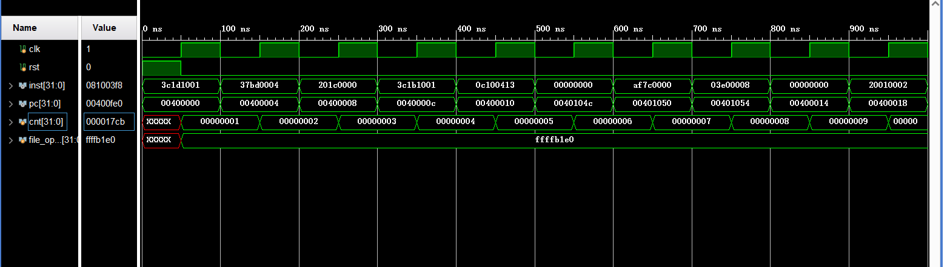

后仿真结果
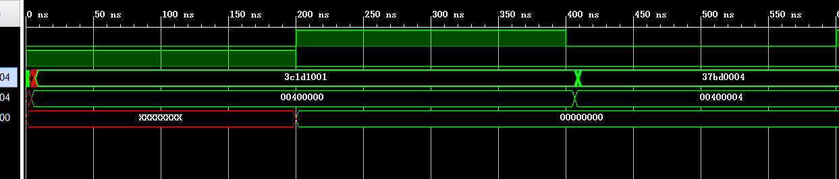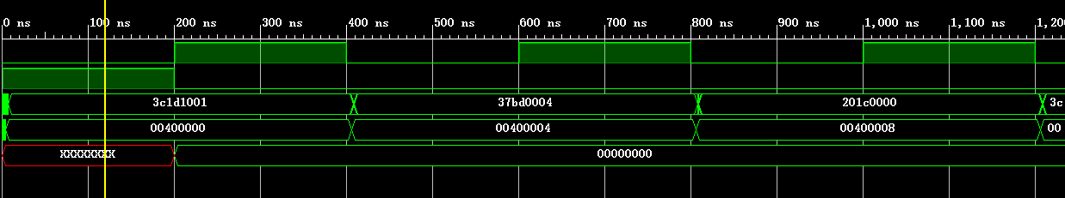

分频1/1000000下板结果(显示PC)
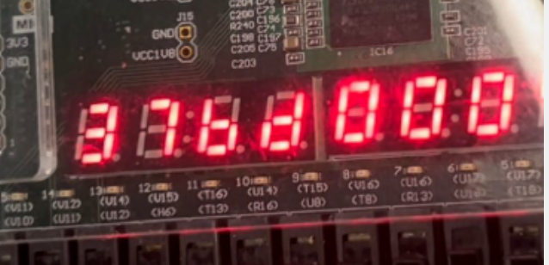
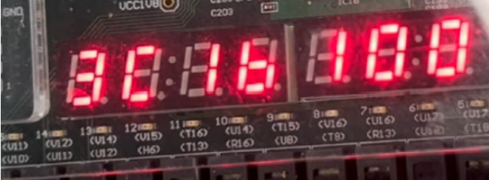
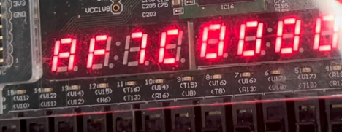

RTL图预览
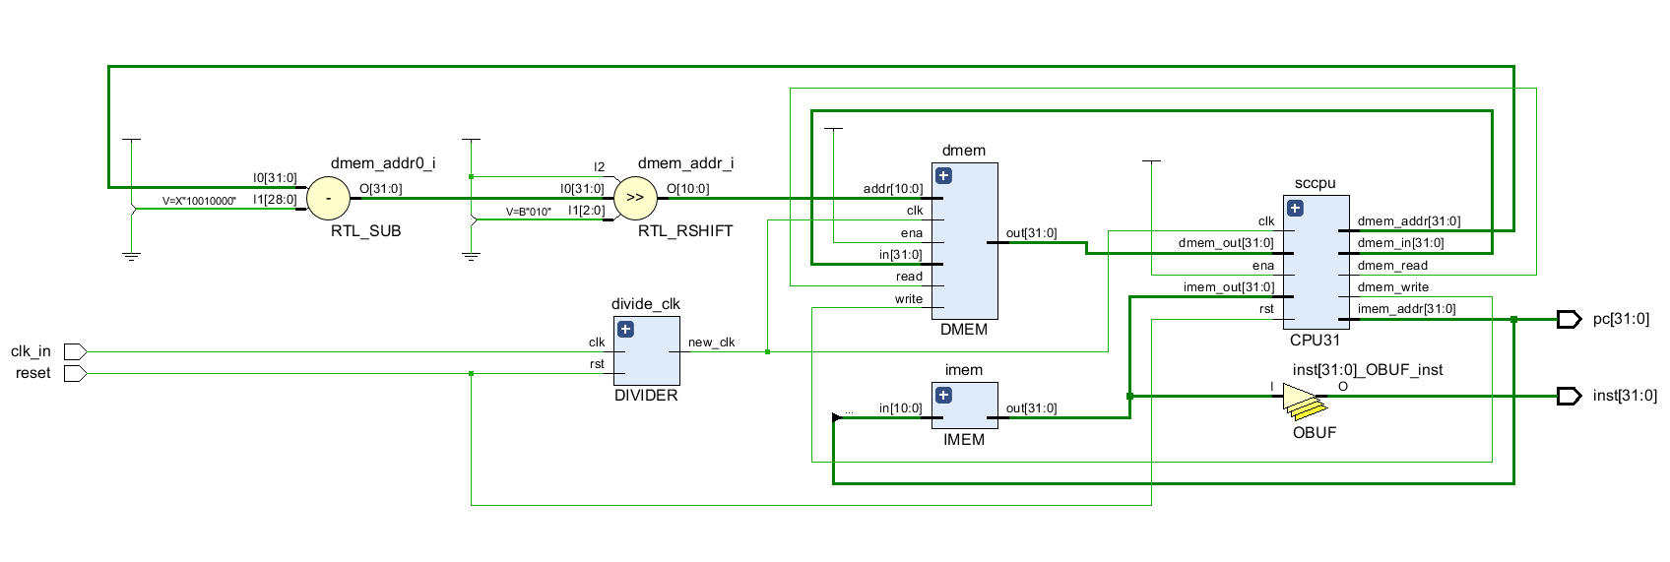

顶层控制器逻辑
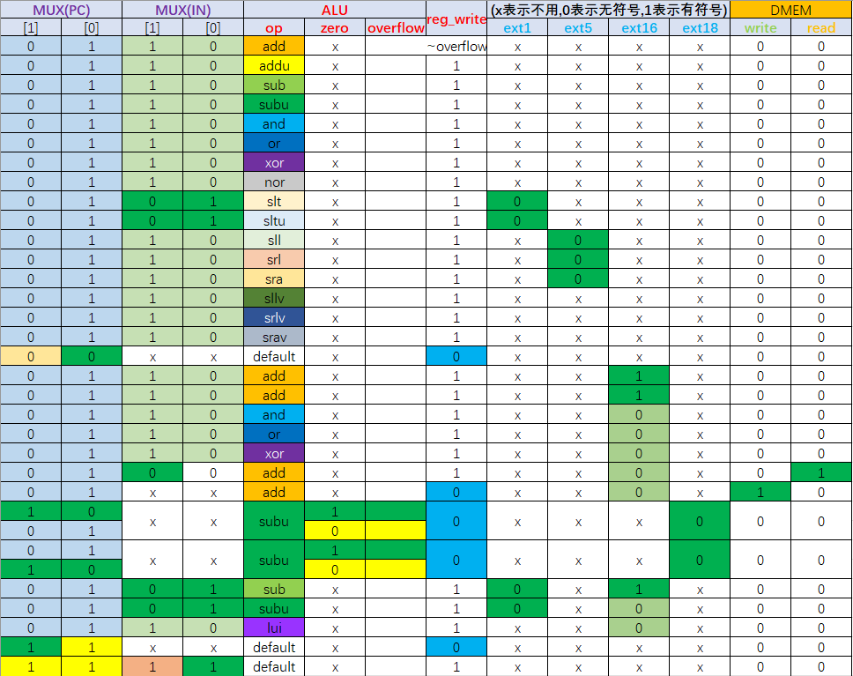

ALU编码
