|  |  |  |
| --- | --- | --- |
|  | f1_score | Auc |
| LogisticFlatten | 0.701059 | 0.94951 |
| LogisticSingle | 0.792121 | 0.940074 |
| NaiveBayesFlatten | 0.810589 | 0.88027 |
| Gaussian | 0.635354 | 0.753186 |
| Bernoulli | 0.785408 | 0.861887 |
| Multinomial | 0.810589 | 0.88027 |
| NaiveBayesSingle | 0.72035 | 0.811887 |
| Gaussian | 0.577677 | 0.735539 |
| Bernoulli | 0.72035 | 0.811887 |
| Multinomial | 0.622424 | 0.731618 |
| RandomForestFlatten | 0.816466 | 0.877255 |
| RandomForestSingle | 0.713543 | 0.797782 |
| SVMFlatten | 0.732927 | 0.93701 |
| SVMSingle | 0.803916 | 0.950123 |
| XGBFlatten | 0.768425 | 0.854534 |
| XGBSingle | 0.720779 | 0.815319 |
|  |  |  |

LogisticFlatten/ LogisticSingle

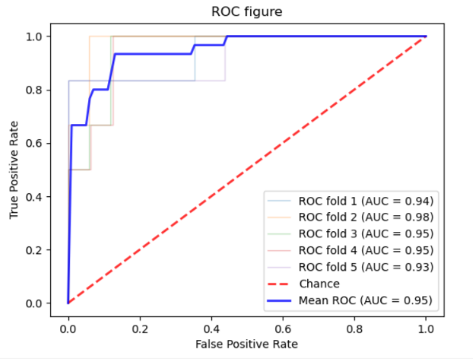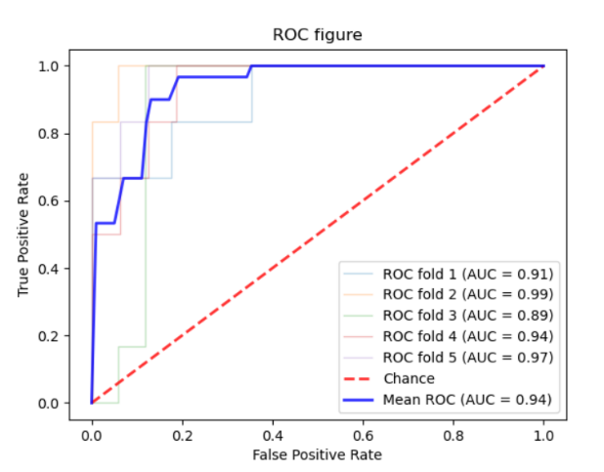

NaiveBayesFlatten/ NaiveBayesSingle

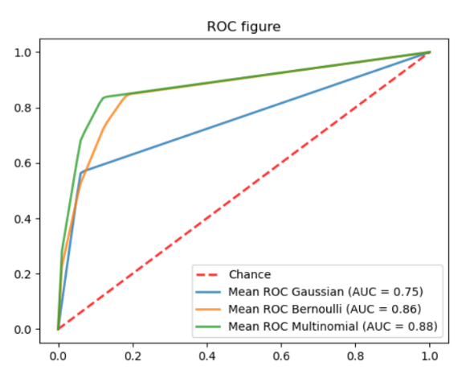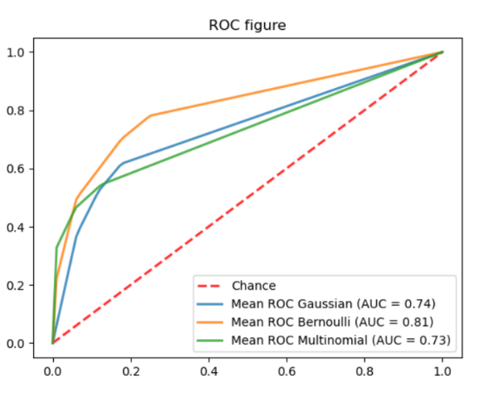

RandomForestFlatten/ RandomForestSingle

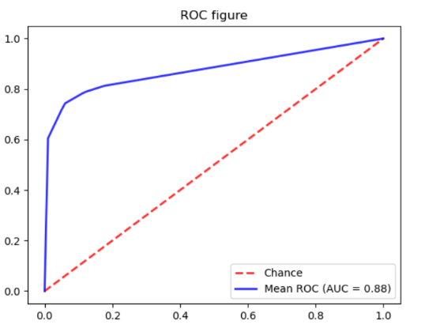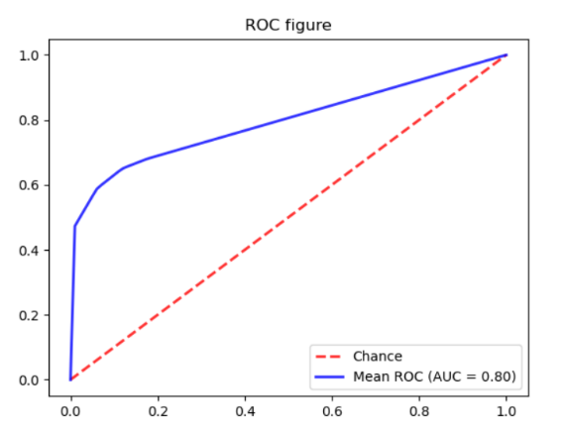

SVMFlatten/ SVMSingle

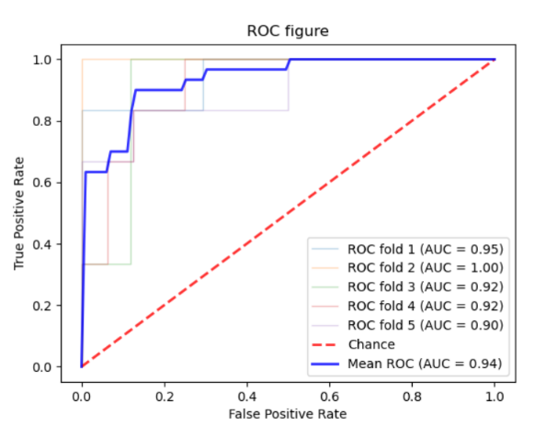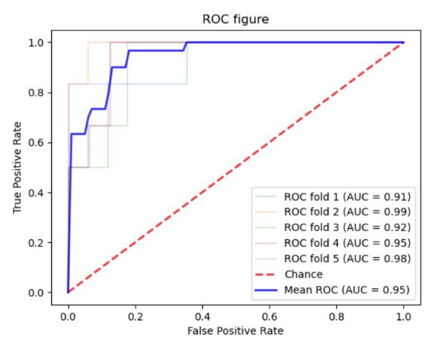

XGBFlatten/ XGBSingle

