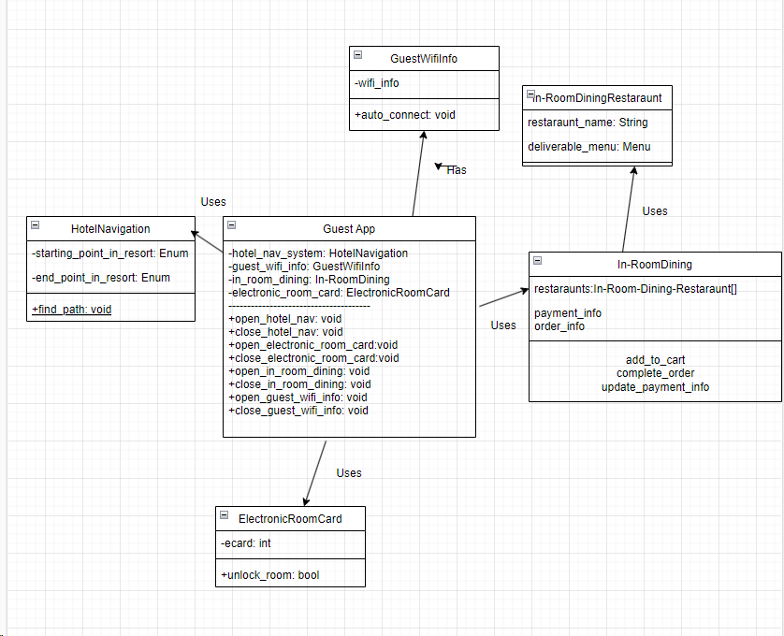

=

GuestWifilnfo

-wifi_info

En-Room Dining Restaraunt

+auto_connect: void

restaraunt_name: String

HotelNavigation

-starting_point_in_resort: Enum

-end_point_in_resort: Enum

+find path: void

Guest App

-hotel_nav_system: HotelNavigation

-guest_wifi_info: GuestWifilnfo

-in_room_dining: In-Room Dining

-electronic_room_card: ElectronicRoomCard

+open_hotel_nav: void

+close_hotel_nav: void

+open_electronic_room_card:void

+close_electronic_room_card:void

+open_in_room_dining: void

+close_in_room_dining: void

+open_guest_wifi_info: void

+close_guest_wifi_info: void

ElectronicRoomCard

-ecard: int

+unlock room: bool

deliverable_menu: Menu

In-Room Dining

restaraunts:In-Room-Dining-Restaraunt[]

payment_info

order_info

add_to_cart complete_order update_payment_info