 | HO CHI MINH CITY UNIVERSITY OF TECHNOLOGY  INSTITUTE OF INTERNATIONAL EDUCATION

Course Project
[CMP175] - WEB PROGRAMMING

Major: Information Technology

Supervisor: Mr. Trịnh Công Nhựt
Student’s name:
- Full Name ID: ….. Class: ….
- Full Name ID: ….. Class: ….
- Full Name ID: ….. Class: ….

Ho Chi Minh City, 2026
TABLE OF CONTENTS

TOPIC 2. LANGUAGE CENTER WEBSITE
Part 1. Project Introduction (5 Points)
1.1 Problem Statement
Language centers commonly manage learners, teachers, courses, class schedules, registrations, placement tests, and tuition payments through separate spreadsheets, paper forms, messaging applications, and manual confirmation. This fragmented process makes information difficult to search, creates duplicate records, delays registration approval, and increases the risk of incorrect class capacity, payment status, or test results.
The problem is important because a language center serves several groups at the same time. Learners need accurate course information and a simple registration process; teachers need timely class lists and teaching materials; administrators need reliable operational data. When these groups work with disconnected information, the center spends more time correcting records and less time supporting learning quality.
The Language Center Management Website provides one shared web-based system. Guests can explore programs, classes, and teachers. Registered students can update profiles, register for classes, review payments, book placement tests, and submit consultation requests. Teachers can monitor assigned classes, view students, and manage class materials. Administrators can approve accounts and manage programs, classes, teachers, students, registrations, payments, and placement-test results.
- For learners: faster access to program details, class availability, registration status, payment information, and placement-test schedules.
- For teachers: a consolidated teaching dashboard, class roster, schedule overview, and document-upload area.
- For the center: centralized records, role-based workflows, operational statistics, reduced manual work, and more consistent service.
1.2 Topic Selection
The team selected this topic because language-center operations combine public information, user authentication, role-based authorization, database relationships, transactional workflows, file uploads, search, filtering, pagination, and dashboard statistics. It is therefore suitable for demonstrating the major learning outcomes of the Web Programming course while solving a recognizable real-world management problem.
Target users
- Guest: explores the center, programs, classes, and teacher information; creates an account and logs in.
- Student: maintains a personal profile, registers for classes, follows registration/payment status, books a placement test, and requests consultation.
- Teacher: views assigned classes and students, checks placement-test and consultation information, and manages learning materials.
- Admin: approves user requests and manages the center's complete operational dataset and dashboard.
1.3 Survey of Existing Websites
The survey was conducted on 9 June 2026 using the public home pages of VUS and Wall Street English Vietnam. The comparison focuses on information architecture and learner-facing functions rather than internal systems that are not publicly visible.
Website 1: VUS
Official website: https://vus.edu.vn/
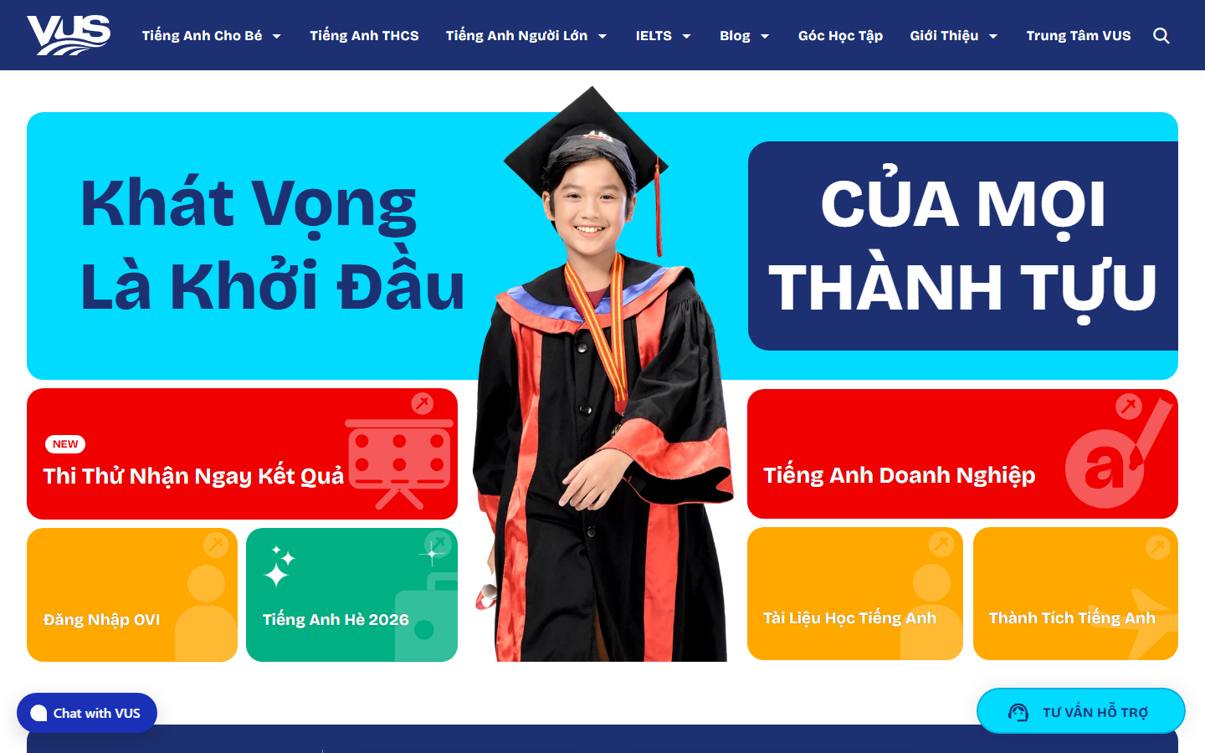
Figure 1. VUS home page captured on 9 June 2026.
Aspect | Analysis
Advantages | Strong visual branding; clear course groups by age and learning need; prominent trial-test, support, and consultation actions; rich learning resources.
Disadvantages | The home page contains many promotional blocks and competing calls to action; key operational information such as class capacity, registration status, and payment progress is not presented as one simple workflow.
Features adopted | Program categories, visual program cards, teacher/center credibility, placement-test entry point, consultation call to action, and responsive navigation.

Website 2: Wall Street English Vietnam
Official website: https://www.wallstreetenglish.edu.vn/
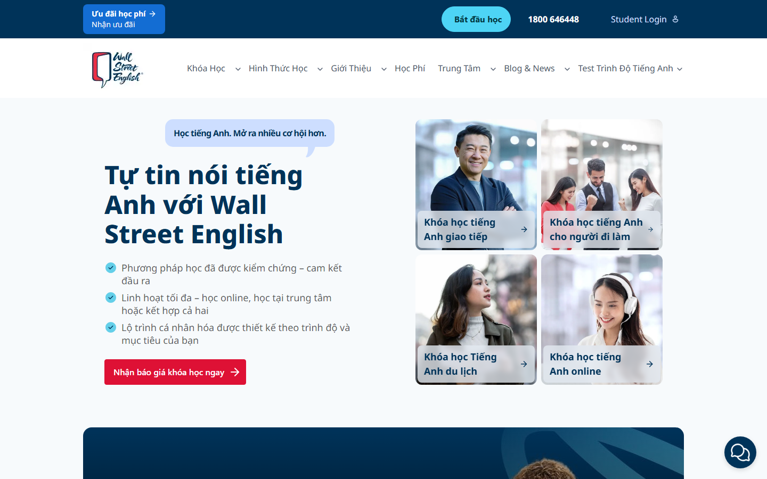
Figure 2. Wall Street English Vietnam home page captured on 9 June 2026.
Aspect | Analysis
Advantages | Clean hierarchy; clear value proposition; course cards for different learner goals; visible level-test and student-login links; strong consultation call to action.
Disadvantages | Course pricing and detailed class availability are not immediately visible; the public journey is consultation-oriented, so users cannot see a complete registration/payment workflow before contacting the center.
Features adopted | Simple hero message, goal-based program discovery, student login, level-test access, clear program detail pages, and focused calls to action.

Proposed feature set after the survey
- Public home page with banner, statistics, featured programs, new classes, teachers, and clear Login/Register links.
- Program list with search, level filter, pagination, fee, duration, image, and detail page.
- Integrated account approval and role assignment instead of a purely promotional lead form.
- Student self-service for class registration, payment tracking, placement-test booking, and consultation requests.
- Teacher and Admin workspaces so the public website and internal operations share one database.
Part 2. System Design (15 Points)
2.1 ERD Diagram
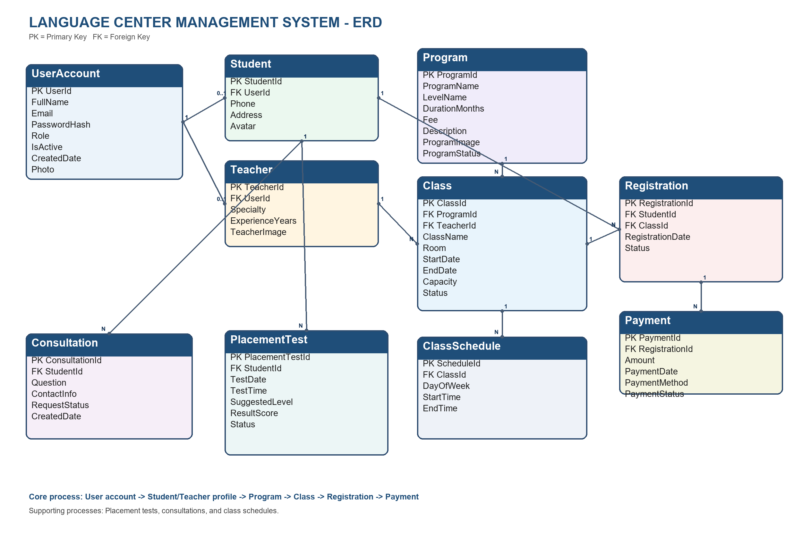
Figure 3. Entity Relationship Diagram of the Language Center Management System.
The database contains ten implemented entities. UserAccount stores authentication and role information. Student and Teacher extend a user account with role-specific profile data. Program and Class describe the academic offering. Registration links a student to a class, while Payment records tuition transactions for that registration. PlacementTest and Consultation support learner services, and ClassSchedule represents recurring teaching times.
Table | Primary key | Purpose
UserAccount | UserId | Authentication, identity, role, active status, and profile photo.
Student | StudentId | Student-specific phone, address, and avatar; references UserAccount.
Teacher | TeacherId | Teacher specialty, experience, and image; references UserAccount.
Program | ProgramId | Course name, level, duration, fee, description, image, and status.
Class | ClassId | Program offering assigned to a teacher, room, dates, capacity, and status.
ClassSchedule | ScheduleId | Day and start/end time for a class.
Registration | RegistrationId | Connects a student with a class and stores registration status.
Payment | PaymentId | Amount, date, method, and status for a registration.
PlacementTest | PlacementTestId | Test appointment, suggested level, score, and status.
Consultation | ConsultationId | Student question, contact information, request status, and date.

Key relationships
- One UserAccount may have one Student profile or one Teacher profile, depending on the approved role.
- One Program has many Classes; each Class belongs to one Program.
- One Teacher may teach many Classes; each Class is assigned to zero or one Teacher during planning.
- Student and Class have a many-to-many relationship resolved by Registration.
- One Registration may have multiple Payment records to support transaction history or installments.
- One Student may create many PlacementTest and Consultation records.
- One Class may contain many ClassSchedule records.
2.2 Use Case Diagram
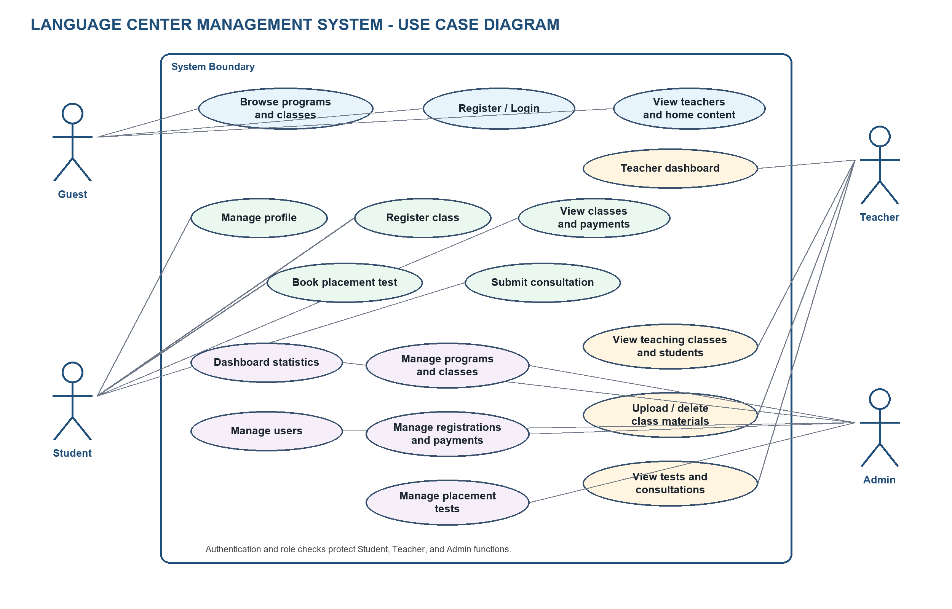
Figure 4. Use Case Diagram with Guest, Student, Teacher, and Admin actors.
Role | Main use cases
Guest | View home page, browse/search/filter programs, view program details and classes, view teachers, register, and log in.
Student | View/update profile, change password, upload avatar, register for a class, view classes and payments, book placement test, and submit consultation request.
Teacher | View dashboard, assigned classes and student lists, upload/delete class materials, view placement-test results and consultation feedback, and upload profile photo.
Admin | View dashboard statistics; approve accounts; manage students, teachers, programs, classes, registrations, payments, and placement tests.

Authorization is based on Session values (UserId and Role). Public actions are available to guests, while Student, Teacher, and Admin actions verify the current role before accessing role-specific data.
2.3 Sample Data
The following dataset is designed for demonstration and testing. It meets the minimum requirement: 5 programs, 10 classes, 10 students, 3 teachers, 20 registrations, and 10 placement-test records.
Programs (5 records)
ID | Program name | Level | Months | Fee (VND) | Status
P01 | General English Foundation | A1 | 3 | 3,500,000 | Active
P02 | English Communication | A2-B1 | 4 | 4,800,000 | Active
P03 | IELTS Preparation | B1-B2 | 6 | 8,500,000 | Active
P04 | TOEIC Intensive | A2-B2 | 4 | 5,900,000 | Active
P05 | Business English | B1-C1 | 5 | 7,200,000 | Active

Teachers (3 records)
ID | Full name | Specialty | Experience (years)
T01 | Nguyen Minh Anh | IELTS / Academic English | 8
T02 | Tran Hoang Nam | Communication / TOEIC | 6
T03 | Le Thu Ha | Business / General English | 10

Classes (10 records)
ID | Class | Program | Teacher | Room | Start | End | Cap. | Status
C01 | GEF-A1-Morning | P01 | T03 | A101 | 01/07/2026 | 30/09/2026 | 20 | Open
C02 | GEF-A1-Evening | P01 | T03 | A102 | 06/07/2026 | 05/10/2026 | 20 | Open
C03 | COM-A2-Weekend | P02 | T02 | B201 | 04/07/2026 | 31/10/2026 | 18 | Open
C04 | COM-B1-Evening | P02 | T02 | B202 | 13/07/2026 | 13/11/2026 | 18 | Open
C05 | IELTS-5.5 | P03 | T01 | C301 | 01/08/2026 | 31/01/2027 | 16 | Open
C06 | IELTS-6.5 | P03 | T01 | C302 | 08/08/2026 | 07/02/2027 | 16 | Planned
C07 | TOEIC-550 | P04 | T02 | B203 | 20/07/2026 | 20/11/2026 | 22 | Open
C08 | TOEIC-750 | P04 | T02 | B204 | 27/07/2026 | 27/11/2026 | 20 | Planned
C09 | Business-B1 | P05 | T03 | D401 | 03/08/2026 | 03/01/2027 | 18 | Open
C10 | Business-B2 | P05 | T03 | D402 | 10/08/2026 | 10/01/2027 | 18 | Planned

Students (10 records)
ID | Full name | Email | Phone | Address
S01 | Pham Gia Bao | bao.pham@example.com | 0901000001 | District 1
S02 | Nguyen Ngoc Lan | lan.nguyen@example.com | 0901000002 | District 3
S03 | Tran Minh Khoa | khoa.tran@example.com | 0901000003 | Binh Thanh
S04 | Le Hoang Yen | yen.le@example.com | 0901000004 | District 7
S05 | Vo Thanh Tung | tung.vo@example.com | 0901000005 | Thu Duc
S06 | Do My Linh | linh.do@example.com | 0901000006 | Go Vap
S07 | Bui Quoc Huy | huy.bui@example.com | 0901000007 | Tan Binh
S08 | Hoang Thu Trang | trang.hoang@example.com | 0901000008 | Phu Nhuan
S09 | Dang Anh Tuan | tuan.dang@example.com | 0901000009 | District 10
S10 | Mai Khanh Vy | vy.mai@example.com | 0901000010 | District 5

Registrations (20 records)
ID | Student | Class | Registration date | Status
R01 | S01 | C05 | 01/06/2026 | Confirmed
R02 | S01 | C03 | 02/06/2026 | Pending
R03 | S02 | C01 | 03/06/2026 | Confirmed
R04 | S02 | C07 | 04/06/2026 | Confirmed
R05 | S03 | C04 | 05/06/2026 | Pending
R06 | S03 | C05 | 06/06/2026 | Confirmed
R07 | S04 | C02 | 07/06/2026 | Confirmed
R08 | S04 | C09 | 08/06/2026 | Pending
R09 | S05 | C03 | 09/06/2026 | Confirmed
R10 | S05 | C07 | 10/06/2026 | Pending
R11 | S06 | C01 | 11/06/2026 | Confirmed
R12 | S06 | C04 | 12/06/2026 | Confirmed
R13 | S07 | C05 | 13/06/2026 | Pending
R14 | S07 | C09 | 14/06/2026 | Confirmed
R15 | S08 | C02 | 15/06/2026 | Confirmed
R16 | S08 | C03 | 16/06/2026 | Confirmed
R17 | S09 | C07 | 17/06/2026 | Confirmed
R18 | S09 | C09 | 18/06/2026 | Pending
R19 | S10 | C04 | 19/06/2026 | Confirmed
R20 | S10 | C05 | 20/06/2026 | Pending

Placement tests (10 records)
ID | Student | Date | Time | Level | Score | Status
PT01 | S01 | 15/06/2026 | 08:00 | B1 | 62 | Completed
PT02 | S02 | 15/06/2026 | 09:00 | A1 | 35 | Completed
PT03 | S03 | 16/06/2026 | 08:00 | B2 | 78 | Completed
PT04 | S04 | 16/06/2026 | 09:00 | A2 | 49 | Completed
PT05 | S05 | 17/06/2026 | 08:00 | B1 | 65 | Completed
PT06 | S06 | 17/06/2026 | 09:00 | A2 | 52 | Completed
PT07 | S07 | 18/06/2026 | 08:00 | B1 | - | Pending
PT08 | S08 | 18/06/2026 | 09:00 | A2 | - | Pending
PT09 | S09 | 19/06/2026 | 08:00 | B2 | - | Pending
PT10 | S10 | 19/06/2026 | 09:00 | B1 | - | Pending

Data integrity rules used during testing: email addresses are unique; a student cannot register for the same class twice; class and program status values control availability; payment and registration statuses are updated only by authorized actions; foreign keys must reference existing records.
Part 3. Functional Requirements (70 Points)
Guest (10 Points)
1/ View Home (Banner, Programs, New Classes, Teachers, Navigation Menu, Login/Register Links)
2/ View Program List (Program Image, Program Name, Level, Duration, Fee, Search, Filter, Pagination)
3/ View Program Detail (Description, Output Standard, Fee, Duration, Related Classes, Register Button)
4/ Register (Full Name, Email, Password, Confirm Password, Validation)
5/ Login (Email, Password, Remember Me, Forgot Password)
Student (15 Points)
1/ My Profile (View Profile, Update Profile, Change Password, Upload Avatar)
2/ Register Class (Login Required, Class Selection, Registration Information, Confirmation)
3/ My Classes (Registered Classes, Schedule, Teacher, Registration Status)
4/ Payment (Payment Information, Amount, Payment Date, Payment Status)
5/ Placement Test Registration (Test Date, Test Time, Level, Status)
6/ Consultation Request (Question, Contact Information, Request Status)
Teacher (15 Points)
1/ Teacher Dashboard (Total Classes, Total Students, Teaching Schedule, Recent Activities)
2/ My Teaching Classes (Class List, Schedule, Room, Student Count, Class Status)
3/ View Class Students (Student List, Registration Date, Payment Status, Attendance Status)
4/ Manage Class Materials (Add Material, Edit Material, Delete Material, Upload Documents)
5/ View Placement Test Results (Student Name, Test Date, Suggested Level, Result)
6/ View Student Feedback (Feedback Content, Rating, Feedback Date)
Admin (15 Points)
1/ Dashboard (Total Programs, Total Classes, Total Students, Total Teachers, Total Revenue)
2/ Manage Programs (Add Program, Edit Program, Delete Program, Program Status)
3/ Manage Classes (Add Class, Edit Class, Delete Class, Assign Teacher, Class Status)
4/ Manage Teachers (Add Teacher, Edit Teacher, Activate/Deactivate Account)
5/ Manage Students (View Students, Edit Student Information, Activate/Deactivate Account)
6/ Manage Registrations (View Registration List, Update Status, Cancel Registration)
7/ Manage Payments (View Payments, Confirm Payment, Update Payment Status)
8/ Manage Placement Tests (Create Test Schedule, Update Result, View Test List)
Additional Features (10 Points)
a) Email Notification (Account Verification, Class Registration Confirmation, Payment Confirmation)
b) Online Payment (VNPay, MoMo, PayPal, Payment Confirmation, Transaction History)
c) Deployment (Publish Website, Deploy to Hosting, Public Access URL)
d) Dashboard Enhancement (Charts, Revenue Statistics, Student Statistics, Top Classes)
e) File Upload (Profile Image, Teacher Image, Class Materials, Documents)
f) Security Enhancement (Role-based Authorization, Password Encryption, Account Lockout)
UI/UX (5 Points)
- Responsive
- Validation
- Upload Image
- Error Handling
Part 4. Project Understanding Test (15 Points)
a) Question 1. Database Understanding
b) Question 2. Function Understanding
c) Question 3. Basic Code Modification

