Lab report

Prelab:

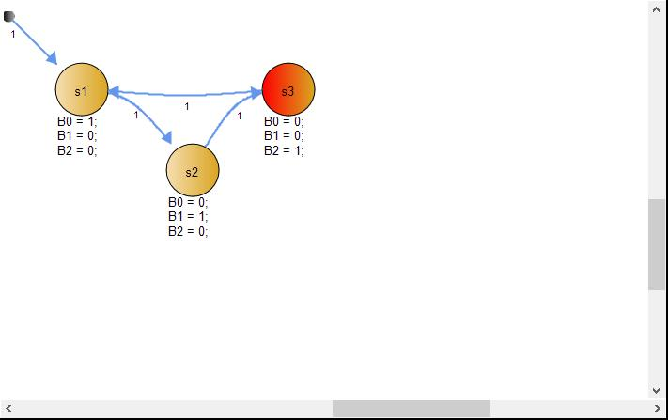

Work distribution:

I worked on A and B1 while my partner helped with debugging and changing some of the conditions. My partner did most of B2 at home and I helped with the debugging of the remaining program

Problems faced:

One of the problems faced in this lab is the user input and the timing needed for the inputs. We need the clock fast enough to get input no matter how fast the button press but still match up with the blinking of the lights.