Pre-lab:

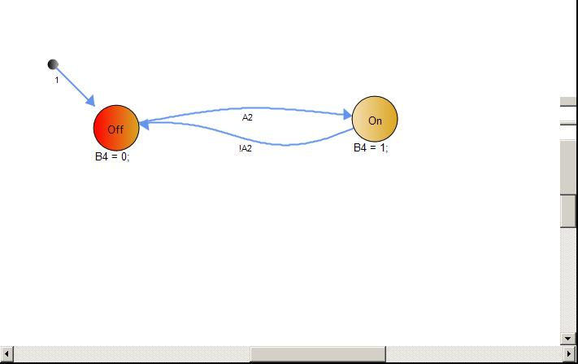

Work distribution:

I worked on the code for exercise 1 and parts of 2. The exercises were debugged during lab by my partner and I and he finished some parts of exercise 2.

Problems faced:

Reading the book and figuring out the frequencies and a second state machine. Switching the output on and off with the clock is also quite confusing.