**The function of software** is to extract the location data(latitude, longtitude and address) of any kind of facilities and organizations from Yellow Page. Please type the root url in "Your Root Url", and the position you want to save the coordinates and addresses in your computer in the "Your coordinate" and "Your address".

**For instance, if you want to get all the location of restaurants in Queens, NY from Yellow page:**

the url circled in blue is root url, copy it to “Your Root Url”, and choose position you want to save the coordinates and addresses.

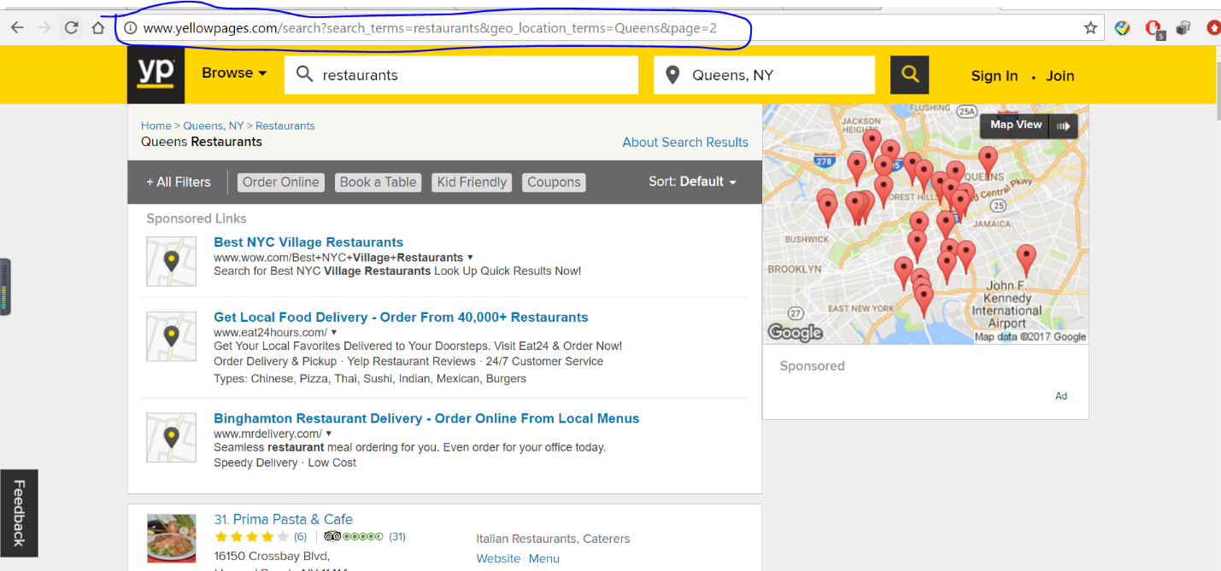

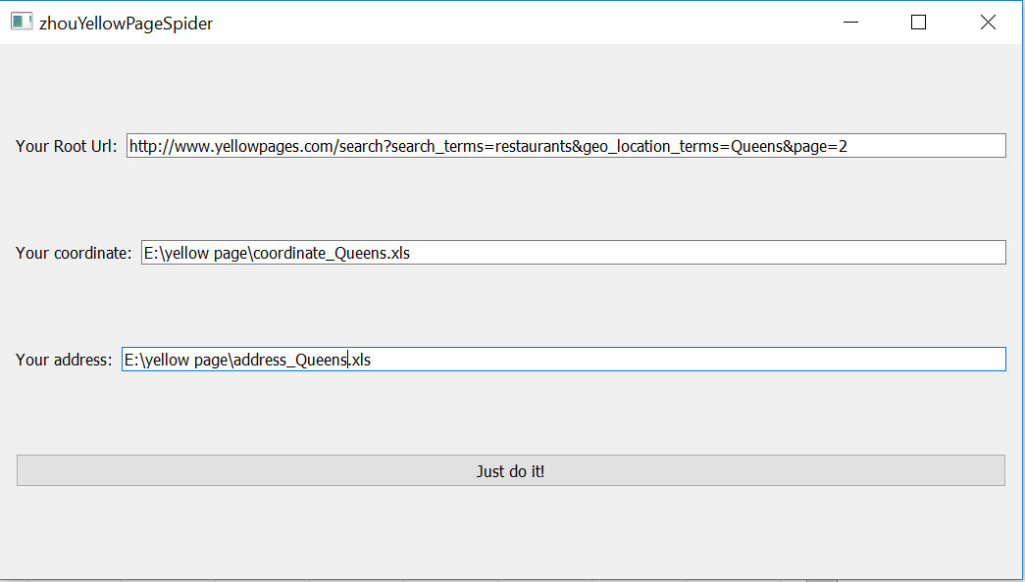

This is **the results .xls** you get:

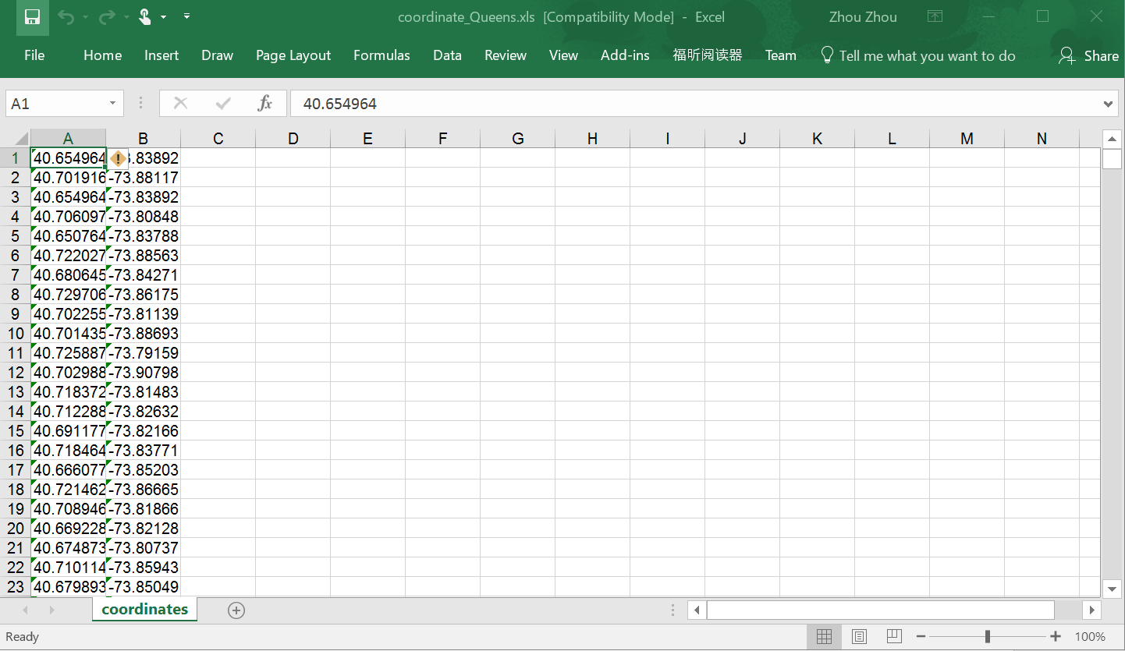

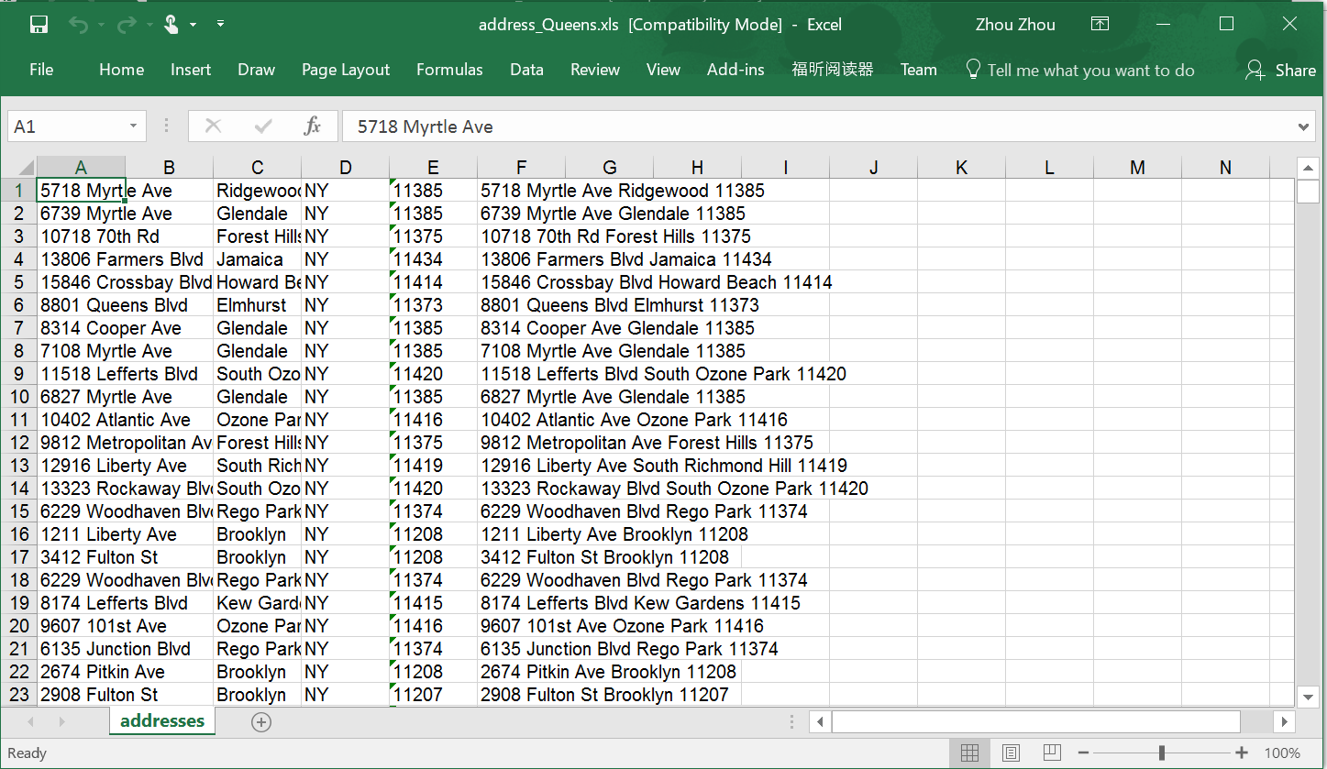

You have got the two excel files for coordinates and addresses of all restaurants in Queens, NY, around 3000 rows of data.