数据挖掘作业二：分类数据集letter-recognition

利用4000个训练数据，构造matlab决策树分类器，给出16000个测试数据的预测结果。另外提供测试集正确率的估计值。

比如，第2小组认为他们的决策树在测试集上的正确率是0.83（2位小数），将提交的文件命名成 2-letter-83.xls，提交到教学服务器（目录：学生作业/数据挖掘/作业2-letter /）

xls文件中，每一行是相应测试数据的类别，比如
T
P
E
。。。

Relevant Information:

The objective is to identify each of a large number of black-and-white
rectangular pixel displays as one of the 26 capital letters in the English
alphabet. The character images were based on 20 different fonts and each
letter within these 20 fonts was randomly distorted to produce a file of
20,000 unique stimuli. Each stimulus was converted into 16 primitive
numerical attributes (statistical moments and edge counts) which were then
scaled to fit into a range of integer values from 0 through 15.
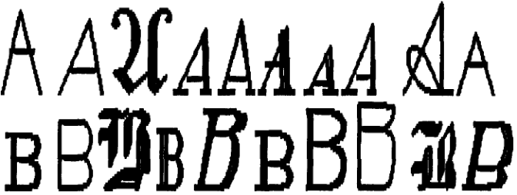

Number of Attributes: 17 (Letter category and 16 numeric features)

No. training data: 4000
No. test data: 16000

Attribute Information:
1. lettr capital letter (26 values from A to Z)
2. x-box horizontal position of box (integer)
3. y-box vertical position of box (integer)
4. width width of box (integer)
5. high height of box (integer)
6. onpix total # on pixels (integer)
7. x-bar mean x of on pixels in box (integer)
8. y-bar mean y of on pixels in box (integer)
9. x2bar mean x variance (integer)
10. y2bar mean y variance (integer)
11. xybar mean x y correlation (integer)
12. x2ybr mean of x * x * y (integer)
13. xy2br mean of x * y * y (integer)
14. x-ege mean edge count left to right (integer)
15. xegvy correlation of x-ege with y (integer)
16. y-ege mean edge count bottom to top (integer)
17. yegvx correlation of y-ege with x (integer)

