1，Table join

|  |  |  |  |  |
| --- | --- | --- | --- | --- |
| **Tables used** | | | | |
| patients | icustays | chartevents | outputevents | d_items |

|  |  |  |  |  |
| --- | --- | --- | --- | --- |
| **Personal Info** | | | | |
| **Feature Name** | **subject_id** | **icustay_id** | **age** | **gender** |
| **Explain** | Number for each patient | Number for each icu case | age | gender |
| **Feature Name** | **marital_status** | **ethnicity** | **icu_duration_hour** | **icu_times** |
| **Explain** | marital_status | ethnicity | Time spend in ICU | The ith time being admitted to ICU |
| **Feature Name** | **icu_times_total** | **icu_times_sepsis** | **icu_times_total_sepsis** | **hospital_expire_flag** |
| **Explain** | How many times being admitted to ICU | The ith time being admitted to ICU because of sepsis | How many times being admitted to ICU because of sepsis | Died in hospital |
| **Feature Name** | **expire_flag** | **died_immediately** |  |  |
| **Explain** | Died eventually | Died in hospital or within 24h left hospital |  |  |

Test labels selection

|  |  |  |
| --- | --- | --- |
| **Initial label** | **Merged label** | **values** |
| Glouse | glouse | min |
| Glucose (70-105) | max |
| avg |
| Fingerstick Glucose | Fingerstick Glucose | min |
| max |
| avg |
| potassium | potassium | min |
| Potassium (3.5-5.3) | max |
| Potassium (3.5-5.3) | avg |
| Sodium (135-148) | Sodium | min |
| max |
| avg |
| Hematocrit | Hematocrit | min |
| Hematocrit (35-51) | max |
| avg |
| Chloride (100-112) | Chloride | min |
| max |
| avg |
| BUN (6-20) | BUN | min |
| BUN | max |
| avg |
| Creatinine (0-1.3) | Creatinine | min |
| max |
| avg |
| Hemoglobin | Hemoglobin | min |
| max |
| avg |
| Carbon Dioxide | Carbon Dioxide | min |
| max |
| avg |
| RBC | RBC | min |
| RBC(3.6-6.2) | max |
| avg |
| Platelets | Platelets | min |
| max |
| avg |
| WBC (4-11,000) | WBC | min |
| WBC (4-11,000) | max |
| WBC 4.0-11.0 | avg |
| Heart Rate | Heart Rate | min |
| max |
| avg |
| Heart Rhythm | Heart Rhythm | mode |
| last |
| Magnesium (1.6-2.6) | Magnesium | min |
| max |
| avg |
| Respiratory Rate | Respiratory Rate | min |
| max |
| avg |
| Temperature F | Temperature (if C then F) | min |
| max |
| avg |

Why sepsis?

Except for newborn, sepsis is the second largest disease in this dataset. Also it’s one of the most dangerous diseases in USA.

All diagnosis with ‘sepsis’ will all be considered as sepsis.

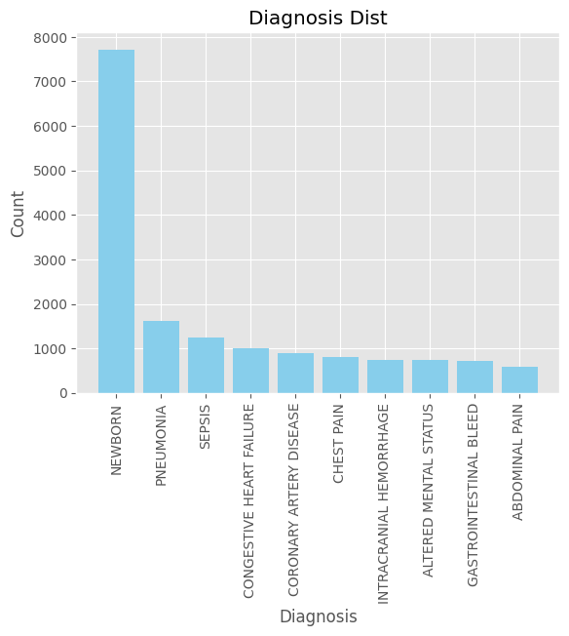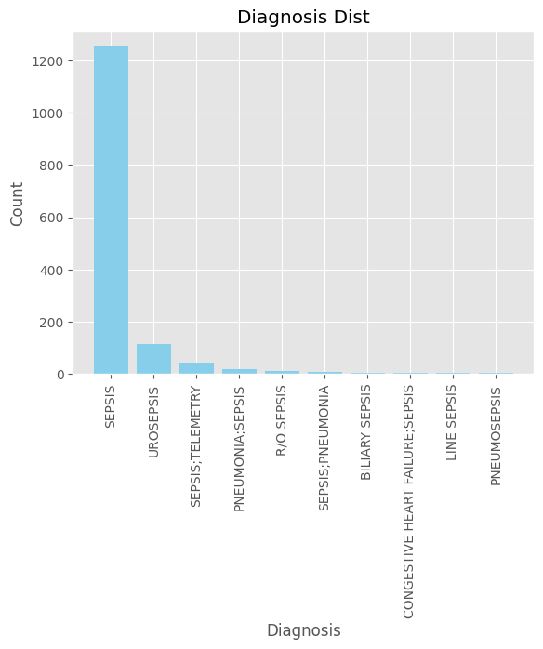

Comorbidity?

Will not be considered.

Sepsis is caused by other diseases and is not a spontaneous condition. Therefore, sepsis inevitably accompanies comorbidity. In the original dataset, only a few medical records have noted the cause, so it is not considered for the time being.

2 Pre-process

2.1 the last case

Since the same patient will have similar test values, which might affect the model, we select the last time one patient get admitted to ICU because of sepsis if the patient get admitted to ICU for multiple times.

2.2 Drop dup

Since the mode of heart rhythm might not be a unique value if two or more values have the same amount. We decided to delete all of them completely. Only 10 patients (20 records) will be removed, which might not affect the data set too much. Also, only one of the duplicated records ends up died. If we are doing an outlier detection, this also does not remove too much of the positive samples.

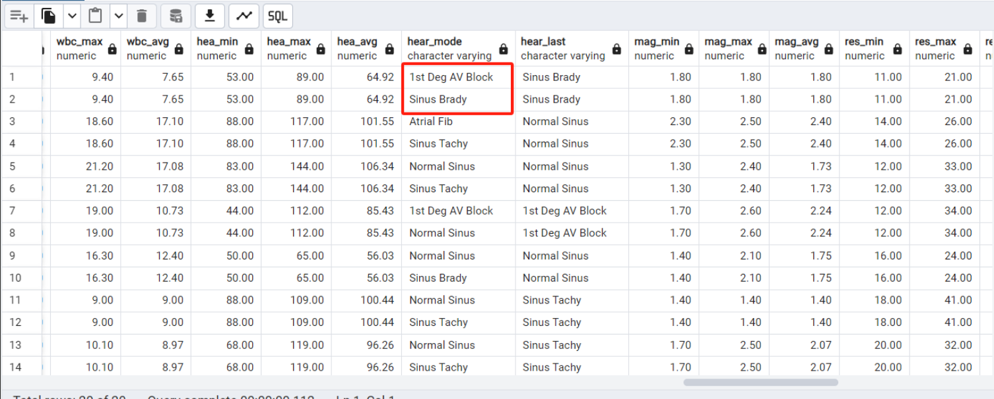

2.3 Drop null

Top 20 most common tests among sepsis patients.If a patient has more than 25% of tests not conducted, then remove that patient.

End up in 922 cases in total.

2.3 Outliers

Age: 121-300 outliers. Delete

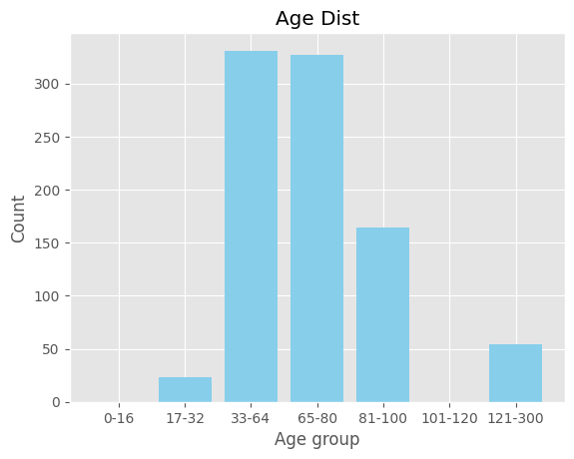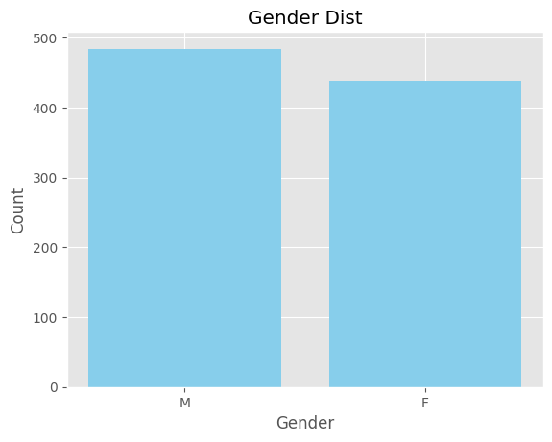

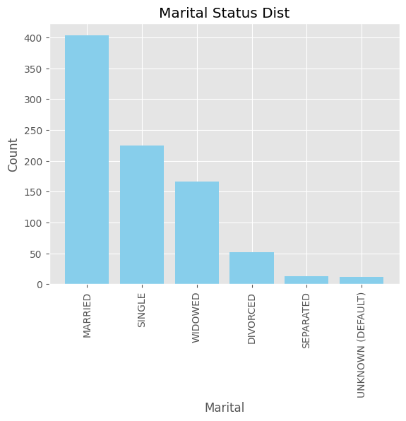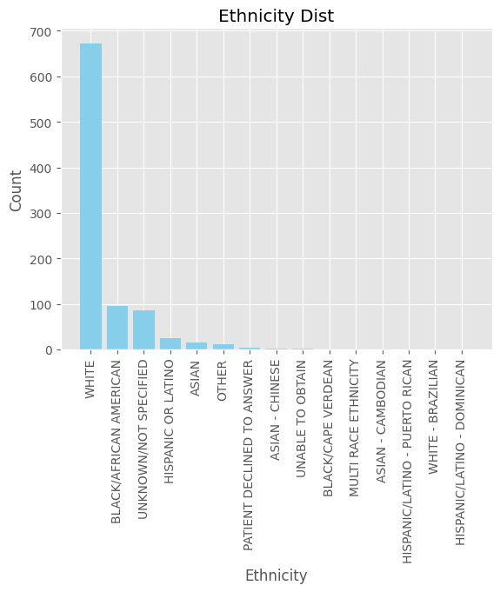

Gender/marital_status/ethnicity/icu_duration_hour/icu_times/icu_times_total/icu_times_total_sepsis的分布

Test value的最大最小平均值的分布

针对数值类型的test value，用平均值填补空值。