Project report 5&6
（2015 Fall）

Course name：J1799d Instructor：Ming Li TA：Wenbo Liu
ID number | 15213787 / 15213791 | Name | Wei Fang / Zhouchenye Peng
Tel | 18806687702/13719378062 | Email | 254245851@qq.com / 183215910@qq.com
Starting date | 2015.11.19 | Finished date | 2015.12.2

Project requirement
Problem 5.1
Build a continuous-speech recognition system that can recognize telephone numbers.
- Connect the digit models learned via segmental K-means into the larger HMM.
- Telephone digits number is either as a 7-digit number or a 4-digit number.
- The first digit in a telephone number is never 0 or 1.
- Allow for optional pauses at specific locations.
- Record 25 valid telephone numbers randomly and report recognition accuracy.

Problem 5.2
Do the above using a backpointer table and report accuracies.

Problem 5.3
Build a system to recognize unrestricted digit strings. Use the following graph:

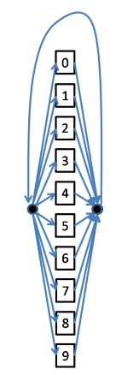
- Assign an "insertion penalty" to the loopback to ensure that large numbers of digits are not hypothesized randomly.
- Report both the optimal insertion penalty and the recognition performance.

Problem 6.1
- Record each of the following digit sequences five times each. (Record the digit "0" as "zero")
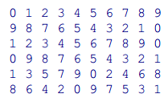
- Record each digit sequence as a continuous recording
- Train models for all ten digits from these continuous recordings.
- Initialize the HMMs for all digits by the models learned from isolated recordings.
- Recognize all the continuous digit sequences recorded for project 5 using these models and report accuracies.

Problem 6.2
- Train models from a medium sized corpus of recordings of digit.
(“http://asr.cs.cmu.edu/spring2014/assignments/assignment6/assign6.data.tar”)
- "0" is recorded both as "zero" and as "oh".
- The "test" directory contains 1000 test recordings. Report the recognition accuracy.

Design your program
Problem 5.1
We design a graph structure. By BFS, we put the HMMs that we trained in project3 into this graph as emitting states. So these isolated HMMs with graph structure will now become a continuous speech recognition system.

Problem 5.2
Like what we have done in the previous project, we define a table to store the best path which we call it backpointer table here. But the difference here is that we only need to store words level backpointer to save memory, so we only need two columns to do the alignment. After every interpolation, the last column will overlap the first column. Until it reaches the non-emitting state, the backpointer will be stored.
Problem 5.3
For this problem, we change the previous graph structure. Whenever one word reach to the last state and try to jump into the next word, the graph node will now loop back to the beginning non-emitting state. We add an insertion penalty which is 200 to discourage loop back. We "merge" the final absorbing state with the destination state of the HMM.

Problem 6.1
We compose the model for each digit string by concatenating the models for the individual digits, including silence models on either side. We use the previous loop-back graph structure which initialized by isolated HMMs. For "silence" HMMs, we record 5 separate 1-second segments of silence, and train an HMM from them and use that to initialize the models. We use the recordings to do alignment with the initialized model. After all the alignments finished, we upload the GMM, and continue to do next round of alignments until the model is converged.

Problem 6.2
The model training process is just like that of previous problem. But we record a few instances of "oh" to initialize the models for "oh"(Which also means "0"). We write code to load the data from that corpus and train new models.

Program implementation and testing
The main class to combine previous homework is:
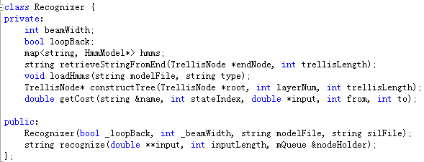
The class to train continuous speech is:
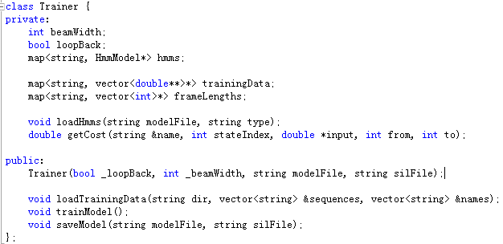

Experimental results and discussion
Problem 5.1
We test 25 valid telephone numbers randomly.
Sentence accuracy: 16%
Word accuracy: 73%

Problem 5.2
Use the previous recorded 25 telephone numbers to check.
Sentence accuracy: 16%
Word accuracy: 73%

Problem 5.3
We record the following 10 digit strings as test data:
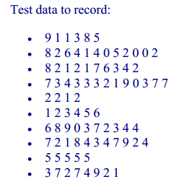
Sentence accuracy: 12%
Word error rate: 39%

Problem 6.1
We recognize all the continuous digit sequences that we have recorded.
Sentence accuracy: 31%
Word accuracy: 84%

Problem 6.2
The "test" directory contains 1000 test recordings.
Sentence accuracy: 93%
Word accuracy: 96%

Discussion
  - The performance highly rely on the environment, maybe we can do some preprocessing to eliminate the influence of the environment.
  - Now we use batch mode to train the continuous speech, maybe we can try stochastic mode later.

