

**School of IoT**

**Final Year Project**

**Project Specification Report**

Project Title:Distributed Dynamic Deployment Framework for IoT Systems

Student Name: ziming zhang

Student ID: 2033956

Project field:

Supervisor: Yuji Dong

Co-supervisor (if applicable):

(Font: Times New Roman; font-size: 12, Line spacing1.5)

(Page Limit: maximum 12 pages excluding the reference.)

1. **Project Description and Problem Statement**

Nowadays, the scale of Internet of things(IoT) devices is constantly expanding. Low-power, large-scale wireless connectivity will be a fundamental component of the future IoT. However, given the limited capabilities of these devices in terms of computation, memory, and energy, it is a significant challenge to integrate these devices into IoT applications [1]. To address the IoT system integration issues from distributed IoT devices with limited resources, the project hopes to establish a complete set of distributed IoT deployment framework by using cloud services to virtualize things, simplify the development process of IoT technology and alleviate the pressure on embedded devices to access the system. The proposed solution has the potential to lower the technical threshold of the IoT, attract more talents, and expand the industry prospects [2].

This project compiles a set of scheduling algorithms in the context of fog computing through the HarmonyOS(Hramony Operating System) development platform. HarmonyOS is a new generation of intelligent terminal operating system, which provides a unified language for the intelligence, interconnection and collaboration of different devices. It brings a simple, smooth, continuous, safe and reliable full-scene interaction experience. By using this system, it is possible to realizes effective communication between multiple devices. The algorithm framework will support the efficient connection between different IoT terminal devices and server devices (such as mobile phones), and ensure the normal interaction between devices and users and between devices. Users can directly connect different kinds of devices through this framework, avoiding a lot of code and basic logic writing work.

1. **Literature Review**

With the rapid development of IoT technology, more and more ordinary objects with independent functions are interconnected, and everything is interconnected. Benefiting from the characteristics of the IoT, all walks of life are using the IoT technology to quickly realize digital transformation, and more and more industrial terminal equipment is connected through the network. As a large and complex system, the market of IoT is also expanding rapidly. By 2025, there will be more than 80 billion terminal devices connected, and the amount of terminal data will exceed 250zetabytes[3]. If these data are processed in the traditional way and all the data are uploaded to the cloud platform, it will lead to huge bandwidth pressure on the cloud computing platform and excessive power consumption. Access by a large number of devices can even directly crash the server. Moreover, due to the number and geographical distribution of IoT + cloud devices, it is becoming increasingly difficult to support data transfer between billions of IoT devices [4].

In order to solve these problems, it is very important to develop a distributed algorithm framework. The distributed algorithm uses multiple devices to meet the demand of IoT technology for huge data computing power. The algorithm framework uses fog computing to return computing tasks to the local area, which greatly reduces the impact of possible problems such as network delay and data overload on the system [5]. The introduction of fog computing becomes a very important solution. Fog computing can offload tasks of devices at the edge of the network, and has become an effective paradigm for real-time applications in the IoT field. In particular, many emerging in-vehicle applications require real-time interaction between end-users and computing servers, which can be implemented in fog-based architectures [6]. Fog computing as a kind of fog computing, it allows the user to be very close to the local computing state without uploading all the data to the cloud. It greatly increases the development convenience and development possibility of complex projects in the IoT[7].

All these works optimize resource allocation at the algorithm level. However, it is difficult to apply these algorithms in real systems. As a result, this project will give developers an easier way to optimize algorithms, saving a lot of development effort and lowering the open valve. The main focus of this project is not the performance optimization of the algorithm, but how to provide a framework to enable the IoT system to effectively and flexibly use various advanced resource optimization allocation algorithms.

Distributed IoT architectures have many applications in reality. For example, in a smart city scenario, a large number of devices are connected and various computations are performed simultaneously [8]. This necessitates the use of fog computing to allow fog-to-cloud or fog-to-fog communication. This project provides a lot of optimizations for fog computing. This not only reduces the cost in terms of time and resource utilization, but also reduces the time for algorithm development and optimization and improves energy efficiency [9].

1. **Aims and Objectives**

The Aim of this project is to build a complete distributed fog computing framework.

The aim can be realized via four different objectives:

1.A virtual phone was created in DevEco Studio using the ArkTS development language

2.Extending the abstraction on top of the Harmony OS

3.Simulation tests are performed by connecting virtual devices

4.The visual interaction between virtual devices is realized on the HarmonyOS operating system platform

1. **Methodology and Project Deliverables**

To implement the structure, the project will first set up the system framework. This introduces multiple virtual end devices using Dev Eco. Then these virtual devices were used to realize direct communication between devices, and finally the server (virtual phone) received and fed back the device data to the user.

Fog computing is considered to be the most suitable method to effectively utilize edge devices. It can transfer computing power from centralized cloud computing to decentralized computing [10]. By exploiting the fog resources close to the edge of the network, one can reduce the latency and overhead involved in processing data by deploying the required services on the fog resources.

The fog landscape built by this porject consists of fog nodes connected by various IoT devices. The specific framework is shown as follows:

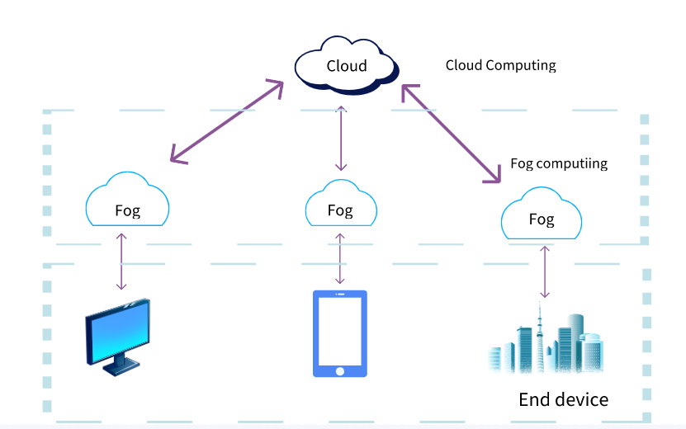

Figure1:The structure of Fog Computing

The project will eventually complete the basic structure diagram of the distributed computing framework, the fog computing algorithm, the virtual device connection interaction algorithm, and finally demonstrate the system through the Hramony OS virtual mobile phone device.

In this presentation, I'll use Dev Eco to demonstrate how to use a distributed iot architecture to connect and interact with multiple devices. It also shows the advantages of fog computing over cloud computing: cloud computing requires data to be uploaded to the IoT platform, while fog computing can be directly performed locally to improve development efficiency.

1. **Project Plan: Gantt Chart and Milestones**

The project was divided into five phases according to the plan, as shown in the figure below.

In the first stage: Design the basic framework and implementation method of the project, including writing the Literature Review

In the second stage: Investigate and studied the mechanisms underlying the distributed capabilities of the Harmony operating system. Make sure the project is feasible.

In the third stage, Develop the main algorithm and build the structure. This is the main part of the project.

In stage four: Implement the algorithm and connect the virtual device for experiments. Once this phase is complete, It will be able to show the project in action.

In stage five: Write reports and optimize projects.

Milestone record:

11 /30 /2023 Framwork and Method Design finished

12 /03 /2023 Literature review finished

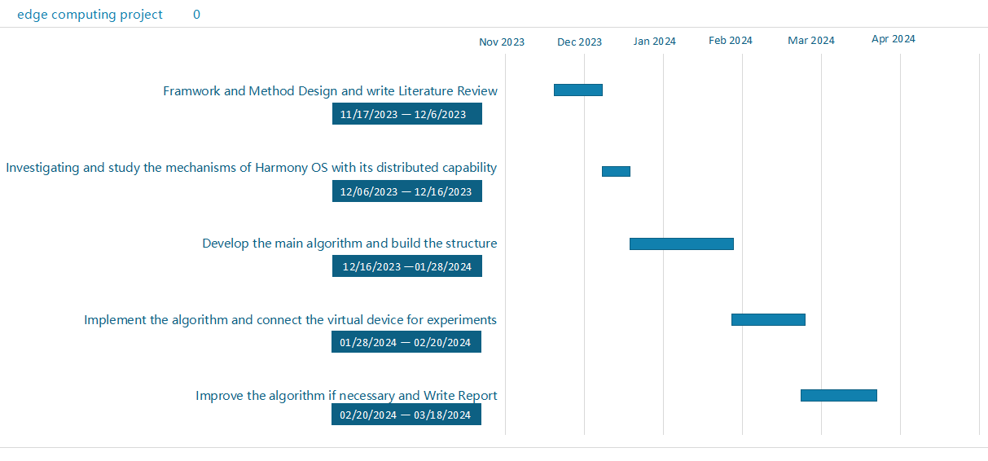

**References**

1. G. Tanganelli, C. Vallati and E. Mingozzi, (2017,10,27). Edge-Centric Distributed Discovery and Access in the IoT [Online].Available:

<https://ieeexplore.ieee.org/abstract/document/8086146>

[2]G. Rakshith, M. V. Rahul, G. S. Sanjay, B. V. Natesha and G. Ram Mohana Reddy, (2019/5/9). Resource Provisioning Framework for IoT Applications in Fog Computing Environment [Online].Available:https://ieeexplore.ieee.org/document/8710172

[3] D. Beverungen, M. Matzner, and C. Janiesch, (2017, 11 , 15). Information systems for smart services [Online]. Available: <https://doi.org/10.1007/s10257-017-0365-8.>

1. N. K. Giang, M. Blackstock, R. Lea and V. C. M. Leung, (2017, 12 , 17). Developing IoT applications in the Fog: A Distributed Dataflow approach[Online].Available:

<https://ieeexplore.ieee.org/abstract/document/7356560/references#references>

1. A. Brogi and S. Forti, (2017,5,4). QoS-Aware Deployment of IoT Applications Through the Fog [Online]. Available: <https://ieeexplore.ieee.org/abstract/document/7919155>

[6]T.Hoa, D.Kim,(2022 , 11 , 4) A Survey on Matching Theory for DistributedComputation Offloading in IoT-Fog-Cloud [Online].Available :https://ieeexplore.ieee.org/document/9938439

[7] W. T. Vambe and K. Sibanda, (2020,1,1). A Fog Computing Framework for Quality of Service Optimisation in the IoT (IoT) Ecosystem [Online]. Available:

<https://ieeexplore.ieee.org/document/9334083>

1. R. S. Gargees, (2022,12,17). Leveraging Fog Computing for Geographically Distributed Smart Cities [Online]. Available: <https://ieeexplore.ieee.org/document/9914276>

[9] R. S. Gargees, (2022,12,17). Leveraging Fog Computing for Geographically Distributed Smart Cities [Online]. Available: https://ieeexplore.ieee.org/document/9914276

[10] G. Rakshith, M. V. Rahul, G. S. Sanjay, B. V. Natesha and G. Ram Mohana Reddy, (2019,5,9). Resource Provisioning Framework for IoT Applications in Fog Computing Environment [Online].Available :https://ieeexplore.ieee.org/document/8710172