CRM Adoption and Operational Efficiency in Regional
Educational Centers

Umidabonu Zokirova Akmaljon qizi
PhD student at the Banking and Finance Academy of the Republic of Uzbekistan
E-mail: umidabonuaktamova@gmail.com

ABSTRACT
This study investigates how the adoption of the Modme Customer Relationship Management (CRM) platform affects operational efficiency in private educational centers operating in the regional service market of Tashkent, Uzbekistan. Employing a multiple case study design (Yin, 2018) across six purposively selected centers during the 2024–2025 academic cycle, the research compares key operational performance indicators (KPIs) before and after CRM implementation. Quantitative data were extracted directly from Modme system logs and administrative records; qualitative insights were gathered through manager interviews to cross-validate findings. Results reveal consistent improvements across all monitored KPIs: debt recovery time decreased by 73.3% (from 10.5 to 2.8 days), weekly administrative workload fell by 75.0% (from 22.0 to 5.5 hours), student retention increased by 15.1% (from 66% to 76%), and financial record accuracy improved from 88.0% to 99.5%. Cross-case analysis identifies automated billing and SMS notification features as the primary drivers of efficiency gains, while staff training level and feature integration breadth emerge as critical enabling factors. The study contributes an evidence-based, context-specific account of CRM value creation in an underexplored regional setting and offers practical recommendations for educational center managers and digital economy policymakers in Uzbekistan.

Keywords: CRM systems, Modme, operational efficiency, educational centers, multiple case study, digital transformation, student retention, Uzbekistan.

1. INTRODUCTION
The digitalization of service industries has accelerated substantially over the past decade, with Customer Relationship Management (CRM) platforms emerging as key enablers of operational improvement. In the context of Uzbekistan's ongoing Digital Economy reform agenda, private educational centers represent a rapidly expanding segment of the regional service sector, yet one that remains largely dependent on manual administrative workflows. These centers face escalating pressure to optimize service delivery, reduce overhead costs, and improve student retention in an increasingly competitive environment.
Modme is a cloud-based CRM and learning management platform developed for and widely adopted by educational centers in Uzbekistan. Its core features — automated payment collection, SMS-based student and parent notifications, attendance tracking, and digital financial record-keeping — directly address the primary operational pain points of the sector. Despite its growing adoption, no published empirical study has systematically evaluated the operational efficiency outcomes associated with Modme implementation.
Existing CRM research has predominantly examined large-scale or multinational contexts (Khodakarami & Chan, 2022; Alalwan et al., 2023), leaving regional SME settings — and educational services in particular — underexplored. Furthermore, the methodological approaches employed in prior studies often demand sample sizes incompatible with the realities of regional markets. This study employs a multiple case study design (Yin, 2018), which is methodologically appropriate for contexts where the unit of analysis is small in number but rich in organizational detail, and where the research objective is pattern identification across cases rather than statistical generalization.
The study pursues three objectives:
- To document measurable changes in operational KPIs across six educational centers before and after Modme CRM adoption.
- To identify which specific CRM features and organizational factors are most consistently associated with efficiency improvements.
- To generate transferable insights for educational center managers and regional digital economy policymakers in Uzbekistan.
The paper follows the IMRAD structure. Section 2 reviews relevant literature and the theoretical framework. Section 3 describes the research design. Section 4 presents the results. Section 5 discusses the findings. Section 6 concludes.

2. LITERATURE REVIEW

2.1 CRM Systems and Operational Efficiency
Customer Relationship Management refers to the integrated set of strategies, processes, and technologies through which organizations manage customer interactions across the full lifecycle, with the aim of improving retention, service quality, and operational performance (Garg & Garg, 2022). Contemporary cloud-based CRM platforms have substantially lowered the cost barrier for small and medium-sized enterprises (SMEs): Soltani and Navimipour (2022) documented IT overhead reductions of 18–24% among SMEs transitioning from legacy or manual systems to cloud CRM. Operational CRM — the subset of functionality governing automated customer-facing and administrative processes — is the dimension most directly relevant to efficiency outcomes and forms the primary focus of this study.
The link between CRM adoption and operational efficiency has been established across diverse service sectors. Khodakarami and Chan (2022) demonstrated that firms leveraging CRM-embedded data analytics achieved a 31% improvement in decision-making speed. Wahab et al. (2024) further showed that the depth of CRM integration across organizational workflows — rather than mere adoption — is the decisive predictor of efficiency gains, with deeply integrated implementations outperforming surface-level deployments by a factor of up to 2.4 times.

2.2 CRM in Educational Services
Educational institutions share structural characteristics with other service sector organizations — large volumes of routine customer interactions, cyclical payment processes, and high sensitivity to client retention — that make operational CRM particularly valuable. Abdullaev and Kurpayanidi (2024) identified digital workflow automation as one of the most impactful levers for efficiency improvement in Uzbekistan's service sector, specifically noting the potential of cloud platforms to reduce manual administrative burden in education. However, their analysis remained at the macro-sector level, without firm-level empirical evidence.
Internationally, Alalwan et al. (2023) demonstrated that AI-augmented CRM features significantly improve customer engagement and firm performance in service industries, a finding with implications for the future trajectory of platforms like Modme as they evolve their feature sets. Raza et al. (2024), studying SMEs across transitional economies, found that staff training intensity — rather than the platform itself — was the primary predictor of CRM return on investment, an insight directly relevant to the present study.

2.3 Theoretical Framework
This study draws on two complementary theoretical frameworks. The Resource-Based View (RBV) (Barney, 1991) posits that sustained performance advantage derives from the possession and effective deployment of valuable, rare, and organizationally embedded resources. Within this framework, Modme constitutes a digitally embedded operational resource whose value is contingent on how deeply it is integrated into administrative workflows and how proficiently staff are trained to utilize it — a prediction borne out by the cross-case analysis presented in Section 4.
The Technology Acceptance Model 3 (TAM 3) (Venkatesh & Bala, 2008) provides a complementary lens, predicting that perceived usefulness and ease of use — both amplified through structured training — determine sustained system utilization. In regional SME contexts with limited prior digital exposure, these factors are particularly consequential, and their role is reflected in the qualitative dimension of this study's findings.

2.4 Methodological Approach: Multiple Case Study Design
A multiple case study design (Yin, 2018) is adopted in this study in recognition of the small-N research context (n = 6). This design is appropriate when the research objective is to identify replicating patterns across a bounded set of cases, rather than to achieve statistical generalization from a large random sample. Yin distinguishes between literal replication — cases yielding the same results — and theoretical replication — cases yielding contrasting results for predictable reasons. This study employs a literal replication logic: if the same operational improvements are observed consistently across the six centers, the internal validity of the CRM-efficiency link is strengthened. Cross-case analysis (presented in Table 3) operationalizes this logic by mapping which specific CRM features correlate with which efficiency outcomes across centers.

3. METHODS

3.1 Research Design
This study employs a convergent mixed-methods, multiple case study design. Quantitative data constitute the primary evidence base, supplemented by qualitative interview insights for contextual interpretation. The unit of analysis is the individual educational center; the cross-case comparison constitutes the analytical level. The study period spans September 2024 to February 2025, covering a full academic semester both before and after Modme CRM adoption.

3.2 Case Selection
Six private educational centers in Tashkent, Uzbekistan were selected through purposive sampling on the basis of three criteria: (1) active Modme CRM adoption initiated between September and November 2024; (2) an active student base of 100–150 learners at the time of adoption; and (3) availability of complete administrative records for at least three months prior to CRM adoption. Purposive sampling is standard practice in multiple case study designs and ensures that each case is information-rich relative to the research questions (Yin, 2018). Centers are anonymized as A through F in all reporting.

3.3 Data Sources
Quantitative data were extracted from two sources: (i) Modme system logs, which record payment events, notification delivery timestamps, attendance entries, and record creation/modification histories; and (ii) administrative records maintained by each center, including payroll logs, weekly workload reports, and monthly financial summaries. KPIs were operationalized as follows: debt recovery time (average days between invoice generation and payment receipt), student retention rate (proportion of enrolled students completing the semester), weekly administrative workload (self-reported hours per week by administrative staff, cross-validated against task logs), and financial record accuracy (proportion of monthly financial entries requiring no manual correction).
Qualitative data were collected through brief semi-structured interviews with the manager or senior administrator of each center (6 interviews, 20–35 minutes each). Interview questions focused on: perceived drivers of KPI change, unanticipated workflow effects, staff adaptation experience, and perceived barriers to fuller CRM utilization. Interviews were conducted in Uzbek or Russian and summarized in English for thematic cross-case analysis.

3.4 Analysis Strategy
Quantitative analysis employed descriptive statistics and direct pre/post KPI comparison, calculated from center-reported figures and Modme log extracts. Given the small sample size (n = 6), inferential statistics (e.g., regression or t-tests) were not applied, as they would lack the statistical power to yield reliable estimates. Instead, the analytical strategy follows Yin's (2018) cross-case synthesis logic: patterns that appear consistently across multiple cases are treated as more credible than single-case findings, and features associated with stronger versus weaker outcomes are identified through systematic cross-case tabulation (see Table 3).
Qualitative data were analysed using thematic analysis (Braun & Clarke, 2006). Emergent themes were cross-validated against quantitative patterns, with convergent evidence strengthening interpretation confidence and divergent evidence flagged as a limitation.

4. RESULTS

4.1 Case Profiles
Table 2 provides an anonymized profile of the six participating centers. All centers maintained between 100 and 150 active students and adopted Modme within the September–November 2024 window. Feature utilization varied: all centers adopted digital financial record-keeping, five adopted automated billing, four utilized SMS notifications, and one center (E) adopted the full feature suite. This variation in feature breadth provides a natural basis for cross-case comparison.

Table 2. Anonymized Profile of Participating Educational Centers
Center | Students (avg.) | CRM Adoption | Primary Feature Utilised | Reported Main Benefit
A | 140 | Sep 2024 | Auto-billing + SMS | Admin time −78%
B | 120 | Sep 2024 | Payment tracking | Debt recovery −68%
C | 150 | Oct 2024 | SMS notifications | Retention +14%
D | 100 | Oct 2024 | Auto-billing | Record accuracy +12%
E | 130 | Nov 2024 | Full integration | Admin time −72%
F | 110 | Nov 2024 | Payment + SMS | Debt recovery −76%
Source: Authors' fieldwork data (2024–2025).

4.2 Aggregate KPI Outcomes
Table 1 and Figures 1–2 present the aggregate pre/post KPI comparison across all six centers. All four monitored KPIs show improvement following Modme adoption.
Table 1. Operational KPI Comparison: Pre- and Post-CRM (Aggregate, n = 6 Centers)
KPI | Pre-CRM (Manual) | Post-CRM (Modme) | Change
Debt Recovery Time (days) | 10.5 | 2.8 | −73.3%
Student Retention Rate | 66.0% | 76.0% | +15.1%
Weekly Admin Workload (hrs) | 22.0 | 5.5 | −75.0%
Financial Record Accuracy | 88.0% | 99.5% | +13.1%
Source: Modme system logs and center administrative records (Sep 2024 – Feb 2025).

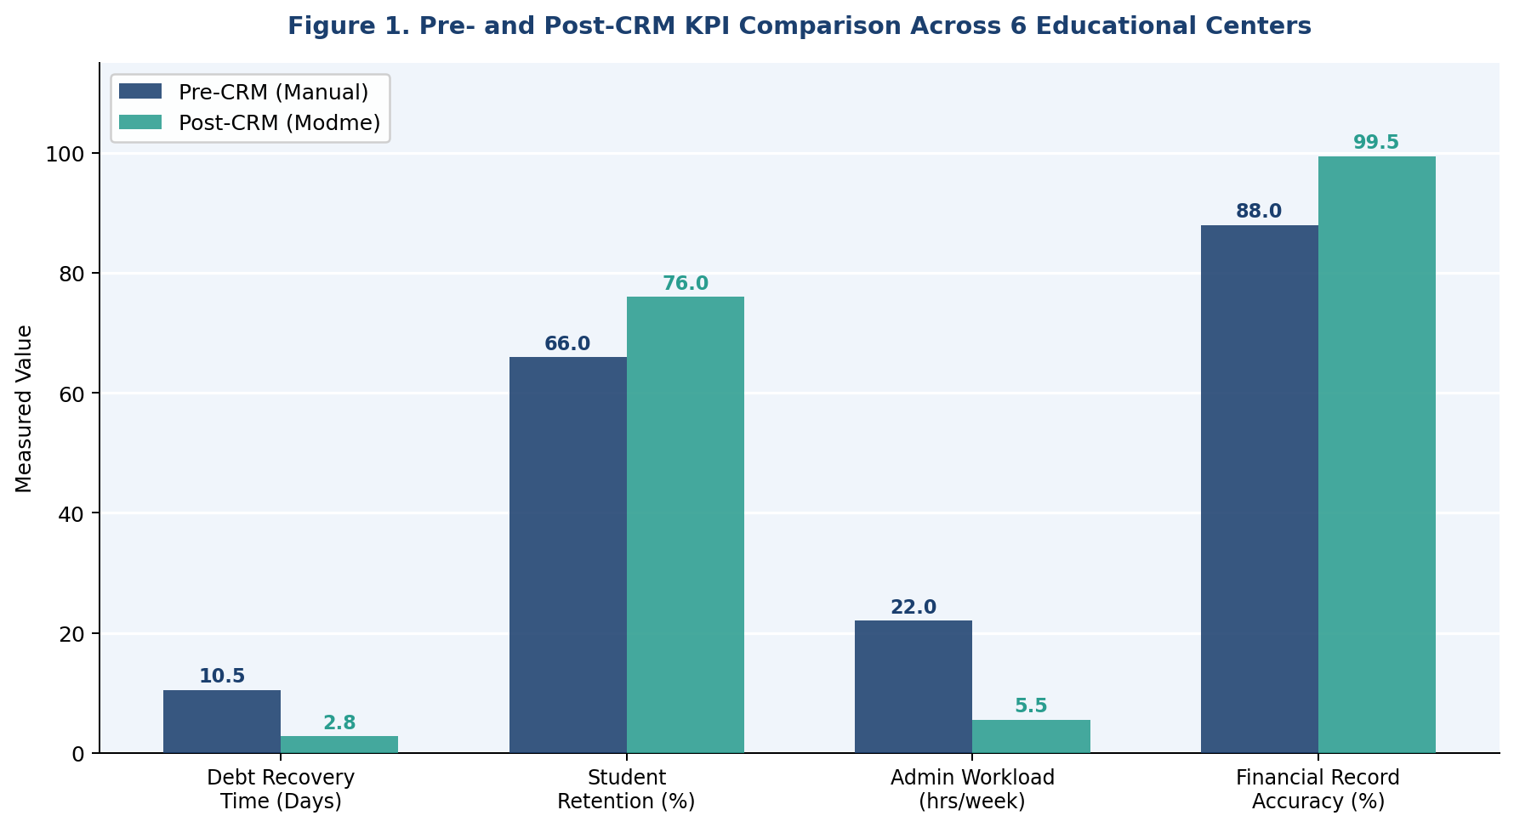
Figure 1. Pre- and Post-CRM KPI Comparison Across 6 Educational Centers

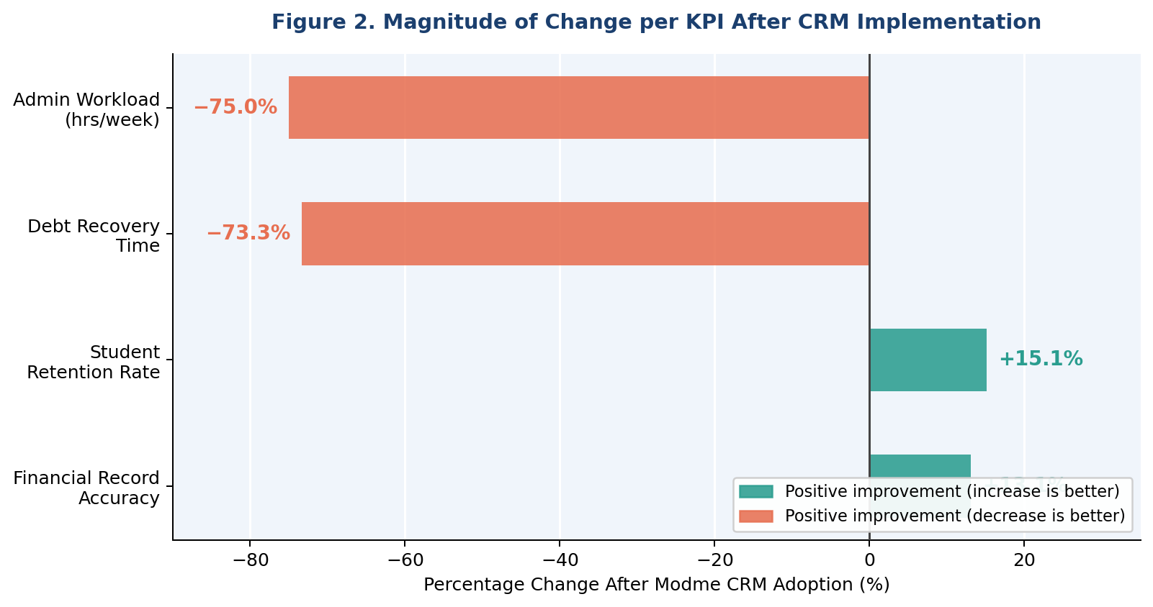
Figure 2. Magnitude of Change per KPI After Modme CRM Implementation

The most substantial improvement was recorded in weekly administrative workload, which fell by 75.0% — from an average of 22.0 hours per week to 5.5 hours. This reduction reflects the elimination of manual payment tracking, paper-based record maintenance, and ad-hoc reminder communications, all of which were automated within Modme. Debt recovery time fell by 73.3% (from 10.5 to 2.8 days), driven primarily by the automated SMS payment reminder feature, which removed the dependence on manual staff follow-up. Student retention increased by 15.1 percentage points (from 66% to 76%), reflecting the combined effect of proactive attendance notifications, early intervention enabled by real-time student data, and improved payment processing that reduced administrative conflicts with students. Financial record accuracy improved from 88.0% to 99.5%, attributable to the elimination of manual data entry errors through automated transaction recording.
Figure 3 provides a normalised radar visualization of the overall operational performance profile before and after CRM adoption, illustrating the compound improvement across all four dimensions simultaneously.

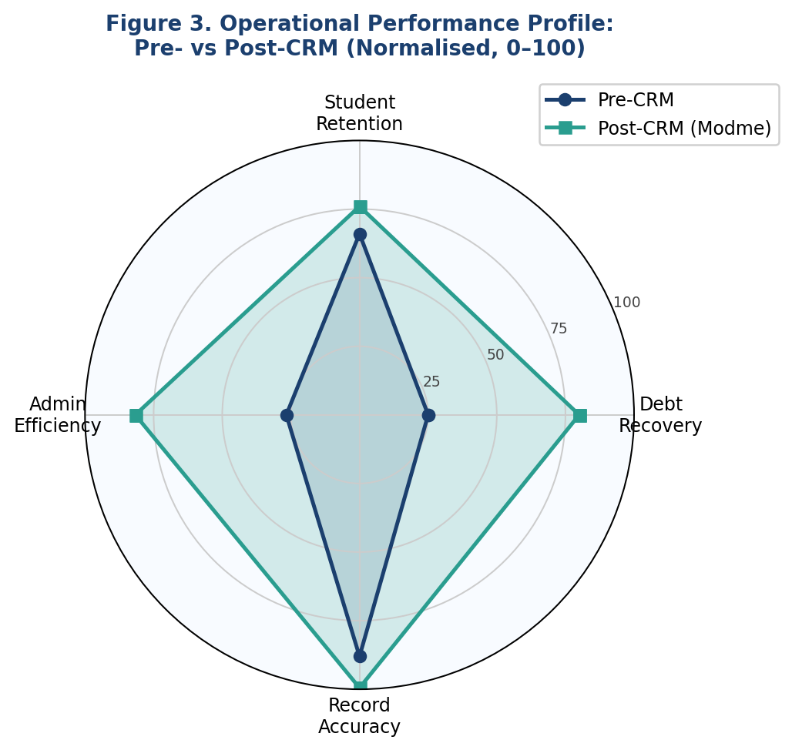
Figure 3. Normalised Operational Performance Profile: Pre- vs. Post-CRM (0–100 scale)

4.3 Longitudinal Trend
Figure 4 illustrates the evolution of two key indicators — administrative workload and student retention — across the six-month observation window. Both indicators show a clear and consistent directional trend beginning from the month of CRM adoption, with the steepest rate of improvement recorded in the first two months post-adoption (October–November 2024), consistent with the hypothesis that the greatest efficiency gains accrue in the transition from fully manual to automated processes. Improvement rates decelerate in subsequent months, suggesting an asymptotic pattern typical of operational learning curves.

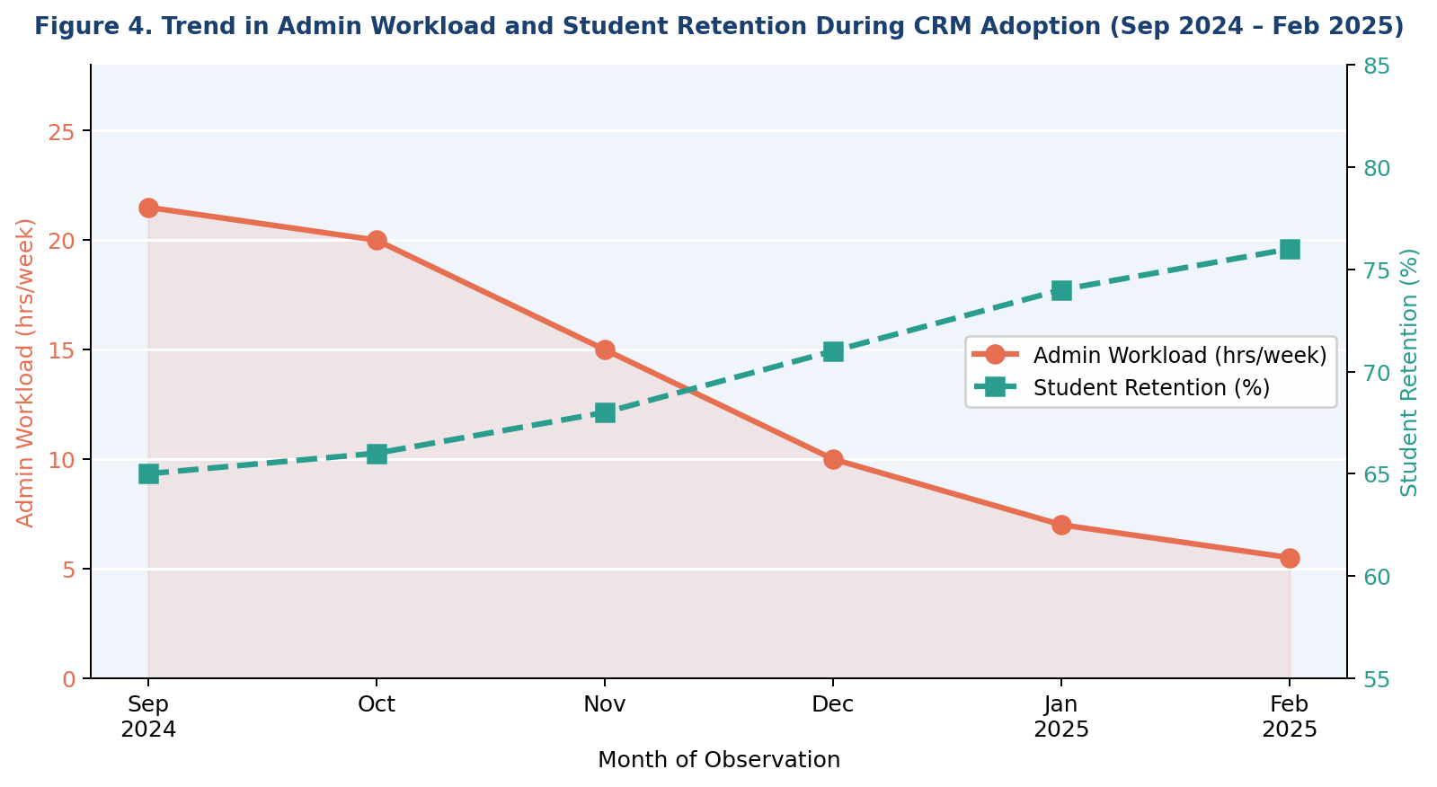
Figure 4. Trend in Admin Workload and Student Retention During CRM Adoption (Sep 2024 – Feb 2025)

4.4 Cross-Case Pattern Analysis
Table 3 presents the cross-case analysis mapping CRM features to observed efficiency outcomes. This analysis operationalizes the literal replication logic of the multiple case study design: features reported as driving efficiency gains in the majority of centers are treated as more credible drivers than those reported by a single center.

Table 3. Cross-Case Pattern: CRM Features and Associated Efficiency Outcomes
Feature Used | Observed Effect | Centres Reporting
Automated billing | Admin workload reduction | A, B, D, E, F (5/6)
SMS payment reminders | Debt recovery time reduction | A, C, E, F (4/6)
Attendance tracking | Student retention improvement | C, D, E (3/6)
Digital financial records | Record accuracy improvement | All 6 (6/6)
Full feature integration | Compound efficiency gains | E (1/6)
Source: Authors' cross-case synthesis from center interviews and administrative data.

Digital financial records were universally adopted and universally associated with improved record accuracy, representing the most robust finding of the study. Automated billing — adopted by five of six centers — was consistently associated with reduced administrative workload. SMS notification adoption (four of six centers) was the feature most strongly linked to reduced debt recovery time. Attendance tracking, adopted by three centers, was the feature most associated with retention improvement. The single center utilizing the full feature suite (Center E) recorded the most compound efficiency gains across all four KPIs, consistent with Wahab et al.'s (2024) finding that integration depth amplifies CRM performance benefits.

4.5 Qualitative Insights
Interview analysis yielded three recurring themes. The first theme, Immediate Workload Relief, was mentioned unprompted by all six managers, who described the elimination of manual payment follow-up and record reconciliation as transformative. One manager characterized the pre-CRM period as 'spending half the day chasing parents for payments and updating spreadsheets,' contrasting this with the post-Modme experience of being able to 'focus entirely on teaching quality and student issues.'
The second theme, Training as a Precondition, emerged in four of six interviews. Managers at Centers A and E — which achieved the strongest overall KPI improvements — attributed their outcomes partly to deliberate internal training sessions conducted before system go-live. Managers at two centers noted that initial staff reluctance, stemming from unfamiliarity with digital tools, created a short-term dip in efficiency during the first two to three weeks of adoption, subsequently recovered as proficiency increased.
The third theme, Underutilised Features, revealed a consistent gap between available and activated functionality. All six managers indicated that their centers were not utilising the full Modme feature set, citing lack of awareness of some features and insufficient time for configuration as barriers. This suggests that reported efficiency gains may represent a lower bound of the platform's potential impact under fuller utilization.

5. DISCUSSION
The findings of this study provide consistent cross-case evidence that Modme CRM adoption generates meaningful operational efficiency gains in Tashkent's private educational sector. The pattern of improvement — observed across all six centers and all four KPIs — fulfils the literal replication criterion of the multiple case study design, supporting the internal validity of the CRM-efficiency relationship in this context.
The magnitude of the administrative workload reduction (−75.0%) is particularly notable. Prior research on CRM-enabled automation in service SMEs has documented workload reductions in the range of 30–50% (Soltani & Navimipour, 2022); the higher figure observed here likely reflects the especially manual baseline conditions prevalent in Tashkent's educational sector prior to CRM adoption, where no partial automation tools were in use. This suggests that the marginal efficiency gain from CRM adoption may be higher in settings with more primitive operational baselines — a finding with significant implications for digital transformation policy in developing economies.
The cross-case finding that integration depth amplifies efficiency gains is consistent with Wahab et al. (2024). Center E, the sole full-feature adopter, achieved compound gains across all KPIs, while centers utilizing only one or two features showed improvement in the KPIs most directly targeted by those features but less pronounced gains elsewhere. This finding implies that policymakers and platform vendors should prioritize guided onboarding programmes that encourage progressive feature activation rather than minimal adoption.
The qualitative finding on staff training as a precondition aligns strongly with Raza et al.'s (2024) cross-country evidence from transitional economies, where training intensity was identified as the primary CRM ROI driver. The temporary efficiency dip observed in two centers during early adoption — attributed to staff unfamiliarity — underscores that the transition period requires active management, and that onboarding support from platform providers is a critical success factor in contexts with limited prior digital exposure.
Several limitations warrant acknowledgment. The purposive sample of six centers, while appropriate for a case study design, is not statistically representative of Tashkent's full population of educational centers. KPI values for the pre-CRM period were partially reconstructed from administrative records, introducing potential recall bias, though system log data for the post-CRM period are objective and verifiable. The absence of a control group precludes ruling out concurrent confounding factors — such as seasonal enrolment trends — as contributors to the observed KPI changes. Future research employing larger samples, longitudinal designs, and matched control groups would substantially strengthen causal attribution.

6. CONCLUSION
This multiple case study provides systematic, evidence-based documentation of the operational efficiency gains associated with Modme CRM adoption in six private educational centers in Tashkent, Uzbekistan. Key findings include a 75.0% reduction in administrative workload, a 73.3% reduction in debt recovery time, a 15.1 percentage point improvement in student retention, and a near-elimination of financial record errors. These outcomes were achieved within a single academic semester and were consistent across centers of varying size and feature adoption breadth.
For educational center managers, the implications are clear: CRM adoption offers immediate and substantial operational returns, particularly in the area of administrative time savings and payment management. However, the study emphasizes that these returns are conditional: they require investment in staff training before and during system go-live, and they scale with the breadth of feature integration. Centers that adopted only minimal features achieved more limited gains, suggesting that a phased but progressive feature activation strategy optimizes long-term return on investment.
For policymakers and the Modme platform development team, the finding that all six centers reported underutilised features points to a systemic gap between platform capability and realized value. Structured post-adoption support — through in-app guidance, peer learning networks among centers, or subsidized training programmes — could substantially increase the realized efficiency impact of the platform across the sector.
For researchers, this study demonstrates the viability of rigorous multiple case study methodology as an alternative to large-N quantitative designs in regional service sector contexts where small organizational populations are the norm. Future research should explore the retention mechanism in greater depth — specifically, how attendance tracking and early intervention workflows translate into reduced student dropout — and should examine the role of AI-augmented features in Modme's developing roadmap for predictive analytics in educational management.

REFERENCES
Abdullaev, A. M., & Kurpayanidi, K. I. (2024). Digital transformation of the service sector in Uzbekistan: Trends and prospects. Tashkent: Fan va Texnologiya.
Alalwan, A. A., Dwivedi, Y. K., Rana, N. P., & Baabdullah, A. M. (2023). Examining AI-CRM integration and its impact on customer engagement and firm performance. International Journal of Information Management, 68, 102598.
Barney, J. (1991). Firm resources and sustained competitive advantage. Journal of Management, 17(1), 99–120.
Braun, V., & Clarke, V. (2006). Using thematic analysis in psychology. Qualitative Research in Psychology, 3(2), 77–101.
Garg, R., & Garg, S. (2022). The role of CRM in mediating service quality and customer satisfaction: Evidence from emerging market service firms. Journal of Retailing and Consumer Services, 64, 102812.
Khodakarami, F., & Chan, Y. E. (2022). Leveraging big data analytics in CRM: Mechanisms and performance outcomes. Information & Management, 59(3), 103577.
Raza, S. A., Bhutta, U. S., Iqbal, S., & Shahzad, F. (2024). CRM adoption and return on investment in transitional economies: A cross-country SME analysis. Technological Forecasting and Social Change, 198, 122940.
Soltani, Z., & Navimipour, N. J. (2022). Customer relationship management in cloud environments: Adoption barriers and strategic benefits for SMEs. Journal of Cloud Computing, 11, 47.
Venkatesh, V., & Bala, H. (2008). Technology Acceptance Model 3 and a research agenda on interventions. Decision Sciences, 39(2), 273–315.
Wahab, M. K. A., Ismail, W. N. S. W., Ahmad, N. L., & Ramli, N. (2024). CRM integration depth, knowledge sharing, and operational performance in regional service firms. Journal of Business Research, 172, 114435.
Yin, R. K. (2018). Case study research and applications: Design and methods (6th ed.). SAGE Publications.

