1011011011001001
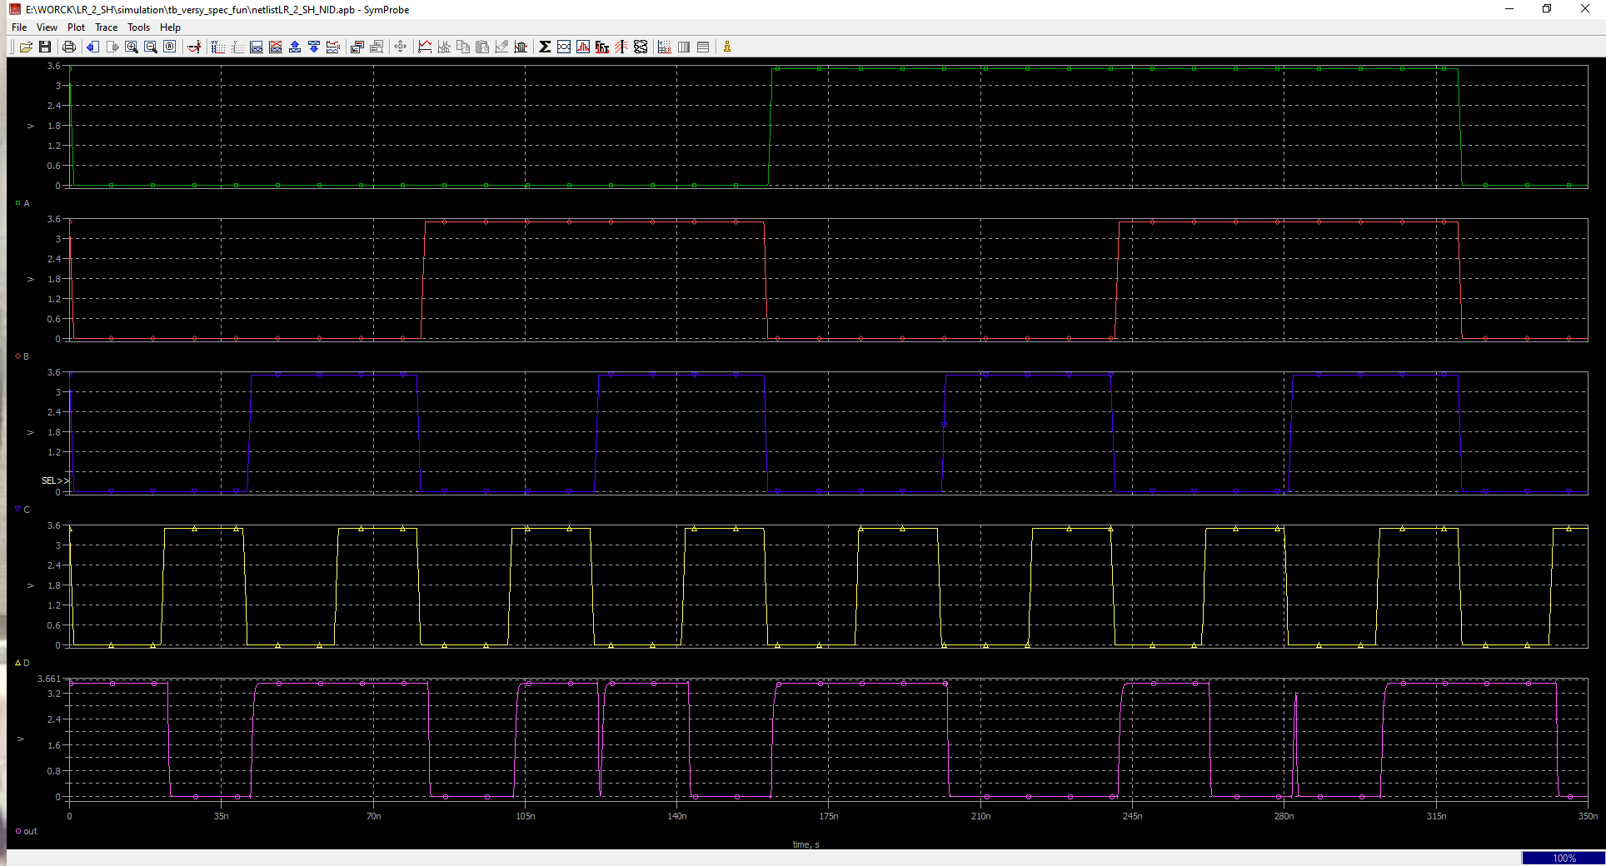
(!a|b|!c)(!a|!c|d)(!a|!b|c|!d)(a|!b|c|d)(a|!b|!c|!d)(a|b|c|!d)

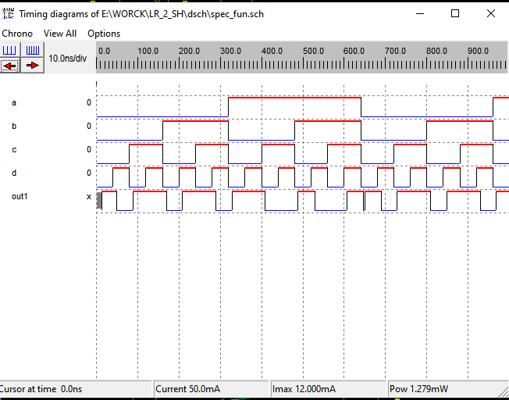
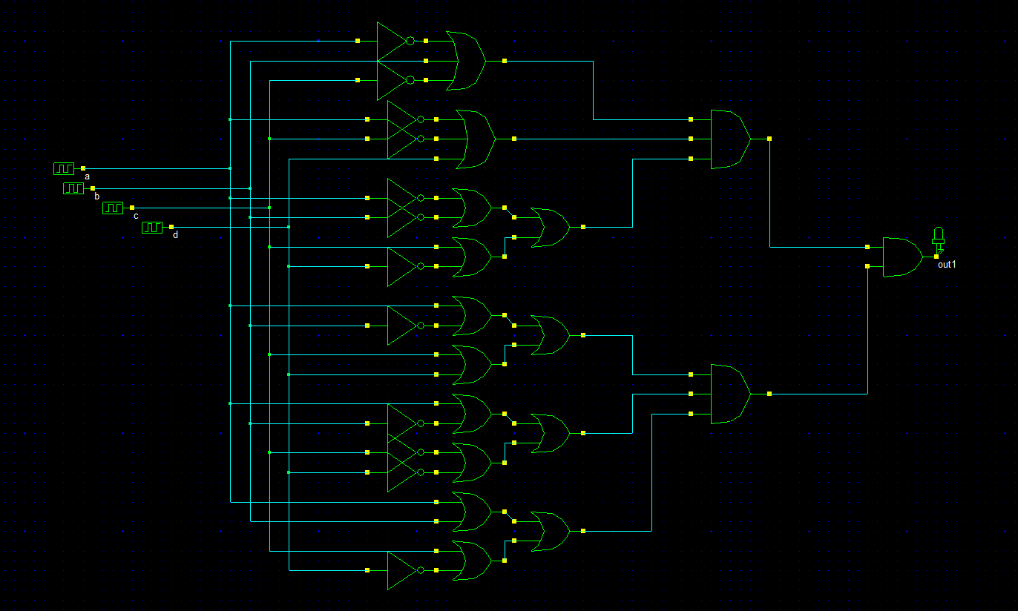
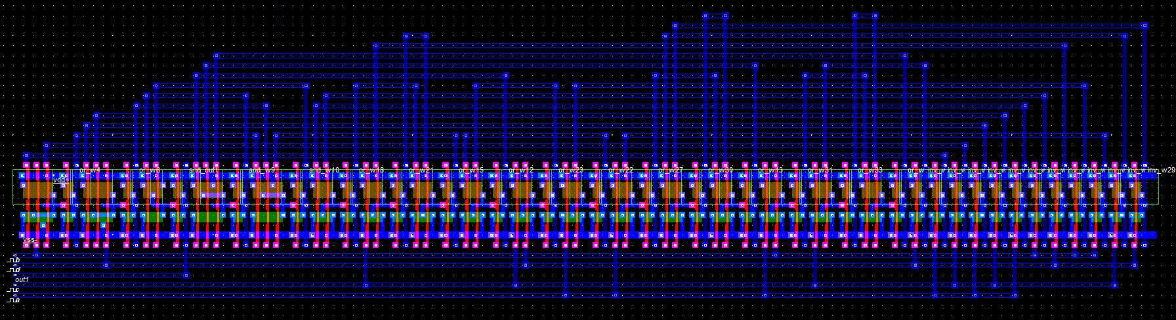
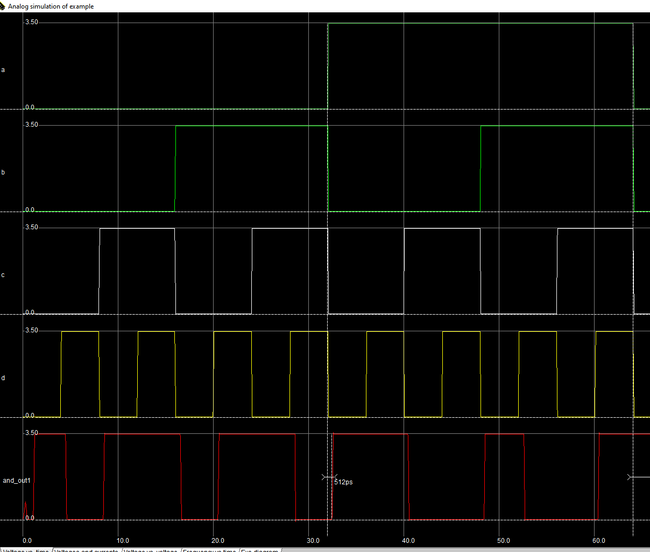
3v | 3.5v | 5v
(1.58+1.78)/2=1.68n | (1.4+1.6)/2=1.5n | (1.17+1.46)/2=1.3n
(0.606+0.540)/2=0.57n | (0.572+0.498)/2=0.56n | (0.62+0.516)/2=0.53n

