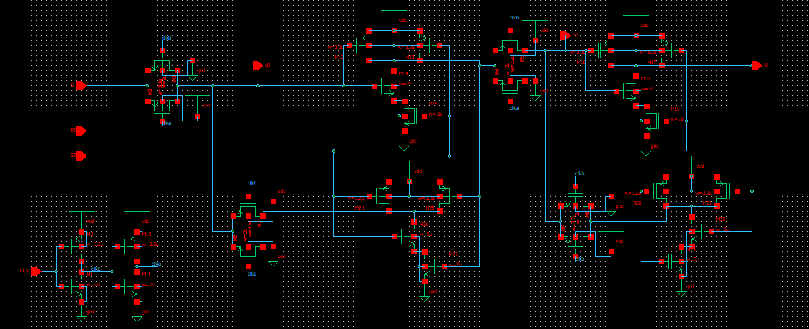
Vdd | 2.7 | 3.0 | 3.3
TGL | (1.129+0.922)/2 = 1.02  1.3u | (1.046+0.852)/2 = 0.94  1.48u | (0.985+0.802)/2 = 0.89  1.6u
CMOS | (1.16+0.928)/2 = 1.04  1.8u | (1.036+0.879)/2 = 0.95  2.04u | (1+0.801)/2 = 0.9  2.2u

