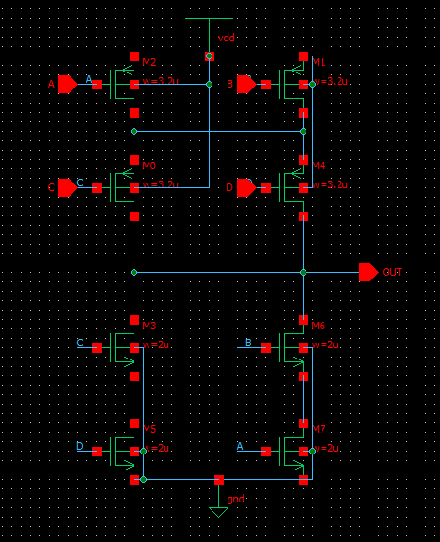
~((A&B)|(C&D))
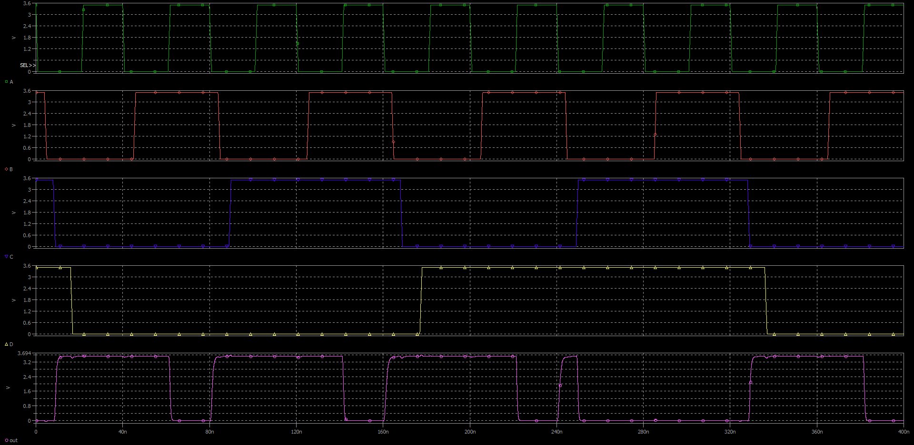

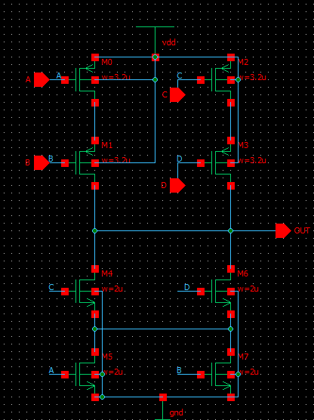
~((A|B)&(C|D))
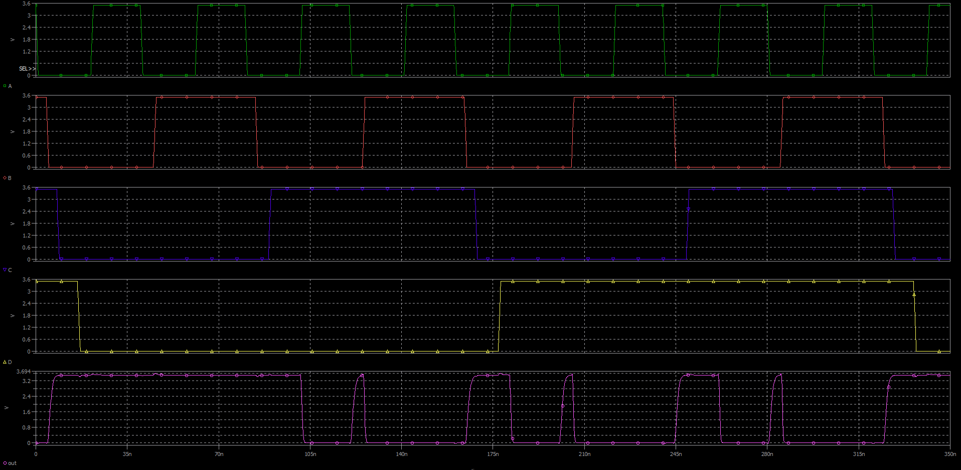

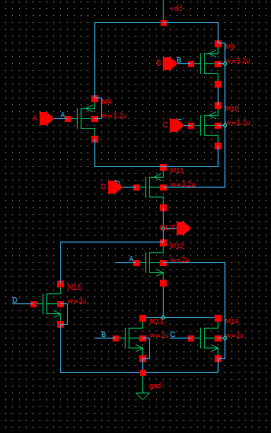
~(D|(A(B+C)))
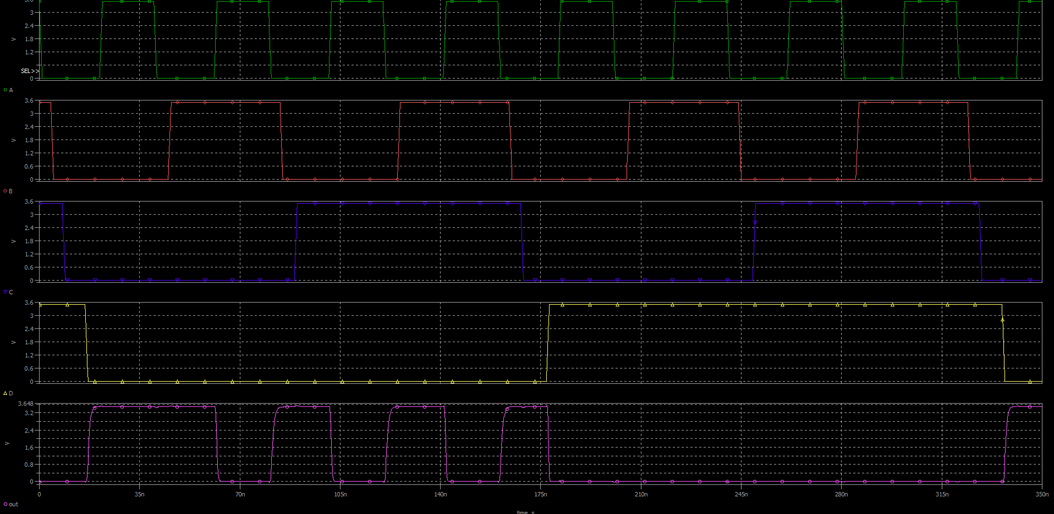

 | 2.7 |  | 3 |  | 3.3
n | Pull up/do | Std cell | Pull up/do | Std cell | Pull up/do | Std cell
~((A&B)|(C&D)) | (0.511+0.951)/2 = 0.731 | (0.651+1.36)/2 = 1 | (0.465 + 0.875)/2 = 0.67 | (0.603 + 1.25)/2 = 0.92 | (0.43+0.819)/2 = 0.62 | (0.567+1.17)/2 = 0.86
~((A|B)&(C|D)) | (0.515+1.17)/2=0.84 | (0.711+1.03)/2=0.87 | (0.468+1.08)/2 = 0.77 | (0.647+0.961)/2 =0.8 | (0.432+1)/2 =0.71 | (0.601+0.911)/2 = 0.75
~(D|(A(B+C))) | (0.546+1.11)/2 =0.82 | (0.618+1.418)/2 =1.04 | (0.51+1.01)/2 =0.76 | (0.56+1.31)/2 =0.935 | (0.483+0.951)/2 = 0.72 | (0.526+1.23)/2 =0.89

 | 2.7 | 3 | 3.3
~((A&B)|(C&D)) | 27%win | 27%win | 27%win
~((A|B)&(C|D)) | 3.4%win | 3.7%win | 4.7%win
~(D|(A(B+C))) | 21%win | 19%win | 19%win

 | 2.7 |  | 3 |  | 3.3
u | Pull up/do | Std cell | Pull up/do | Std cell | Pull up/do | Std cell
~((A&B)|(C&D)) | 10.67 | 10.22 | 11.87 | 11.3 | 13.35 | 12.84
~((A|B)&(C|D)) | 11.3 | 12.12 | 13.28 | 14 | 14.9 | 15.7
~(D|(A(B+C))) | 9 | 9.37 | 10.2 | 10.5 | 11 | 11.33

 | 2.7 |  | 3 |  | 3.3
 | Pull up/do | Std cell | Pull up/do | Std cell | Pull up/do | Std cell
~((A&B)|(C&D)) | 4%loss |  | 5%loss |  | 3.8%loss
~((A|B)&(C|D)) | 6.7%win |  | 5%win |  | 5%win
~(D|(A(B+C))) | 3.9%win |  | 2.8%win |  | 2.9%win

