1, go to drawio via link <https://app.diagrams.net/>

2,

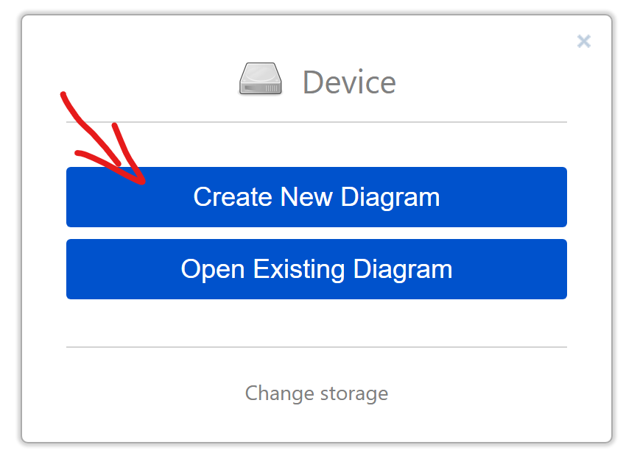

3, create a class diagram and put a name for your class diagram, then delete the example in the new created workspace.

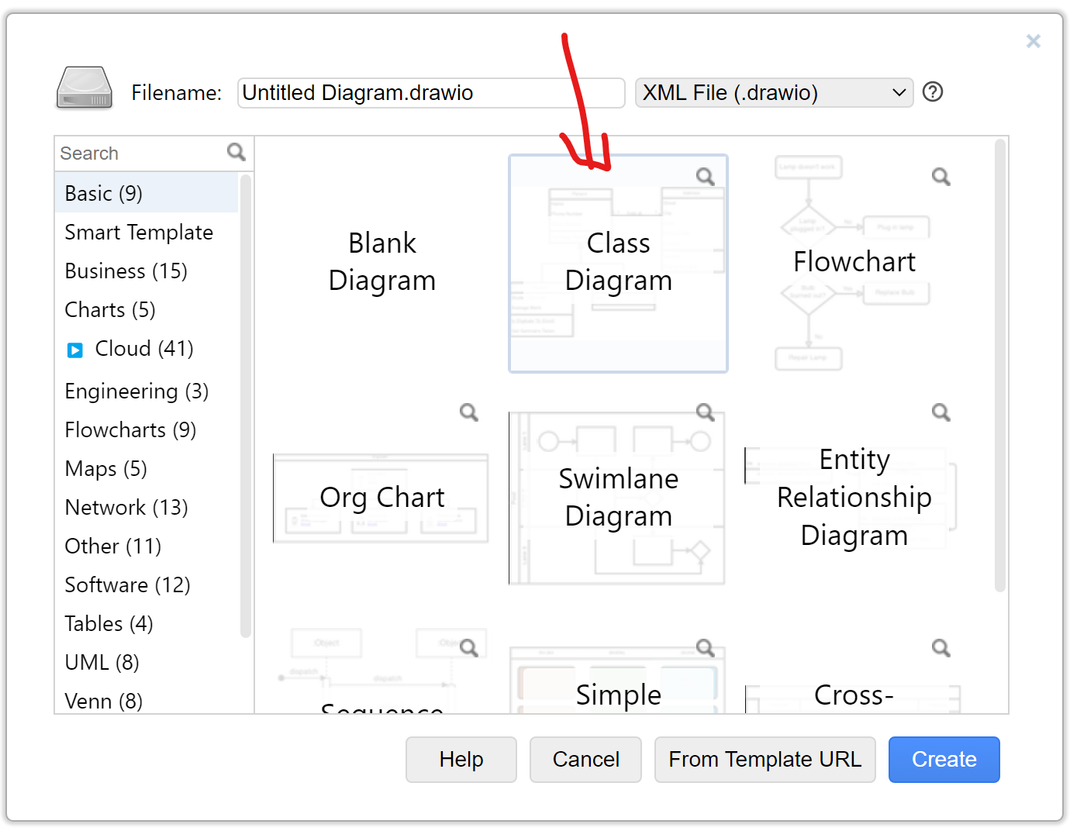

4, click **more shapes**

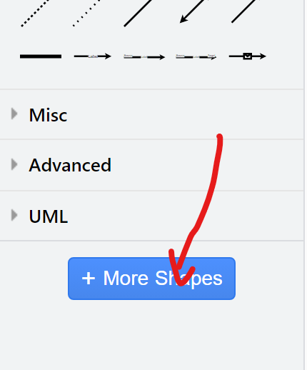

5, choose **UML 2.5**

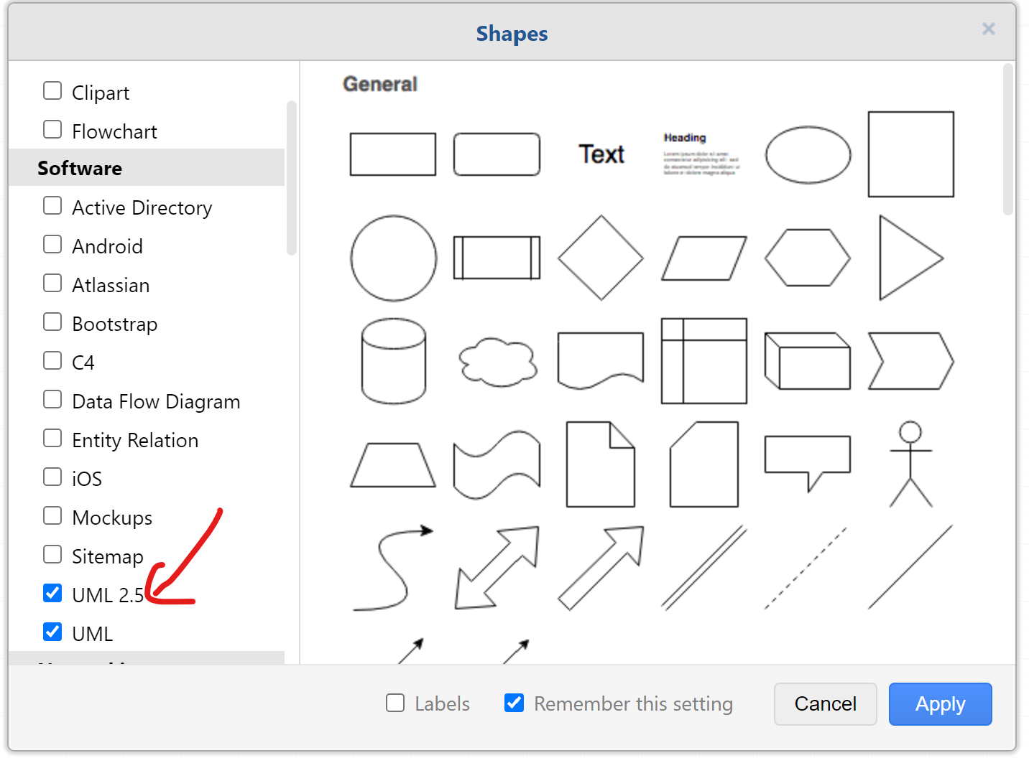

6, click or drag the **Diagram** in UML2.5

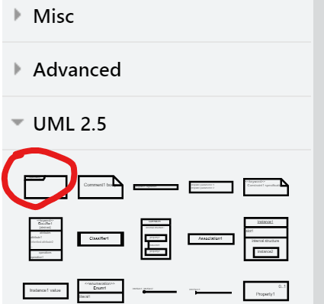

7, click or drag the **class** in UML

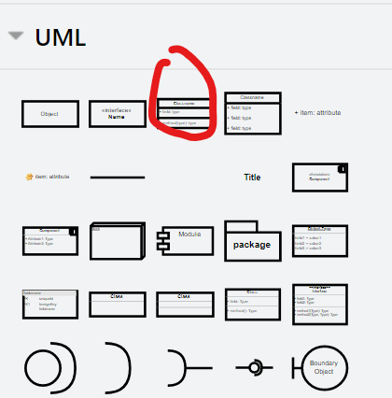

8, then you can use the relationship line in either UML2.5 or UML. <Refer to lecture slide 22 for the relationships>

9, add new rows: **right click** the row and **Duplicate**, **drag** the new rowto the place where you want to put, as shown in the following steps.

