FINAL PROJECT / WEEK 4

FitForm
  - Personalised 2D Outfit Visualiser
Course  [Insert course code / name] | Group  [Insert group name / number] | Members  [Insert names + student IDs] | Submission  30 August 2026

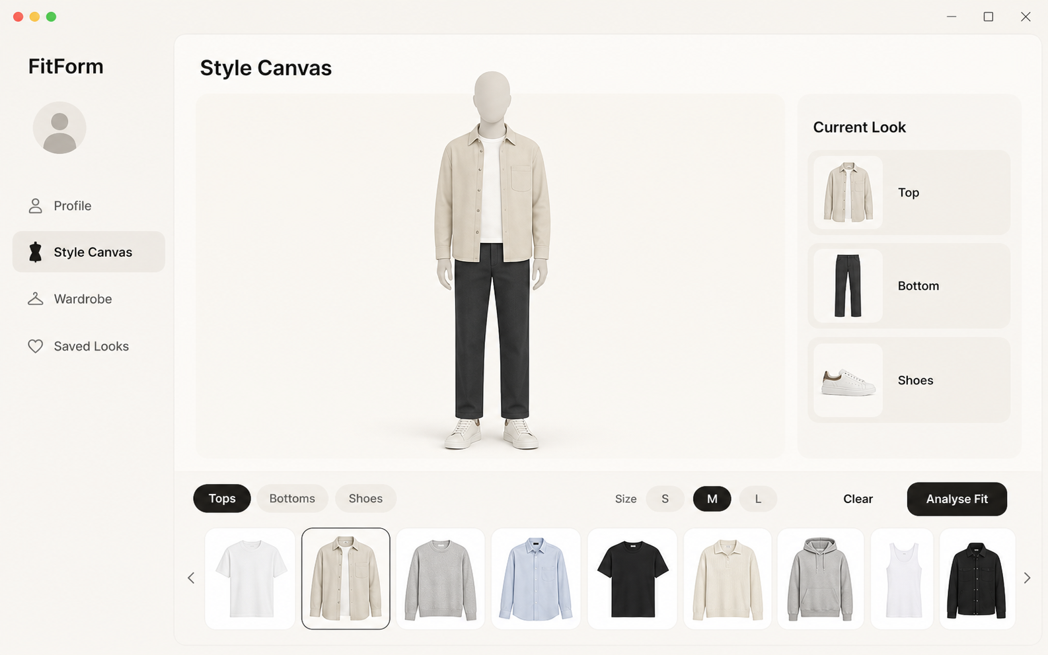
A beginner-friendly JavaFX application that creates a measurement-responsive neutral avatar, supports simple outfit visualisation and provides explainable size guidance.

1. Current project idea
FitForm is a JavaFX desktop application that allows users to enter height, chest, waist and hip measurements, generate an approximate neutral 2D avatar and preview prepared clothing items on proportions closer to their own.
The system uses a hybrid method: it first classifies a broad body type using measurement ratios, then adjusts key avatar widths and lengths with the user's actual measurements. Clothing is selected from a curated transparent-PNG wardrobe and positioned using simple shoulder, waist and hip anchors.
Core innovation: unlike a standard wardrobe application, FitForm combines measurement-responsive 2D visualisation with a Java-based fit score and size recommendation, without claiming realistic 3D or cloth simulation.

2. Idea inspiration
The idea responds to a common online-shopping problem: garments are usually shown on a limited range of models, making it difficult for users to imagine the same outfit on different proportions. Commercial virtual try-on tools can require computer vision, AI or 3D assets, so our project explores a deliberately simpler and more explainable alternative.
INSPIRATION | DESIGN RESPONSE
Generic product-model imagery | Generate a neutral avatar whose main proportions respond to user measurements.
Warm, accessible wardrobe apps | Use an ivory/beige JavaFX interface with large headings, rounded filters and clear clothing cutouts.
Need for technical depth | Use OOP, inheritance, collections, procedural shapes, body classification and fit-scoring algorithms.
Risk of over-complexity | Exclude 3D bodies, cloth physics, AI try-on, photo measurement and automatic image processing.

Proposed user flow
Profile > Generate avatar > Select top / bottom / shoes > Choose size > Analyse fit > Save look

3. Progress so far
At Week 4, the project remains in concept validation and feasibility planning. The team has defined the problem, selected JavaFX as the implementation platform, established the MVP, mapped the main Java classes and developed a consistent four-screen UI direction.
AREA | CURRENT STATUS | NEXT VERIFIABLE OUTPUT
Concept | Defined: measurement-responsive neutral 2D outfit visualiser | Tutor validation of scope and project value
MVP | Profile, avatar, wardrobe, style canvas, fit result and saved looks | Acceptance criteria and prioritised backlog
Technical plan | JavaFX, procedural shapes, PNG overlays, OOP and collections | BodyProfile class and avatar proof of concept
UI direction | Four beige desktop screens designed for JavaFX implementation | FXML/Pane structure and shared CSS tokens
Testing | Success criteria drafted for classification, alignment and fit score | Sample profiles, expected outputs and user test script

Current challenges and responses
CHALLENGE | WHY IT MATTERS | PLANNED RESPONSE
Measurements cannot precisely reconstruct a person | People with similar measurements may have different shapes | Classify a broad body type, then adjust only key control points; label the result as approximate
Garment alignment can look inconsistent | Images may have different proportions or transparent margins | Use a curated asset library and fixed anchors for each garment category
Realistic fit is technically complex | Cloth drape and collision require advanced graphics | Evaluate visual proportion and size ranges, not physical cloth behaviour
Scope can expand quickly | Search, upload, weather and AI features could delay the MVP | Use preloaded items and click-to-select interactions; complete core acceptance tests first

Immediate success criteria
A successful first prototype will classify sample profiles consistently, visibly change the avatar proportions, keep one top and bottom aligned, and update the fit result when measurements exceed a garment's recommended range.

4. Visual group work plan
The project will use short build-test cycles. Each phase produces an observable output that can be demonstrated to the tutor, reducing the risk of spending too long on unvalidated features.
W4 | W5 | W6 | W7 | W8 | W9+
Validate | Profile | Avatar | Wardrobe | Algorithms | Refine
Tutor feedback  Scope + UI | BodyProfile  Rules | JavaFX shape  Response | PNG assets  Anchors | Fit score  Size | Testing  Demo + report

Suggested team responsibilities
WORKSTREAM | PRIMARY OWNER | SUPPORT | WEEKLY OUTPUT
Research + testing | [Member A] | All members | User problem, test profiles and findings
UX + visual design | [Member B] | Member A | JavaFX screen layouts, CSS and assets
Java + algorithms | [Member C] | Member B | BodyProfile, classification and fit score
Avatar + wardrobe | [Member D / shared] | Member C | Procedural shape, anchors and PNG overlays
Coordination + report | [Rotate] | All members | Backlog, meeting notes and evidence

Scope priorities
- Core: measurements, body type, 2D avatar, wardrobe selection and outfit display.
- Creative: proportional avatar adjustment, garment size choice, fit score and size recommendation.
- Stretch: saved looks and simple wardrobe search only after the core workflow is stable.
- Excluded: 3D modelling, AI try-on, face upload, automatic body measurement, image recognition and cloth physics.

Questions for the tutor meeting
- Is the combination of body-type classification and proportional adjustment sufficiently strong for the algorithmic component?
- Should evaluation prioritise calculation correctness, garment alignment, usability or a combination?
- Is the proposed Core / Creative / Stretch scope realistic for the remaining project schedule?

UI concept gallery
The four-screen concept translates the warm wardrobe-app inspiration into a beginner-friendly JavaFX desktop structure. Each screen maps to standard JavaFX layout containers and avoids technically expensive interactions.
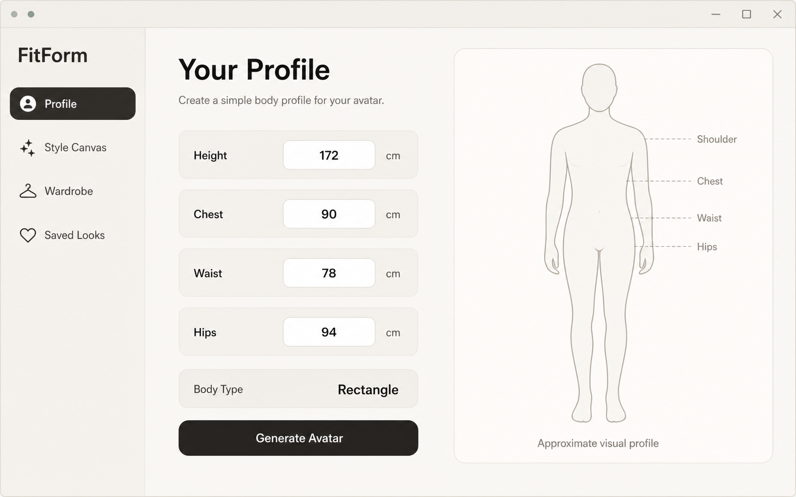  01 Profile |   02 Style Canvas
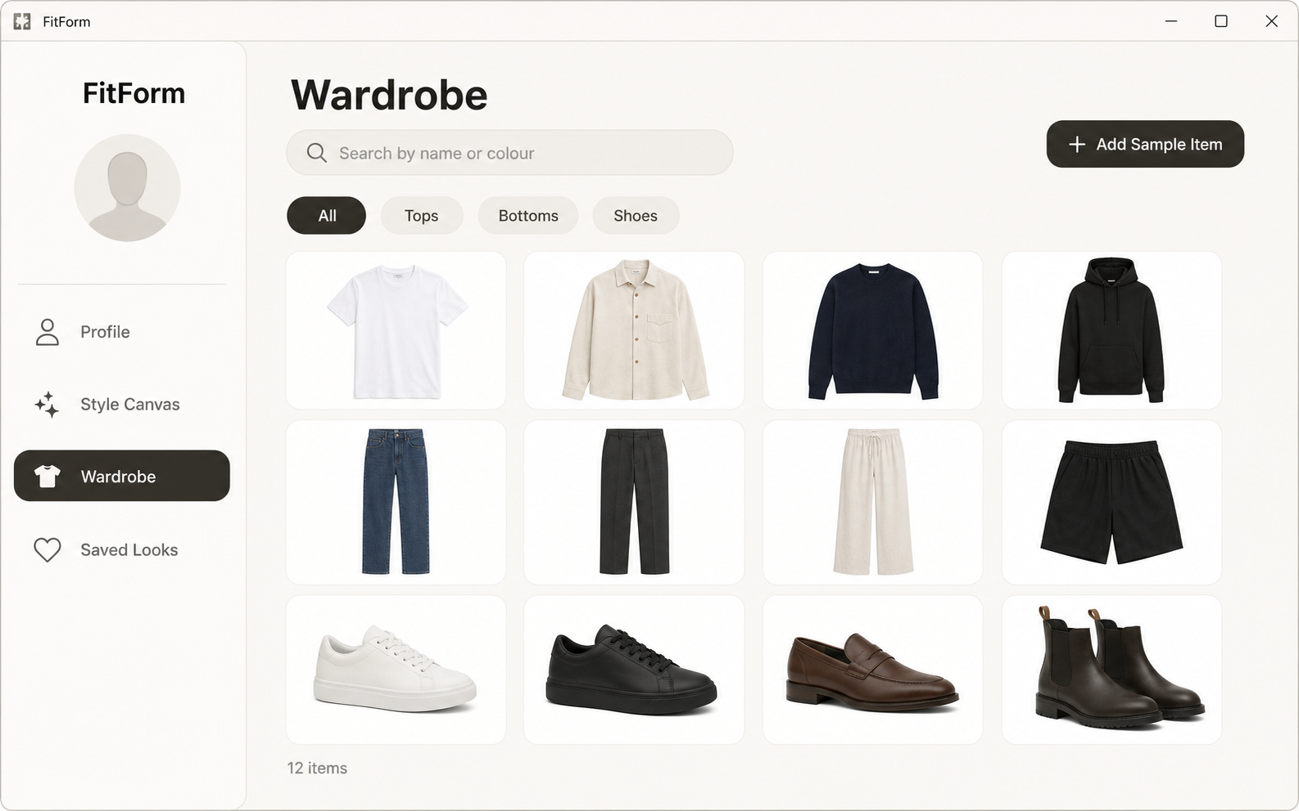  03 Wardrobe | 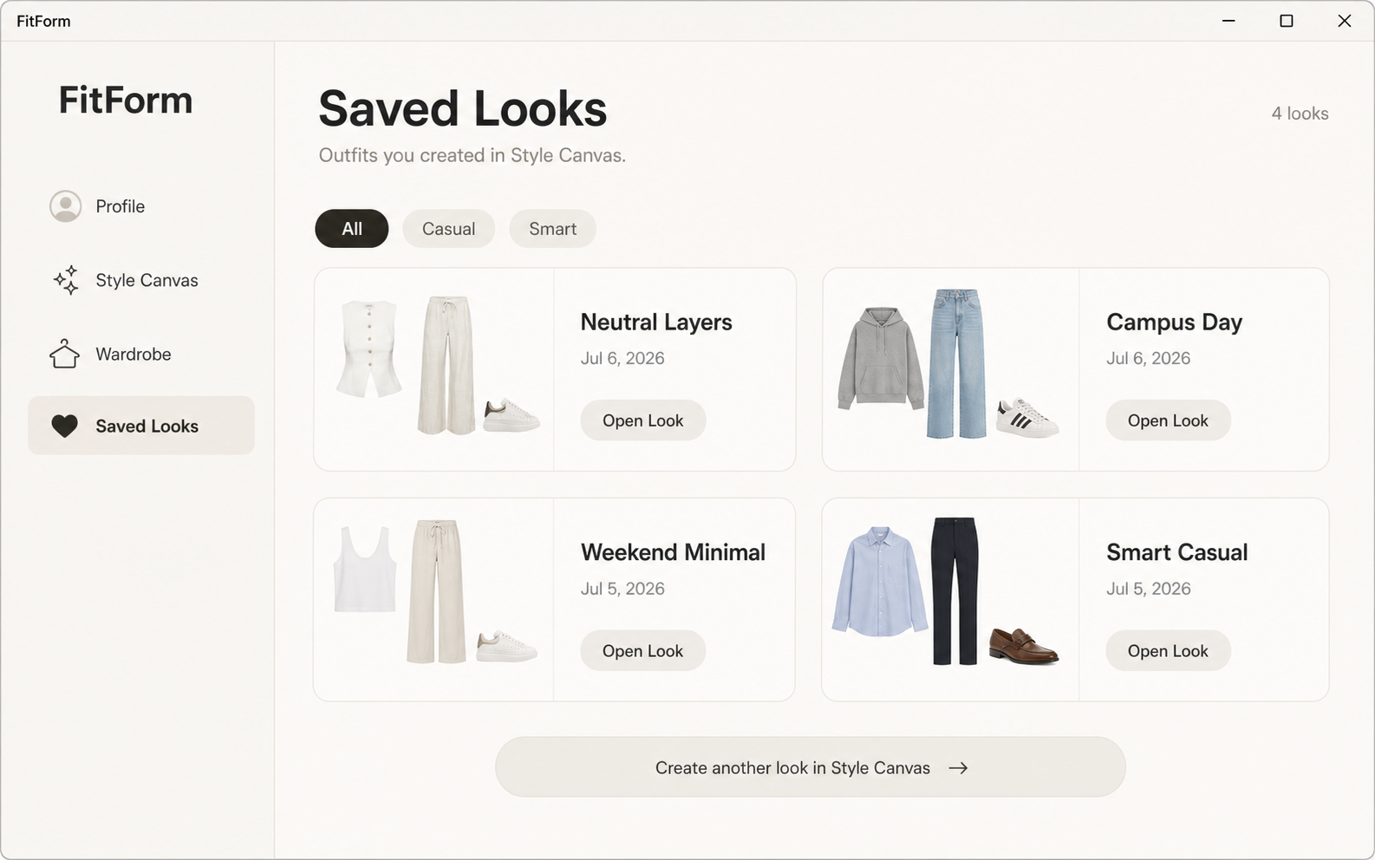  04 Saved Looks

JavaFX implementation mapping
SCREEN | SIMPLE JAVAFX STRUCTURE
Profile | HBox + VBox input rows + Canvas/Pane avatar preview
Style Canvas | BorderPane + ImageView layers + horizontal ScrollPane
Wardrobe | TilePane/GridPane inside ScrollPane using preloaded assets
Saved Looks | ArrayList<Outfit> rendered as repeated HBox/VBox items
Before submission: replace all bracketed course, group, member and responsibility placeholders with confirmed information.

