5.1
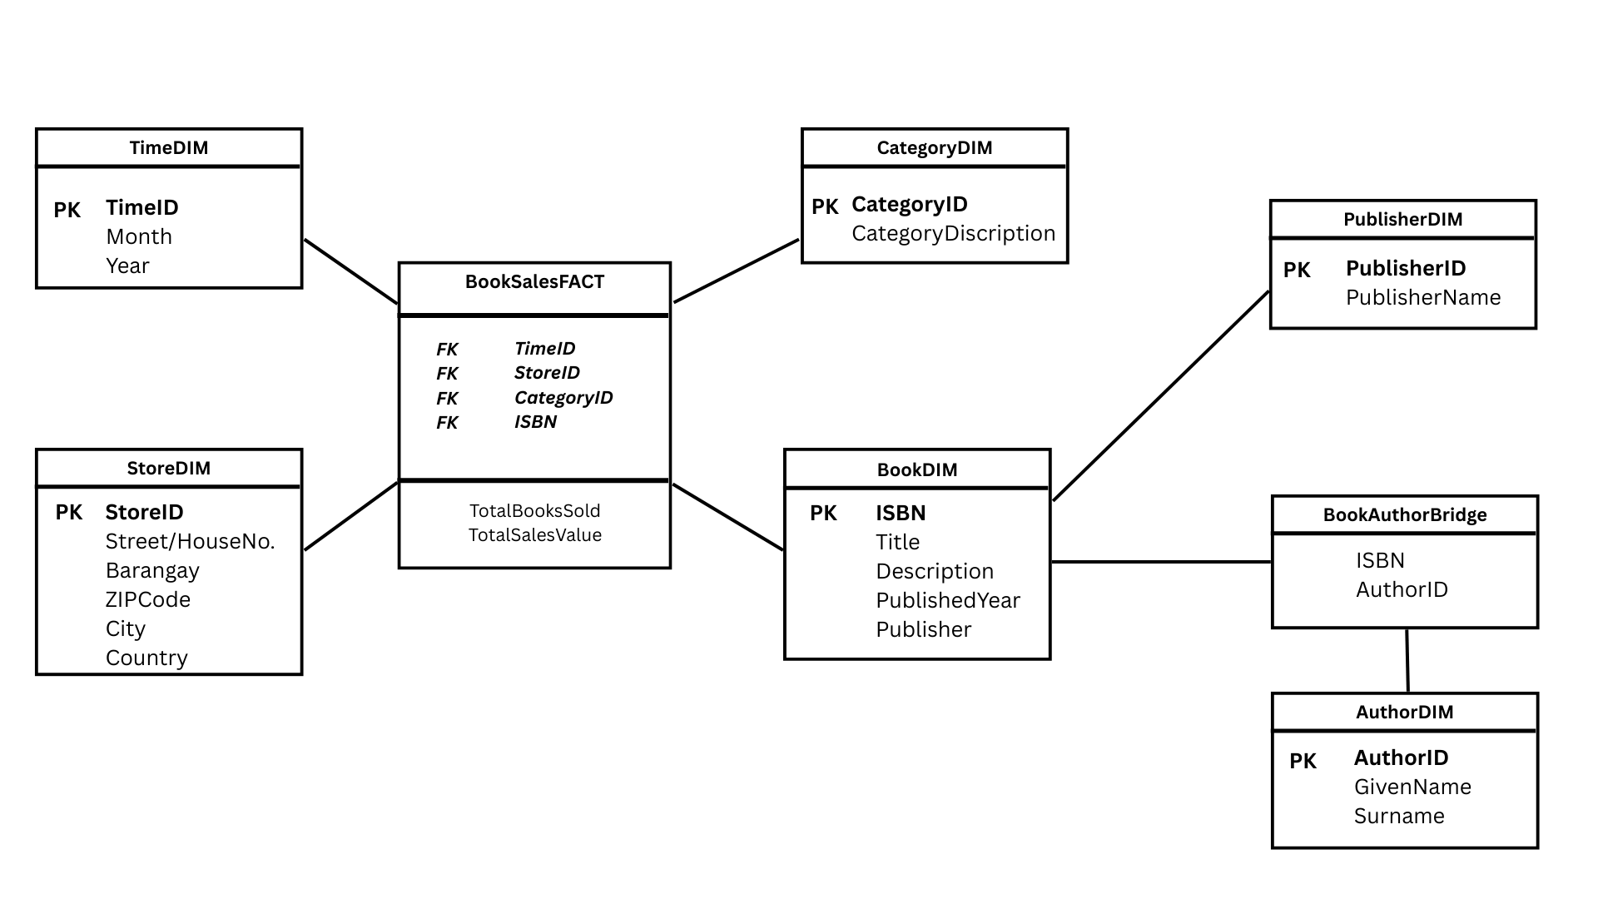
Snowflake Schema with Bridge Table for data warehouse:

SQL commands to create the dimensions and Fact Tables:

- Dimensions Table
-- Time Dimension
create table TimeDIM as
select
distinct to_char(SalesDate, 'YYYYMM') as TimeID,
to_char(SalesDate, 'YYYY') as Year,
to_char(SalesDate, 'MM') as Month
from Sales;

-- Store Dimension
create table StoreDIM as
select
distinct StoreID, Address, Suburb, State, Country
from Store;

-- Category Dimension
create table CategoryDIM as
select
distinct CategoryID, CategoryDescription
from Category;

-- Author Dimension
create table AuthorDIM as
select
distinct AuthorID, LastName, FirstName
from Author;

- Fact table
-- Fact Table
create table BookSalesFACT as
select
to_char(S.SalesDate, 'YYYYMM') as TimeID,
S.StoreID,
SD.ISBN,
B.CategoryID,
sum(SD.Quantity) as TotalQuantity,
sum(SD.TotalPrice) as TotalSalesValue
from Sale S, SalesDetails, Book B
where S.SalesID = SD.SalesID
and SD.ISBN = B.ISBN
group by
to_char(S.SalesDate, 'YYYYMM'),
S.StoreID,
SD.ISBN,
B.CategoryID;

