CS 3050 Homework # 5. Name : Zhiqian Zhou

Submitted to Blackboard, due at 11:59pm on April 20, 2018.

- Give an adjacency-list representation for a binary tree on 6 vertices. Give an equivalent adjacency-matrix representation. Assume that vertices are numbered from 1 to 6 as in a binary heap.

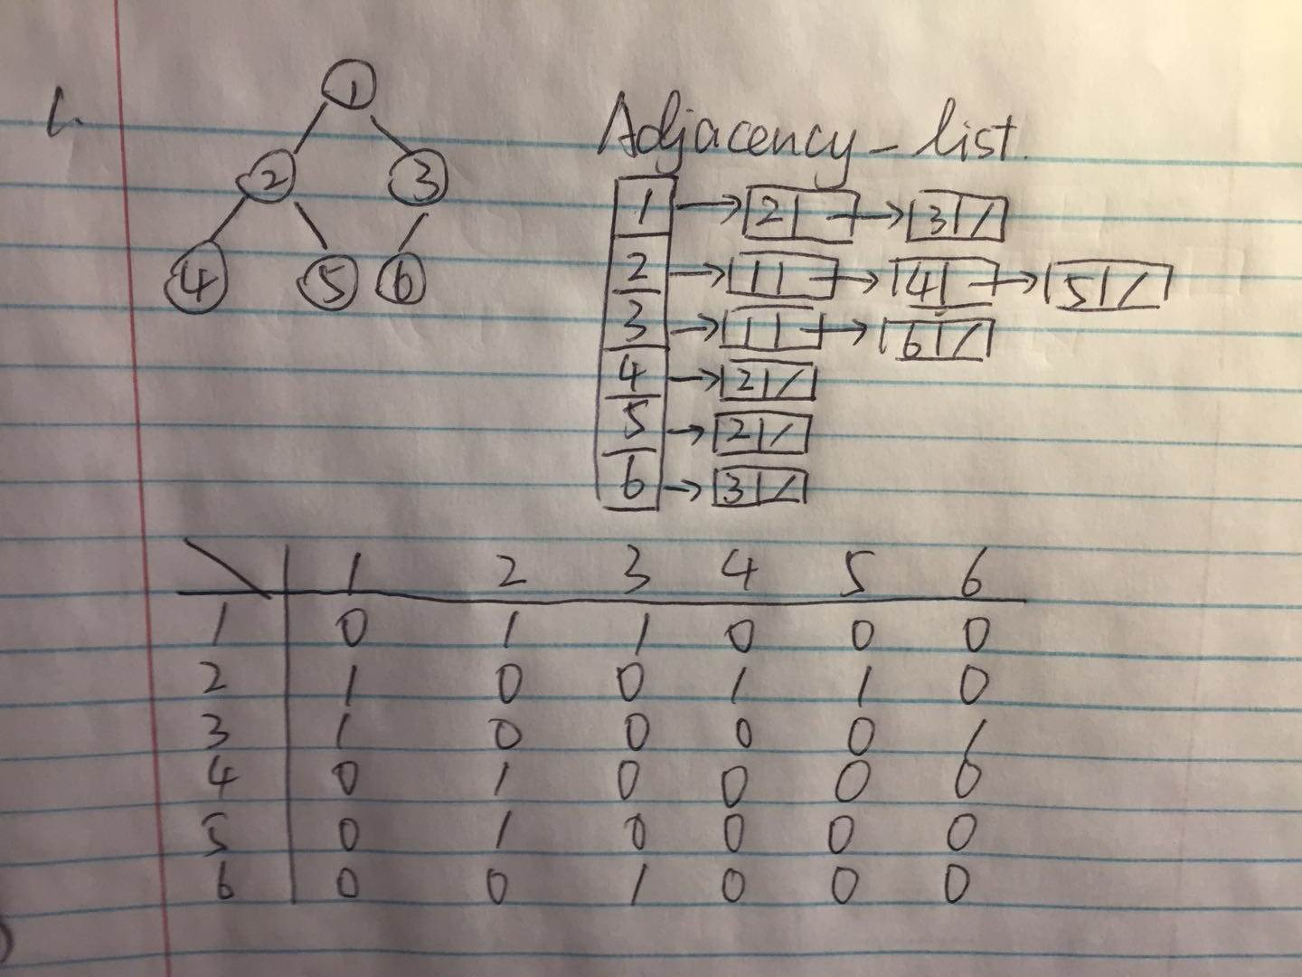

2. Consider the following undirected graph G:

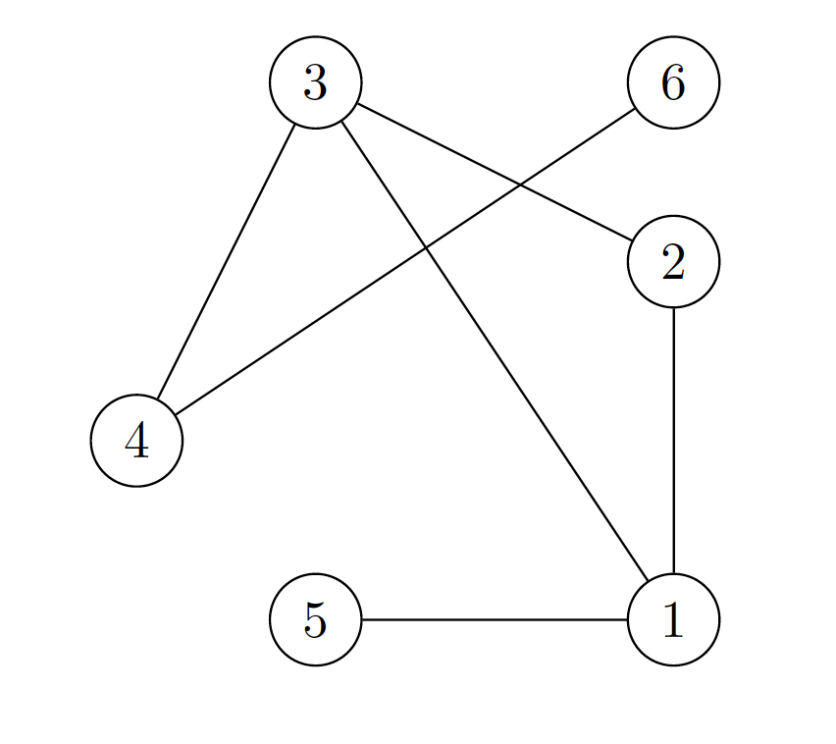
(a) Give the adjacency matrix representation of G.
(b) Give the adjacency list representation of G for every vertex.
(c) Give the search ordering by running the Breadth First Search (BFS) algorithm on G with 3 as the source vertex.
(d) Give the search ordering generated by running the Depth First Search (DFS) algorithm on G with 3 as the source vertex. For each vertex in the DFS tree, please also indicate the start time and the finish time generated by the DFS algorithm.

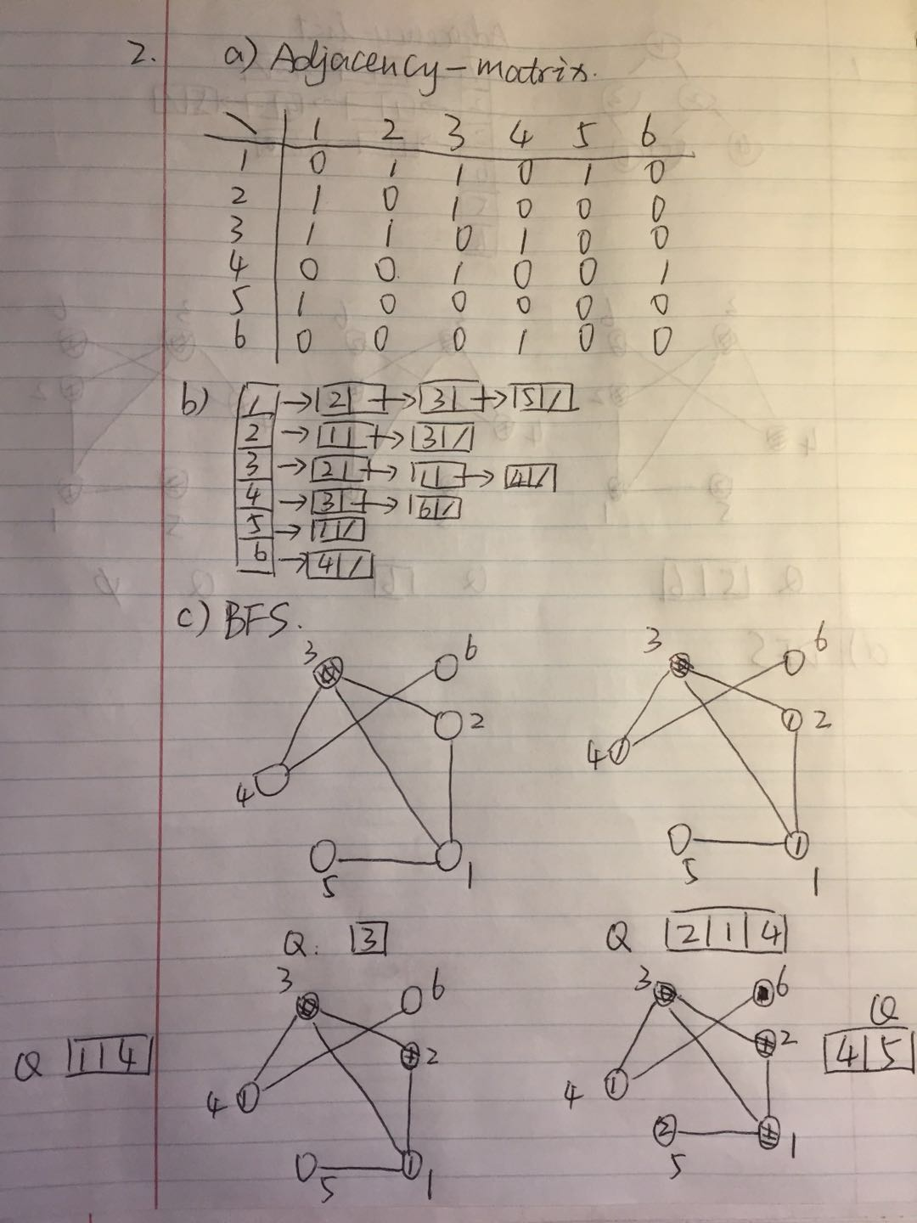

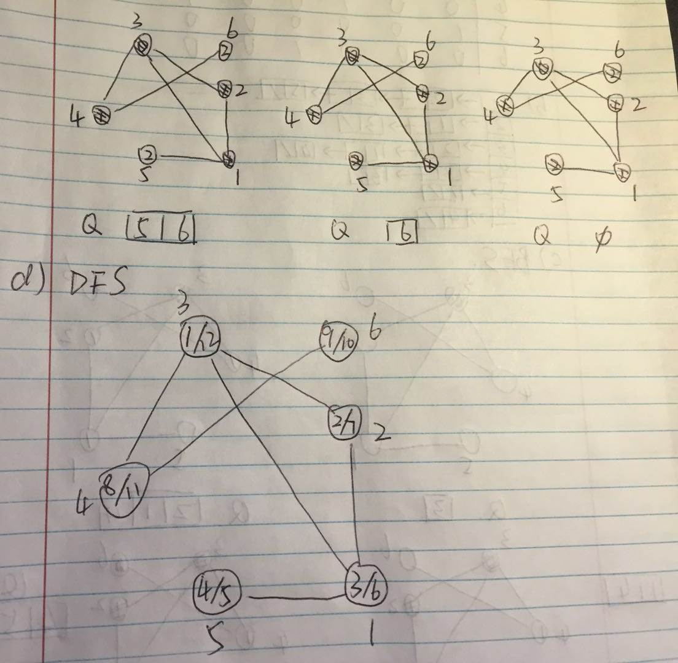

3. Make a 3-by-3 chart with row and column labels WHITE, GRAY, and BLACK. In each cell (i,j), indicate whether, at ANY point during a depth-first search of a directed graph, there can be an edge from a vertex of color i to a vertex of color j . For each possible edge, indicate what edge types it can be (Tree edge, Back edge, Forward edge, or Cross edge). Make a second such chart for depth-first search of an undirected graph.

Directed
i\j | WHITE | GRAY | BLACK
WHITE | TBFC | BC | C
GRAY | TF | TFB | TFC
BLACK | / | B | TFBC

Undireted
i\j | WHITE | GRAY | BLACK
WHITE | TB | TB | /
GRAY | TB | TB | TB
BLACK | / | TB | TB

4. Show the ordering of vertices produced by topological-sort of the following graph (start the DFS at node r):

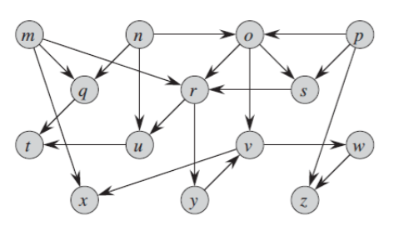
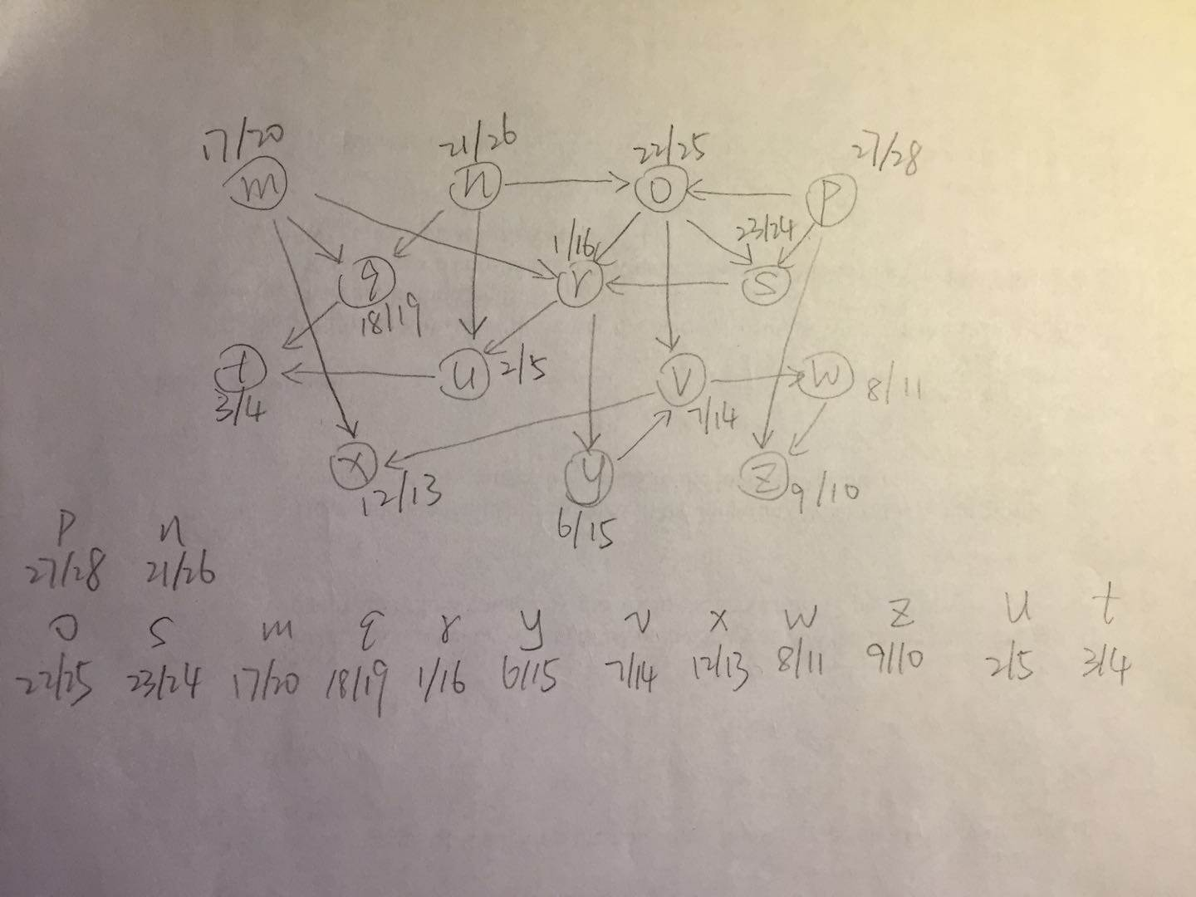
5. Show how the procedure STRONGLY-CONNECTED-COMPONENTS works on the following graph. Specifically, show the finishing times computed in line 1 and the forest produced in line 3. Assume that the loop of lines 5-7 of DFS considers vertices in alphabetical order and that the adjacency lists are in alphabetical order. (from the textbook problem 22.5-2)

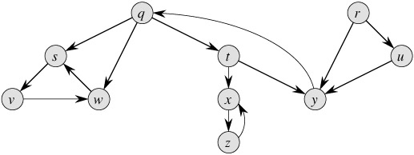
G
 | q | r | s | t | u | v | w | x | y | z
d | 1 | 17 | 2 | 8 | 18 | 3 | 4 | 9 | 13 | 10
f | 16 | 20 | 7 | 15 | 19 | 6 | 5 | 12 | 14 | 11

Transpose G
 | q | r | s | t | u | v | w | x | y | z
d | 5 | 1 | 15 | 7 | 3 | 17 | 16 | 11 | 6 | 12
f | 10 | 2 | 20 | 8 | 4 | 18 | 19 | 14 | 9 | 13

{r} -> {u} -> {q, y, t} -> {x, z} -> {s, w, v}

