CS 3050 Homework # 6. Name : Zhiqian Zhou

Submitted to Blackboard, due at 11:59pm on May 1, 2018.

1. Given a graph G=(V,E) with a minimum spanning tree T of G, add a new edge {u,v} to G. Describe (in words) a method for determining if T is still a minimum spanning tree for G. If not, how to construct a new minimum spanning tree.

Check the path from vertex u to v in the minimum spanning tree T. If all of the edges are smaller than the one that is added, T is still a minimum spanning tree for G. If not, we can remove the max edge in this path and then add the new edge into T to construct a new minimum spanning tree T’.

2. Suppose that a graph G has a minimum spanning tree already computed. Design an efficient algorithm (in pseudo code) to quickly update the minimum spanning tree if we add a new vertex and incident edges (new edges are all connected to the new vertex) to G?

UpdateTree(T, vertex, edges):
If edges.empty()
Return
If edges.size() == 1
T.add(edges)
Else
For e in edges:
T.add(e)
If exist loop in T:
Remove maximum edge in the loop

3. Execute Prim’s minimal spanning tree algorithm on the graph given below using the vertex START as the source.
a. Provide an explanation of this execution for the first three iterations.
b. Show the final minimal spanning tree.

1st: Extractmin: START, update 2 and 10
2nd: Extractmin: 2, update 20 and 8
3rd: Extractmin: 8, update 12

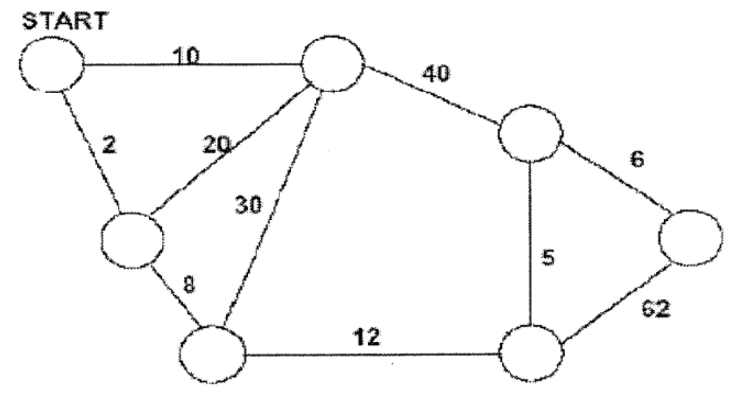

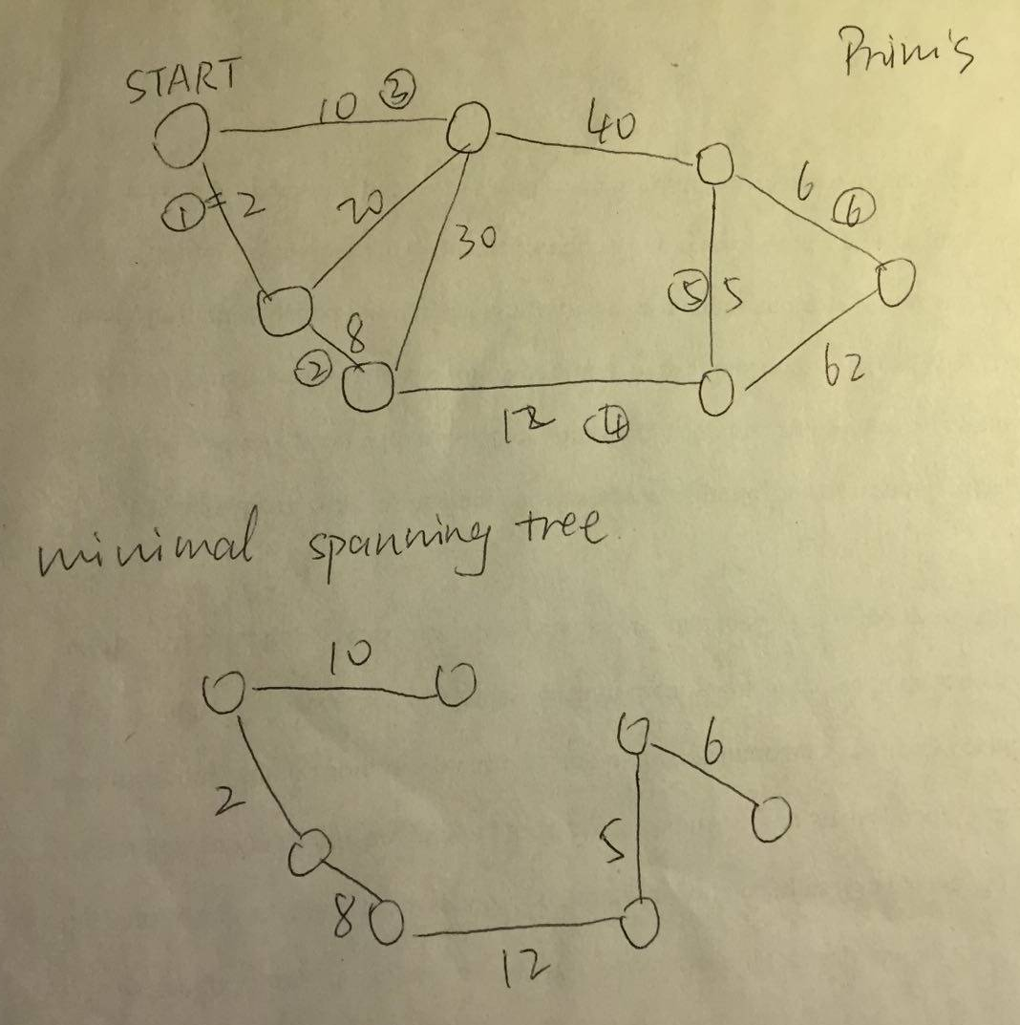
4. Suppose that all edge weights in a graph are integers in the range from 1 to |V|. How fast can you make Kruskal's algorithm run? What if the edge weights are integers in the range from 1 to W for some constant W?

Sort all the edges: O(ElogE)
Union trees E times: O(E * union(V))
Therefore, the time complexity is O(ElogE).
If the weights are in the range from 1 to |V|, using counting sort, the time complexity for sort becomes O(E), then the time complexity for the Kruskal’s algorithm becomes O(E * union(V)).
If the weights are in the range from 1 to W for some constant W, the time complexity is O(ElogE).

5. Write an efficient algorithm in psuedo code to compute a Bottleneck Spanning Tree of an undirected connected weighted graph G = (V, E). Assume that all the edge
weights are distinct. A Bottleneck Spanning Tree T minimizes the weight of the
largest edge among all possible spanning trees of G.

MBST(G):
if G.empty()
return NULL
max = maxEdge(MST(G))
T = forest(G)
for tree in T:
if maxEdge(tree) > max:
T.remove(tree)
return T

