CS 3050 Homework # 1. Name : Zhiqian Zhou

Submitted to Canvas, due at 11:59pm on Feb. 6, 2018.

1. Use Insertion Sort on array A and show the numbers and their position in the Array for each Iteration; also show the “key” position in each iteration.

A = {3,1,4,1,5,9,2,6}

3,1,4,1,5,9,2,6
1,3,4,1,5,9,2,6
1,3,4,1,5,9,2,6
1,3,4,1,5,9,2,6
1,3,4,1,5,9,2,6
1,1,3,4,5,9,2,6
1,1,3,4,5,9,2,6
1,1,3,4,5,9,2,6
1,1,3,4,5,9,2,6
1,1,3,4,5,9,2,6
1,1,3,4,5,9,2,6
1,1,2,3,4,5,9,6
1,1,2,3,4,5,9,6
1,1,2,3,4,5,6,9

2. Use Bubble Sort on the following letters to sort it alphabetically and give each outer step with i and j.

{S T R A I G H T}

// bubble.c
#include <stdlib.h>
#include <stdio.h>
#include <string.h>

void swap(char* a,char* b){
char tmp = *a;
*a = *b;
*b = tmp;
}

int main(){

char array[] = "STRAIGHT\0";
printf("%s\n",array);
int length = strlen(array);
int i, j;

for(i = 1; i < length; ++i){
printf("i = %d\n",i);
for(j = 1; j < length; ++j){
if(array[j] < array[j-1])
swap(&array[j],&array[j-1]);
printf("j = %d ",j);
printf("%s\n",array);
}
}

return 0;

}

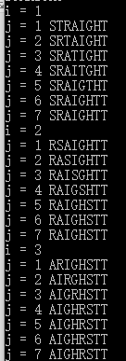

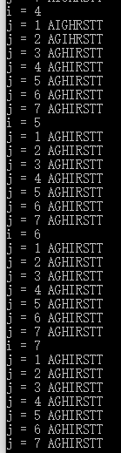

3. What is the number of basic steps executed by the following method (as a function of n)? What is the big-O of the method?

Public int howLongA(int n) {
int k = 0, kk = 0;
for(int i = 0; i < n/2 ; i++) { basic steps: n*n/4
k++; O(n^2)
for(int j = 0; j < n/2; j++)
kk++;
}
return k*kk;
}

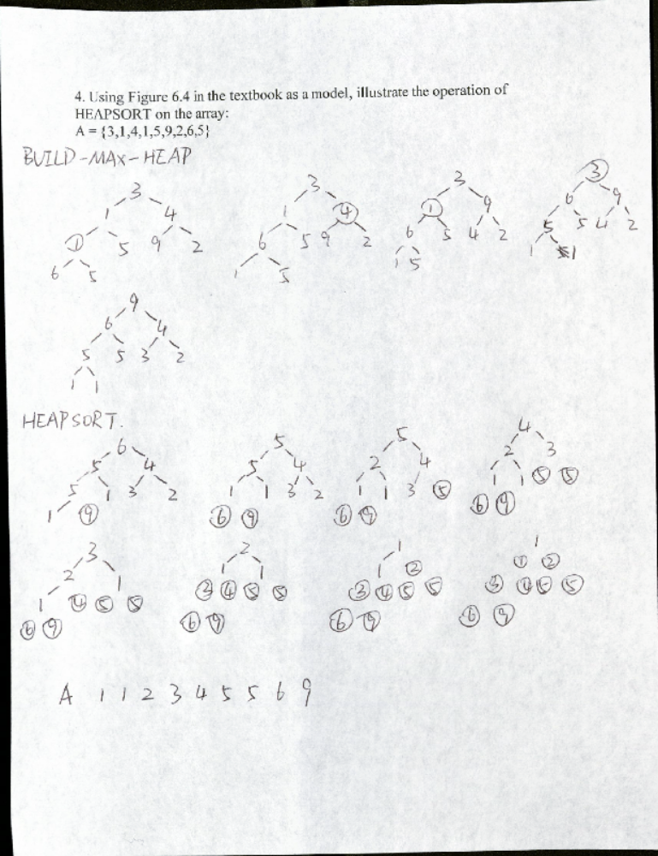

5. Analysis of tertiary heaps: A ternary heap is like a binary heap, non-leaf
nodes have 3 children instead of 2 children.
a. How would you represent a ternary heap in an array?
b. What is the height of a ternary heap of n elements in terms of n?
c. Give an efficient implementation (in pseudo code) of EXTRACT-MAX in a tertiary max-heap. Analyze its running time in terms of n.
d. Give an efficient implementation (in pseudo code) of INSERT in a ternary max-heap. Analyze its running time in terms of n.
e. Give an efficient implementation (in pseudo code) of INCREASE-KEY(A,i,k), which flags an error if k < A[i], but otherwise sets A[i] = k and then updates the ternary maxheap structure appropriately. Analyze its running time in terms of n.

- Node = Heap[i], Parent = Heap[floor((i-1)/3)], LeftChild = Heap[3i+1], MidChild = Heap[3i+2], RightChild = Heap[3i+3]
- Height: ceil(log3(2n+3))
- Max-Heapify(A,i)
l = LEFT(i)
m = MID(i)
r = RIGHT(i)
if l < A.heap-size and A[l] > A[i]
largest = l
if m < A.heap-size and A[m] > A[largest]
largest = m
if r < A.heap-size and A[r] > A[largest]
largest = r
if largest != i
exchange A[i] with largest
Max-Heapify(A,largest);

EXTRACT-MAX(A)
if A.heap-size < 1
error “heap underflow”
max = A[0]
A[0] = A[A.heap-size - 1]
A.heap-size = A.heap-size - 1
Max-Heapify(A,1)
return max

- HEAP-UP(A,i)
if i == 0
return
parent = PARENT(i)
if A[parent] < A[i]
exchange A[parent] with A[i]
HEAP-UP(A,parent)

INSERT(A,key)
A.heap-size = A.heap-size + 1
A[A.heap-size-1] = key
HEAP-UP(A,A.heap-size-1)

- INCREASE-KEY(A,i,k)
if k < A[i]
error “new key is smaller than current key”
A[i] = k
HEAP-UP(A,i)

