CS 3050 Homework # 4. Name : Zhiqian Zhou

Submitted to Blackboard, due at 11:59pm on March 20, 2018.

1. For the following Trees, tell whether they are valid Red and Black trees or not. If not, point out which property the tree violates. The nil leaves are not drawn for convenience. (Please note that a node with double circles indicates black, and a node with single circle indicates red)

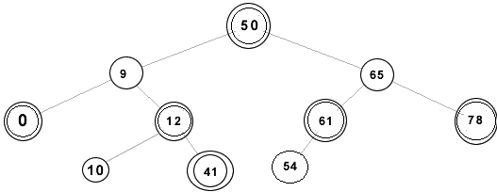
(i)

No. For node 12, 9 and 50, the black-height is not equal in all paths.

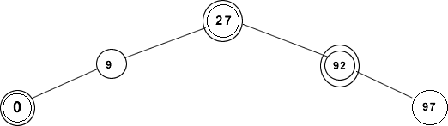
(ii).

No. For node 9 and 27, the black-height is not equal in all paths.

(iii).
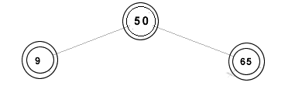

Yes.

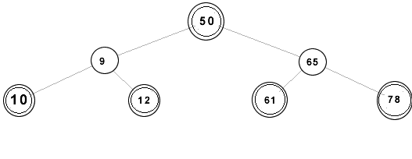
(iv).

No. 10 is greater than 9. Thus, node 10 should not be the left child of node 9.

2. Write pseudocode for RIGHT-ROTATE by modifying the algorithm in Figure 13.3 of the textbook.

RIGHT-ROTATE(T,x)
y = x.left
x.left = y.right
if y.right != T.nil
y.right.p = x
y.p = x.p
if x.p == T.nil
T.root = y
elseif x == x.p.left
x.p.left = y
else
x.p.right = y
y.right = x
x.p = y

3. Draw the red-black trees that result after successively inserting the keys P, S, E, U, D, O, C into an initially empty red-black tree. The order of letters are alphabetical. You may use filled circles to indicate black and unfilled circles to indicate red.

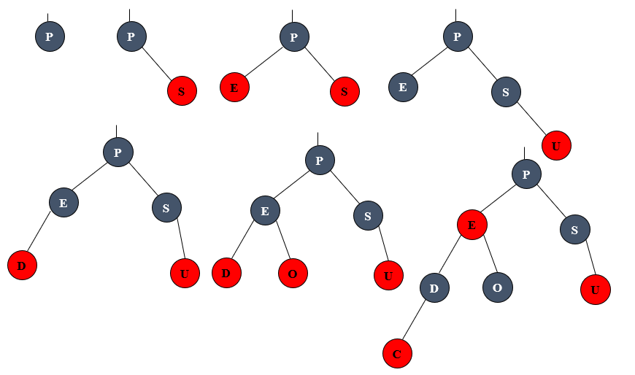

4. For the following order-statistics tree T, (1) show how OS-SELECT (T, 9) operates; (2) show how OS-RANK(T, 35) operates.

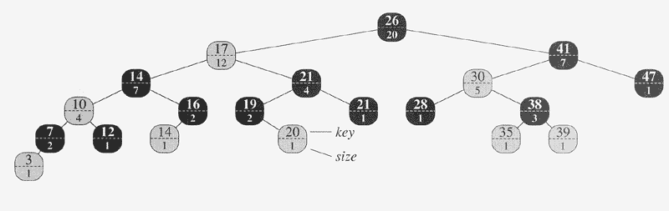

(1)
Node 26: r = 13, i = 9
Node 17: r = 8, i = 9
Node 21: r = 5, i = 1
Node 19: r = 1, i = 1
Return 19

(2)
Node 35: r = 1
Node 38: r = 1
Node 30: r = 1+1+1=3
Node 41: r = 3
Node 26: r = 3+12+1=16
Return 16

5. Given an interval tree T and an interval i , describe how to list all intervals in T that overlap i efficiently using pseudo code. [Hint: There are multiple ways to solve it. One way is to check both right and left subtrees from the root iteratively.]

AllOverlap(T,i)
x = T->root
while !stack.empty() && x != NULL
while x != NULL
stack.push_back(x)
x = x->left
if !stack.empty()
x = stack.top()
stack.pop();
if overlap(i,x->interval)
result.push_back(x)
x = x->right
return result

