CS 3050 Programming Assignment # 2. Name :

Submitted to Blackboard, due at 11:59pm on April 10, 2018.

In this assignment, you will develop a C program to construct a red and black tree. For a given input sequence the tree is unique by using RB-INSERT on one number at a time. Below is an example:
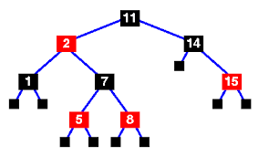

The input is a sequence of numbers separated by comma, e.g. 1,8,11,2, … You can enter the numbers using an input file and output the tree, or through a command line with one number at a time (with “X” to stop entering and printing the output). The output should be the following to reflect the above tree (i.e., listing nodes from top to bottom, and from left to right, with B and R indicating the black and red colors):

11-B; 2-R; 14-B; 1-B; 7-B; 15-R; 5-R; 8-R

• Your program should compile using gcc on a unix/lunix machine. Using a makefile is encouraged but not required. You can also provide a readme file if needed.

• Although not encouraged, you may use g++ for a C++ code. Provide a readme file if you use C++ to explain how to compile and run the program. No other programming language will be accepted.

