Zhiqian Zhou

Question 1

a)

Using the library function in matlab.

mean

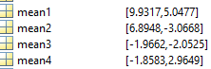

covariance

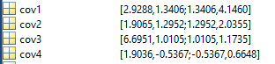

Calculating covariance by hand.

Using the formula Cov(X,Y) = E((X-μ)(Y-v)) directly.

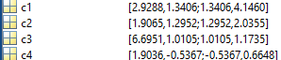

Using the formula E((X-μ)(Y-v)) = E(XY)-μv to simplify the process.

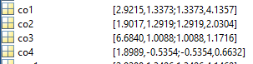

The result is different.

In the first case, the formula uses unbiased estimator. Its denominator is n-1 instead of n. In the second case, since it’s calculate the mean to gain the covariance, its denominator is n.

I believe that if I implement the process in another language, the result can be different as different precision might be reserved in different language.

b)

using function [value,vector] = eigen(class) at line 116 in cov.m

eigenvalue

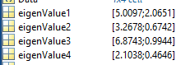

eigenvector

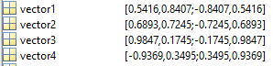

c)

