Zhiqian Zhou Student Number: # 14303902

HW2

**Question 1**

a)

Sample x1, x2 are included in x in the form of [x1;x2], x is a 2*d matrix.

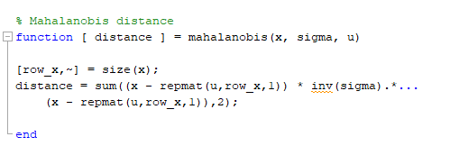

b)

Using the function above, the ‘discriFunction’ Function calculate the value of discriminate function.

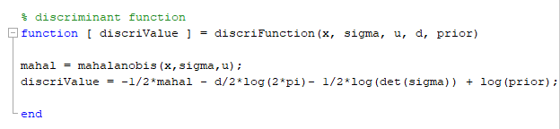

c)

Compute mean and covariance.

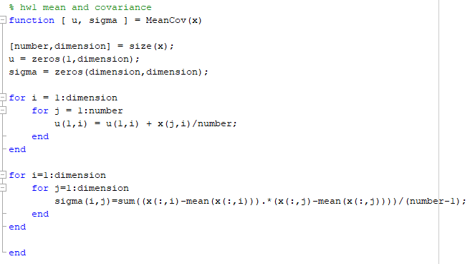

Calculate the value of discriminate function using the function above, the result is listed below.

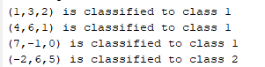

**Question 2**

a), b)

Generates the (say,1000) samples.

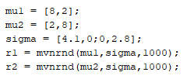

Calculate the scope using the mean and variance.

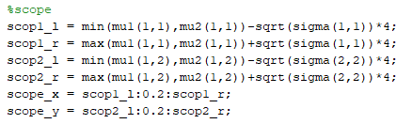

Derive the decision boundary.

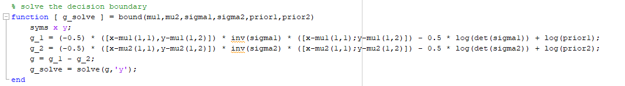

Plot the boundary on top of the generated samples.

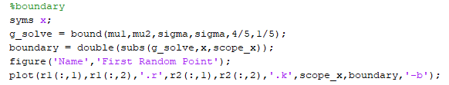

Boundary for the first distribution.

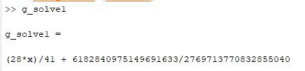

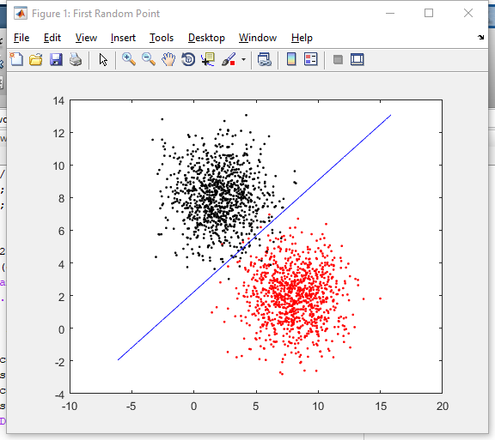

Plot the two classes in 3D.

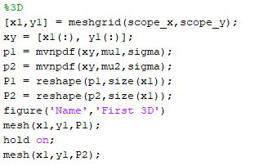

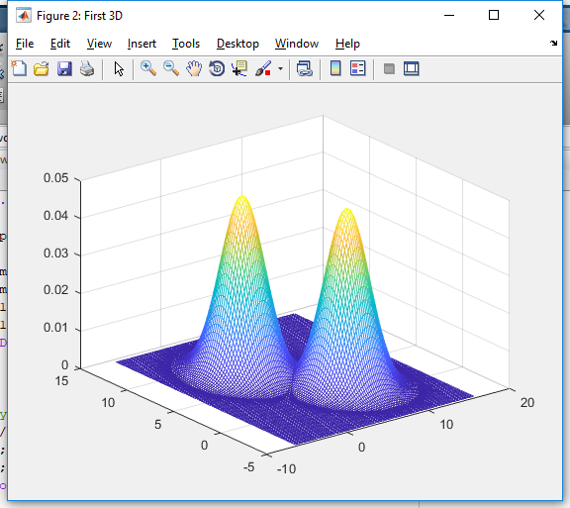

c)

Plot the posterior probabilities. Using the total probability formula to calculate the evidence P(x) and the Bayes Formula to calculate the posterior probability. P(w1) = 4/5, P(w2) = 1/5.

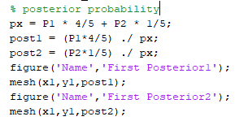

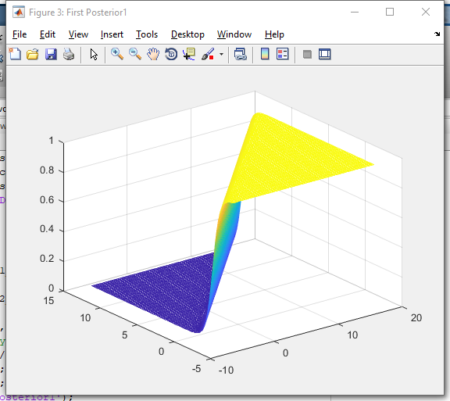

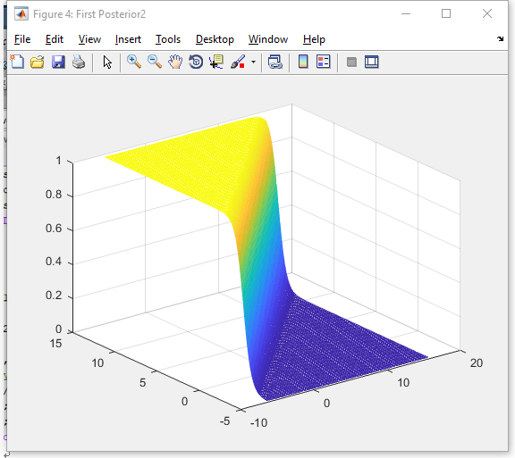

Code are nearly the same for the rest of them.

Therefore, only figure will be showed below.

d)

boundary for the second distribution

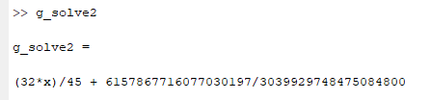

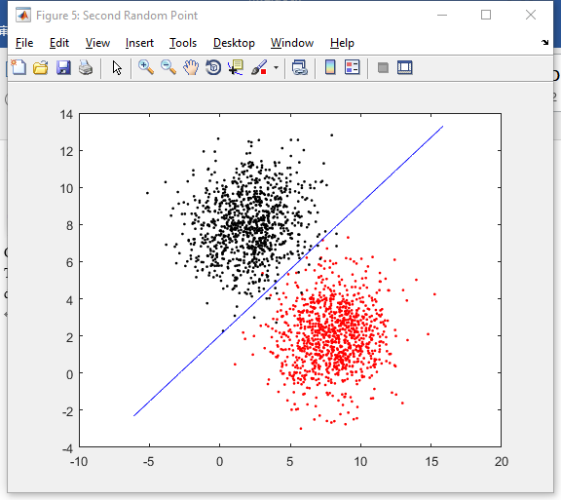

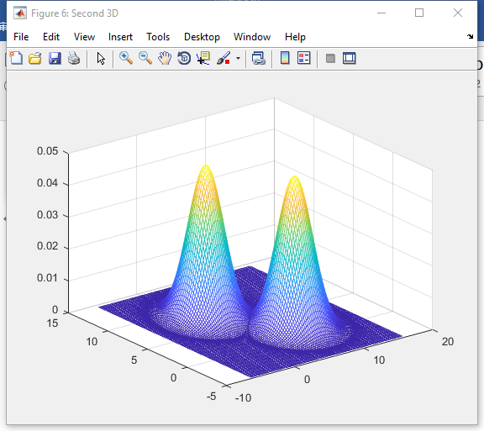

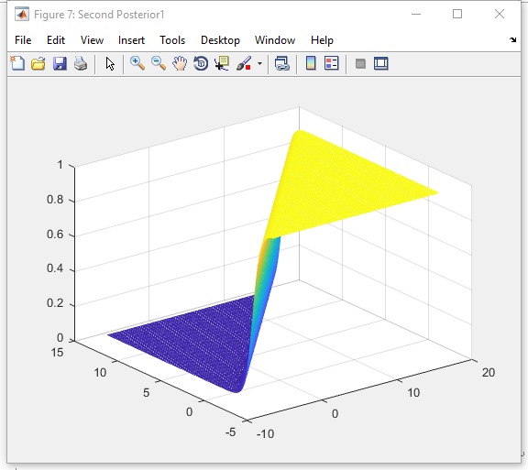

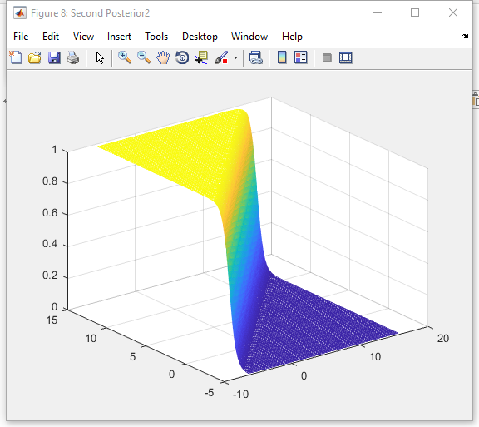

e)

For this graph, there is two boundaries, but one of them is two far away to plot in this graph.

Boundary for the third distribution

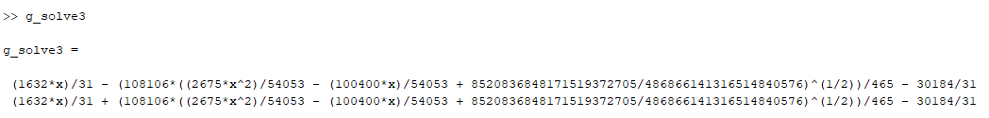

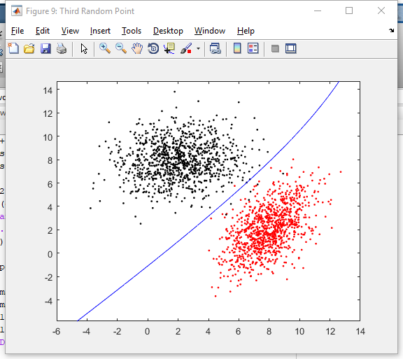

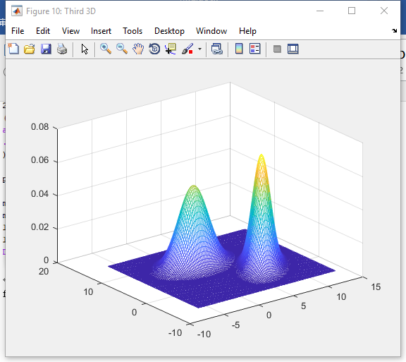

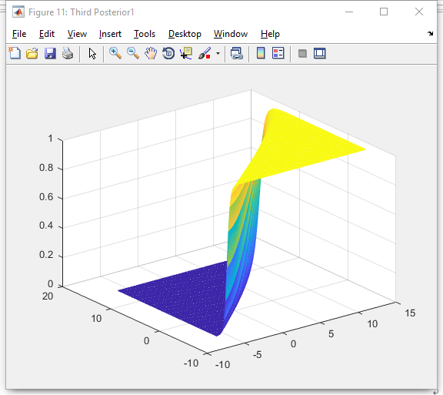

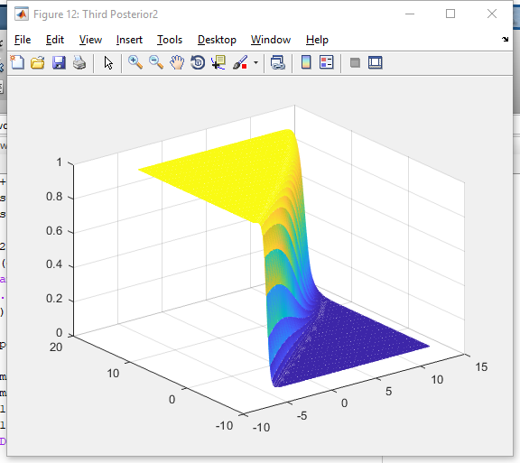

f)

The second boundary line cannot show either.

Boundary for the fourth distribution



