Zhiqian Zhou

Hw3 Question 2

Scan input and transform the text to the corresponding feature and number. Calculate the joint pdf.

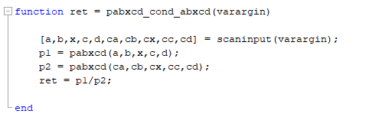

Calculate the possibility for Question2.

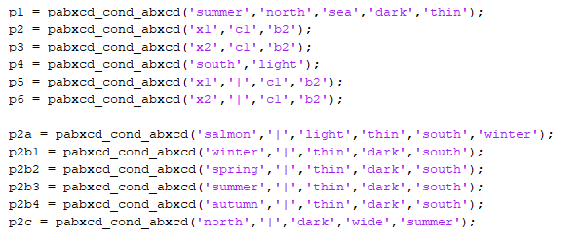

The result was shown below.

