Zhiqian Zhou

Hw4 Question 1

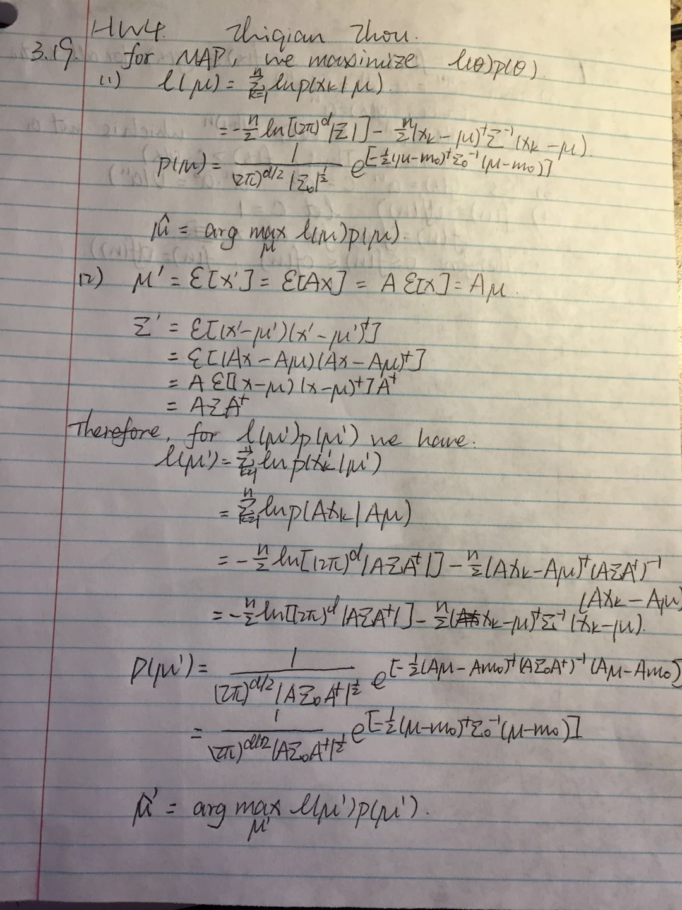

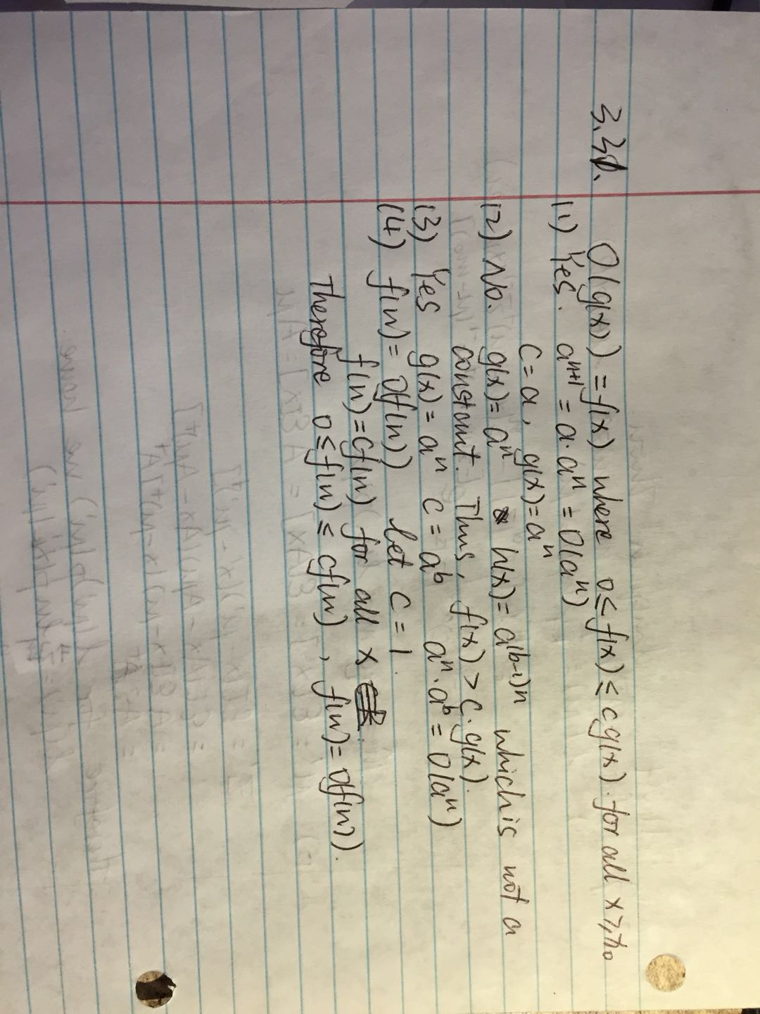

Question 2

1. Maximum-likelihood values mu and sigma

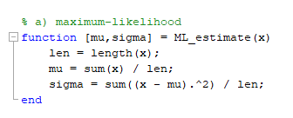

Three features xi of category w1

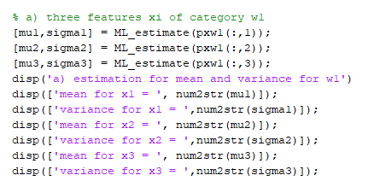

Result:

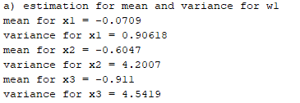

b/c) Multi-dimension estimation

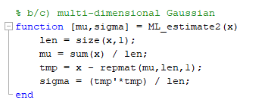

1. Two-dimension

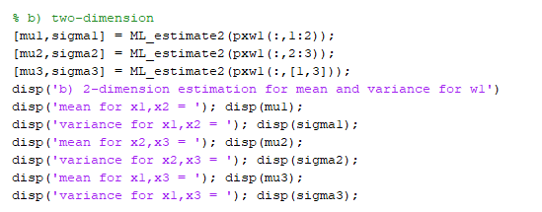

Result:

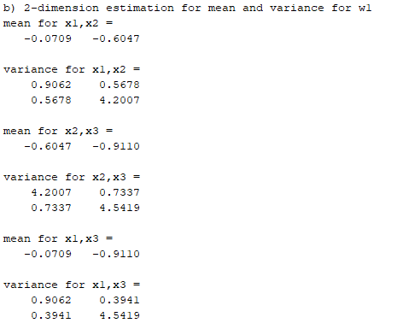

1. Three-dimension

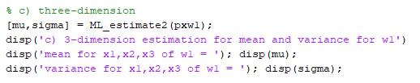

Result:

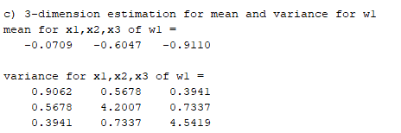

1. Diagonal of the covariance

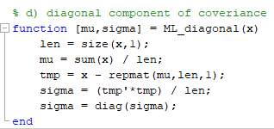

Result:

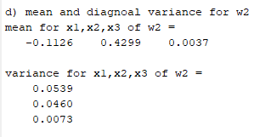

e/f) compare the mean and variance calculated in above ways.

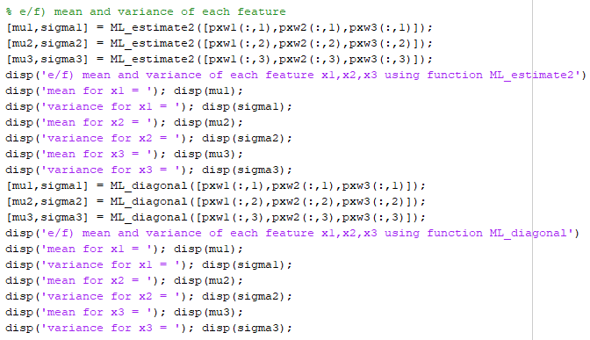

Result:

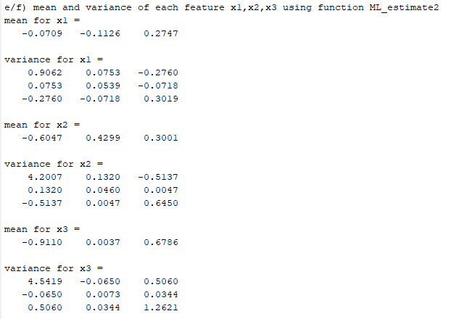

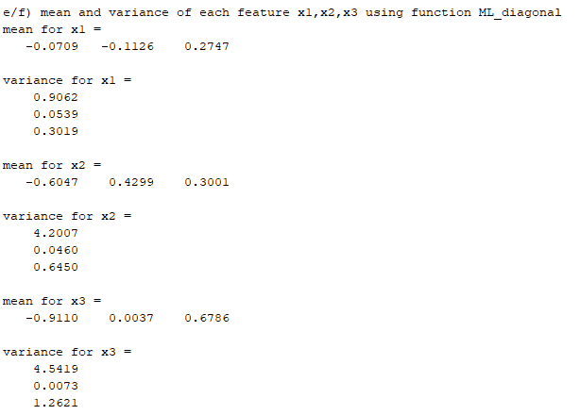

Conclusion:

The value of estimation of mean and covariance are the same.

For the mean, using the maximum-likelihood estimation, the estimated mean is the sample mean. Therefore, it doesn’t matter the variance is diagonal matrix or not.

As for the variance, the diagonal one is actually the diagonal value of the covariance matrix in the former function. They are calculated by the same way and thus they are the same.