Zhiqian Zhou

HW5 Question 1

Load Data

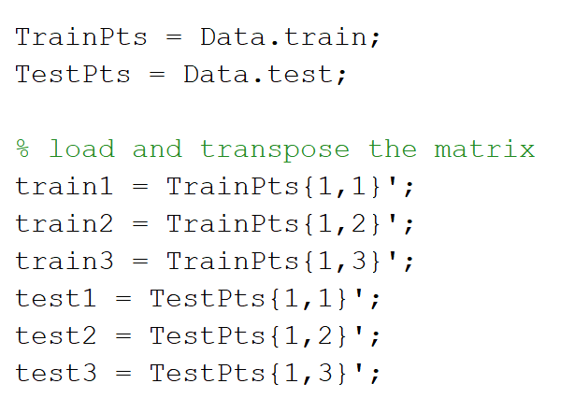

a) Maximum Likelihood Estimates

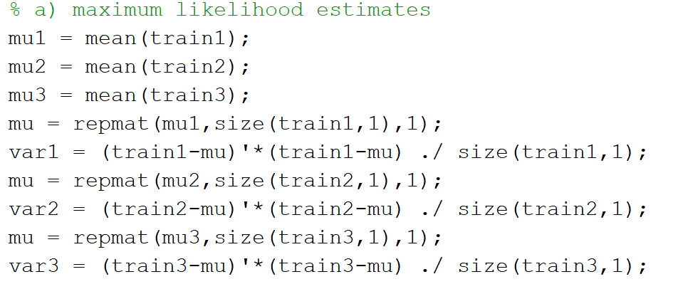

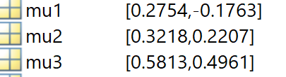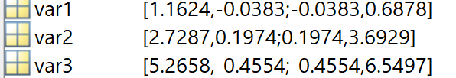

b) HW2 Question 1

Write function to compute the Mahalanobis distance, and another function to call the function above and compute the discrimination function with the following generic form.



For the return value of classify function, the row of gx represent the gi(x) value for each x, and the column of gx represent its value of discrimination function for different class.

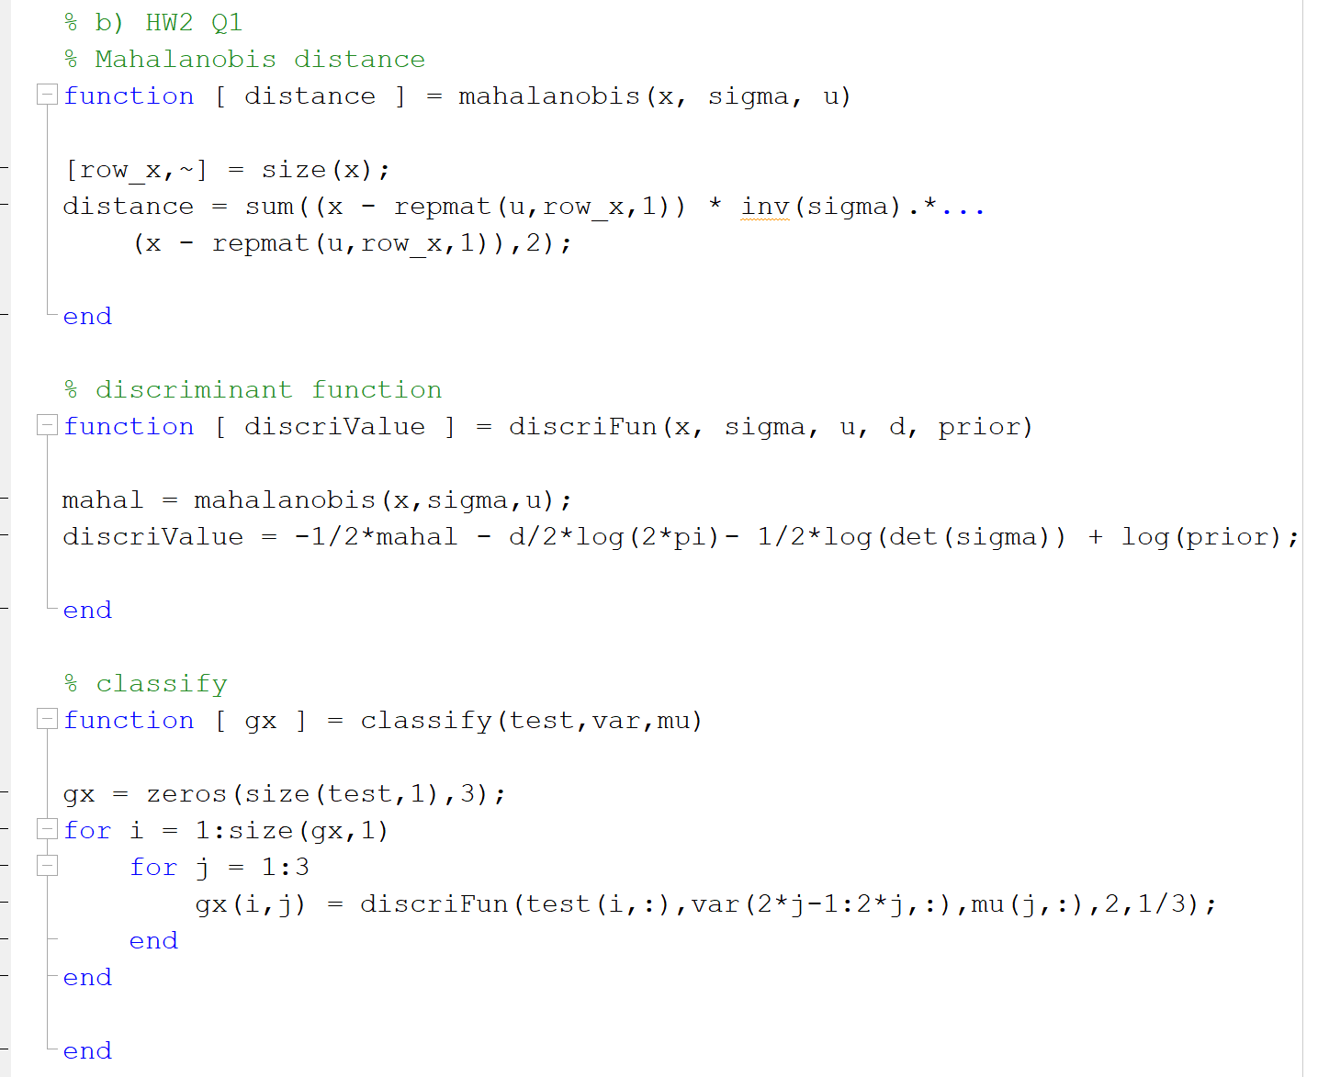

c) Classify the test data

The variables, index1, index2, index3, represent which class the data was classified into.

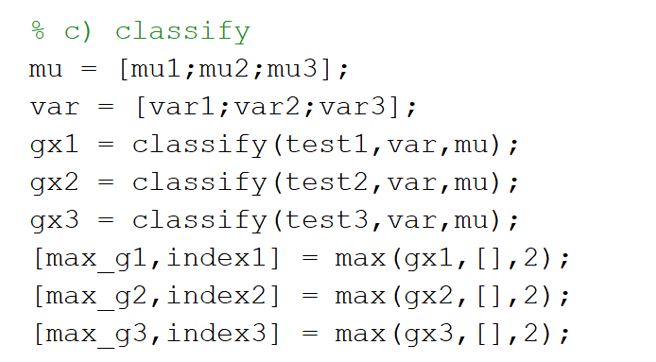

Compute confusion matrix, each column is actual value and each row is estimate value.

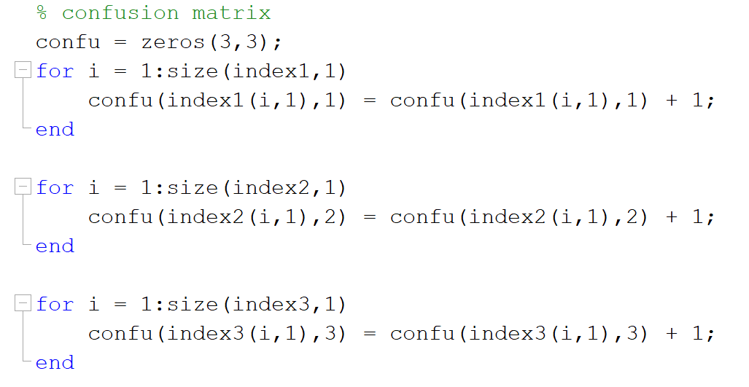

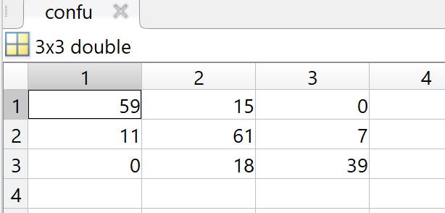

d) Bayesian estimates

Transform data into the polar coordinates and scatter the data.

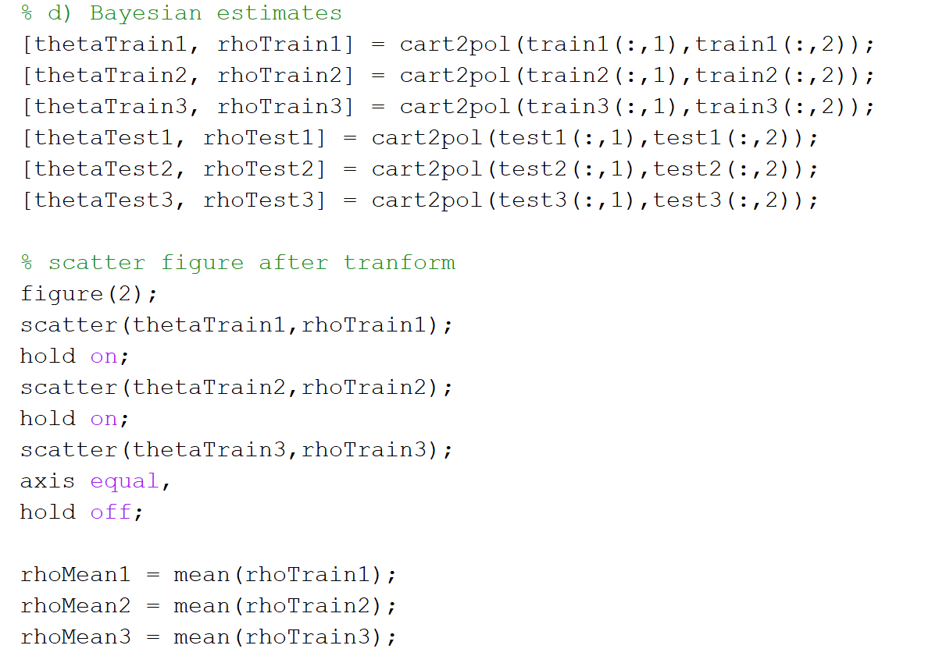

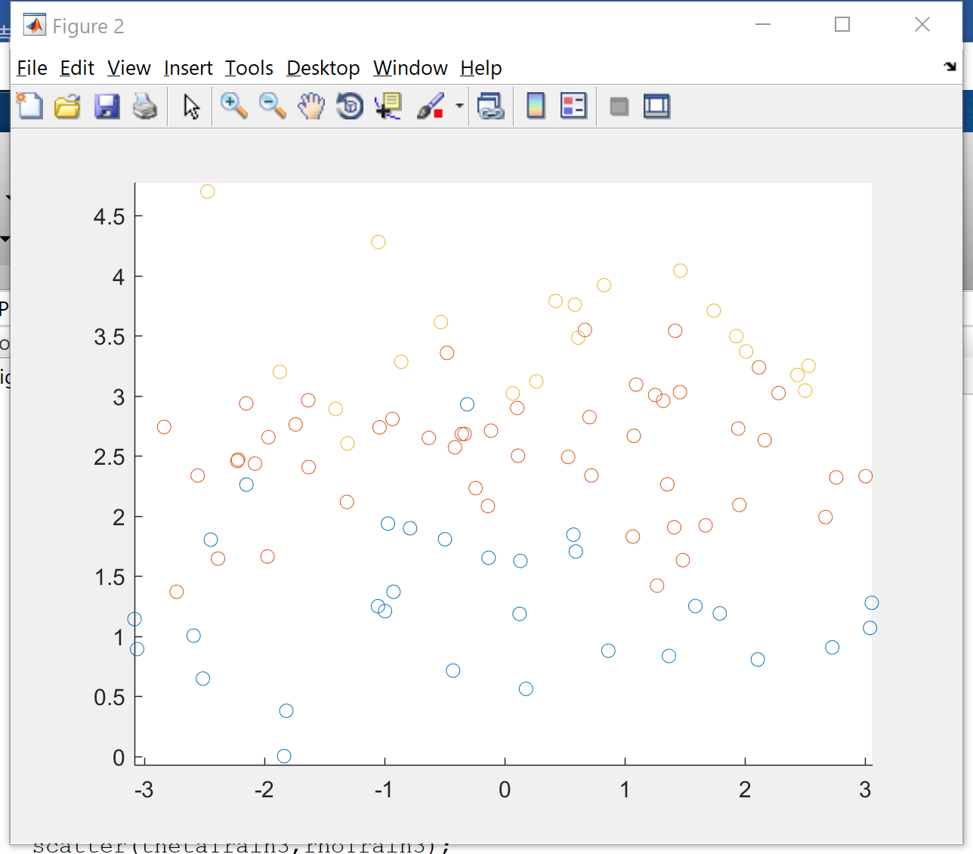

Ignore the θand classify based only on r.

Calculate the θand σ.

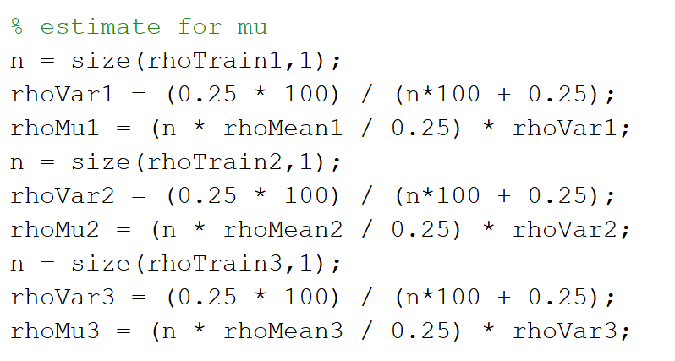

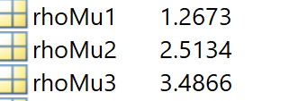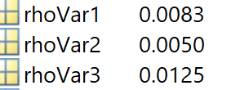

The posterior distribution.

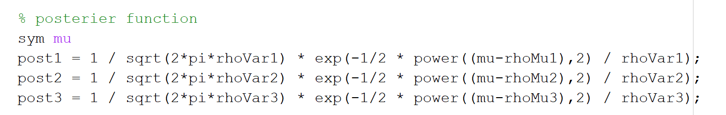

Compute density estimate to classify.

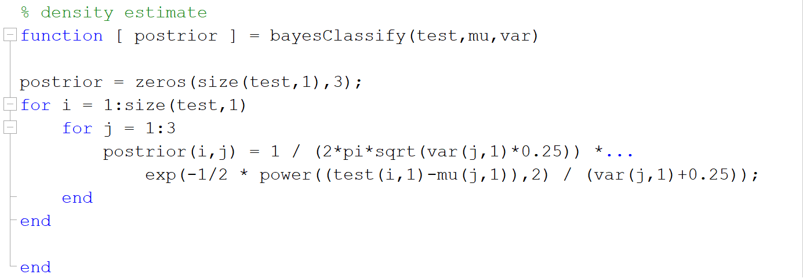

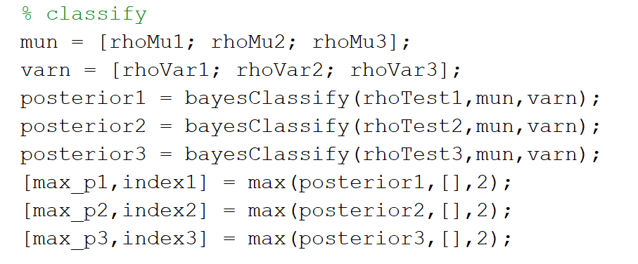

Confusion Matrix, also actual for column and estimate for row.

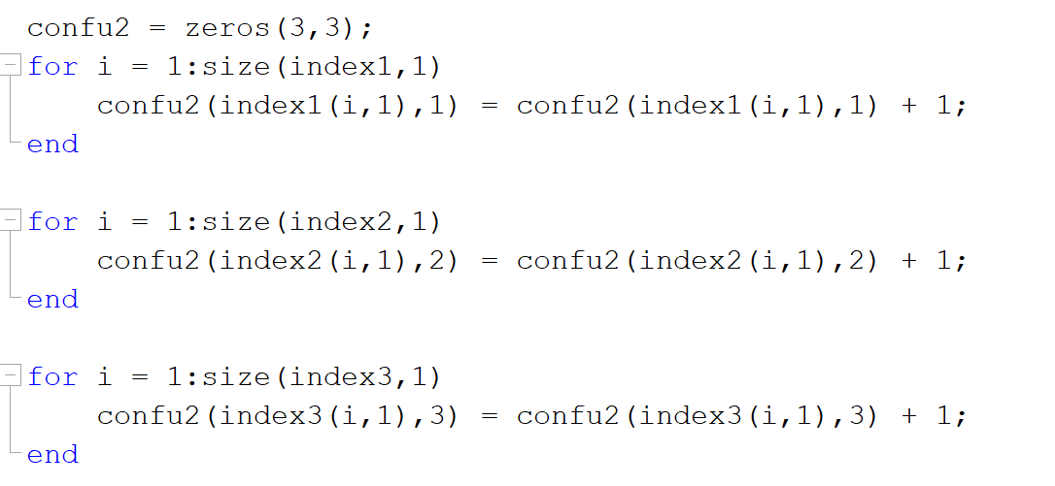

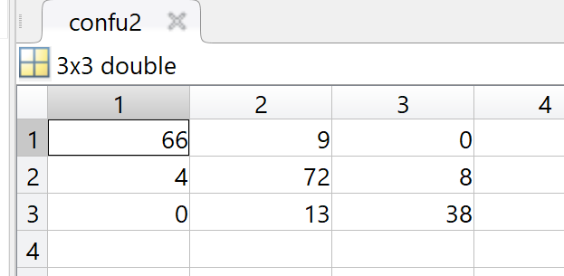

Compute and Compare the error rate of two methods

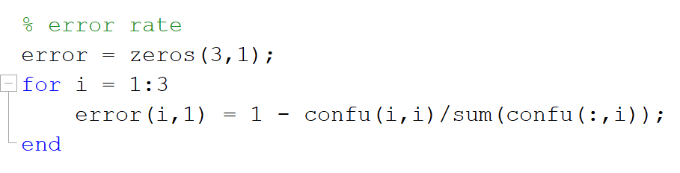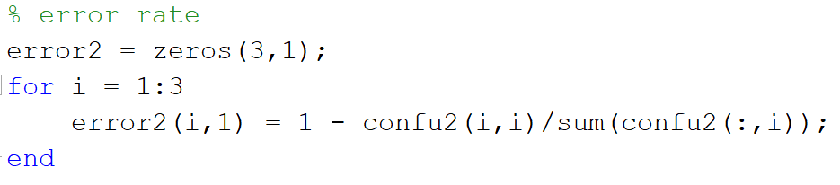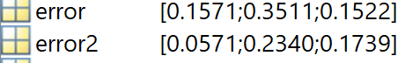

From the result above, we can see that the error rate after transformation is relatively lower than the likelihood estimates before the transformation. Besides, after the transformation, the problem becomes a 1-D classification problem. Therefore, proper transformation can both simplify the question and improve the accuracy.

We can see how importance it is to transform and select data in this case. It’s very important for us to learn knowledge from simple cases and then apply them to the problems in reality in the future.