Zefeng Shen

August 8, 2020

IT FDN 110A

Assignment05

<https://github.com/zzsocool/python-class>

Modify other people’s script

**Introduction:**

In this week, I learned how list and dictionary work in python, how to use and convert the data between list and dictionary. I used these knowledges to modify an existing template. I also got familiar with Github created my first Github account and upload my script on it. I can use it to edit my script anywhere I would like to.

**List:**

A list is a data type that allows you to store various types data in it. List is a compound data type which means you can have different-2 data types under a list, for example we can have integer, float and string items in a same list.

(Begginnersbook, <https://beginnersbook.com/2018/02/python-list/>) (External website)

I can add elements into the list by using list.append(). Or I can delete elements from the list by using list.pop().

**Dictionary:**

Creating a dictionary is as simple as placing items inside curly braces {} separated by commas.

An item has a key and a corresponding value that is expressed as a pair (**key: value**).

While the values can be of any data type and can repeat, keys must be of immutable type ([string](https://www.programiz.com/python-programming/string), [number](https://www.programiz.com/python-programming/numbers) or [tuple](https://www.programiz.com/python-programming/tuple) with immutable elements) and must be unique.

(Programiz, <https://www.programiz.com/python-programming/dictionary>) (External website)

I can add elements into the dictionary by using dic.append(). Or I can delete elements from the dictionary by using dic.pop().

**Separation of concerns :**

The most important principle in Software Engineering is the [Separation of Concerns](http://en.wikipedia.org/wiki/Separation_of_concerns) (SoC): The idea that a software system must be decomposed into parts that overlap in functionality as little as possible. It is so central that it appears in many different forms in the evolution of all methodologies, programming languages and best practices.

(Effectivesoftwarewdesign, <https://effectivesoftwaredesign.com/2012/02/05/separation-of-concerns/>) (External website)

**Modify Script :**

For this assignment, I need to modify an existing template. First, I read through the entire code and try to get basic idea about what the script will be used for. The script already created an outline, so I need to fill out how to handle the data. I read the data section and what variables were created. I also added extra variables as shown in figure 1.

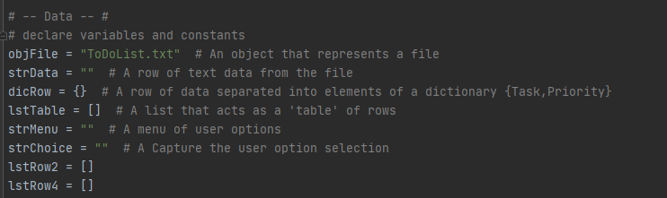

**Figure 1:** New variables and old variables

In the processing section, the requirement was load any data you have in a text file called ToDolist.txt into a python list of dictionaries row. So I used open() with ‘a’ to create a file and follow with open()with ‘r’ to read any data in the file as shown in figure 2.



**Figure 2:** Create and read file

For any data loaded from the file, I split row of data into columns separated by comma. Then I used for loop to extract the data into dictionary and list. I used .append() to add data into each row. I used the dictionaries rows to display for the users and list rows to save into the file,

In the input and output section, first I need to display the current data. I used for loop to display the data in a python list of dictionaries rows to users as shown in figure 3.

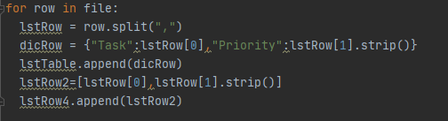

**Figure 3**: Load the data from file.

In step 3, I used a for loop to display the current data in the file.

In step 4, I need add user’s input to list. I passed user’s input into both dictionary rows and list rows at same time. I used .append() to add data at the bottom of the list and dictionary as shown in figure 4.

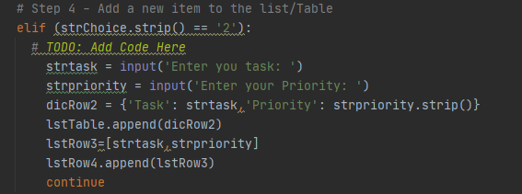

**Figure 4**: Add a new item.

In step 5, I need removed a new item from the list. I let user to choose which row of data user wants to be removed. Since python list index start with 0 as the first row, I used user’s input subtract one to match the python list index. I used pop() to remove the row from both list and dictionary as shown in figure  5.

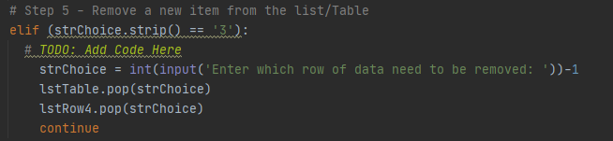

**Figure 5:** remove one item.

In step 6, I need to save the tasks to the file. I used open() with ‘w’ mode to erase all the data was saved in file before. I used the for loop with .write() to pass in the updated data from the list into the file as shown in figure 6.

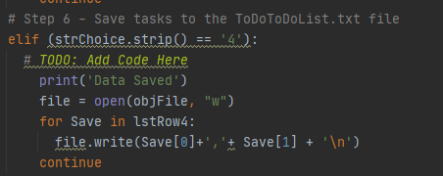

**Figure 6**: Save data.

In step 7, I need to exit the program. I used print() to indicate the user file closed and .close() to close the file as shown in figure 7.

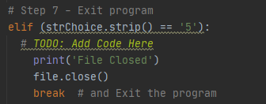

**Figure 7**: Exit the program.

Here is the result of running my script as shown in figure 8.

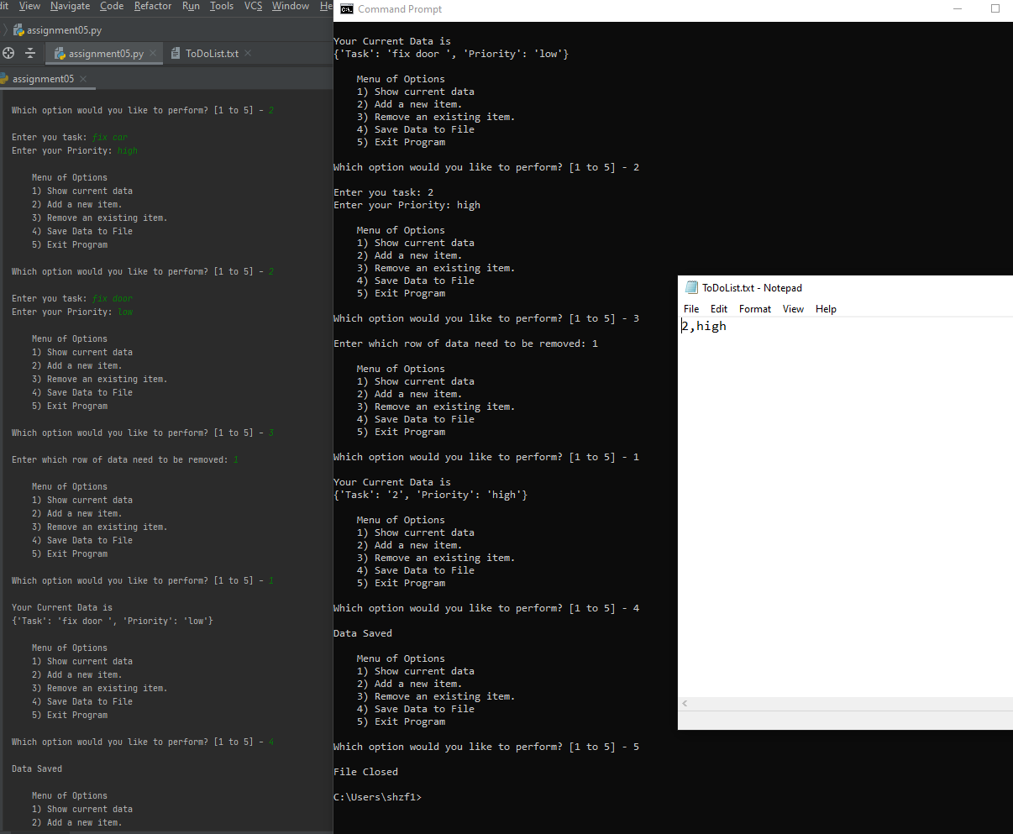

**Figure 8:** Final result.

**Github:**

GitHub is a code hosting platform for version control and collaboration. It lets you and others work together on projects from anywhere.

This tutorial teaches you GitHub essentials like *repositories*, *branches*, *commits*, and *Pull Requests*. You’ll create your own Hello World repository and learn GitHub’s Pull Request workflow, a popular way to create and review code.

(Github, <https://guides.github.com/activities/hello-world/>) (external website)

I created an account and loaded the code on the Github by the website address <https://github.com/zzsocool/python-class>.

**Summary:**

Before editing other people script, understanding the intention of the script and the variable are important, but it will take some time to pick up. Github is a powerful website for programmers. I can share my code and learn from others. Once I upload the script, I can download at anywhere from their server to continue my work. I will explore more about it.