WTP Adaptor for Jetty 7.x/8.x

Sommaire
1.WTP Adaptor for Jetty 7.x/Jetty 8.x 2
2.Create Jetty server 3

WTP Adaptor for Jetty 7.x/Jetty 8.x
This documentation explain how use WTP Adaptor for jetty 7.x/Jetty 8.x to start/stop WTP Dynamic Web Project(or external WEB application) with Jetty by using Eclipse WTP. Eclipse JEE Helios is required (don't works with Eclipse JEE Galileo). Those Jetty WTP Adaptor are developed by copying/pasting WTP Adaptor for Tomcat (so code is very , very uggly!!!) . It is managed with 2 Plug-Ins :

- org.eclipse.jst.server.jetty.core :
- org.eclipse.jst.server.jetty.ui :

You can find this documentation and thoses 2 Plug-In at SVN at https://dynaresume.googlecode.com/svn/trunk/org.eclipse.jst.server.jetty

Create Jetty server
To create a WTP Jetty/Server, go at File/New/Other... and select Server node :

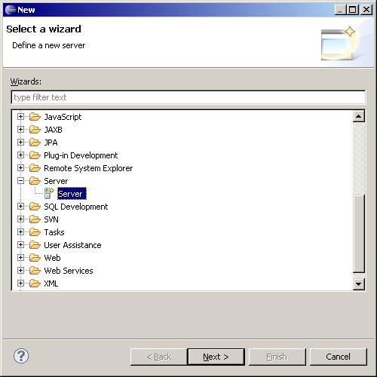

Click on Next button. You can use Jetty7x or Jetty 8x. In this documentation we will use Jetty 7.0 Server :

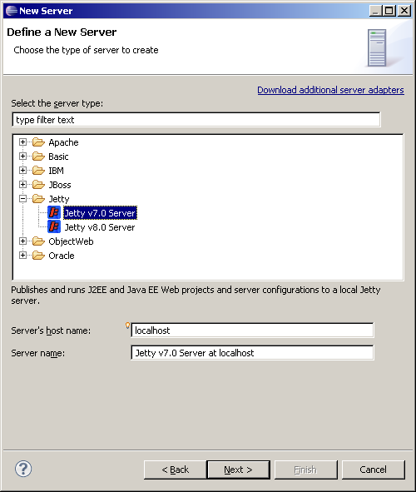

Click on Next button, now you must specify the installation directory for Jetty. Use Browse button to do that OR click on Download and Install... button to download the Jetty v7. In this documentation, we will do that. :

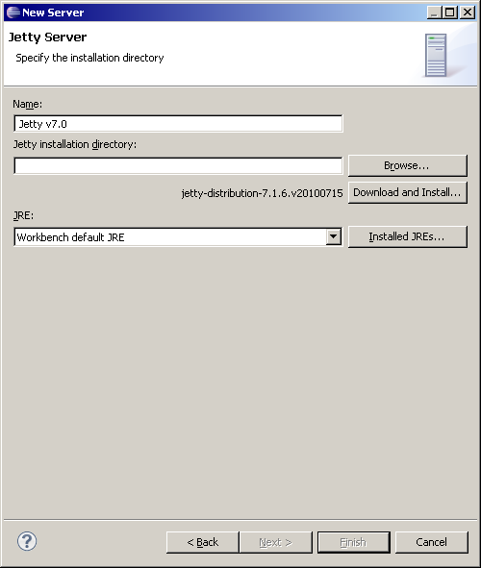

Click on Download and Install... the dialog opens :

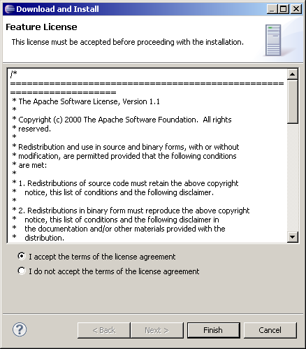

Accept the license and click on Finish button. Select the base directory where you wish install the Jetty. In my case I have selected D:\Servers\jetty-distribution-7.1.6.v20100715 and the download will set stable Jetty v7 server in this folder.

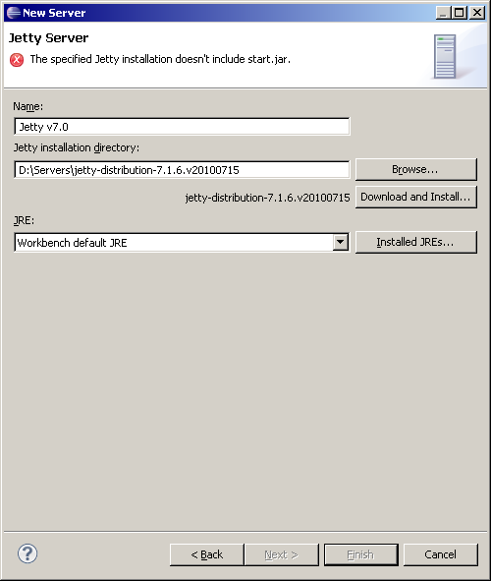
Once you have selected a folder, download is processed. You have an error because the wizard check that start.jar exist in the D:\Server\jetty-distribution-7.1.6.v20100715 (this JAR doesn't exist because the download is not finished).

In my case, download is slowly. Wait for enabling Finish button. Once Download is finished, Finish button is enable

Once download is finished, you will have D:\Server\jetty-distribution-7.1.6.v20100715 which contains start.jar...from the Jetty7 :

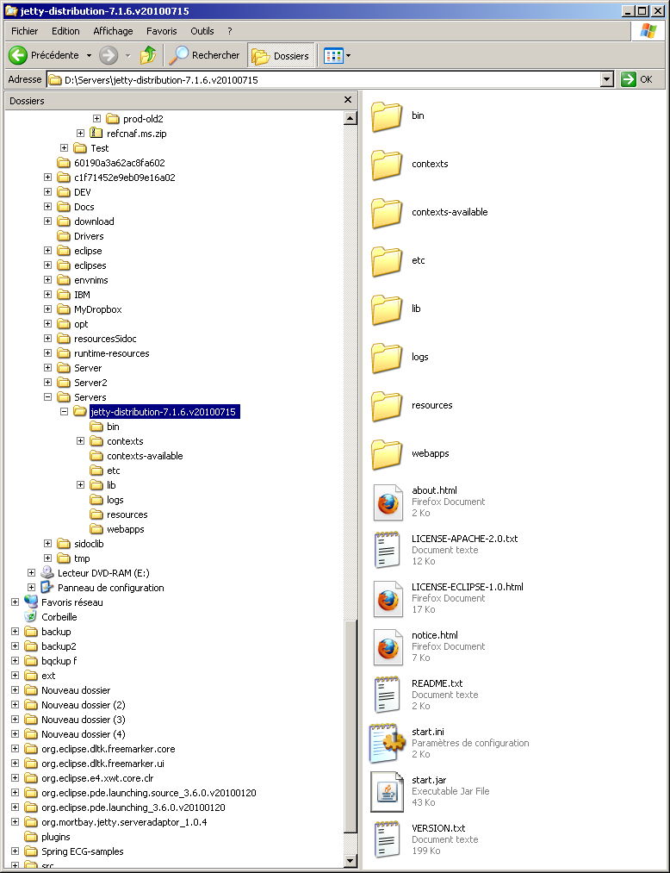

Click on Next button, here you can select existing Dynamic Web project from your workspace. In this documentation, teher are not WTP Dynamic WebProject.
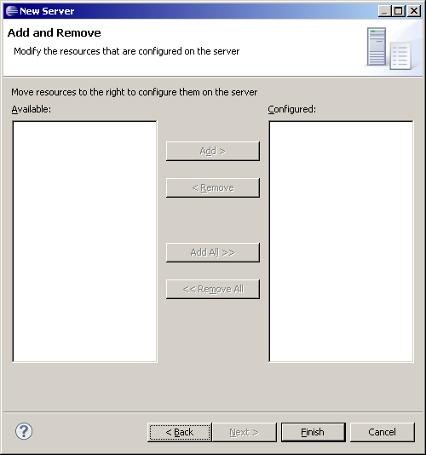
Click on Finish button :
- A Server Project is created in the workspace
- if you go at WTP Server View , you will see the launch Jetty v7.0 Server at localhost that you can use to start/stop/debug the Jetty install server.

Servers contains the Jetty v7.0 Server at localhost-config folder which contains :
- start.ini coming from the Jetty install (D:\Servers\jetty-distribution-7.1.6.v20100715)
- start.config : coming from the JAR start.jar from the Jetty install.
- the jetty*.xml files which are declared in the original start.ini.

You can notice Server/start.config is not the same than Jett install/start.jar. Jetty Home is not the Jetty Install server but a WTP folder (created in the .metdata of your workspace). When Jetty server is called it use :
- -Djetty.home : which is the WTP folder.
- -Dinstall.jetty.home : which is the Jetty install folder.

Jetty*.xml files are preprocessed too to transform <Property to <SystemProperty.

Create Dynamic Web Project
To create a Dynamic WTP Project, go at File/New/Other... and select Web/Dynamic Web Project node :

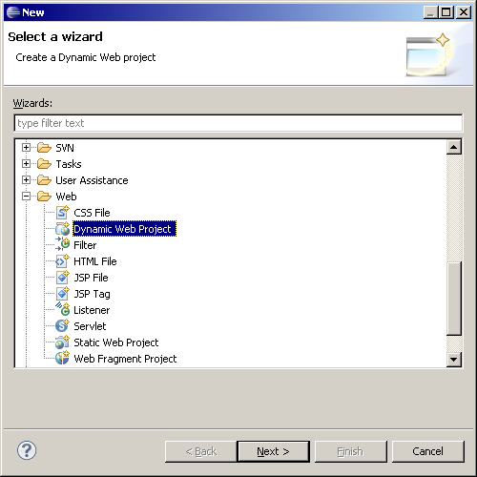

Click on Finish button, The WTP Dynamic Web Project is created and you can use JAR from the Jetty install with the Jetty v7.0 library which was created :

Drag and drop the project mywebapp to the launc :

You can start/stop the Jetty server :

Start :

Go at

