30s break
Test 1
Speaking(4+16s)
Section A
Directions: Read aloud the following sentences. For each sentence, you will have thirty seconds to prepare and fifteen seconds to read.
1. The mountain areas provide a crucial, expansive habitat for some endangered species.(30+15s)
2. Calligraphy is the essential bridge between language and art, where the meaning of the words is ultimately enhanced by the beauty of their form. (30+15s)
10s break
Section B 12s
Directions: Read aloud the following passage. You will have one minute to prepare and thirty seconds to read.
Regretfully, the connections between mathematics and literature have not received the attention they deserve. There is a deep reason we find the former at the heart of literature. The universe is full of underlying structure, pattern and order. Mathematics is definitely the best tool we have for understanding it—that is why mathematics is often called the language of the universe and why it is so vital to science. Since we human are part of the boundless universe, it is only natural that our forms of creative expression, literature among them, will essentially reveal a tendency for pattern and structure. (60s+30s)
10s break
Section C(13s)
Directions: Ask two questions about each situation given below. At least one special question should be asked about each situation.
Question 1-2: ( 读问题所需时间+20s)
Your cousin Linling has just adopted a puppy. Ask her about the puppy.
Question 3-4: ( 读问题所需时间+20s)
Your father is going to attend a lecture on AI. Ask him about the lecture.
【参考答案】
1~2: Where did you adopt/get the puppy?
How much did you pay for its adoption?
What does the puppy like to eat most?
What do you usually feed it?
What does the puppy look like?
What color is it?
How old is it?
What breed is the puppy?
How often do you walk it/take it for a walk?
What is the name of the puppy?
Did you pay any money for it?
Does it bark a lot?
Does it eat a lot?
Has it received any training before adoption?
Does the puppy follow your instructions?
Does it need any special care?
Do you walk it very day?
Do you have to give it a bath every day?
Is it expensive to keep a dog as a pet?
Do you enjoy its company?
Do your family members like it?
…
3~4: Who will give the lecture?
Where will the lecture be held?
How long will the lecture last?
How many people will attend the lecture?
What is the specific theme of the lecture?
What is special about the lecture/lecturer?
Is there any requirement for the participation?
Is the lecture free of charge?
Will you be allowed to take photos/notes there?
…
注：答案可以有很多
10s break
Section D（15s）
Directions: You will have one minute to prepare and another minute to talk about the following pictures with at least five sentences. Begin your talk with the sentence given.

It was Saturday evening.（60s+60s）
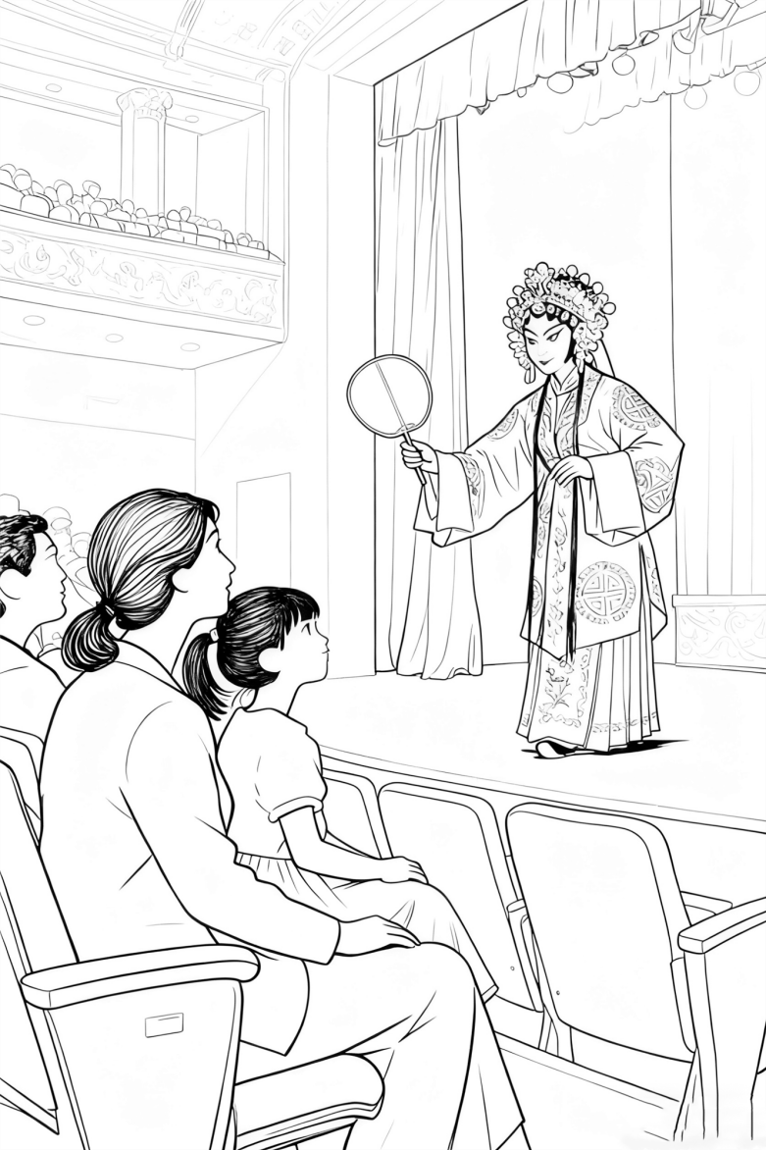1 | 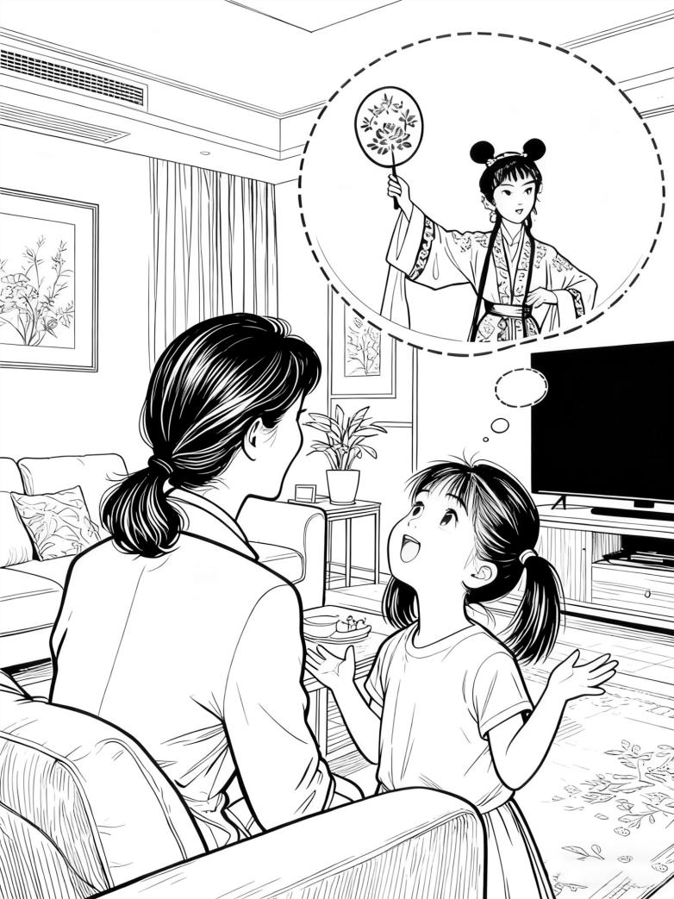2
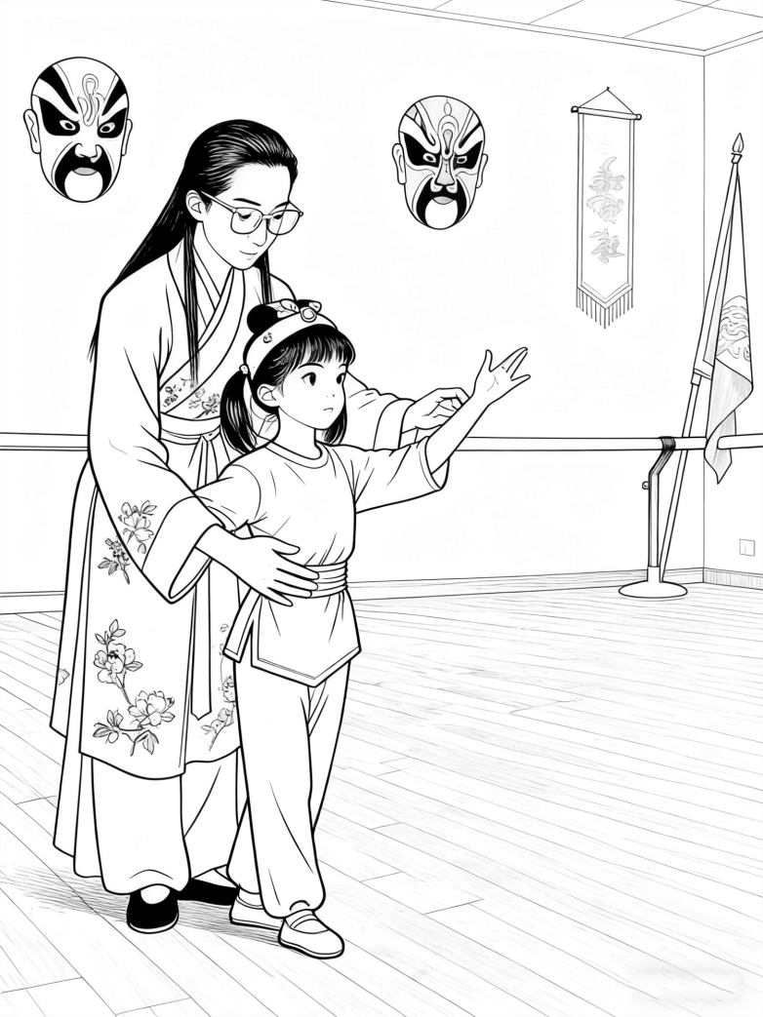3 | 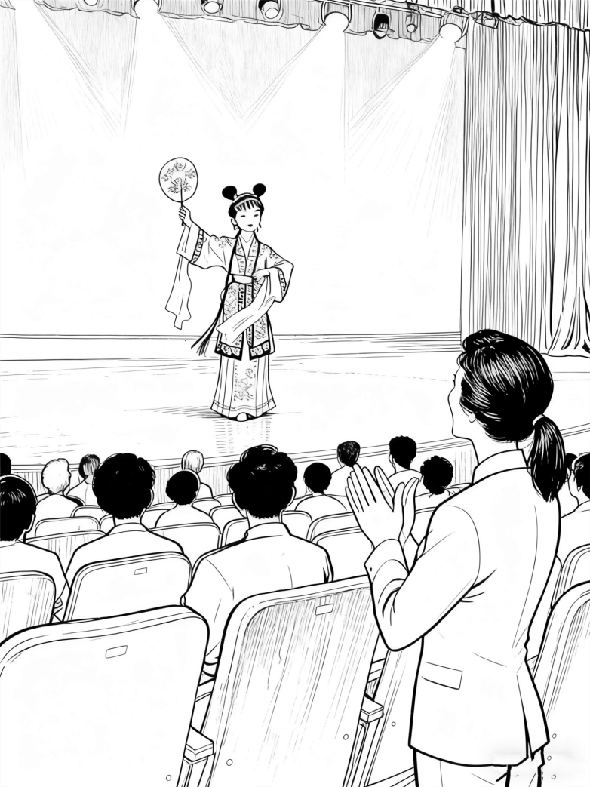4

【参考答案】
It was Saturday evening. Mom took Lingling to the theatre to watch Peiking opera. The little girl was so amazed with the wonderful arts and dreamed of performing Beijing opera herself one day. So Mom sent the girl to the Opera school. Lingling practiced very hard with the help of the master. Several years later, she had the chance to perform on the stage and Mom was so proud of her.
注：答案可以千变万化
10s break
Listening & Speaking (15s)
Section A
Directions: In Section A, you will hear four sentences. Make quick responses to the sentences you have heard.
1. Dear, will you please help me load the washing machine?(6s+5s)
2. Sorry for the noise. I didn’t realize you were preparing for the exam. (6s+5s)

3. Watch out! The traffic is very busy at the crossing. (7s+5s)

4. I wonder whether I should take part in the writing competition. (7s+5s)

【参考答案】
1. Sure, no problem.
With pleasure.
Ok, just wait a minute.
Sorry, but I’m occupied for the moment.
2. That’s all right.
That’s OK.
Never mind.
No worries.
It’s Ok, and I just need a break.
3. Thank you for reminding/ warning me.
Thanks. I should be more careful.
Thanks a lot. I should look both ways first.
Got it. Thanks!
4. Of course you should!
Definitely you should!
Of course you should. I believe in you.
No one can do it better than you!
Just have a try!
注：答案可以有很多
10s break
Section B(35s)
Directions: In Section B, you will hear a short passage about how to deal with change. The passage will be read twice. After you hear the passage, answer the first question with the information you hear and the second in your own opinion with at least 3 sentences. For the first question, you will have 30 seconds to prepare and 30 seconds to talk. For the second question, you will have one minute to prepare and another minute to talk. (按照这篇文章篇幅计时，该篇为191s)

Does change frighten you? It’s a natural reaction. Our brains are wired to be curious about change, associating it with the uncertainty and danger our ancestors faced. While modern changes are rarely life-or-death, our bodies still react with a "fight or flight" response. The good news is that we can learn to manage this reaction. Here’re two key tips for dealing with change so you can face new challenges with confidence.
You should always learn to control what you can. Even in the toughest situations, there are elements within your control. Make a list of these things, no matter how small they seem, and start taking action on them. The simple act of clearing the minor tasks off your list will make even the most uncontrollable problem feel much more manageable.
Regarding change as an opportunity, not a disaster really matters too in face of an obstacle. Suppose a rejected university application or missing-out on a dream job—a natural response is to see it as a tragedy. However, this achieves nothing and only brings you down. Studies show that people who train themselves to see change as a potential opportunity, rather than a disaster, cope with it far more effectively.
30s+30s+60s+60s
Questions:
1. The speaker mentions two tips on dealing with change. List the two of them.
2. What do you think of the lying-flat attitude among some young people these days?
【参考答案】
1. control what you can/ (list things and) clear the small tasks first/take action on small things first;
regard change as an opportunity not a disaster/ see change as a potential opportunity rather than a disaster
2. Personally, I don’t like the lying-flat attitude among the young people. As a young generation, we are supposed to strive for a better life. If you choose to lie flat, then you parents will have to take the heavy burden of your life. What’s worse, you will gradually lose the ability to live on your own.
注：答案可以千变万化，只要紧扣问题后逻辑地表达，自圆其说就行

Test 2
Speaking
Section A
Directions: Read aloud the following sentences. For each sentence, you will have thirty seconds to prepare and fifteen seconds to read.
1. A person with integrity has respect for principle over convenience in any situation.
2. We tend to get embarrassed and shrug off the words we’re so glad to hear because few of us know how to accept positive feedback gracefully.

Section B
Directions: Read aloud the following passage. You will have one minute to prepare and thirty seconds to read.
Fascinated by the internet, some wealthy countries wrongly decided that goods making was out of date and they could build their economy on ideas alone. This "post-industrial" belief led them to neglect their factories, harming their economic health. Even more worryingly, they are concerned about the digital divide across the world. Thus, many companies and individuals have been encouraged to donate money to provide computers and internet access for developing countries. However, this aid might be misdirected. Some less trendy but basic projects, such as digging wells or extending electrical networks, might bring far greater benefits for communities in need.

Section C
Directions: Ask two questions about each situation given below. At least one special question should be asked about each situation.

Question 1-2:
Your friend Lee has just joined a rock-climbing club. Ask him about the club.
Question 3-4:
Your Mom is planning a birthday party for your grandpa. Ask her about the plan.

【参考答案】
1~2: Where is the club located?
What is special about the club?
What is the fee for membership?
How does the club make sure of the safety of the members?
How long has the club been running?
Is the club popular (with young people)?
Is the club well-managed?
Is it expensive to join the club?
Does the club offer courses for rock-climbing?
Is there any professional coach there to help?
…
3~4: Where will the birthday party be held?
Which restaurant will you choose for the party?
What’s your budget for the party?
Who will pay for the birthday party?
What present have you got for Grandpa?
Does Grandpa know about your plan?
Is it a surprise party?
Should I buy a birthday cake for Grandpa?
…
注：答案可以有很多

Section D
Directions: You will have one minute to prepare and another minute to talk about the following pictures with at least five sentences. Begin your talk with the sentence given.

It was Sunday morning.
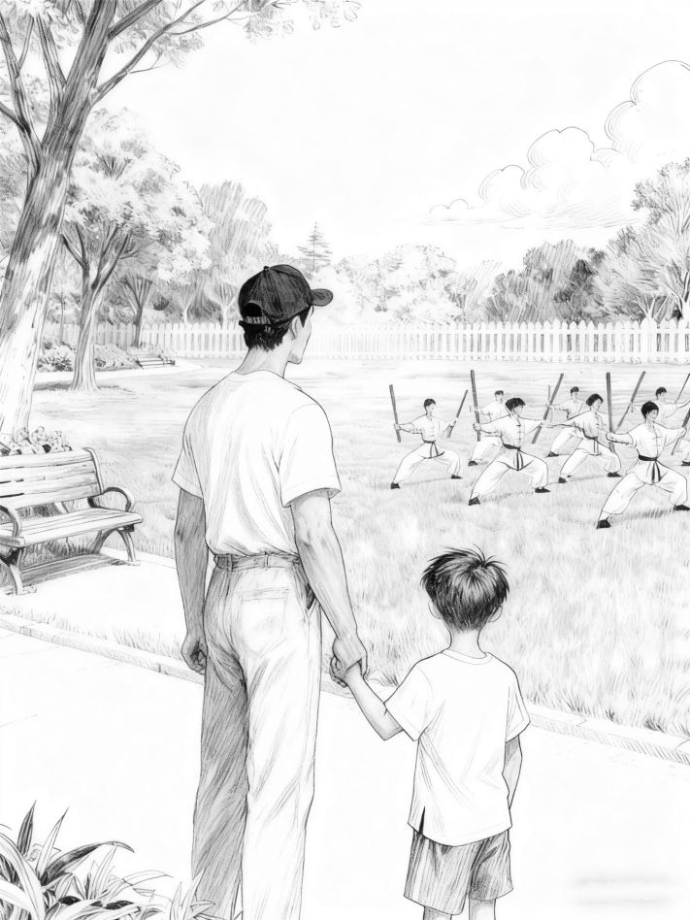1 | 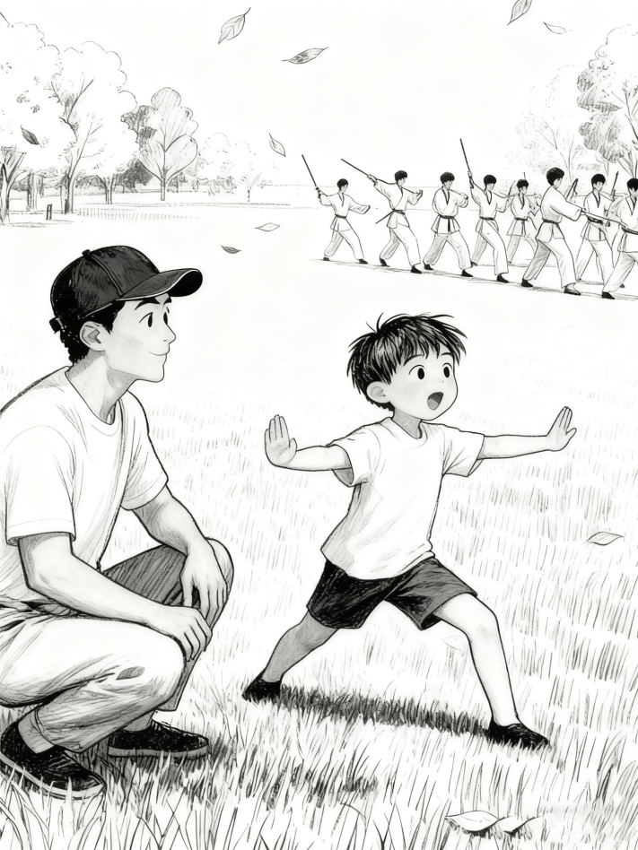2
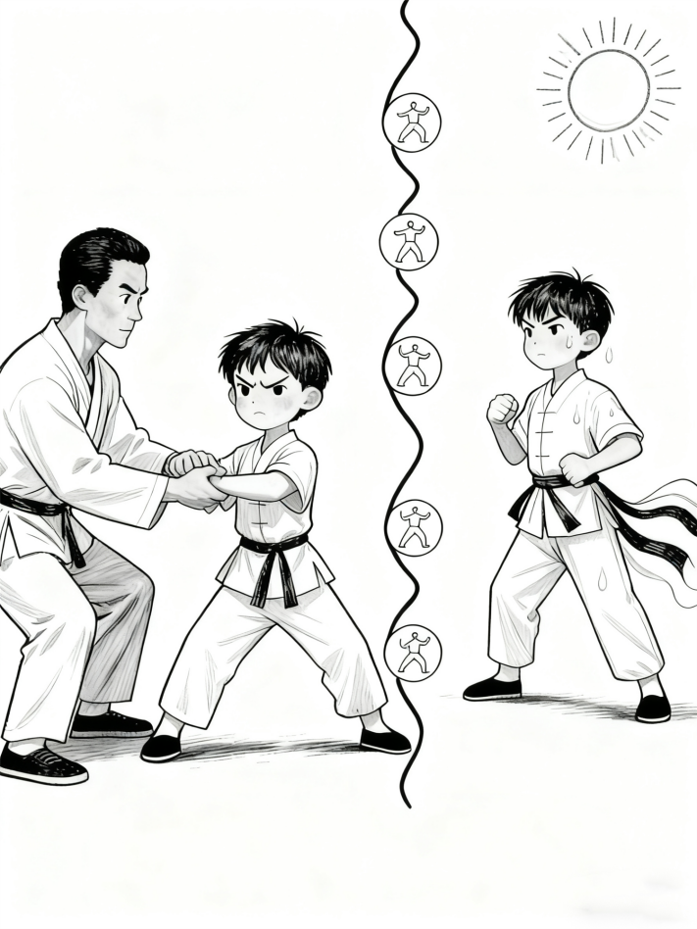3 | 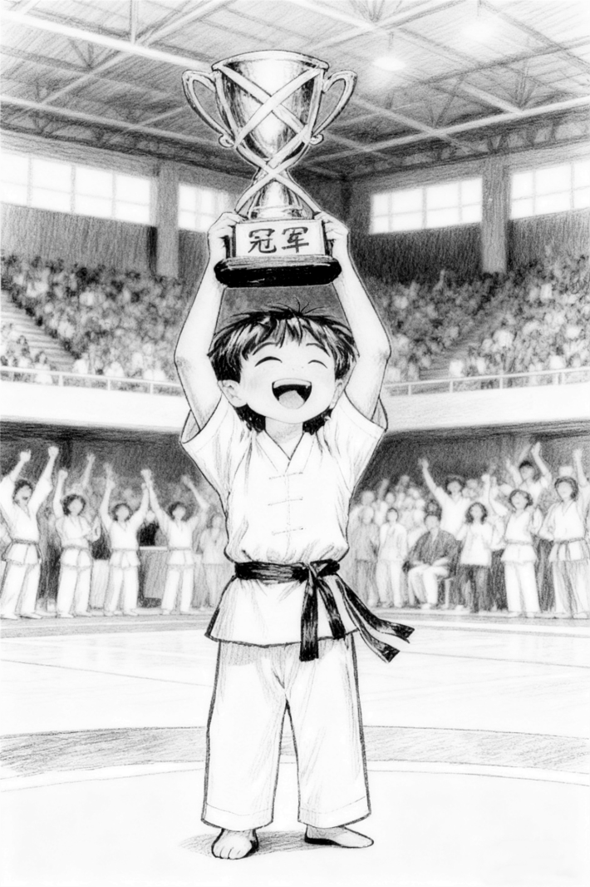4

【参考答案】
It was Sunday morning. Dongdong was taking a walk with his father in the park when they saw some young people practicing martial art/Kongfu. Dongdong couldn’t help himself and imitated their move. So his father sent him to a Kongfu master. Dongdong trained himself very hard and made great progress. At last, he won the championship in a Kongfu competition.
注：答案可以千变万化

Listening & Speaking
Section A
Directions: In Section A, you will hear four sentences. Make quick responses to the sentences you have heard.
- I’ve enjoyed every minute of the party. The food and music are superb.
- It is a bit noisy here. Would you mind turning down the radio?
- Watch your step. There is a gap in between.
- I didn’t expect that I would be awarded the first prize in the contest.

【参考答案】
1. The pleasure is mine.
It’s really sweet/kind of you to say so.
It’s so nice to have you here.
I’m glad that you were having a great time.
It is really a wonderful night!
2. No, of course not.
Not at all.
Out of question.
Surely not.
3. Thank you for reminding/ warning me.
Thank you very much and I will be more careful.
Thanks. I should be more careful.
Got it. Thanks!
I would fall into that gap but for your warning.
4. Wow! That’s great!
Congratulations!
You deserve it!
Hard work pays off.
I’m so proud of you!
I really feel great for you!
注：答案可以有很多

Section B
Directions: In Section B, you will hear a short passage about how to protect eyesight. The passage will be read twice. After you hear the passage, answer the first question with the information you hear and the second in your own opinion with at least 3 sentences. For the first question, you will have 30 seconds to prepare and 30 seconds to talk. For the second question, you will have one minute to prepare and another minute to talk.

We watch our salt and fat levels to protect our heart. We exercise and take milk to protect our bones. But what about our eyes? We asked experts what lifestyle steps people should be taking to safeguard our vision. There seem to be quite a lot.
The easiest way is to invest in quality sunglasses. Protecting your eyes from UV light is one of the most critical steps for long-term eye health. UV exposure from sunlight can significantly harm your sight. For the best protection, choose glasses that are guaranteed to block 99-100% of UVA and UVB rays. Note that dark sunglasses are not necessarily the most effective.
As a 7/24 generation, it is also advisable to take regular screen breaks. Screen light has not been proven to cause permanent damage, but staring at a screen can leave eyes tired and vision cloudy. To avoid this, follow the recommended "20-20-20" rule: every 20 minutes, look at something 20 feet away for 20 seconds. Glasses that block blue light do not seem to do the trick according to multiple studies.
While diet and environment play a role, consistently applying these two practical tips is sure to benefit your precious eyesight.

Questions:
1. The speaker mentions 2 keys to eye-protection. List the two of them.
2. Do you think eye-exercise is beneficial to eyesight? Explain.
【参考答案】
1. Invest in quality sunglasses/ choose glasses guaranteed to block 99-100% rays; take regular screen breaks/ follow the “20-20-20” rule
2. In my opinion, eye-exercise will surely benefit our eyesight. Eye exercise is the perfect combination of traditional wisdom and modern science. By stimulating certain points around our eyes, we can relieve tired eyes and keep our vision sharp. (Eye exercise is designed to relax the eye muscle, ease tension, and support long-term eye care.) If we follow the proper instructions, doing eye exercise will definitely help.
注：答案可以千变万化，只要紧扣问题后逻辑地表达，自圆其说就行

