Subject Number | Gender | Major

Introduction
In this experiment you will rate how well you feel you understand various procedures. We’ll ask you to rate your understanding on a seven-point scale. Before you get started, this introduction will try to explain what the scores on the scale are supposed to reflect.

Some people don't have a very good understanding of a particular procedure. For example, if they are asked about the correct procedure for how to fold an American flag, they would not be able to say much. They might know that there are a series of folds that have to be made, but they don't know how to make the particular folds.

Some people may know more details about folding an American flag. They may know that two people need to work together to fold the flag, that initially the flag is folded widthwise, and that ultimately the flag ends up folded into a small triangle with stars showing. Yet, they do not know all of the steps.

Some people understand a particular procedure very well. That is, they can tell you about all the steps involved. For example, when asked about the correct procedure for folding an American flag, they might say:

Step 1: Get ready with your partner

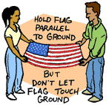
Grab your partner and your flag. Stand facing your partner while you hold two corners of the flag and he or she holds the other two at about waist level. The flag should be parallel to the ground, and the sides facing both of you should be the shorter ones.

Careful--it's taboo to let the flag touch the ground.

Step 2: Fold widthwise twice
Raise the side of the flag that normally hangs on the bottom, the side entirely covered by stripes, over the side with the "union" on it (the union is the upper corner of the flag with the stars). Grab the new corner you have made along the crease so that again the flag is parallel to the ground, all-stripe side up.

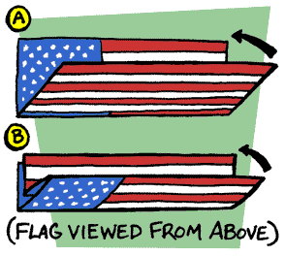
Repeat this widthwise fold so that the union is now on either side, half facing the ground and half facing the sky.

Step 3: Corner your flag
Now that you're holding your twice-folded flag, notice that of the new rectangle shape you have made, one long side is "open," and one is "closed." The open side consists of the original perimeter of the flag--you can still separate the folds into individual layers of material. The crease on the other side encloses the layers of fabric under it, so it's "closed."
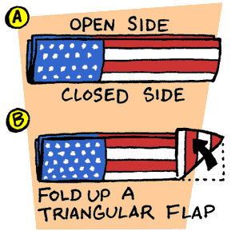
Now fold the flag in a series of triangles. To do it scrupulously correct, you've got to start the folding at a specific point. Start at the striped end of your rectangle. Take the corner of the closed side and bring it diagonally over to the open side, forming a triangular flap.

Step 4: Continue cornering
You've created a most unharmonious shape at this point: a long, rectangular shape with a corner lopped off. Take the pointy corner and fold it down, over the other triangular fold, to create a straight edge once again. Now repeat this folding process, switching corners with each fold, until just a blue square of the union is peeking out from the triangular fold.

Only one person does this triangular folding; your partner ceremoniously and patiently holds the other end (ensuring that it doesn't touch the floor!).
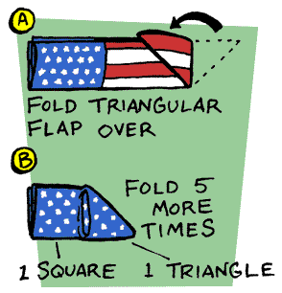

Step 5: Master the Final Fold and Tuck
All you've got left is the final fold--the tricky turn that some argue is at the crux of the whole operation. Instead of you folding the thick triangle of folded flag fabric over the last remaining blue square, your partner--who has waited for you so patiently--finally gets to do some creasing. The person on the union end of the flag will take the corner on the open leg and fold it down along the edge of the other leg to form a triangle. He or she then tucks the remaining blue tab under the folds of the thick triangle until the flag is a neat triangle and can't easily unravel.

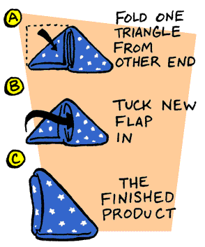

Using the American flag example, what we will try to demonstrate is that you can think of knowledge about how things work as arranged along a continuum, which we can represent as a seven-point scale.

<1 2 3 4 5 6 7>

For the flag, many people are probably close to a 1, such as the hypothetical person who would not give detailed instructions. Others are close to a 4, such as the hypothetical person who only knew some of the steps, and some, such as a person who would know all of the flag-folding steps are close to a 7.

Note that one does not need to be an expert to have level 7 knowledge – an intelligent, educated lay-person who has read and understood a good description of the procedures in an appropriate reference source probably has level 7 knowledge, as we define it. An expert in a particular phenomenon would almost necessarily have level 7 knowledge, since experts know more than even the most knowledgeable lay-people. Thus, our rating scale is not sensitive to degrees of expert knowledge – the experts know so much they are “off the scale.” The 1-7 scale we described only measures levels of non-expert knowledge.

Instructions
In this experiment you will rate how well you feel you understand certain procedures. We’ll ask you to rate your understanding on a seven-point scale.

We are trying to get a sense of how people feel about their understandings of various procedures as part of a larger study of how people make sense of the world. We are going to present you with 14 items; we want you to rate on a 7-point scale how well you feel you understand each one. By "understand" we mean how well you feel that you know how to perform an action and how well you feel like you could explain the instructions to another person. You should give the item close to a “7” if you feel your understanding of the item is excellent, and you should give a “1” if you feel your understanding is very very basic.
There is one tricky part to keep in mind. Some of our participants get confused and think they are rating how well they feel they understand each procedure relative to how well other people understand the same procedure. That’s not your task. The 7-point scale is meant to be absolute – it does not depend on what you think others may know about each item. In other words, you will be rating how well you feel you understand the procedure relative to all other procedures you know. Remember, 7 means you have a very thorough understanding of a procedure, 1 means you have a very vague understanding of the procedure.
Finally, it is very important to give us your first impression. We find that taking too long really hurts people’s answers. Please go through the list below as quickly as possible and circle the number from 1-7 on the scale next to the item, telling us how well you feel you understand each item.

Rating 1: Distracters & Test (Randomized)

Procedure | Scale
A correct procedure for how to drive from New Haven to New York City | < 1 2 3 4 5 6 7 >
The correct procedure for how to tie a tie | < 1 2 3 4 5 6 7 >
The correct procedure for how to file your taxes | < 1 2 3 4 5 6 7 >
A correct procedure for how to drive from New Haven to Chicago | < 1 2 3 4 5 6 7 >
A correct procedure for how to make scrambled eggs | < 1 2 3 4 5 6 7 >
The correct procedure for how to set a table | < 1 2 3 4 5 6 7 >
A correct procedure for how to make pasta | < 1 2 3 4 5 6 7 >
The correct procedure for how to tie a bowtie | < 1 2 3 4 5 6 7 >
The correct procedure for how to make an international telephone call | < 1 2 3 4 5 6 7 >
A correct procedure for how to make chocolate chip cookies from scratch | < 1 2 3 4 5 6 7 >

Write Explanations
Now, we'd like to probe your knowledge in a little more detail on some of the items.
For each of the following, please describe all the steps in the procedure that you know, going from the first step to the last. For each procedure, try to tell as complete a story as you can, with no gaps.

If you find that your story does have gaps (that is, you are not sure about some of the steps or how they are connected) please write the word “GAP” in your description at that point, and then continue. Feel free to use labeled diagrams, or flow-charts to get your meaning across.

When you are done, please re-rate your knowledge of the procedures on a 1-7 scale in the space provided.

Explain how to drive from New Haven to New York City.

Now, please rate how well you feel you understand this procedure.
A correct procedure for how to drive from New Haven to New York City | < 1 2 3 4 5 6 7 >
Explain the correct procedure for how to tie a bowtie.

Now, please rate how well you feel you understand this procedure.
The correct procedure for how to tie a bowtie | < 1 2 3 4 5 6 7 >
Explain how to how to make pasta.

Now, please rate how well you feel you understand this procedure.
A correct procedure for how to make pasta | < 1 2 3 4 5 6 7 >
Explain how to make an international telephone call.

Now, please rate how well you feel you understand this procedure.
The correct procedure for how to make an international telephone call | < 1 2 3 4 5 6 7 >
Explain how to make chocolate chip cookies from scratch.

Now, please rate how well you feel you understand this procedure.
A correct procedure for how to make chocolate chip cookies from scratch | < 1 2 3 4 5 6 7 >

Now please rate how well you feel you understand five additional procedures:
Procedure | Scale
The correct procedure for how to tie a tie | < 1 2 3 4 5 6 7 >
The correct procedure for how to file your taxes | < 1 2 3 4 5 6 7 >
A correct procedure for how to drive from New Haven to Chicago | < 1 2 3 4 5 6 7 >
A correct procedure for how to make scrambled eggs | < 1 2 3 4 5 6 7 >
The correct procedure for how to set a table | < 1 2 3 4 5 6 7 >

Read Expert Explanations
Below you will find the explanations of each procedure provided by an expert. Let’s assume that the expert explanations and the diagrams represent Level 7 knowledge. Please read each explanation carefully, and re-rate your initial level of understanding of each explained item, i.e. your level of understanding before you read the explanation. Then, rate your current level of understanding of the explained item, i.e. how well you feel you understand the procedure after you’ve read the explanation.

How To Drive from New Haven to New York City

Please read the explanation provided by an expert.

How well do you feel you understood the procedure before reading the explanation?
A correct procedure for how to drive from New Haven to New York City | < 1 2 3 4 5 6 7 >

How well do you feel you understand the procedure after reading the explanation?
A correct procedure for how to drive from New Haven to New York City | < 1 2 3 4 5 6 7 >

How To Tie a Bowtie

Please read the explanation provided by an expert.

How well do you feel you understood the procedure before reading the explanation?
The correct procedure for how to tie a bowtie | < 1 2 3 4 5 6 7 >

How well do you feel you understand the procedure after reading the explanation?
The correct procedure for how to tie a bowtie | < 1 2 3 4 5 6 7 >

How To Make Pasta

Please read the explanation provided by an expert.

How well do you feel you understood the procedure before reading the explanation?
A correct procedure for how to make pasta | < 1 2 3 4 5 6 7 >

How well do you feel you understand the procedure after reading the explanation?
A correct procedure for how to make pasta | < 1 2 3 4 5 6 7 >

How To Make International Phone Calls

Please read the explanation provided by an expert.

How well do you feel you understood the procedure before reading the explanation?
The correct procedure for how to make an international telephone call | < 1 2 3 4 5 6 7 >

How well do you feel you understand the procedure after reading the explanation?
The correct procedure for how to make an international telephone call | < 1 2 3 4 5 6 7 >

How To Make Chocolate Chip Cookies

Please read the explanation provided by an expert.

How well do you feel you understood the procedure before reading the explanation?
A correct procedure for how to make chocolate chip cookies from scratch | < 1 2 3 4 5 6 7 >

How well do you feel you understand the procedure after reading the explanation?
A correct procedure for how to make chocolate chip cookies from scratch | < 1 2 3 4 5 6 7 >

Now please rate how well you feel you understand five additional procedures:
Procedure | Scale
The correct procedure for how to tie a tie | < 1 2 3 4 5 6 7 >
The correct procedure for how to file your taxes | < 1 2 3 4 5 6 7 >
A correct procedure for how to drive from New Haven to Chicago | < 1 2 3 4 5 6 7 >
A correct procedure for how to make scrambled eggs | < 1 2 3 4 5 6 7 >
The correct procedure for how to set a table | < 1 2 3 4 5 6 7 >

