Week 3 Homework
Data Fetching and Cleaning from Public Repositories
Student | Zixuan Zeng
Student ID | SUAT24000114
Course | Bioinformatics: From Multi-Omics Data to Discovery (Dr. Liwei Xie, SUAT, Fall 2026)
Primary dataset | GSE111889 - host mucosal RNA-seq, HMP2 / IBDMDB cohort (Task A, Table 0)
Mini-case dataset | GSE87487 - 20 liver allograft biopsies (Task B, Table 1)
Environment | R 4.6.1, GEOquery 2.80.0, Windows 11
Data accessed | 2026-09-10 (Asia/Shanghai)

Every number, accession and file size below was read out of the GEO record or computed from the downloaded files by the scripts in Appendix A. Nothing is quoted from memory or from secondary summaries. Where my own earlier preparation notes disagreed with the record, the record wins and the correction is listed in section 5.

0. The Week 2 data-driven question, restated in one sentence
Question (PECO): In adult and paediatric patients with inflammatory bowel disease, sampled as intestinal mucosal biopsies in the HMP2 / IBDMDB cohort (population / system), is disease status - Crohn's disease or ulcerative colitis versus non-IBD control (exposure and comparison), associated with differences in host mucosal gene expression (outcome), measured as gene-level bulk RNA-seq counts (data type)?
Link back to Week 2: the Nature Microbiology paper from last week (Priya et al. 2022, on host gene - microbiome associations across human diseases) draws its IBD host transcriptomics from the IBDMDB cohort. GSE111889 is that layer as deposited in GEO, which is why it is the dataset carried into Week 3.

1. Table 0 - the five steps, completed for GSE111889
Step 1 - State the Week 2 data-driven question
See section 0. Population / system: human intestinal mucosal biopsies from the HMP2 / IBDMDB cohort. Comparison: Crohn's disease or ulcerative colitis versus non-IBD. Outcome: host mucosal gene expression. Data type: bulk RNA-seq gene-level counts produced by htseq-count.
Step 2 - Confirm study identity
Field | Value verified from the GEO record | Evidence source
GEO Series | GSE111889 | series matrix header
Title | Longitudinal Multi-omics of the Human Microbiome in Inflammatory Bowel Disease | !Series_title
Organism | Homo sapiens (taxid 9606) | !Series_sample_taxid
Publication | PubMed 31142855 = Lloyd-Price J et al., Multi-omics of the gut microbial ecosystem in inflammatory bowel diseases, Nature 2019; 569:655-662 (doi 10.1038/s41586-019-1237-2) | !Series_pubmed_id
Platform | GPL11154 = Illumina HiSeq 2000 (Homo sapiens) | !Series_platform_id and instrument_model
Assay | Expression profiling by high throughput sequencing; library strategy RNA-Seq, source transcriptomic, selection cDNA | !Series_type and library_* fields
Submitter | Curtis Huttenhower, Department of Biostatistics, Harvard T.H. Chan School of Public Health | !Series_contact_* fields
Status | Public 17 Mar 2018; last updated 4 Jun 2019 | !Series_status
Samples | 251 (not 28 - see section 5) | nrow(pData(eset))

Step 3 - Map accessions
Accession layer | Value | Note
Series | GSE111889 | -
Samples | GSM3043377 - GSM3043627 (n = 251) | one contiguous block
Example sample | GSM3043377 = title CSM5FZ1G; sigmoid colon; Crohn's disease; female | the GEO title is the HMP2 external ID
BioProject | PRJNA438663 (not PRJNA398089 - see section 5) | !Series_relation
BioSample | one per sample, e.g. GSM3043377 = SAMN08723464 | 251 of 251 samples carry a BioSample link
SRP / SRX / SRR | NONE - 0 of 251 samples carries an SRA relation | the Series states raw data go to dbGaP for patient privacy
Per-sample file | ftp://...GSM3043nnn/GSM3043377/suppl/GSM3043377_CSM5FZ1G.tsv.gz | one htseq-count table per sample

Step 4 - Identify available data layers
Layer | Present? | Evidence and size
Series matrix | Yes, but metadata only | GSE111889_series_matrix.txt.gz, 13,525 bytes. exprs() returns a 0 x 251 matrix and data_row_count = 0, so there is NO expression table in the series matrix at all - the counts must come from the supplementary files. Anyone who assumed the series matrix held the data would get an empty object.
Series supplementary counts | Yes - the layer I used | GSE111889_host_tx_counts.tsv.gz, 11,130,307 bytes, md5 ff2ee7167b202448be2441e03b7ed996; genes x samples = 55,765 x 251.
Series raw archive | Yes | GSE111889_RAW.tar, about 68 MB - the per-sample tsv tables bundled together.
Per-sample supplementary | Yes | GSMxxxxxxx_<title>.tsv.gz, one file per sample (251 files).
Raw reads (FASTQ) | NO - controlled access | 0 of 251 samples has an SRA link, and !Series_overall_design states that the submitter will deposit raw data in dbGaP because of patient privacy concerns. Open reprocessing from FASTQ is therefore NOT possible for this study.
Single-cell files | No | Series type is bulk expression profiling.
Upstream processing | Documented in the record | data_processing: reads aligned to hg19 with TopHat v2.0.14, counted with htseq-count v0.6.1; a sample failed QC if more than 40 percent of reads mapped outside exons, and the submitter reports that no sample failed.

Step 5 - Reconstruct the design
Design element | What the metadata actually supports
Sample size | n = 251 biopsies; all Homo sapiens; one platform; one submission.
Groups (n) | Crohn's disease 127 | Ulcerative colitis 74 | Non-IBD 50
Biopsy site (9 levels) | Rectum 100 | Ileum 89 | Sigmoid colon 22 | Transverse colon 14 | Descending (left-sided) colon 9 | Ascending (right-sided) colon 8 | Cecum 5 | Terminal ileum 3 | Non-inflamed 1
Sex | Female 139 | Male 112
Subject and paired structure | NOT RECOVERABLE FROM GEO. The only sample characteristics present are biopsy location, disease status and gender - there is no subject, participant, donor or visit field. The titles are HMP2 external IDs (CSM5FZ1G, HSM6S4..., MSM...), and their 6-character prefixes collapse the 251 samples into only 18 groups, the largest holding 50 samples, so the prefix is a shipment or plate grouping rather than a participant. Because HMP2 is a longitudinal design with repeated biopsies per subject, these samples are almost certainly NOT independent - but that has to be established by joining to the IBDMDB metadata (hmp2_metadata.csv) on External ID. Until that join is done, independence is unverified and no paired model can honestly be specified.
Batch | No batch field exists. One platform (GPL11154), one submission date, one processing pipeline. The 6-character title prefix (18 levels) is the only available proxy, and because it is unlabelled it can be inspected but not trusted as a batch variable.
Covariate that actually dominates (measured, not assumed) | PC1 carries 41.6 percent of the variance and is driven by biopsy site (ANOVA p < 2e-16), NOT by diagnosis (p = 0.545). Diagnosis appears only on PC2 (21.5 percent, p = 0.0024). Sequencing depth is not a driver: the correlation of PC1 with log10 library size is r = -0.064.
Consequence for analysis | The comparison of interest is not the largest signal in this dataset. A differential expression model must therefore condition on biopsy site, for example ~ site + diagnosis, and must additionally account for the repeated-measures structure once subject IDs are recovered. Fitting ~ diagnosis alone would attribute anatomical differences between ileum and colon to disease.

2. Table 1 - the four judgment questions, answered for GSE87487
Instructor-supplied description: GSE87487 is a human bulk RNA-seq study of 20 liver allograft biopsies, with pre- and post-reperfusion sampling and a 3.7 MB supplementary count matrix; the Series links to SRA project SRP090633. Each answer below was verified against the record rather than assumed from that description.
# | Question | My decision | Evidence I actually checked
1 | Are the values counts? | YES - raw integer counts, usable directly in DESeq2 or edgeR. | Downloaded GSE87487_counts.20samples.txt.gz: 3,901,096 bytes (the ~3.7 MB described), md5 8efee79167460de2f5d66bead5187d60. It reads as 60,498 rows x 21 numeric columns - 21, not 20, because the first column is Length, a gene length in bp whose column sum is 133,873,265. That is a featureCounts annotation column, not a sample, and treating it as one would corrupt every normalisation, so it is dropped explicitly, leaving 60,498 x 20. On the sample columns: all(x == floor(x)) is TRUE, min 0, max 1,003,757, no negative and no fractional values. Gene IDs are versioned Ensembl / GENCODE (ENSG00000223972.5) and the sample columns are BAM filenames (Sample_HBBx1.bam), which together confirm featureCounts run on aligned BAMs. Library sizes span 7,059,456 to 10,610,420, a 1.5-fold range.
2 | Are samples independent? | NO - 10 donors contributing 2 biopsies each. The pairing must be preserved in the metadata and in the design. | The 20 count columns map 20 of 20 onto GSMs, giving 10 donors (HB, MJ, OC, PT2, PT6, PT8, PT9, PT10, PT12, RJ) with exactly 2 samples each - one pre-reperfusion and one post-reperfusion. The donor x stage table is complete and balanced, every cell equal to 1. The design is therefore ~ donor + stage, not ~ stage. Mapping caveat: the count columns (Sample_Pt10-Bx1.bam) do not match the GEO titles (Pt10Bx1) verbatim, so both sides had to be normalised - strip the Sample_ prefix and .bam suffix, remove non-alphanumeric characters, upper-case - before the 20 of 20 match was obtained.
3 | Can all 20 samples be compared directly? | NO - they span two crossed factors, so a specific contrast has to be defined before any analysis. | Two factors are present: transplant stage (pre 10 / post 10) and ischemia-reperfusion injury status (IRI negative 12 / positive 8). Cross-tabulated: pre/negative 6, pre/positive 4, post/negative 6, post/positive 4. Critically, IRI is constant within a donor - 4 donors positive, 6 negative - so IRI is a BETWEEN-donor factor while stage is WITHIN-donor. A model with donor as a fixed effect absorbs IRI completely; testing IRI needs either a donor random effect or a stage-by-IRI interaction applied to the within-donor differences. Practical choices: (a) post versus pre within donor, paired, n = 10 pairs; or (b) IRI positive versus negative on the within-donor post-minus-pre change, 4 donors versus 6. Depth is not a confounder here (1.5-fold range).
4 | Is full raw-read reprocessing possible? | Technically YES, but deliberately out of scope for a one-hour homework - I use the supplied matrix and record its provenance. | All 20 samples carry an SRA experiment link (SRX2199841 to SRX2199860; SRA project SRP090633), so the FASTQs are openly retrievable. Reprocessing 20 human RNA-seq libraries means tens of GB of downloads plus alignment and quantification - hours of CPU. The supplied featureCounts matrix already passes every integrity check, so reprocessing would buy reproducibility of the annotation choice, not a different answer to the present question. Decision: use the supplied counts, and record the file name, byte size, md5 and annotation style (versioned Ensembl IDs) so that the choice is auditable; treat reprocessing as the escalation path if the annotation build turns out to matter. Note the contrast with GSE111889, whose raw reads are NOT open - the same question has opposite answers for the two studies.

3. Cleaning and QC actually performed on GSE111889
3.1 Integrity checks (each enforced with stopifnot, so a failure halts the pipeline)
Check | Result
Duplicated sample columns | 0
Duplicated gene IDs and NA values | 0 duplicated IDs and 0 NA values across 55,765 x 251
Are the values counts? | TRUE - storage mode integer, min 0, max 1,831,534, no negative values
Matrix columns versus metadata rows | 251 versus 251
Sample-order alignment | The count columns are HMP2 titles, not GSM IDs, so columns were matched to pData$title (251 of 251 matched) and the metadata reordered; identical(colnames(expr), rownames(meta)) is TRUE afterwards. Assuming the two were already in the same order would have silently mislabelled every sample.

3.2 Low-count filter
Threshold: keep a gene if it has at least 10 counts in at least 50 samples, where 50 is the smallest group size (Non-IBD), so that a gene expressed only in the smallest group is still retained. Result: 20,516 of 55,765 genes retained (36.8 percent); 35,249 removed, of which 2,700 were all-zero. Filtering was applied to raw counts, and filtered raw counts are what any statistical model would receive.
3.3 Sample-level QC and two documented exclusions
Library sizes range from 0 to 73,262,244 with a median of 39,225,482. Four samples fall below 50 percent of the median depth:
Sample | GSM | Diagnosis | Library size | Action taken
CSMDRVXI | GSM3043430 | Crohn's disease | 0 | EXCLUDED from normalisation and PCA only - a zero-count library cannot be CPM-normalised, since 0/0 gives NaN. Recorded in results/excluded_samples.csv.
MSM719ME | GSM3043591 | Ulcerative colitis | 0 | EXCLUDED for the same reason and recorded in the same file.
HSM5FZAZ | - | Crohn's disease | 148,660 | RETAINED and flagged - about 260 times below median depth, but not empty.
CSMDRVXQ | - | Crohn's disease | 371,588 | RETAINED and flagged - about 105 times below median depth, but not empty.

Both excluded samples remain in the library-size figure and in the exclusion CSV, and 249 of 251 samples were carried into the normalisation-dependent plots. No sample was removed to improve the appearance of a figure; the two low-but-nonzero libraries were kept precisely because there was no analytical reason to drop them.
3.4 What the QC figures show
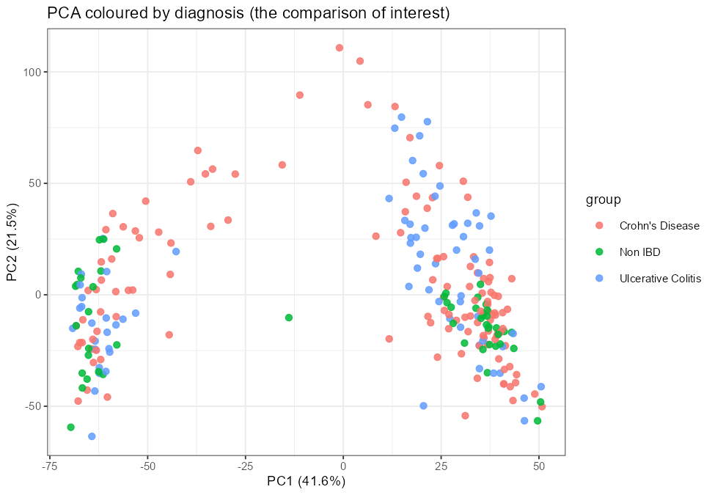
Figure 1. PCA of log2(CPM+1) on the 2,000 most variable genes, coloured by diagnosis - the comparison of interest. The three groups are intermixed along PC1: diagnosis is not the dominant axis of variation (PC1 versus diagnosis, p = 0.545).
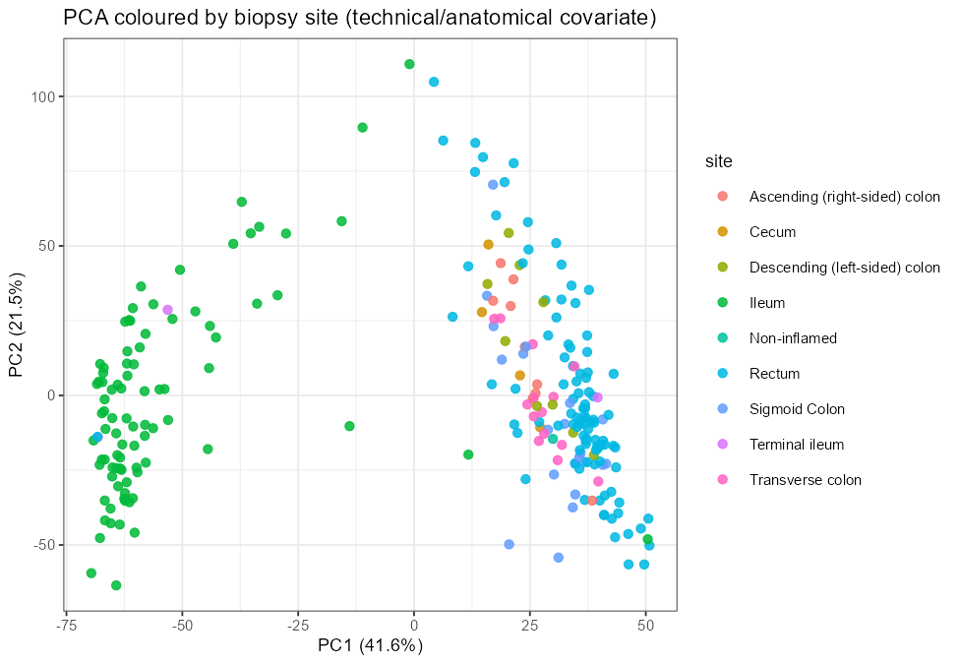
Figure 2. The same PCA coloured by biopsy site. PC1 (41.6 percent of variance) separates ileum from colon and rectum almost completely (PC1 versus site, p < 2e-16). The largest structure in this dataset is anatomical rather than clinical, which is exactly why a differential expression model here has to include biopsy site.
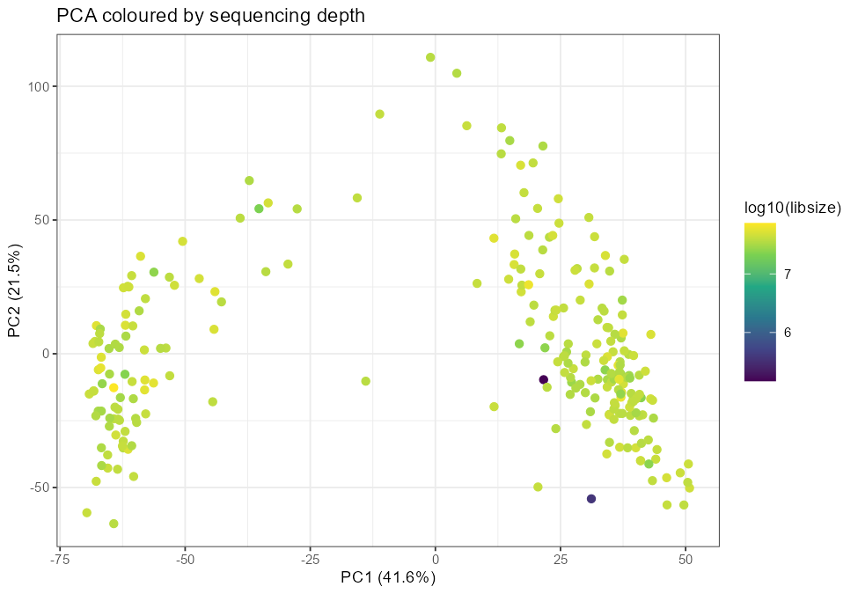
Figure 3. The same PCA coloured by log10 library size. There is no depth gradient along PC1 (r = -0.064), so the dominant axis is not a sequencing-depth artefact.
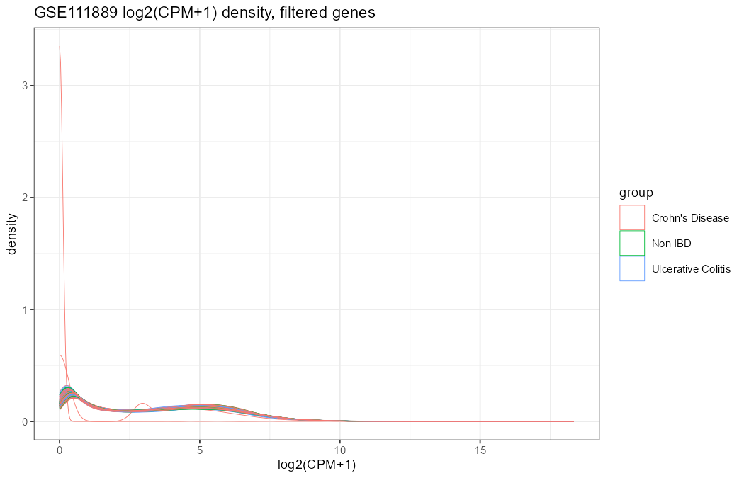
Figure 4. log2(CPM+1) density per sample after filtering. The curves are largely superimposed, indicating comparable distributions; the two zero-count libraries are absent by construction and the two very-low-depth libraries are the visibly outlying curves.
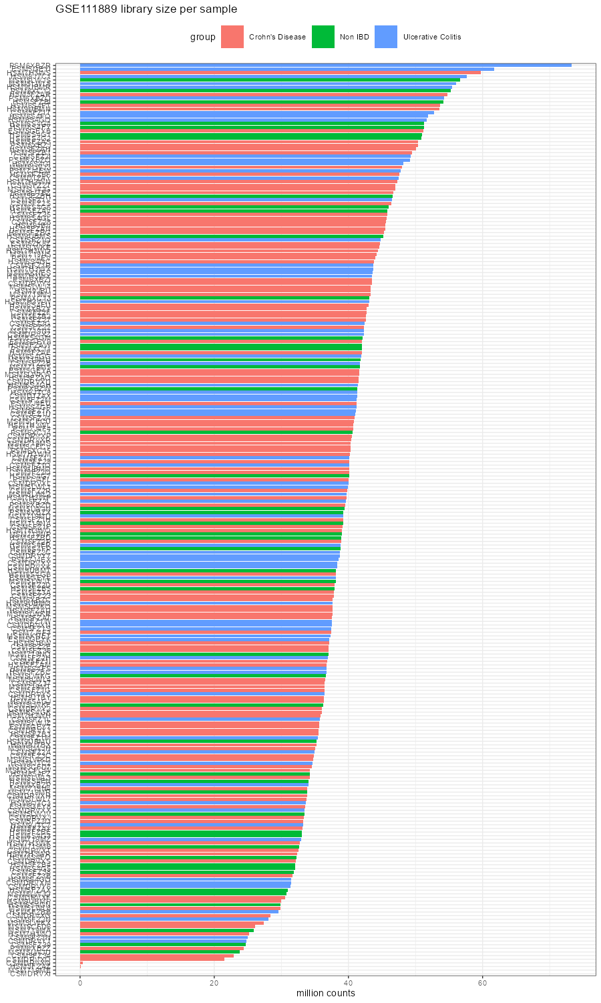
Figure 5. Library size per sample in millions of counts, ordered by depth and coloured by diagnosis. The two zero-depth samples appear as empty bars; depth is otherwise tightly distributed around 39 million.

4. Provenance record
GSE111889 counts file | GSE111889_host_tx_counts.tsv.gz
bytes / md5 | 11,130,307 | ff2ee7167b202448be2441e03b7ed996
source URL | https://ftp.ncbi.nlm.nih.gov/geo/series/GSE111nnn/GSE111889/suppl/GSE111889_host_tx_counts.tsv.gz
GSE111889 series matrix | GSE111889_series_matrix.txt.gz | 13,525 bytes
GSE87487 counts file | GSE87487_counts.20samples.txt.gz
bytes / md5 | 3,901,096 | 8efee79167460de2f5d66bead5187d60
GSE87487 series matrix | GSE87487_series_matrix.txt.gz | 2,833 bytes
Date accessed | 2026-09-10, Asia/Shanghai
Filter threshold | GSE111889: a gene is kept if it has at least 10 counts in at least 50 samples (50 = smallest group size)
Documented exclusions | GSE111889: CSMDRVXI and MSM719ME (zero-count libraries), from normalisation and PCA only
Software | R 4.6.1 (2026-06-24), GEOquery 2.80.0, Biobase 2.72.0, ggplot2 4.0.3; the full sessionInfo is in sessionInfo.txt and at the end of results/run_log.txt
Files produced | metadata/sample_dictionary.csv, metadata/GSE87487_sample_dictionary.csv, metadata/GSE111889_pheno_raw.csv, metadata/GSE111889_supp_manifest.csv, metadata/GSE87487_supp_manifest.csv, data_clean/counts_filtered.rds, results/library_sizes.csv, results/pca_coordinates.csv, results/excluded_samples.csv, results/pca_by_group.png, results/pca_by_site.png, results/pca_by_depth.png, results/qc_density.png, results/qc_library_size.png, results/run_log.txt

5. Corrections the data forced on my own preparation notes
I had two sets of preparation notes written before any download - a project README and a shorter quick-reference summary - and they disagreed with each other on three points. The GEO record settled every one of them in favour of the README; the errors below are the quick-reference version, and the fact that two of my own documents conflicted is precisely what made checking the primary record unavoidable. They are listed here rather than quietly fixed, because catching this kind of error is the point of the exercise.
# | What I had written | What the record says | How it was caught
1 | Publication: Anhe FF et al., Nature 2019 | !Series_pubmed_id is 31142855, which is Lloyd-Price J et al., Nature 2019; 569:655-662. The DOI I had recorded (10.1038/s41586-019-1237-2) does belong to Lloyd-Price - so the DOI was right and the author name attached to it was wrong. | Reading !Series_pubmed_id straight out of the series matrix header instead of trusting the note.
2 | BioProject PRJNA398089 | !Series_relation gives BioProject PRJNA438663. PRJNA398089 is not a fiction - it is the 16S amplicon BioProject for the same HMP2 cohort, which is the accession cited in the Priya et al. Week 2 paper. It is the wrong layer, not the wrong study: the host RNA-seq reads sit under PRJNA438663. | The same header, plus noticing that the two accessions belong to different assay layers of one cohort.
3 | 28 samples, 14 paired donor samples | 251 samples, GSM3043377 to GSM3043627 - and no donor or subject field exists in the GEO metadata at all, so no pairing can be asserted from GEO in the first place. | nrow(pData(eset)), plus a search of every characteristics column for a subject-like field.
4 | (not anticipated) one column per sample in the count matrix | The GSE87487 matrix has 21 numeric columns for 20 samples; the extra one is Length, a featureCounts gene-length annotation column. | Printing the column names and their column sums before using them - the Length column's sum of 133,873,265 is not a plausible library size.

6. Limitations
- GSE111889 subject IDs are not in GEO, so the repeated-measures structure cannot yet be specified. A differential expression result computed before joining the IBDMDB metadata would treat correlated biopsies as independent and understate the standard errors. This is the largest open item.
- GSE111889 raw reads are under dbGaP controlled access, so the upstream choices (hg19, TopHat 2.0.14, htseq-count 0.6.1) cannot be revisited without an application - the supplied counts have to be taken as given.
- Biopsy site is severely unbalanced: rectum 100 and ileum 89 against cecum 5, terminal ileum 3 and non-inflamed 1. A ~ site + diagnosis model will be poorly determined for the rare sites, so a practical analysis would restrict to rectum and ileum, or pool sites into colon versus ileum, and state which was done.
- One level of the biopsy-site variable, Non-inflamed (n = 1), describes inflammation status rather than an anatomical location, so the variable as distributed is not clean and would need recoding before modelling.
- PCA here was run on log2(CPM+1) purely for visualisation. It is not the input to any statistical test; a differential expression analysis would use the filtered raw counts with DESeq2's own variance-stabilising machinery. No ComBat or other batch correction was applied to data destined for testing.
- For GSE87487 only the count matrix and the metadata were verified; the study was not reanalysed, for the reason recorded in Table 1 question 4.

Appendix A. R scripts used
The working directory for all scripts is week3_project. Run order: R/00_setup.R once, then R/run_all.R, which sources 01 to 04 and captures every line of output to results/run_log.txt. These scripts were written for this assignment with AI assistance (Claude) and were run unmodified to produce every number in this report.
A.1 R/00_setup.R - one-time package installation and project folders
## 00_setup.R -- one-time package installation + project folders
## Week 3 homework | Zixuan Zeng (SUAT24000114)
## Run this ONCE. Safe to re-run: it skips anything already installed.

pkgs_cran <- c("ggplot2", "reshape2", "pheatmap")
pkgs_bioc <- c("GEOquery", "Biobase", "SummarizedExperiment")

if (!requireNamespace("BiocManager", quietly = TRUE))
install.packages("BiocManager", repos = "https://cloud.r-project.org")

need_cran <- pkgs_cran[!vapply(pkgs_cran, requireNamespace, logical(1), quietly = TRUE)]
if (length(need_cran))
install.packages(need_cran, repos = "https://cloud.r-project.org")

need_bioc <- pkgs_bioc[!vapply(pkgs_bioc, requireNamespace, logical(1), quietly = TRUE)]
if (length(need_bioc))
BiocManager::install(need_bioc, ask = FALSE, update = FALSE)

## project folders
for (d in c("data_raw", "data_clean", "metadata", "results", "R"))
dir.create(d, showWarnings = FALSE, recursive = TRUE)

cat("\n--- package status ---\n")
for (p in c(pkgs_cran, pkgs_bioc))
cat(sprintf("%-24s %s\n", p,
if (requireNamespace(p, quietly = TRUE))
paste("OK", as.character(packageVersion(p))) else "MISSING"))
cat("\n00_setup.R done\n")

A.2 R/utils_download.R - retry helpers, because this network resolves ftp.ncbi.nlm.nih.gov only intermittently
## utils_download.R -- resilient download helper
## Week 3 homework | Zixuan Zeng (SUAT24000114)
## This network resolves ftp.ncbi.nlm.nih.gov only intermittently
## ("Could not resolve hostname"). Every fetch is therefore retried with
## backoff instead of failing the whole pipeline on one bad DNS lookup.

robust_download <- function(url, dest, tries = 10, wait = 6, quiet = TRUE) {
options(timeout = 3600)
if (file.exists(dest) && file.size(dest) > 0) {
cat(" [cache] already on disk:", basename(dest),
file.size(dest), "bytes\n")
return(invisible(TRUE))
}
for (k in seq_len(tries)) {
r <- try(suppressWarnings(
download.file(url, dest, mode = "wb", quiet = quiet)),
silent = TRUE)
ok <- !inherits(r, "try-error") && file.exists(dest) && file.size(dest) > 0
if (ok) {
cat(" [ok] attempt", k, "->", basename(dest),
file.size(dest), "bytes\n")
return(invisible(TRUE))
}
if (file.exists(dest)) unlink(dest)
cat(" [retry", k, "of", tries, "] DNS/connection failed; waiting",
wait, "s\n")
Sys.sleep(wait)
}
stop("robust_download failed after ", tries, " attempts: ", url)
}

## GEOquery reuses a series matrix already present in destdir, so pre-fetching
## it with the retry helper makes getGEO() itself offline-safe.
prefetch_series_matrix <- function(gse, destdir = "data_raw", ...) {
stub <- paste0(substr(gse, 1, nchar(gse) - 3), "nnn")
url <- sprintf(
"https://ftp.ncbi.nlm.nih.gov/geo/series/%s/%s/matrix/%s_series_matrix.txt.gz",
stub, gse, gse)
dest <- file.path(destdir, paste0(gse, "_series_matrix.txt.gz"))
dir.create(destdir, showWarnings = FALSE, recursive = TRUE)
cat("prefetch series matrix:", url, "\n")
robust_download(url, dest, ...)
invisible(dest)
}

## The supplementary-file listing scrapes the same flaky host, so retry it too.
robust_supp_list <- function(gse, tries = 10, wait = 6) {
for (k in seq_len(tries)) {
s <- try(GEOquery::getGEOSuppFiles(gse, fetch_files = FALSE), silent = TRUE)
if (!inherits(s, "try-error") && !is.null(s) && NROW(s) > 0) {
cat(" [ok] supp listing on attempt", k, "->", NROW(s), "file(s)\n")
return(s)
}
cat(" [retry", k, "of", tries, "] supp listing empty/failed; waiting",
wait, "s\n")
Sys.sleep(wait)
}
stop("robust_supp_list failed for ", gse)
}

## getGEO(<accession>) always lists the remote matrix directory first, so it
## fails on a bad DNS lookup even when the file is already cached. Fetching the
## file ourselves (with retries) and handing GEOquery the local path via
## getGEO(filename=) removes that network dependency entirely.
load_series_matrix <- function(gse, destdir = "data_raw", ...) {
dest <- prefetch_series_matrix(gse, destdir, ...)
cat("parsing local series matrix:", dest, "\n")
e <- GEOquery::getGEO(filename = dest, getGPL = FALSE)
if (is.list(e) && !methods::is(e, "ExpressionSet")) e <- e[[1]]
cat(" parsed:", class(e), " dim:", paste(dim(e), collapse = " x "), "\n")
e
}

A.3 R/01_fetch.R - list supplementary files first, then fetch GSE111889
## 01_fetch.R -- fetch GSE111889 (Task A primary dataset) from GEO
## Week 3 homework | Zixuan Zeng (SUAT24000114)
## Principle from the lecture: LIST supplementary files first, decide, THEN download.

suppressPackageStartupMessages({
library(GEOquery)
library(Biobase)
})
source(file.path("R", "utils_download.R")) # retry helpers: this network's DNS is flaky
options(timeout = 3600) # 10.6 MB over a slow link needs more than the 60 s default
GSE <- "GSE111889"
for (d in c("data_raw", "data_clean", "metadata", "results")) dir.create(d, showWarnings = FALSE)

cat("\n================ STEP 1: list supplementary files (no download) ================\n")
supp <- robust_supp_list(GSE)
print(supp[, intersect(c("fname", "size", "url"), colnames(supp))])
write.csv(supp, file.path("metadata", paste0(GSE, "_supp_manifest.csv")), row.names = FALSE)

cat("\n================ STEP 2: download the series matrix (metadata layer) ==========\n")
eset <- load_series_matrix(GSE, "data_raw")
cat("class:", class(eset), "\n")
cat("dim (features x samples):", paste(dim(eset), collapse = " x "), "\n")
cat("platform:", unique(as.character(eset$platform_id)), "\n")

pheno <- as.data.frame(pData(eset))
cat("n samples in series matrix:", nrow(pheno), "\n")
cat("GSM range:", pheno$geo_accession[1], "...", pheno$geo_accession[nrow(pheno)], "\n")
cat("\n-- phenoData columns --\n"); print(colnames(pheno))
cat("\n-- first 3 sample titles --\n"); print(head(pheno$title, 3))
cat("\n-- characteristics columns, first sample --\n")
ch <- grep("^characteristics_ch1", colnames(pheno), value = TRUE)
for (c1 in ch) cat(sprintf(" %-24s : %s\n", c1, as.character(pheno[1, c1])))
cat("\n-- relation fields (BioProject / SRA links) --\n")
rel <- grep("^relation", colnames(pheno), value = TRUE)
for (r in rel) cat(sprintf(" %-24s : %s\n", r, as.character(pheno[1, r])))
cat("\n-- supplementary_file_1 of first 2 samples (raw-read layer) --\n")
sfc <- grep("^supplementary_file", colnames(pheno), value = TRUE)
if (length(sfc)) print(head(pheno[, sfc[1], drop = FALSE], 2))

cat("\n-- does the series matrix itself carry an expression table? --\n")
em <- exprs(eset)
cat("exprs() dim:", paste(dim(em), collapse = " x "),
" (0 rows means: NO data table in the series matrix -> counts must come from the",
"supplementary file. This is itself an answer for Table 0 Step 4.)\n")

write.csv(pheno, file.path("metadata", paste0(GSE, "_pheno_raw.csv")), row.names = FALSE)

cat("\n================ STEP 3: download the supplementary count matrix ===============\n")
i <- grep("host_tx_counts", supp$fname)
if (!length(i)) i <- grep("counts", supp$fname)[1]
stopifnot(length(i) >= 1)
i <- i[1]
target <- file.path("data_raw", supp$fname[i])
cat("chosen file :", supp$fname[i], "\n")
cat("reported size:", as.character(supp$size[i]), "bytes\n")
cat("url :", as.character(supp$url[i]), "\n")
robust_download(as.character(supp$url[i]), target)
cat("downloaded bytes:", file.size(target), "\n")
cat("md5 :", unname(tools::md5sum(target)), "\n")
cat("download date :", format(Sys.time(), "%Y-%m-%d %H:%M:%S %Z"), "\n")

saveRDS(list(eset = eset, pheno = pheno, supp = supp, counts_file = target,
md5 = unname(tools::md5sum(target)),
fetched_at = format(Sys.time(), "%Y-%m-%d %H:%M:%S %Z")),
file.path("data_clean", "01_fetch_objects.rds"))

cat("\n01_fetch.R done. Provenance saved to data_clean/01_fetch_objects.rds\n")

A.4 R/02_inspect_clean.R - integrity checks, ID mapping, low-count filter
## 02_inspect_clean.R -- integrity checks, metadata alignment, low-count filter
## Week 3 homework | Zixuan Zeng (SUAT24000114)

suppressPackageStartupMessages({ library(Biobase) })
obj <- readRDS(file.path("data_clean", "01_fetch_objects.rds"))
pheno <- obj$pheno
cfile <- obj$counts_file

cat("\n================ READ THE SUPPLEMENTARY COUNT MATRIX ================\n")
cat("file:", cfile, " md5:", obj$md5, "\n")
raw <- read.delim(gzfile(cfile), header = TRUE, check.names = FALSE,
row.names = 1, stringsAsFactors = FALSE)
expr <- as.matrix(raw)
cat("dim (genes x samples):", paste(dim(expr), collapse = " x "), "\n")
cat("gene ID examples :", paste(head(rownames(expr), 4), collapse = ", "), "\n")
cat("column examples :", paste(head(colnames(expr), 4), collapse = ", "), "\n")
cat("storage mode :", storage.mode(expr), "\n")

cat("\n================ 5 INTEGRITY CHECKS (stopifnot = failures are LOUD) =========\n")
## 1. duplicated sample columns
cat("1. duplicated sample columns :", anyDuplicated(colnames(expr)), "(0 = none)\n")
stopifnot(!anyDuplicated(colnames(expr)))
## 2. duplicated / missing gene IDs
cat("2. duplicated gene IDs :", anyDuplicated(rownames(expr)), "(0 = none)\n")
cat(" NA values in matrix :", sum(is.na(expr)), "\n")
stopifnot(!anyDuplicated(rownames(expr)))
## 3. ARE THE VALUES COUNTS? (integer test -- Table 1 Q1 logic applied to Task A too)
is_int <- all(expr == floor(expr), na.rm = TRUE)
cat("3. all values integers? :", is_int, "\n")
cat(" min / max :", min(expr, na.rm = TRUE), "/", max(expr, na.rm = TRUE), "\n")
cat(" any negative? :", any(expr < 0, na.rm = TRUE), "\n")
print(summary(as.vector(expr[, 1:min(5, ncol(expr))])))
if (!is_int) cat(" !! NOT integers -> these are normalized values, NOT raw counts.",
"Report this honestly; do NOT round them.\n")
## 4. dimensions vs metadata
cat("4. ncol(expr) =", ncol(expr), " vs nrow(pheno) =", nrow(pheno), "\n")

cat("\n================ MAP COUNT COLUMNS TO GSM METADATA ================\n")
cn <- colnames(expr)
key <- list(title = as.character(pheno$title),
geo = as.character(pheno$geo_accession),
desc = if ("description" %in% colnames(pheno)) as.character(pheno$description) else NA)
hits <- vapply(key, function(k) sum(cn %in% k), integer(1))
print(hits)
use <- names(which.max(hits))
cat("best matching metadata column:", use, "-> matched", max(hits), "of", ncol(expr), "columns\n")
if (max(hits) == 0) {
cat("!! No exact match. Showing both sides so the mapping can be built by hand:\n")
print(head(cn, 10)); print(head(key$title, 10))
stop("Stopping: sample-ID mapping must be resolved before any analysis (lecture pitfall #6).")
}
mkey <- key[[use]]
ord <- match(cn, mkey)
meta <- pheno[ord, , drop = FALSE]
keep_s <- !is.na(ord)
cat("samples with metadata:", sum(keep_s), " | without:", sum(!keep_s), "\n")
expr <- expr[, keep_s, drop = FALSE]
meta <- meta[keep_s, , drop = FALSE]
rownames(meta) <- colnames(expr)

## 5. order must be identical -- never assume
cat("5. identical(colnames(expr), rownames(meta)) :",
identical(colnames(expr), rownames(meta)), "\n")
stopifnot(identical(colnames(expr), rownames(meta)))

cat("\n================ BUILD THE SAMPLE DICTIONARY (design reconstruction) ========\n")
ch <- grep("^characteristics_ch1", colnames(meta), value = TRUE)
getch <- function(tag) {
out <- rep(NA_character_, nrow(meta))
for (c1 in ch) {
v <- as.character(meta[[c1]])
j <- grepl(tag, v, ignore.case = TRUE) & is.na(out)
out[j] <- trimws(sub("^[^:]*:\\s*", "", v[j]))
}
out
}
dict <- data.frame(
sample_col = colnames(expr),
gsm = as.character(meta$geo_accession),
title = as.character(meta$title),
diagnosis = getch("diagnosis|disease"),
subject_id = getch("subject|participant|patient|donor"),
biopsy_site = getch("biopsy|location|site|tissue"),
visit_week = getch("week|visit|time"),
sex = getch("sex|gender"),
age = getch("age"),
stringsAsFactors = FALSE
)
cat("\n-- group sizes (diagnosis) --\n"); print(table(dict$diagnosis, useNA = "ifany"))
cat("\n-- biopsy site --\n"); print(table(dict$biopsy_site, useNA = "ifany"))
cat("\n-- unique subjects --\n"); cat(length(unique(na.omit(dict$subject_id))), "\n")
cat("\n-- samples per subject (repeated-measures / paired structure) --\n")
print(table(table(dict$subject_id[!is.na(dict$subject_id)])))
cat("\n-- head of dictionary --\n"); print(head(dict, 5))
write.csv(dict, file.path("metadata", "sample_dictionary.csv"), row.names = FALSE)

cat("\n================ LOW-COUNT FILTER ================\n")
min_count <- 10
min_samp <- max(3, min(table(dict$diagnosis, useNA = "no")))
cat("threshold: >=", min_count, "counts in >=", min_samp,
"samples (min_samp = smallest group size, floor 3)\n")
keep <- rowSums(expr >= min_count) >= min_samp
expr_f <- expr[keep, , drop = FALSE]
cat(sprintf("genes retained: %d of %d (%.1f%%); removed %d\n",
nrow(expr_f), nrow(expr), 100 * nrow(expr_f) / nrow(expr),
nrow(expr) - nrow(expr_f)))
cat("all-zero genes before filtering:", sum(rowSums(expr) == 0), "\n")

saveRDS(list(counts = expr_f, meta = meta, dict = dict,
is_integer = is_int, min_count = min_count, min_samp = min_samp,
n_genes_before = nrow(expr), n_genes_after = nrow(expr_f),
md5 = obj$md5, fetched_at = obj$fetched_at),
file.path("data_clean", "counts_filtered.rds"))
cat("\n02_inspect_clean.R done -> data_clean/counts_filtered.rds\n")

A.5 R/03_qc.R - library size, distribution, PCA by group, site and depth
## 03_qc.R -- library size, distribution, PCA by group and by batch/covariate
## Week 3 homework | Zixuan Zeng (SUAT24000114)
## Normalization here is for VISUALIZATION ONLY. Statistics stay on raw counts.

suppressPackageStartupMessages({ library(ggplot2) })
obj <- readRDS(file.path("data_clean", "counts_filtered.rds"))
counts <- obj$counts
dict <- obj$dict
dir.create("results", showWarnings = FALSE)

cat("\n================ LIBRARY SIZE ================\n")
lib <- data.frame(sample = colnames(counts), libsize = colSums(counts),
group = dict$diagnosis, stringsAsFactors = FALSE)
print(summary(lib$libsize))
cat("min / median / max library size:",
format(c(min(lib$libsize), median(lib$libsize), max(lib$libsize)), big.mark = ","), "\n")
cat("fold range (max/min):", round(max(lib$libsize) / min(lib$libsize), 1), "\n")
low <- lib[lib$libsize < 0.5 * median(lib$libsize), ]
cat("samples below 50% of median depth (flag, do NOT delete):", nrow(low), "\n")
if (nrow(low)) print(low[order(low$libsize), ])
write.csv(lib, "results/library_sizes.csv", row.names = FALSE)

p1 <- ggplot(lib, aes(x = reorder(sample, libsize), y = libsize / 1e6, fill = group)) +
geom_col() + coord_flip() +
labs(title = "GSE111889 library size per sample", x = NULL, y = "million counts") +
theme_bw(base_size = 7) + theme(legend.position = "top")
ggsave("results/qc_library_size.png", p1, width = 6, height = 10, dpi = 150)

cat("\n================ ZERO-DEPTH SAMPLES: DOCUMENT BEFORE EXCLUDING ================\n")
## A sample with 0 total counts cannot be CPM-normalised (0/0 -> NaN) and would
## crash PCA. Per the lecture: never silently drop a sample. Every exclusion is
## logged, such samples stay in the library-size figure above, and they are
## excluded ONLY from the normalisation-dependent plots below.
zero_s <- colnames(counts)[colSums(counts) == 0]
cat("samples with ZERO total counts after filtering:", length(zero_s), "\n")
excl <- data.frame(sample = zero_s,
gsm = dict$gsm[match(zero_s, dict$sample_col)],
diagnosis = dict$diagnosis[match(zero_s, dict$sample_col)],
reason = rep("zero total counts; cannot be CPM-normalised",
length(zero_s)),
stringsAsFactors = FALSE)
if (nrow(excl)) print(excl)
write.csv(excl, "results/excluded_samples.csv", row.names = FALSE)
cat("-> results/excluded_samples.csv written (declare these in the report)\n")
cat("very low depth (<50% of median) but RETAINED:",
paste(setdiff(low$sample, zero_s), collapse = ", "), "\n")

keep_n <- colSums(counts) > 0
counts <- counts[, keep_n, drop = FALSE]
dict <- dict[keep_n, , drop = FALSE]
stopifnot(identical(colnames(counts), dict$sample_col))
cat("samples carried into normalisation/PCA:", ncol(counts), "of",
length(keep_n), "\n")

cat("\n================ DISTRIBUTION (log2 CPM density) ================\n")
cpm <- t(t(counts) / colSums(counts)) * 1e6
logcpm <- log2(cpm + 1)
df <- data.frame(value = as.vector(logcpm),
sample = rep(colnames(logcpm), each = nrow(logcpm)),
group = rep(dict$diagnosis, each = nrow(logcpm)))
p2 <- ggplot(df, aes(value, group = sample, colour = group)) +
geom_density(alpha = .3, linewidth = .2) +
labs(title = "GSE111889 log2(CPM+1) density, filtered genes", x = "log2(CPM+1)") +
theme_bw(base_size = 9)
ggsave("results/qc_density.png", p2, width = 7, height = 4.5, dpi = 150)
cat("density plot written. Any single curve far from the bulk = candidate outlier.\n")

cat("\n================ PCA (on log2 CPM, visualization only) ================\n")
v <- apply(logcpm, 1, var)
top <- head(order(v, decreasing = TRUE), 2000)
pca <- prcomp(t(logcpm[top, ]), center = TRUE, scale. = FALSE)
pv <- round(100 * pca$sdev^2 / sum(pca$sdev^2), 1)
cat("variance explained PC1-PC4:", paste0(pv[1:4], "%", collapse = " "), "\n")

pdf_df <- data.frame(PC1 = pca$x[, 1], PC2 = pca$x[, 2],
sample = rownames(pca$x),
group = dict$diagnosis, site = dict$biopsy_site,
subject = dict$subject_id, libsize = colSums(counts))

mk <- function(colvar, ttl) {
ggplot(pdf_df, aes(PC1, PC2, colour = .data[[colvar]])) +
geom_point(size = 1.8, alpha = .85) +
labs(title = ttl, x = paste0("PC1 (", pv[1], "%)"), y = paste0("PC2 (", pv[2], "%)"),
colour = colvar) +
theme_bw(base_size = 9)
}
ggsave("results/pca_by_group.png", mk("group", "PCA coloured by diagnosis (the comparison of interest)"),
width = 6.5, height = 4.5, dpi = 150)
ggsave("results/pca_by_site.png", mk("site", "PCA coloured by biopsy site (technical/anatomical covariate)"),
width = 6.5, height = 4.5, dpi = 150)
p5 <- ggplot(pdf_df, aes(PC1, PC2, colour = log10(libsize))) + geom_point(size = 1.8) +
scale_colour_viridis_c() +
labs(title = "PCA coloured by sequencing depth", x = paste0("PC1 (", pv[1], "%)"),
y = paste0("PC2 (", pv[2], "%)")) + theme_bw(base_size = 9)
ggsave("results/pca_by_depth.png", p5, width = 6.5, height = 4.5, dpi = 150)

cat("\n-- association of PC1/PC2 with candidate drivers (ANOVA p-values) --\n")
for (vn in c("group", "site")) {
x <- pdf_df[[vn]]
if (length(unique(na.omit(x))) > 1) {
for (pc in c("PC1", "PC2")) {
p <- tryCatch(summary(aov(pdf_df[[pc]] ~ factor(x)))[[1]][["Pr(>F)"]][1],
error = function(e) NA)
cat(sprintf(" %s ~ %-6s : p = %s\n", pc, vn, format.pval(p, digits = 3)))
}
}
}
cat(" PC1 ~ log10(libsize) : r =",
round(cor(pdf_df$PC1, log10(pdf_df$libsize)), 3), "\n")

write.csv(pdf_df, "results/pca_coordinates.csv", row.names = FALSE)
writeLines(capture.output(sessionInfo()), "sessionInfo.txt")
cat("\n03_qc.R done. Figures in results/ ; sessionInfo.txt written\n")

A.6 R/04_minicase_GSE87487.R - Task B mini-case, the evidence behind Table 1
## 04_minicase_GSE87487.R -- Task B mini-case: verify the instructor's claims
## Week 3 homework | Zixuan Zeng (SUAT24000114)
## Purpose: answer Table 1 with EVIDENCE, not assumption.
## Q1 are values counts? -> download the supplementary matrix, test integers
## Q2 independent? -> read the metadata, look for donor/subject pairing
## Q3 all 20 comparable? -> inspect the actual factor combinations
## Q4 raw-read reprocessing? -> confirm the SRA link exists

suppressPackageStartupMessages({ library(GEOquery); library(Biobase) })
source(file.path("R", "utils_download.R"))
options(timeout = 3600)
GSE <- "GSE87487"
for (d in c("data_raw", "metadata", "results")) dir.create(d, showWarnings = FALSE)

cat("\n================ supplementary file inventory ================\n")
supp <- robust_supp_list(GSE)
print(supp[, intersect(c("fname", "size", "url"), colnames(supp))])
write.csv(supp, file.path("metadata", paste0(GSE, "_supp_manifest.csv")), row.names = FALSE)

cat("\n================ series metadata ================\n")
e <- load_series_matrix(GSE, "data_raw")
ph <- as.data.frame(pData(e))
cat("n samples:", nrow(ph), "\n")
cat("GSM range:", ph$geo_accession[1], "...", ph$geo_accession[nrow(ph)], "\n")
cat("platform :", unique(as.character(ph$platform_id)), "\n")
cat("\n-- titles (pre/post pairing is usually visible here) --\n")
print(data.frame(gsm = ph$geo_accession, title = ph$title), right = FALSE)
cat("\n-- characteristics --\n")
for (c1 in grep("^characteristics_ch1", colnames(ph), value = TRUE))
print(table(as.character(ph[[c1]]), useNA = "ifany"))
cat("\n-- relation (SRA / BioProject) --\n")
for (r in grep("^relation", colnames(ph), value = TRUE))
print(unique(as.character(ph[[r]])))
write.csv(ph, file.path("metadata", paste0(GSE, "_pheno_raw.csv")), row.names = FALSE)

cat("\n================ Q1: ARE THE VALUES COUNTS? ================\n")
i <- grep("count", supp$fname, ignore.case = TRUE)[1]
if (is.na(i)) i <- 1
tgt <- file.path("data_raw", supp$fname[i])
cat("file:", supp$fname[i], " reported size:", as.character(supp$size[i]), "bytes\n")
robust_download(as.character(supp$url[i]), tgt)
cat("bytes on disk:", file.size(tgt), " md5:", unname(tools::md5sum(tgt)), "\n")
cat("download date:", format(Sys.time(), "%Y-%m-%d %H:%M:%S %Z"), "\n")

m <- read.delim(gzfile(tgt), header = TRUE, check.names = FALSE,
row.names = 1, stringsAsFactors = FALSE)
num <- m[, vapply(m, is.numeric, logical(1)), drop = FALSE]

## TRAP: featureCounts exports gene annotation columns alongside the samples.
## Here the first column is "Length" (a gene length in bp, colSum 1.3e8) --
## numeric, but NOT a library. Treating it as a sample would corrupt every
## downstream normalisation. Drop annotation columns explicitly.
fc_meta <- c("Length", "Chr", "Start", "End", "Strand", "gene_length", "width")
drop_i <- colnames(num) %in% fc_meta
cat("non-sample annotation columns found:",
paste(colnames(num)[drop_i], collapse = ", "),
"-> dropped\n")
num <- num[, !drop_i, drop = FALSE]
mm <- as.matrix(num)
cat("dim (genes x samples):", paste(dim(mm), collapse = " x "), "\n")
cat("columns:", paste(colnames(mm), collapse = ", "), "\n")
cat("gene IDs:", paste(head(rownames(mm), 3), collapse = ", "), "\n")
cat("ALL INTEGER? ->", all(mm == floor(mm), na.rm = TRUE), "\n")
cat("min:", min(mm, na.rm = TRUE), " max:", max(mm, na.rm = TRUE),
" any negative:", any(mm < 0, na.rm = TRUE),
" any fractional:", any(mm != floor(mm), na.rm = TRUE), "\n")
cat("column sums (library sizes):\n"); print(colSums(mm))
print(summary(as.vector(mm[, 1:min(4, ncol(mm))])))

cat("\n================ Q2/Q3: RECONSTRUCT THE PAIRED DESIGN ================\n")
## Map count columns to GSMs. The two naming schemes do NOT match verbatim:
## count column : "Sample_Pt10-Bx1.bam"
## GEO title : "Pt10Bx1"
## so both sides are normalised (drop prefix/suffix, hyphens, case) first.
norm_id <- function(x) toupper(gsub("[^A-Za-z0-9]", "",
sub(".bam", "", sub("^Sample_", "", x), fixed = TRUE)))
cn_n <- norm_id(colnames(mm))
ti_n <- norm_id(as.character(ph$title))
ord <- match(cn_n, ti_n)
cat("count columns matched to a GSM:", sum(!is.na(ord)), "of", length(cn_n), "\n")
if (any(is.na(ord))) {
cat("!! unmatched columns:", paste(colnames(mm)[is.na(ord)], collapse = ", "), "\n")
cat(" GEO titles were:", paste(ph$title, collapse = ", "), "\n")
}

getch2 <- function(tag) {
out <- rep(NA_character_, nrow(ph))
for (c1 in grep("^characteristics_ch1", colnames(ph), value = TRUE)) {
v <- as.character(ph[[c1]])
j <- grepl(tag, v, ignore.case = TRUE) & is.na(out)
out[j] <- trimws(sub("^[^:]*: *", "", v[j]))
}
out
}
stage <- getch2("transplant stage")
iri <- getch2("ischemia|iri")

## donor = title with the trailing Bx1/Bx2 removed
donor_of <- function(t) toupper(gsub("[^A-Za-z0-9]", "",
sub("B[xX][12]$", "", t)))
d87 <- data.frame(
count_column = colnames(mm),
gsm = as.character(ph$geo_accession)[ord],
geo_title = as.character(ph$title)[ord],
donor = donor_of(as.character(ph$title)[ord]),
stage = stage[ord],
iri = iri[ord],
libsize = colSums(mm),
stringsAsFactors = FALSE
)
print(d87, right = FALSE)
write.csv(d87, file.path("metadata", "GSE87487_sample_dictionary.csv"), row.names = FALSE)

cat("\n-- Q2: are samples independent? --\n")
cat("unique donors:", length(unique(d87$donor)), " samples:", nrow(d87), "\n")
cat("samples per donor:\n"); print(table(table(d87$donor)))
cat("=> ", nrow(d87), "samples come from only", length(unique(d87$donor)),
"donors: the samples are NOT independent.\n")

cat("\n-- Q3: is every one of the 20 directly comparable? --\n")
cat("stage x IRI cross-tabulation:\n")
print(table(stage = d87$stage, iri = d87$iri, useNA = "ifany"))
cat("donor x stage completeness (1 = present):\n")
print(table(donor = d87$donor, stage = d87$stage))
cat("library size range:", format(range(d87$libsize), big.mark = ","),
" fold:", round(max(d87$libsize) / min(d87$libsize), 2), "\n")

cat("\n-- Q4: is raw-read reprocessing possible? --\n")
sra <- unlist(lapply(grep("^relation", colnames(ph), value = TRUE),
function(r) grep("SRA|SRX", as.character(ph[[r]]), value = TRUE)))
cat("per-sample SRA experiment links found:", length(sra), "of", nrow(ph), "\n")
if (length(sra)) cat("example:", sra[1], "\n")
cat("=> raw reads are openly accessible for this study (contrast with GSE111889,\n")
cat(" whose Series states raw data go to dbGaP under controlled access).\n")

cat("\n04_minicase_GSE87487.R done\n")

A.7 R/run_all.R - pipeline runner and log capture
## run_all.R -- run the whole pipeline and capture ONE log file to hand back
## Week 3 homework | Zixuan Zeng (SUAT24000114)
## In RStudio: Session > Set Working Directory > To Source File Location's PARENT
## (working directory must be week3_project), then: source("R/run_all.R")

stopifnot(dir.exists("R"))
dir.create("results", showWarnings = FALSE)
log_file <- file.path("results", "run_log.txt")
con <- file(log_file, open = "wt")
sink(con, split = TRUE); sink(con, type = "message")

cat("### Week 3 pipeline run\n")
cat("started :", format(Sys.time(), "%Y-%m-%d %H:%M:%S %Z"), "\n")
cat("R :", R.version.string, "\n")
cat("wd :", getwd(), "\n")

for (s in c("R/01_fetch.R", "R/02_inspect_clean.R", "R/03_qc.R", "R/04_minicase_GSE87487.R")) {
cat("\n\n##############################################################\n")
cat("### SOURCING", s, "\n")
cat("##############################################################\n")
res <- try(source(s, echo = FALSE), silent = TRUE)
if (inherits(res, "try-error")) cat("\n!!! ERROR in", s, ":\n", conditionMessage(attr(res, "condition")), "\n")
}

cat("\n\n### sessionInfo\n")
print(sessionInfo())
cat("\nfinished:", format(Sys.time(), "%Y-%m-%d %H:%M:%S %Z"), "\n")
sink(type = "message"); sink(); close(con)
cat("\nDONE. Send back:", log_file, "and the PNGs in results/\n")

