Emotive Rhetoric in the House of Commons Before and After the Brexit Referendum: A Dictionary-Based Analysis of Parliamentary Debate
2026-04-20
# load all required packages
library(tidyverse) # core data wrangling and ggplot2 visualisation
library(data.table) # fast reading of large csv files
library(tidytext) # tidy text mining framework (Silge and Robinson 2017)
library(quanteda) # quantitative text analysis infrastructure
library(quanteda.textstats) # readability scores and text-level statistics
library(scales) # improved axis label formatting for ggplot2
library(textdata) # provides access to sentiment lexicons (e.g. Bing)
# set a temporary directory for package downloads (specific to my laptop)
Sys.setenv(TMPDIR = "C:/Temp")
dir.create("C:/Temp", showWarnings = FALSE)
# read UK parliamentary speech data from Osnabrugge et al. (2021)
# source: Harvard Dataverse (doi: 10.7910/DVN/QDTLYV)
# fread() from data.table is used for speed on this large csv file
data <- fread("uk_data.csv", encoding = "UTF-8")
# convert the date column from character to Date class
# required for all subsequent time-based filtering and grouping
data$date <- as.Date(data$date)
# verify successful data loading with basic summary statistics
cat("Total speeches:", nrow(data), "\n")
## Total speeches: 958925
cat("Variables:", ncol(data), "\n")
## Variables: 50
# confirm the temporal coverage of the datase
cat("Date range:", as.character(min(data$date, na.rm = TRUE)), "to",
as.character(max(data$date, na.rm = TRUE)), "\n")
## Date range: 2001-06-13 to 2019-11-05
# define the Brexit referendum date as the analytical cutpoint
brexit_date <- as.Date("2016-06-23") # referendum took place on 23 June 2016
# create a binary indicator for the post-referendum period
# post_brexit = 1 for speeches on or after referendum day, 0 otherwise
# period is a labelled version of the same variable for use in plots
data <- data %>%
mutate(
post_brexit = ifelse(date >= brexit_date, 1, 0), # binary indicator
period = ifelse(date >= brexit_date, "Post-Referendum", "Pre-Referendum") # labelled factor
)
# verify the split between pre- and post-referendum speeches
cat("Full data pre-referendum:", sum(data$post_brexit == 0), "\n")
## Full data pre-referendum: 751885
cat("Full data post-referendum:", sum(data$post_brexit == 1), "\n")
## Full data post-referendum: 207040
# draw a stratified random sample balanced across four cells:
# government x post_brexit (2 x 2 = 4 groups, 12500 speeches each)
# the seed is fixed at 12345 so the sample is fully reproducible
set.seed(12345)
data_samp <- data %>%
group_by(government, post_brexit) %>% # stratify by the two key variables
slice_sample(n = 12500) %>% # draw 12500 random rows per cell
ungroup() # remove grouping for later operations
# confirm sample size and verify equal cell sizes
cat("Sample size:", nrow(data_samp), "\n")
## Sample size: 50000
table(data_samp$government, data_samp$post_brexit)
##
## 0 1
## 0 12500 12500
## 1 12500 12500
# create time-related variables on the sampled data for trend analysis
data_samp$year <- as.numeric(format(data_samp$date, "%Y")) # calendar year
data_samp$month <- as.numeric(format(data_samp$date, "%m")) # month number
data_samp$year_month <- format(data_samp$date, "%Y-%m") # year-month label
# create labelled categorical variables for plotting and tables
data_samp <- data_samp %>%
mutate(
period = ifelse(date >= brexit_date, # period label
"Post-Referendum", "Pre-Referendum"),
side = ifelse(government == 1, "Government", "Opposition") # side label
)
# classify each speech into a debate type category
# used as a control variable in Model 3 to test H3
# case_when assigns the most specific category first
# speeches not matching any special type default to "Regular Debate"
data_samp <- data_samp %>%
mutate(debate_type = case_when(
pm_questions == 1 ~ "PMQs", # Prime Minister's Questions
m_questions == 1 ~ "Other Question Time", # other ministerial questions
u_questions == 1 ~ "Urgent Questions", # urgent questions
queen_debate_day1 == 1 ~ "Queen's Speech Opening", # Queen's Speech day 1
queen_debate_others == 1 ~ "Queen's Speech Other", # Queen's Speech other days
TRUE ~ "Regular Debate" # all remaining speeches
))
# load the domain-specific dictionaries from Osnabrugge et al. (2021)
# emotive_uk.csv: 2015 words classified as emotive in parliamentary speech
# neutral_uk.csv: 2095 words classified as neutral in parliamentary speech
emotive_words <- read.csv("emotive_uk.csv", stringsAsFactors = FALSE)
neutral_words <- read.csv("neutral_uk.csv", stringsAsFactors = FALSE)
# trim whitespace from word columns to prevent silent matching failures
emotive_words$word <- trimws(emotive_words$word)
neutral_words$word <- trimws(neutral_words$word)
# confirm the size of each dictionary
cat("Emotive dictionary size:", nrow(emotive_words), "words\n")
## Emotive dictionary size: 2015 words
cat("Neutral dictionary size:", nrow(neutral_words), "words\n")
## Neutral dictionary size: 2095 words
# tokenise all speech texts into one-word-per-row (tidy text) format
# unnest_tokens converts to lowercase automatically; stemming is not applied
# stop words are retained because they may overlap with dictionary entries
tidy_speeches <- data_samp %>%
select(id_speech, text, government, date, year, year_month,
post_brexit, period, side, debate_type) %>% # keep only needed columns
unnest_tokens(word, text) # one token per row individual words
# count total words in each speech for use as the denominato
words_per_speech <- tidy_speeches %>%
group_by(id_speech) %>% # group by speech identifier
summarise(total_words = n()) # count tokens per speech
# summary statistics on token counts
cat("Total tokens:", nrow(tidy_speeches), "\n")
## Total tokens: 8648834
cat("Mean words per speech:", round(mean(words_per_speech$total_words), 1), "\n")
## Mean words per speech: 173
# count emotive dictionary words per speech via inner_join
# inner_join keeps only tokens found in the emotive word list
emotive_counts <- tidy_speeches %>%
inner_join(emotive_words, by = "word") %>% # match tokens to emotive list
group_by(id_speech) %>% # group by speech
summarise(n_emotive = n()) # count matched emotive tokens
# count neutral dictionary words per speech using the same logic
neutral_counts <- tidy_speeches %>%
inner_join(neutral_words, by = "word") %>% # match tokens to neutral list
group_by(id_speech) %>% # group by speech
summarise(n_neutral = n()) # count matched neutral words
# combine counts with total words and compute the emotive rhetoric score
# score = (pct emotive) - (pct neutral), following Osnabrugge et al. (2021)
speech_scores <- words_per_speech %>%
left_join(emotive_counts, by = "id_speech") %>% # add emotive counts
left_join(neutral_counts, by = "id_speech") %>% # add neutral counts
mutate(
n_emotive = replace_na(n_emotive, 0), # zero if no emotive matches
n_neutral = replace_na(n_neutral, 0), # zero if no neutral matches
pct_emotive = (n_emotive / total_words) * 100, # emotive words as pct of total
pct_neutral = (n_neutral / total_words) * 100, # neutral words as pct of total
own_score = pct_emotive - pct_neutral # emotive rhetoric score
)
# merge scores into main dataframe
data_samp <- data_samp %>%
left_join(speech_scores %>% select(id_speech, own_score,
pct_emotive, pct_neutral,
total_words),
by = "id_speech")
# summary statistics for the computed emotive rhetoric score
summary(data_samp$own_score)
## Min. 1st Qu. Median Mean 3rd Qu. Max.
## -27.2727 -2.0833 0.0000 0.5505 3.1250 28.5714
# validate computed score against the authors' pre-calculated variable
# high correlation confirms our implementation replicates theirs
cor_val <- cor(data_samp$own_score, data_samp$emotive_rhetoric,
use = "complete.obs")
cat("Correlation with original authors' score:", round(cor_val, 4), "\n")
## Correlation with original authors' score: 0.9928
# Figure 1: yearly trend in emotive rhetoric score with referendum marker
# shows the mean own_score by calendar year with 95% confidence intervals
# compute yearly mean and standard error
yearly_trend <- data_samp %>%
group_by(year) %>% # group speeches by year
summarise(
mean_score = mean(own_score, na.rm = TRUE), # mean score per year
se = sd(own_score, na.rm = TRUE) / sqrt(n()), # standard error of the mean
.groups = "drop"
)
# plot the yearly trend as a line with confidence ribbon
ggplot(yearly_trend, aes(x = year, y = mean_score)) +
geom_line(colour = "steelblue", linewidth = 0.8) + # trend line
geom_point(colour = "steelblue", size = 2) + # annual data points
geom_ribbon(aes(ymin = mean_score - 1.96 * se, # lower 95% CI
ymax = mean_score + 1.96 * se), # upper 95% CI
alpha = 0.2, fill = "steelblue") +
geom_vline(xintercept = 2016.5, linetype = "dashed", # vertical referendum line
colour = "red") +
annotate("text", x = 2016.7, y = max(yearly_trend$mean_score),
label = "Referendum", hjust = 0, colour = "red", # label for referendum
size = 3.5) +
labs(x = "Year", y = "Mean Emotive Rhetoric Score") +
scale_x_continuous(breaks = seq(2002, 2019, by = 2)) + # x-axis tick marks
theme_minimal()
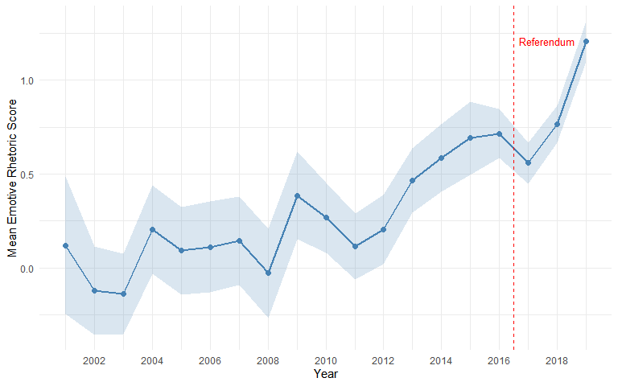
# formal comparison of emotive rhetoric before and after the referendum
# compute group means, standard deviations and 95% confidence intervals
period_comparison <- data_samp %>%
group_by(period) %>%
summarise(
mean_score = mean(own_score, na.rm = TRUE), # group mean
sd_score = sd(own_score, na.rm = TRUE), # standard deviation
n = n(), # group size
.groups = "drop"
) %>%
mutate(
se = sd_score / sqrt(n), # standard error
ci_lower = mean_score - 1.96 * se, # lower 95% CI
ci_upper = mean_score + 1.96 * se # upper 95% CI
)
period_comparison
## # A tibble: 2 × 7
## period mean_score sd_score n se ci_lower ci_upper
## <chr> <dbl> <dbl> <int> <dbl> <dbl> <dbl>
## 1 Post-Referendum 0.830 4.52 25000 0.0286 0.774 0.886
## 2 Pre-Referendum 0.271 4.34 25000 0.0274 0.217 0.325
# two-sample t-test comparing pre- and post-referendum scores
t_result <- t.test(own_score ~ post_brexit, data = data_samp)
cat("t-statistic:", round(t_result$statistic, 3), "\n")
## t-statistic: -14.1
cat("p-value:", format.pval(t_result$p.value, digits = 3), "\n")
## p-value: <2e-16
# Cohen's d as a standardised measure of effect size
# difference in means divided by the pooled standard deviation
pooled_sd <- sqrt(
(period_comparison$sd_score[1]^2 + period_comparison$sd_score[2]^2) / 2
)
cohens_d <- abs(diff(period_comparison$mean_score)) / pooled_sd
cat("Cohen's d:", round(cohens_d, 4), "\n")
## Cohen's d: 0.1261
# Figure 2: grouped bar chart comparing pre/post scores by government vs opposition
# tests H2 visually by showing whether the increase differs by side of the House
# compute group means and confidence intervals by period and side
period_by_side <- data_samp %>%
group_by(period, side) %>%
summarise(
mean_score = mean(own_score, na.rm = TRUE), # group mean
sd_score = sd(own_score, na.rm = TRUE), # group standard deviation
n = n(), # group size
.groups = "drop"
) %>%
mutate(
se = sd_score / sqrt(n), # standard error
ci_lower = mean_score - 1.96 * se, # lower CI bound
ci_upper = mean_score + 1.96 * se # upper CI bound
)
period_by_side
## # A tibble: 4 × 8
## period side mean_score sd_score n se ci_lower ci_upper
## <chr> <chr> <dbl> <dbl> <int> <dbl> <dbl> <dbl>
## 1 Post-Referendum Government 0.927 4.41 12500 0.0394 0.850 1.00
## 2 Post-Referendum Opposition 0.732 4.63 12500 0.0414 0.651 0.813
## 3 Pre-Referendum Government 0.313 4.29 12500 0.0384 0.238 0.388
## 4 Pre-Referendum Opposition 0.229 4.38 12500 0.0392 0.153 0.306
# create grouped bar chart
ggplot(period_by_side,
aes(x = period, y = mean_score, fill = side)) +
geom_bar(stat = "identity",
position = position_dodge(width = 0.7), width = 0.6) + # side-by-side bars
geom_errorbar(aes(ymin = ci_lower, ymax = ci_upper), # error bars
position = position_dodge(width = 0.7), width = 0.15) +
labs(x = "", y = "Mean Emotive Rhetoric Score", fill = "") +
scale_fill_manual(values = c("Government" = "steelblue", # colour scheme
"Opposition" = "indianred")) +
theme_minimal() +
theme(legend.position = "bottom")
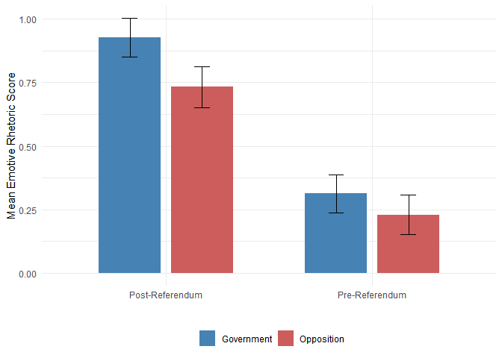
# three nested OLS regression models testing H1, H2 and H3
# Model 1: post_brexit only (tests H1)
model1 <- lm(own_score ~ post_brexit, data = data_samp)
# Model 2: adds government and its interaction with post_brexit (tests H2)
# a significant interaction would indicate asymmetric effects
model2 <- lm(own_score ~ post_brexit * government, data = data_samp)
# Model 3: adds debate type dummies as controls (tests H3)
# significant post_brexit here means the effect is not an artefact of debate mix
model3 <- lm(own_score ~ post_brexit * government + debate_type,
data = data_samp)
# print full summary for each model
cat("=== Model 1: Brexit effect only ===\n")
## === Model 1: Brexit effect only ===
summary(model1)
##
## Call:
## lm(formula = own_score ~ post_brexit, data = data_samp)
##
## Residuals:
## Min 1Q Median 3Q Max
## -27.5439 -2.5981 -0.2711 2.5424 28.3003
##
## Coefficients:
## Estimate Std. Error t value Pr(>|t|)
## (Intercept) 0.27114 0.02802 9.677 <2e-16 ***
## post_brexit 0.55868 0.03962 14.100 <2e-16 ***
## ---
## Signif. codes: 0 '***' 0.001 '**' 0.01 '*' 0.05 '.' 0.1 ' ' 1
##
## Residual standard error: 4.43 on 49998 degrees of freedom
## Multiple R-squared: 0.00396, Adjusted R-squared: 0.00394
## F-statistic: 198.8 on 1 and 49998 DF, p-value: < 2.2e-16
cat("\n=== Model 2: Brexit x Government interaction ===\n")
##
## === Model 2: Brexit x Government interaction ===
summary(model2)
##
## Call:
## lm(formula = own_score ~ post_brexit * government, data = data_samp)
##
## Residuals:
## Min 1Q Median 3Q Max
## -27.5856 -2.6104 -0.2294 2.5463 28.2586
##
## Coefficients:
## Estimate Std. Error t value Pr(>|t|)
## (Intercept) 0.22942 0.03962 5.791 7.06e-09 ***
## post_brexit 0.50294 0.05603 8.976 < 2e-16 ***
## government 0.08345 0.05603 1.489 0.136
## post_brexit:government 0.11148 0.07924 1.407 0.159
## ---
## Signif. codes: 0 '***' 0.001 '**' 0.01 '*' 0.05 '.' 0.1 ' ' 1
##
## Residual standard error: 4.43 on 49996 degrees of freedom
## Multiple R-squared: 0.004246, Adjusted R-squared: 0.004186
## F-statistic: 71.06 on 3 and 49996 DF, p-value: < 2.2e-16
cat("\n=== Model 3: With debate type controls ===\n")
##
## === Model 3: With debate type controls ===
summary(model3)
##
## Call:
## lm(formula = own_score ~ post_brexit * government + debate_type,
## data = data_samp)
##
## Residuals:
## Min 1Q Median 3Q Max
## -27.2865 -2.6112 -0.2819 2.5299 28.1935
##
## Coefficients:
## Estimate Std. Error t value Pr(>|t|)
## (Intercept) -0.08228 0.05218 -1.577 0.11485
## post_brexit 0.51235 0.05614 9.125 < 2e-16 ***
## government 0.09607 0.05604 1.714 0.08646 .
## debate_typePMQs 1.36975 0.11396 12.020 < 2e-16 ***
## debate_typeQueen's Speech Opening 2.27832 0.39885 5.712 1.12e-08 ***
## debate_typeQueen's Speech Other 0.45443 0.17977 2.528 0.01148 *
## debate_typeRegular Debate 0.36417 0.04536 8.029 1.00e-15 ***
## debate_typeUrgent Questions 0.28996 0.08986 3.227 0.00125 **
## post_brexit:government 0.12762 0.07916 1.612 0.10692
## ---
## Signif. codes: 0 '***' 0.001 '**' 0.01 '*' 0.05 '.' 0.1 ' ' 1
##
## Residual standard error: 4.421 on 49991 degrees of freedom
## Multiple R-squared: 0.008118, Adjusted R-squared: 0.00796
## F-statistic: 51.15 on 8 and 49991 DF, p-value: < 2.2e-16
# Figure 3: yearly trend split by government vs opposition
# this visualises whether the two sides diverge after the referendum
# compute yearly means separately for government and opposition
yearly_by_side <- data_samp %>%
group_by(year, side) %>%
summarise(
mean_score = mean(own_score, na.rm = TRUE), # mean per year per side
se = sd(own_score, na.rm = TRUE) / sqrt(n()), # standard error
.groups = "drop"
)
# plot two trend lines with referendum marker
ggplot(yearly_by_side, aes(x = year, y = mean_score, colour = side)) +
geom_line(linewidth = 0.8) + # trend lines
geom_point(size = 1.5) + # data points
geom_vline(xintercept = 2016.5, linetype = "dashed", colour = "grey40") +
annotate("text", x = 2016.7, y = max(yearly_by_side$mean_score),
label = "Referendum", hjust = 0, colour = "grey40", size = 3.5) +
labs(x = "Year", y = "Mean Emotive Rhetoric Score", colour = "") +
scale_colour_manual(values = c("Government" = "steelblue",
"Opposition" = "indianred")) +
scale_x_continuous(breaks = seq(2002, 2019, by = 2)) +
theme_minimal() +
theme(legend.position = "bottom")
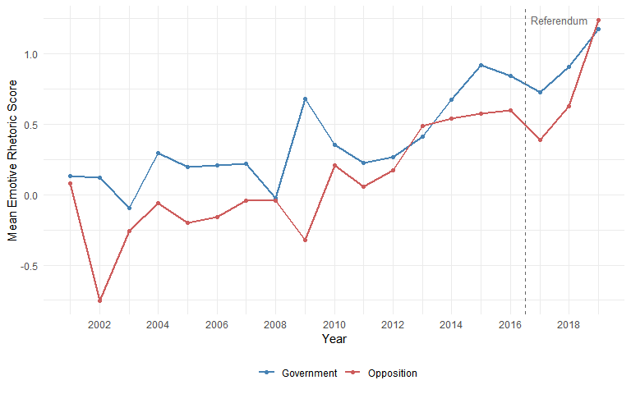
# Figure 4: quarterly trend zoomed in on the 2014-2019 period
# provides a closer view of the trajectory around the referendum date
# compute quarterly means for speeches from 2014 onward
quarterly <- data_samp %>%
filter(year >= 2014) %>% # restrict to 2014+
mutate(quarter = paste0(year, "-Q", ceiling(month / 3))) %>% # create quarter label
group_by(quarter) %>%
summarise(
mean_score = mean(own_score, na.rm = TRUE), # quarterly mean
se = sd(own_score, na.rm = TRUE) / sqrt(n()), # standard error
mid_date = median(date), # midpoint date for x-axis
.groups = "drop"
)
# plot quarterly trend with referendum marker and confidence ribbon
ggplot(quarterly, aes(x = mid_date, y = mean_score)) +
geom_line(colour = "steelblue", linewidth = 0.8) +
geom_point(colour = "steelblue", size = 2) +
geom_ribbon(aes(ymin = mean_score - 1.96 * se,
ymax = mean_score + 1.96 * se),
alpha = 0.2, fill = "steelblue") +
geom_vline(xintercept = brexit_date, # vertical referendum line
linetype = "dashed", colour = "red") +
annotate("text", x = brexit_date + 30,
y = max(quarterly$mean_score),
label = "23 June 2016", hjust = 0, colour = "red", size = 3.5) +
labs(x = "", y = "Mean Emotive Rhetoric Score") +
scale_x_date(date_labels = "%Y-%m", date_breaks = "6 months") +
theme_minimal() +
theme(axis.text.x = element_text(angle = 45, hjust = 1))
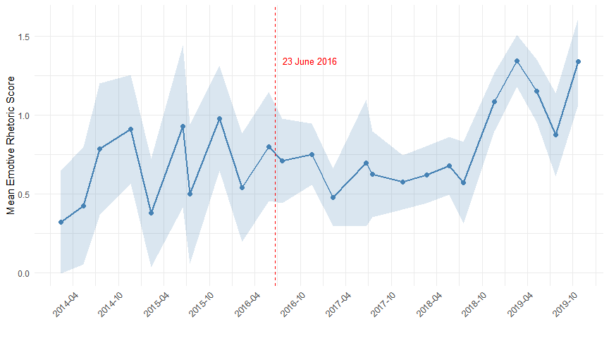
# analyse which emotive dictionary words shifted most after the referendum
# this helps interpret the substantive nature of the aggregate change
# count total tokens in each period for computing rates
total_pre <- tidy_speeches %>% filter(post_brexit == 0) %>% nrow() # total pre-ref tokens
total_post <- tidy_speeches %>% filter(post_brexit == 1) %>% nrow() # total post-ref tokens
# compute per-10,000-word rate for each emotive word in the pre-referendum period
emotive_pre <- tidy_speeches %>%
filter(post_brexit == 0) %>% # select pre-referendum tokens
inner_join(emotive_words, by = "word") %>% # match against emotive dictionary
count(word, sort = TRUE) %>% # count occurrences of each word
mutate(rate_pre = (n / total_pre) * 10000) %>% # normalise to rate per 10,000
select(word, rate_pre)
# same computation for the post-referendum period
emotive_post <- tidy_speeches %>%
filter(post_brexit == 1) %>% # select post-referendum tokens
inner_join(emotive_words, by = "word") %>% # match against emotive dictionary
count(word, sort = TRUE) %>% # count occurrences
mutate(rate_post = (n / total_post) * 10000) %>% # normalise to rate per 10,000
select(word, rate_post)
# join pre and post rates and compute the change for each word
word_shift <- emotive_pre %>%
inner_join(emotive_post, by = "word") %>% # merge pre and post rates
mutate(change = rate_post - rate_pre) %>% # difference in rates
arrange(desc(change)) # sort by largest increase
cat("Top 15 emotive words that increased most after the referendum:\n")
## Top 15 emotive words that increased most after the referendum:
head(word_shift, 15)
## # A tibble: 15 × 4
## word rate_pre rate_post change
## <chr> <dbl> <dbl> <dbl>
## 1 thank 3.30 6.26 2.96
## 2 house 21.2 23.7 2.43
## 3 agreement 2.44 4.87 2.43
## 4 women 3.27 5.58 2.31
## 5 free 2.26 3.32 1.06
## 6 violence 0.913 1.96 1.05
## 7 like 6.45 7.37 0.919
## 8 victims 1.21 2.10 0.893
## 9 people 35.4 36.2 0.830
## 10 committed 1.39 2.22 0.826
## 11 children 6.67 7.48 0.809
## 12 abuse 0.932 1.74 0.803
## 13 life 2.86 3.66 0.803
## 14 safe 0.803 1.58 0.779
## 15 prison 1.13 1.90 0.773
cat("\nTop 15 emotive words that decreased most after the referendum:\n")
##
## Top 15 emotive words that decreased most after the referendum:
tail(word_shift, 15)
## # A tibble: 15 × 4
## word rate_pre rate_post change
## <chr> <dbl> <dbl> <dbl>
## 1 achieve 1.72 1.33 -0.394
## 2 money 6.83 6.41 -0.416
## 3 debt 1.49 1.07 -0.423
## 4 waste 0.932 0.440 -0.493
## 5 poverty 2.08 1.58 -0.495
## 6 better 4.91 4.40 -0.511
## 7 effective 1.76 1.23 -0.532
## 8 understand 4.58 4.02 -0.557
## 9 difficult 3.32 2.61 -0.704
## 10 wrong 2.86 2.05 -0.809
## 11 child 3.23 2.22 -1.01
## 12 home 6.39 5.27 -1.12
## 13 hope 8.25 6.57 -1.68
## 14 energy 4.20 2.01 -2.19
## 15 problem 5.65 3.27 -2.38
# Figure 5: bar chart of the top 10 words that increased and decreased most
# select the top 10 increases and top 10 decreases
top_increase <- word_shift %>% head(10) %>% mutate(direction = "Increased")
top_decrease <- word_shift %>% tail(10) %>% mutate(direction = "Decreased")
shift_plot_data <- bind_rows(top_increase, top_decrease) # combine for plotting
# horizontal bar chart ordered by change magnitude
ggplot(shift_plot_data, aes(x = reorder(word, change), y = change,
fill = direction)) +
geom_bar(stat = "identity", width = 0.7) + # bars
coord_flip() + # horizontal layout
labs(x = "", y = "Change in Rate (per 10,000 words)", fill = "") +
scale_fill_manual(values = c("Increased" = "indianred",
"Decreased" = "steelblue")) +
theme_minimal() +
theme(legend.position = "bottom")
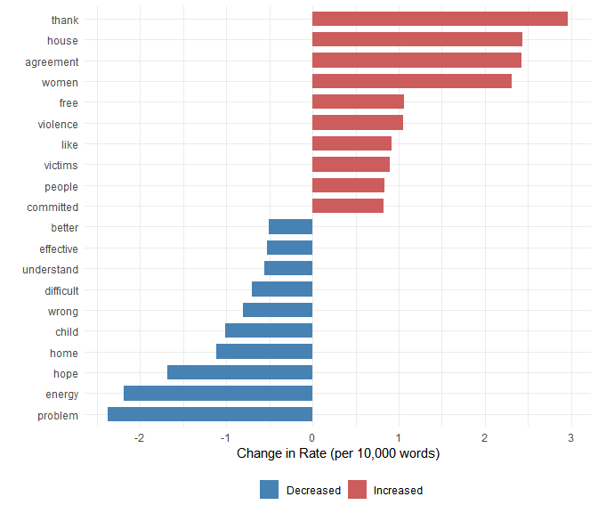
# SUPPLEMENTARY ANALYSIS: linguistic complexity (Week 4 method)
# compute Flesch-Kincaid readability score for each speech
# higher scores indicate easier (less complex) language
# this complements the emotive rhetoric measure by examining
# whether the post-referendum period also saw a change in complexity
# create a quanteda corpus object from the sampled speeches
corp_samp <- corpus(data_samp, text_field = "text")
# compute Flesch-Kincaid grade level for each speech
# textstat_readability is from the quanteda.textstats package (Week 4)
readability_scores <- textstat_readability(corp_samp,
measure = "Flesch.Kincaid")
# attach readability scores back to the main dataframe
data_samp$readability <- readability_scores$Flesch.Kincaid
# compare mean readability before and after the referendum
readability_comparison <- data_samp %>%
group_by(period) %>%
summarise(
mean_readability = mean(readability, na.rm = TRUE), # mean complexity score
sd_readability = sd(readability, na.rm = TRUE), # standard deviation
n = n(), # group size
.groups = "drop"
)
cat("Readability (Flesch-Kincaid) by period:\n")
## Readability (Flesch-Kincaid) by period:
readability_comparison
## # A tibble: 2 × 4
## period mean_readability sd_readability n
## <chr> <dbl> <dbl> <int>
## 1 Post-Referendum 65.4 99.4 25000
## 2 Pre-Referendum 74.7 114. 25000
# t-test for readability difference
t_read <- t.test(readability ~ post_brexit, data = data_samp)
cat("Readability t-statistic:", round(t_read$statistic, 3), "\n")
## Readability t-statistic: 9.713
cat("Readability p-value:", format.pval(t_read$p.value, digits = 3), "\n")
## Readability p-value: <2e-16
# Robustness Check 1: replicate using the authors' pre-computed score
# this verifies that our findings do not depend on our tokenisation
original_comparison <- data_samp %>%
group_by(period) %>%
summarise(
own_dict = mean(own_score, na.rm = TRUE), # our computed score
original = mean(emotive_rhetoric, na.rm = TRUE), # authors' pre-computed score
.groups = "drop"
)
cat("Comparison of our score vs original authors' score:\n")
## Comparison of our score vs original authors' score:
original_comparison
## # A tibble: 2 × 3
## period own_dict original
## <chr> <dbl> <dbl>
## 1 Post-Referendum 0.830 1.76
## 2 Pre-Referendum 0.271 0.605
# Robustness Check 2: compare with the Bing general-purpose sentiment lexicon
# Bing measures positive/negative sentiment, a different construct from
# domain-specific emotive rhetoric; this tests sensitivity to dictionary choice
# count positive and negative Bing words per speech
bing_scores <- tidy_speeches %>%
inner_join(get_sentiments("bing"), by = "word",
relationship = "many-to-many") %>% # match tokens against Bing
count(id_speech, sentiment) %>% # count pos and neg per speech
pivot_wider(names_from = sentiment, # reshape to one row per speech
values_from = n, values_fill = 0) %>%
left_join(words_per_speech, by = "id_speech") %>% # add total word count
mutate(bing_net = ((positive - negative) /
total_words) * 100)
# merge Bing scores into the main dataframe
data_samp <- data_samp %>%
left_join(bing_scores %>% select(id_speech, bing_net), by = "id_speech")
# compare Bing sentiment by period
bing_comparison <- data_samp %>%
group_by(period) %>%
summarise(
bing_sentiment = mean(bing_net, na.rm = TRUE), # mean Bing score per period
.groups = "drop"
)
cat("Bing sentiment by period:\n")
## Bing sentiment by period:
bing_comparison
## # A tibble: 2 × 2
## period bing_sentiment
## <chr> <dbl>
## 1 Post-Referendum 1.57
## 2 Pre-Referendum 1.28
# Robustness Check 3: correlation between the three sentiment measures
# low correlation between domain-specific and general-purpose measures
# confirms they capture different aspects of language
cor_table <- data_samp %>%
select(own_score, emotive_rhetoric, bing_net) %>% # select the three scores
drop_na() %>% # remove missing values
cor() # compute correlation matrix
cat("Correlation matrix:\n")
## Correlation matrix:
round(cor_table, 3)
## own_score emotive_rhetoric bing_net
## own_score 1.000 0.993 0.064
## emotive_rhetoric 0.993 1.000 0.065
## bing_net 0.064 0.065 1.000
# Robustness Check 4: exclude very short speeches (fewer than 20 words)
# short speeches may produce extreme percentage scores due to small denominators
data_long <- data_samp %>% filter(total_words >= 20) # keep only speeches >= 20 words
# compare means on the restricted sample
long_comparison <- data_long %>%
group_by(period) %>%
summarise(
mean_score = mean(own_score, na.rm = TRUE), # mean score per period
n = n(), # sample size per period
.groups = "drop"
)
cat("Results excluding speeches shorter than 20 words:\n")
## Results excluding speeches shorter than 20 words:
long_comparison
## # A tibble: 2 × 3
## period mean_score n
## <chr> <dbl> <int>
## 1 Post-Referendum 0.824 23889
## 2 Pre-Referendum 0.266 23835
# Robustness Check 5: remove formulaic words from the emotive dictionary
# "thank" and "house" are the two largest movers on the increase list
# but both function as parliamentary conventions in most contexts
# this test checks whether the main finding survives their exclusion
# create a filtered emotive dictionary without these two words
emotive_filtered <- emotive_words %>%
filter(!word %in% c("thank", "house")) # drop two formulaic items
cat("Filtered dictionary size:", nrow(emotive_filtered), "words\n")
## Filtered dictionary size: 2013 words
# recount emotive words per speech using the filtered dictionary
emotive_counts_filtered <- tidy_speeches %>%
inner_join(emotive_filtered, by = "word") %>% # match against filtered list
group_by(id_speech) %>% # group by speech
summarise(n_emotive_filt = n()) # count filtered matches
# recompute the emotive rhetoric score with the filtered dictionary
score_filtered <- words_per_speech %>%
left_join(emotive_counts_filtered, by = "id_speech") %>% # add filtered emotive counts
left_join(neutral_counts, by = "id_speech") %>% # add neutral counts as before
mutate(
n_emotive_filt = replace_na(n_emotive_filt, 0), # zero if no matches
n_neutral = replace_na(n_neutral, 0), # zero if no matches
score_filtered = (n_emotive_filt / total_words) * 100 # filtered emotive pct
- (n_neutral / total_words) * 100 # minus neutral pct
)
# merge the filtered score into the main dataframe
data_samp <- data_samp %>%
left_join(score_filtered %>%
select(id_speech, score_filtered),
by = "id_speech")
# compare original and filtered scores by period
filter_comparison <- data_samp %>%
group_by(period) %>%
summarise(
original_score = mean(own_score, na.rm = TRUE), # original dictionary score
filtered_score = mean(score_filtered, na.rm = TRUE), # score without thank/house
.groups = "drop"
)
cat("Original vs filtered dictionary scores by period:\n")
## Original vs filtered dictionary scores by period:
filter_comparison
## # A tibble: 2 × 3
## period original_score filtered_score
## <chr> <dbl> <dbl>
## 1 Post-Referendum 0.830 0.506
## 2 Pre-Referendum 0.271 -0.0139
# t-test on filtered score
t_filtered <- t.test(score_filtered ~ post_brexit, data = data_samp)
cat("Filtered score t-statistic:", round(t_filtered$statistic, 3), "\n")
## Filtered score t-statistic: -13.313
cat("Filtered score p-value:", format.pval(t_filtered$p.value, digits = 3), "\n")
## Filtered score p-value: <2e-16

