可用的class

* icono-home
* icono-mail
* icono-rss
* icono-hamburger
* icono-plus
* icono-cross
* icono-check
* icono-power
* icono-heart
* icono-infinity
* icono-flag
* icono-file
* icono-image
* icono-video
* icono-music
* icono-headphone
* icono-document
* icono-folder
* icono-pin
* icono-smile
* icono-eye
* icono-sliders
* icono-share
* icono-sync
* icono-reset
* icono-gear
* icono-signIn
* icono-signOut
* icono-support
* icono-dropper
* icono-tiles
* icono-list
* icono-chain
* icono-youtube
* icono-rename
* icono-search
* icono-book
* icono-forbidden
* icono-trash
* icono-keyboard
* icono-mouse
* icono-user
* icono-crop
* icono-display
* icono-imac
* icono-iphone
* icono-macbook
* icono-imacBold
* icono-iphoneBold
* icono-macbookBold
* icono-nexus
* icono-microphone
* icono-asterisk
* icono-terminal
* icono-paperClip
* icono-market
* icono-clock
* icono-textAlignRight
* icono-textAlignCenter
* icono-textAlignLeft
* icono-indent
* icono-outdent
* icono-frown
* icono-meh
* icono-locationArrow
* icono-plusCircle
* icono-checkCircle
* icono-crossCircle
* icono-exclamation
* icono-exclamationCircle
* icono-comment
* icono-commentEmpty
* icono-areaChart
* icono-pieChart
* icono-barChart
* icono-bookmark
* icono-bookmarkEmpty
* icono-filter
* icono-volume
* icono-volumeLow
* icono-volumeMedium
* icono-volumeHigh
* icono-volumeDecrease
* icono-volumeIncrease
* icono-volumeMute
* icono-tag
* icono-calendar
* icono-camera
* icono-piano
* icono-ruler

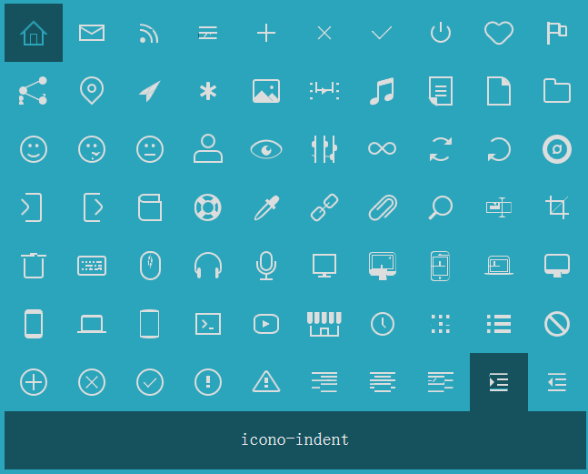

https://saeedalipoor.github.io/icono/