Gif文件格式分析(87a)
---- porsche.gif

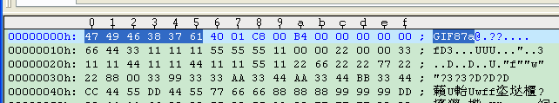
0000h：[6byte] 47 49 46 38 37 61 “GIF87a” gif stamp

0006h: [2byte] 01 40 320 width

0008h: [2byte] 00 c8 200 height

000ah: [3byte] (((0xb4 & 0x70) + 1)>>4) + 1 4 Color Resolution
(0xb4& 0x07) + 1 5 BitsPerPixel
(0xb4& 0x80) 1(yes) have global color map? [length 1<<BitsPerPixel, 32]
0x0 0 BackGroundColor

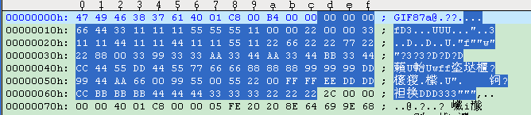
000dh: Red Green Blue global color map datas
- 00 00
66 44 33
11 11 11
....
22 22 22

006dh: 0x2c RecordType: IMAGE_DESC_RECORD_TYPE，图像标识符，表示一帧图像的开始

006eh: 0x0000: Left
0x0000: Top
0x0140: Width
0x00c8: Height

0076h: 0x0
(0x0 & 0x07) + 1 1 BitsPerPixel
(0x0 & 0x40) 0 Interlace
0x0 & 0x80 0(No) have local color map?

PixelCount = Width(0x0140)*Height(0x00c8) = 0xfa00

