GIF文件格式分析(89a)
---- jump.gif

Header Description:
- 00h: (c)GIF[3byte] --- signature
- 03h: (c)89a[3byte] --- version

Logical Screen Descriptor
- 06h: 00 50[2byte] --- width
- 08h: 00 50[2byte] --- height
- 0ah: f7[byte] --- <packed fields>
<packed fields> = Global Color Table Flag 1bit
Color Resolution 3bits
Sort Flag 1bit
Size of Global Color Table 3bits
Global Color Table Flag = byte & 0x80 = true
Color Reslution = ((byte&0x70)+1)>>4+1 = 8
Size of Global Color Table = (byte&0x07)+1 = 8
- 0bh: 0[byte] --- back ground color index
- 0ch: 0[byte] --- pixel aspect ratio

Global Color Table
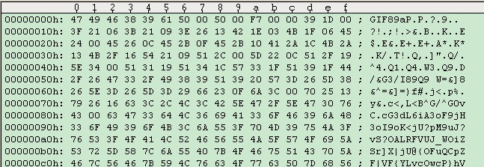
- 0dh: 39 1d 0 .... [3*256byte] --- RGB ...

Application Extension:
0 1 2 3 4 5 6 7 8 9 A B C D E F
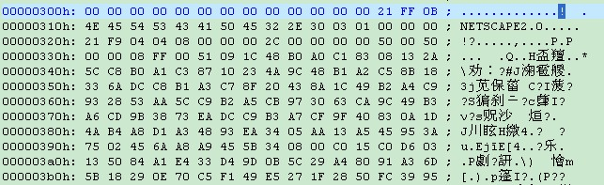
- 30dh: 21[byte] --- extension introducer
- 30eh: ff[byte] --- extension label
- 30fh: 0b[byte] --- block size
- 310h: (c)NETSCAPE2.0[11byte] --- application identifer
- 31bh: 03[byte] --- block size
- 31ch: 01 00 00[3byte] --- block content
- 31fh: 00[byte] --- block size=0 terminal

Graphic Control Extension:
0 1 2 3 4 5 6 7 8 9 a b c d e f
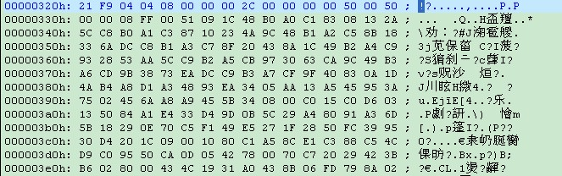
- 320h: 21[byte] --- extension introducer
- 321h: f9[byte] --- graphic control label
- 322h: 04[byte] --- block size
- 323h: 04[byte] --- <packed fields>
<packed fields> = reserved --- 3bits
Disposal method --- 3bits
User input flag --- 1bit
Transparent color flag --- 1bit
- 324h: 00 08[2byte] --- delay time
- 326h: 00[byte] --- transparent color index
- 327h: 00[byte] --- block terminator

Image Descriptor:
0 1 2 3 4 5 6 7 8 9 a b c d e f
- 328h: 2C[byte] --- image separator
- 329h: 00 00[2byte] --- image left position
- 32bh: 00 00[2byte] --- image top position
- 32dh: 00 50[2byte] --- image width
- 32fh: 00 50[2byte] --- image height
- 331h: 00[byte] --- <packed fields>
<packed fields> = local color table flag 1bit
Interlace flag 1bit
Sort flag 1bit
Reserved 2bits
Size of local color table 3bits

Variable Length Code LZW Compression:
0 1 2 3 4 5 6 7 8 9 a b c d e f
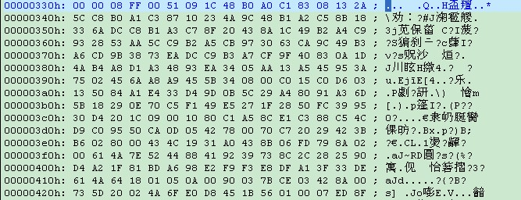
- 332h: 08[byte] --- LZW Minimum Code Size

