Pick Champ

University of Missouri

CS3380: Database Applications and Information Systems

Zhihao, Mark, Yaoxuan, Congyu, Yunfei, and Jiayu

12/13/15

# Introduction

Pick Champ is a fantasy sports website that is different than most fantasy sports platforms. The problem the client had was lack of automation to the competitions and the client had no database, so the goal of this project is to automate the competitions as well as create user analytics. The client wants to have an administrator able to sort through profile characteristics such as gender, age and zip code. The client also wanted the ability to sort and filter data by sports team or user, as well as see the general user user statistics and track what time of day people are entering the contests.

**DISCLAIMER**

The MIT License (MIT)

Copyright (c) <2015> <Zhihao, Mark, Yaoxuan, Congyu, Yunte, and Jiaya>

Permission is hereby granted, free of charge, to any person obtaining a copy of this software and associated documentation files (the "Software"), to deal in the Software without restriction, including without limitation the rights to use, copy, modify, merge, publish, distribute, sublicense, and/or sell copies of the Software, and to permit persons to whom the Software is furnished to do so, subject to the following conditions:

The above copyright notice and this permission notice shall be included in all copies or substantial portions of the Software.

THE SOFTWARE IS PROVIDED "AS IS", WITHOUT WARRANTY OF ANY KIND, EXPRESS OR IMPLIED, INCLUDING BUT NOT LIMITED TO THE WARRANTIES OF MERCHANTABILITY, FITNESS FOR A PARTICULAR PURPOSE AND NONINFRINGEMENT. IN NO EVENT SHALL THE AUTHORS OR COPYRIGHT HOLDERS BE LIABLE FOR ANY CLAIM, DAMAGES OR OTHER LIABILITY, WHETHER IN AN ACTION OF CONTRACT, TORT OR OTHERWISE, ARISING FROM, OUT OF OR IN CONNECTION WITH THE SOFTWARE OR THE USE OR OTHER DEALINGS IN THE SOFTWARE.

# ERD

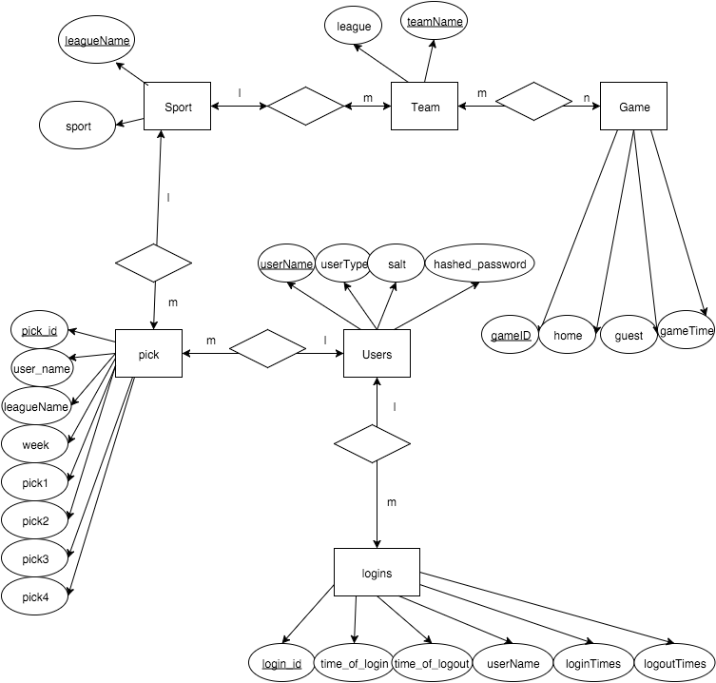

# Queries and Statements

To have the ability to filter and sort through user analytics, there were queries that were implemented.

SELECT salt, hashed_password, usertype FROM users WHERE username = "'.

This is used to log in to the website. Security is very important for this application so all passwords are salted and hashed.

UPDATE logins SET time_of_login="' . $time2 . '" WHERE userName = "' . $_POST['username'].'";';

$query3='UPDATE logins SET loginTimes=loginTimes+1 WHERE userName = "' . $_POST['username'].'";';

The client wanted the ability to see when a user logs in and out, so when a regular user logs in, it calls these two queries. This updates the logins table to the time and date of when the user logged in.

$query2='UPDATE logins SET time_of_logout="' . $time2 . '" WHERE userName = "' .

$_SESSION['username'].'";';

$query3='UPDATE logins SET logoutTimes=logoutTimes+1 WHERE userName = "' . $_SESSION['username'].'";';

From the main page, if the logout button is pressed, it calls these two queries which updates the logins table to the time and date of when the user logged off.

The Administrator has the most abilities, including having the ability to look at user information (excluding passwords).

SELECT username, usertype FROM users;'

DELETE FROM users WHERE username=?

The first query shows all users and the type of users they are. The administrator is able to manage users which includes deleting them. The second statement is used to delete users.

INSERT INTO game VALUES(?,?,?,?)

INSERT INTO team_game VALUES(?,?)

The administrator has the ability to create games for users to pick. These statements insert the games into the games table.

There are two different register pages. The basic user will use the normal register page, which asks for a username and a password.

INSERT INTO users(usertype,username,salt,hashed_password) VALUES ('c',?,?,?)

INSERT INTO logins(username) VALUES("' . $_POST['username'].'");

When you submit your user credentials, the application calls this statement, which adds the user’s username in addition to salted and hashed passwords into the users table. The second statement adds the user into the logins table to show that they logged in.

The administrator has the ability to register staff members who have more permissions than a typical user, but not as much as the administrator. It uses the same queries and statements but the user type is changed.

SELECT * FROM sport ORDER BY leagueName ASC

SELECT * FROM team ORDER BY teamName ASC

SELECT * FROM team WHERE teamName LIKE ? ORDER BY teamName ASC

SELECT * FROM game ORDER BY gameID ASC

SELECT * FROM game WHERE (home LIKE ? OR guest LIKE ?) ORDER BY gameID ASC

The administrator has the ability to see the statistics of a game, and these queries are used to filter each game. The first two queries display all by-league names and team names. The third query is for when a user is typing a team name in the search box. It will return that result. The next query returns the game and orders it by game ID. The last query returns the user’s search who is looking for a specific game. It will return the result and order it by game ID.

# Analytics

Through this application, we are able to see the analytics of a user. All user passwords are salted and hashed. The administrator is a special user that has access to all of the user analytics. The Admin can see when the user logs in and out. The admin can see the any of the picks, which includes the question and the two answers. The user pick consists of the pick ID, user ID, question ID, the team and game ID, and user choice.

# Normalization

All of the tables in the application are normalized into Boyce Codd normal form. This is done to make the queries on the tables efficient and it will decrease time needed to run statement and queries.

# Indexing

Speed and performance are two key principals for a great web application for this web application especially if the administrator needs to filter through hundreds of normal user’s information. So to make the queries run faster the application uses indexes. Each table makes use of a primary key, which is an index. Since there will be users who will constantly be searching for the team name, an index was made on the team table for the team name.

# Security

Security is very important when you are dealing with personal information. Any application is subject to security attacks. To prevent SQL injection attacks, the application uses prepared statements for any queries. When dealing with passwords, they cannot simply be put into a database. To help secure passwords, the application hashes and salts passwords which prevents passwords to be saved in plain text. The web application also takes advantage of HTTPS which makes sure the website is authentic.

# User Manual

## Installation

For the client to be able to host this web application, there are some prerequisites for installation. For the main use of the website PHP 5, MYSQL, and JavaScript are used. A webserver is needed to host the source code and database. Microsoft Azure is recommended. If using Microsoft Azure, please follow these steps: First, create a new virtual machine. Linux is the best, and from there it is possible to name it. To access the virtual machine through SSH so you are able to host the website, use an FTP client. Next, a database must be set up. To set up a database through Microsoft Azure, go to marketplace and download ClearDB. Once the database is created, it is possible to see the Endpoint Information to display Access Credentials. Connect to Microsoft Azure in terminal using SSH. Then log into your server using your Credentials. To add a SQL file to your database, use the MySQL dump command.

## Website Usage

Administrator



To get admin access to the website, login to the website using the admin credentials. Once logged in, it will bring you to the main admin page.



From this page you can insert a team, insert a game, logout, change passwords of users, add new staff, and manage users. On the side you can sort data, by profile characteristics, sort and filter data by sports team or user, see general user statistics, or see activity graphs.

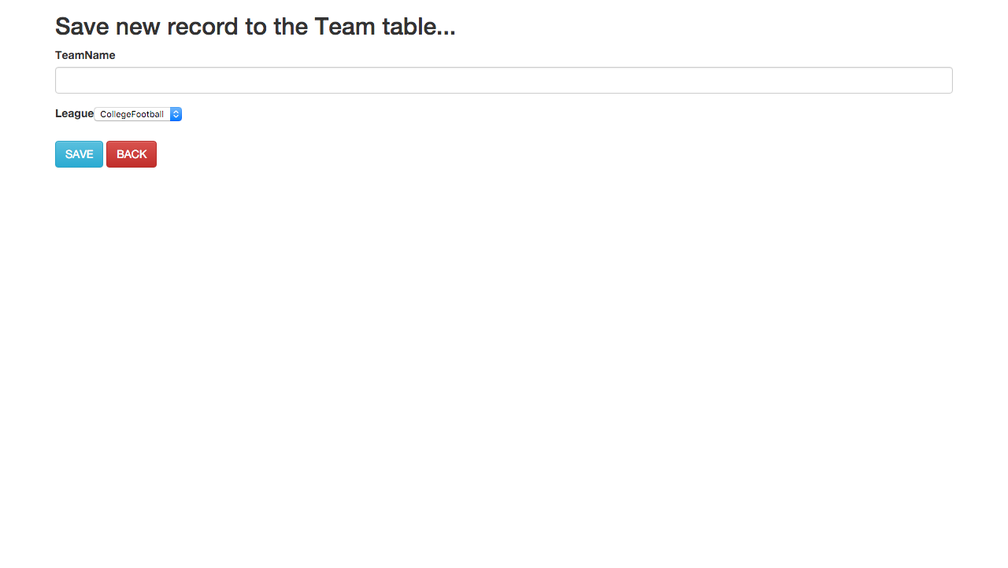

You can add a team on this page by typing in the team name and selecting the league name, then pressing save.

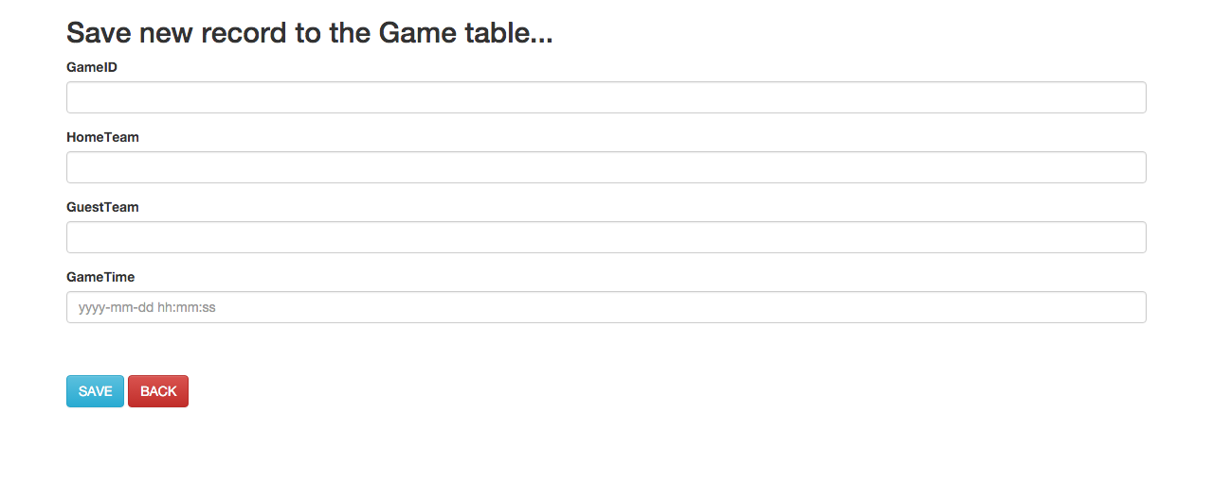

You can add a game by typing in the Game ID, Home Team, Game Team and Game Time. Press save when finished.



On this page to change the password, type in the current password and the new password. The last box is to confirm the new password.

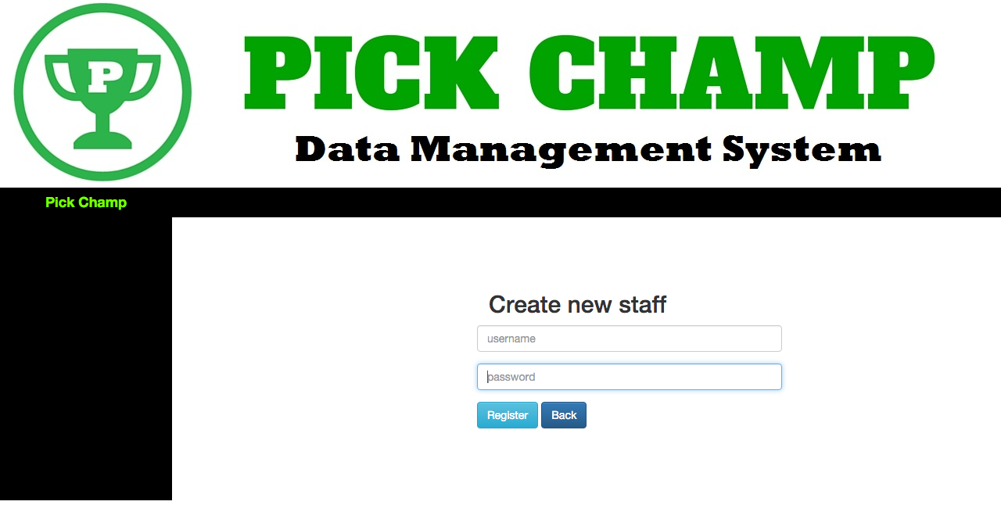

The administrator has the ability to create users that are staff, who have more privileges than the normal users.

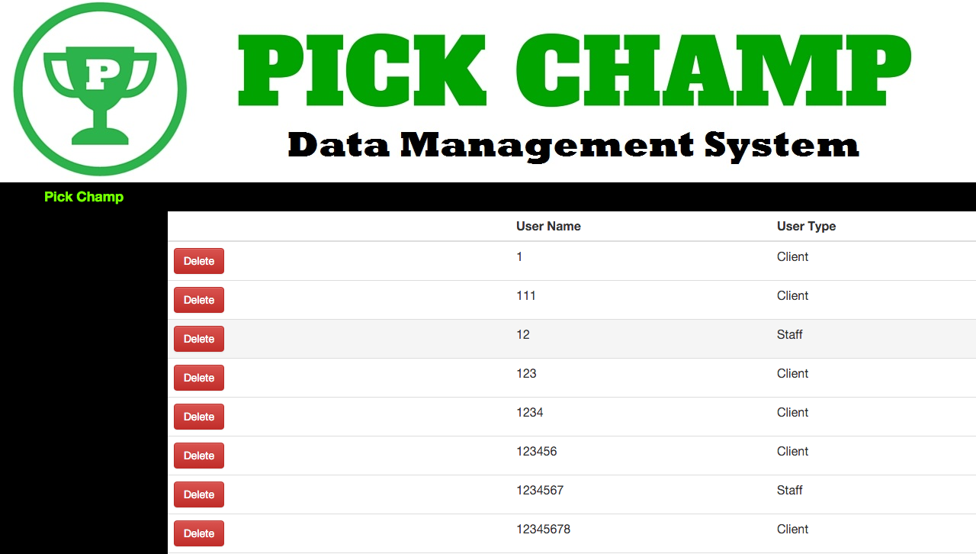

The admin on this page can see all the user data and what type of user they are, and the admin also has the ability to delete a user.



The statistics page is used to sort game data according to either sport, team and game. Select either one to show the sorted data. It is possible to search by typing into the box.

User

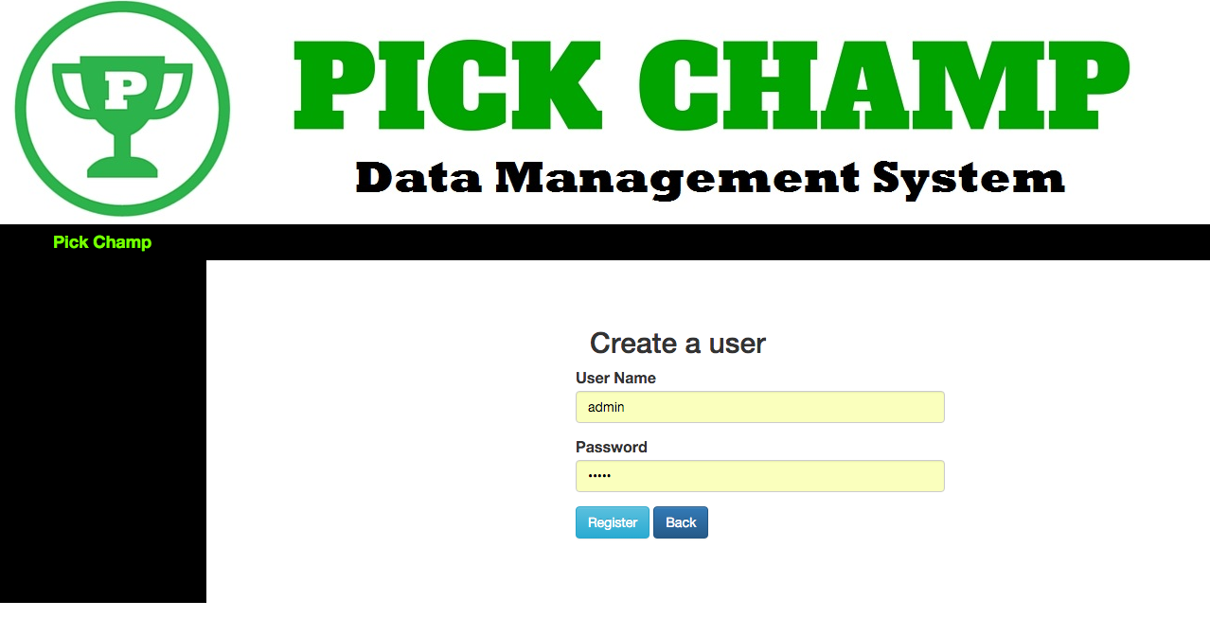

A regular user can register for the page by going to the register page and typing in a username and password then selecting register.



On this page you can select what pick based on each league. It is also possible to logout and change the user password.



Once a league is selected, the user can select a specific week of picks.

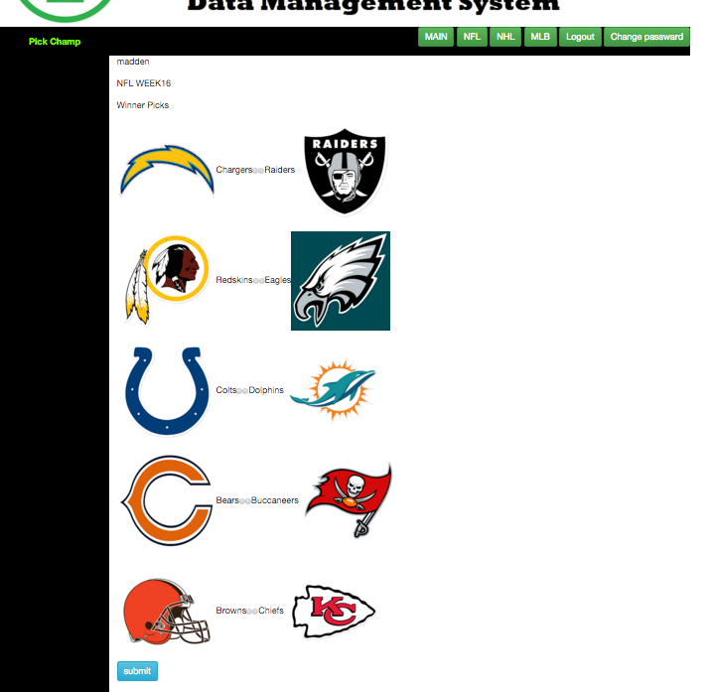

The user then can make their picks for the week then press submit.