

Safety Plan Lane Assistance

**Document Version: [Version]**

**Template Version 1.0, Released on 2017-06-21**



# Document history

**[Instructions: Fill in the date, version and description fields. You can fill out the Editor field with your name if you want to do so. Keep track of your editing as if this were a real world project.**

**For example, if this were your first draft or first submission, you might say version 1.0. If this is a second submission attempt, then you'd add a second line with a new date and version 2.0]**

|  |  |  |  |
| --- | --- | --- | --- |
| Date | Version | Editor | Description |
| 9/2/2019 | 1.0 |  | First attempt |
|  |  |  |  |
|  |  |  |  |
|  |  |  |  |
|  |  |  |  |

# Table of Contents

**[Instructions: We have provided a table of contents. If the table of contents is not showing up correctly in your word processor of choice, please update it. The table of contents should show each section of the document and page numbers or links. Most word processors can do this for you. In [Google Docs](https://support.google.com/docs/answer/116338?co=GENIE.Platform%3DDesktop&hl=en), you can use headings for each section and then go to Insert > Table of Contents. [Microsoft Word](https://support.microsoft.com/en-us/help/285059/how-to-create-a-table-of-contents-by-marking-text-in-word) has similar capabilities]**

Document history

Table of Contents

Introduction

Purpose of the Safety Plan

Scope of the Project

Deliverables of the Project

Item Definition

Goals and Measures

Goals

Measures

Safety Culture

Safety Lifecycle Tailoring

Roles

Development Interface Agreement

Confirmation Measures

# Introduction

A safety plan provides an overall framework for a functional safety project.

## Purpose of the Safety Plan

**[Instructions: Answer what is the purpose of a safety plan?]**

We can guide to what will be done to achieve functional safety,and define responsibilities between the players involved in the project.

## Scope of the Project

**[Instructions: Nothing to do here. This is for your information.]**

For the lane assistance project, the following safety lifecycle phases are in scope:

Concept phase

Product Development at the System Level

Product Development at the Software Level

The following phases are out of scope:

Product Development at the Hardware Level

Production and Operation

## Deliverable of the Project

**[Instructions: Nothing to do here. This is for your information.]**

The deliverable of the project are:

Safety Plan

Hazard Analysis and Risk Assessment

Functional Safety Concept

Technical Safety Concept

Software Safety Requirements and Architecture

# Item Definition

**[Instructions:**

**REQUIRED**

**Discuss these key points about the system:**

The system discussed how design to a safety vehicle assistance.

**What is the item in question, and what does the item do?**

The lane assistance system issues a warning if the vehicle is leaving the lane or/and steers back to the center of the lane.

**What are its two main functions? How do they work?**

The two main functions:

 • the lane departure warning

 • lane keeping assistance is to provide vibration steering feedback and torque to the driver as haptic feedback

**Which subsystems are responsible for each function?**

Subsystems:

• Camera Subsystem

Responsible for detecting lane lines and determining when the vehicle leaves the lane by mistake.

• Display Subsystem

Responsible for lane keeping assistance

• Electronic Power Steering Subsystem

Responsible for measuring the torque provided by the driver and adding an extra amount of torque based on a lane assistance system torque request.

**What are the boundaries of the item? What subsystems are inside the item? What elements or subsystems are outside of the item?**

The item boundary was drawn to include three sub-systems:

• Camera system

• Electronic Power Steering system

• Car Display system

Outside of the item:

• Steering wheel

**OPTIONAL**

**Optionally, include information about these points as well. These were not included in the lectures, but you might be able to find this information online:**

* **Operational and Environmental Constraints. This could especially be limited to camera performance; lane lines are difficult to detect in snow, fog, etc**
* **Legal requirements in your country for lane assistance technology**
* **National and International Standards Related to the Item**
* **Records of previously known safety-related incidents or behavioral shortfalls**

**]**

The lane assistance item alerts the driver that the vehicle has accidentally departed its lane,and attempts to steer the vehicle back the center of the lane.

The Lane Assistance System will have two functions:

1. Lane departure warning
2. Lane keeping assistance

the lane departure warning function shall apply an oscillating steering torque to provide the driver a haptic feedback.

the lane keeping assistance function shall apply the steering torque when active in order to stay in ego lane.

The camera subsystem, the electronic power steering subsystem, and the car display system are all responsible for each of the functions.

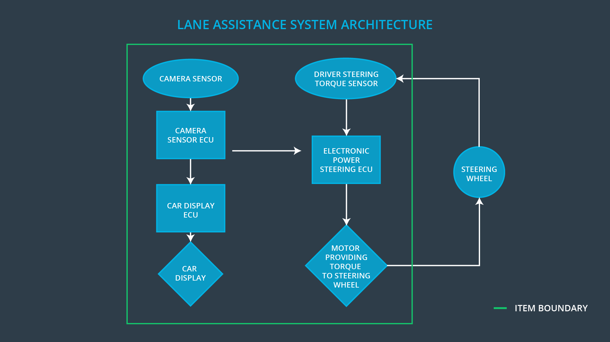

# Goals and Measures

## Goals

**[Instructions:**

**Describe the major goal of this project; what are we trying to accomplish by analyzing the lane assistance functions with ISO 26262?]**

The ultimate goal is avoiding accidents by reducing risk to acceptable.

## Measures

**[Instructions:**

**Fill in who will be responsible for each measure or activity. Hint: The lesson on Safety Management Roles and Responsibilities.**

**The options are:**

**All Team Members**

**Safety Manager**

**Project Manager**

**Safety Auditor**

**Safety Assessor**

**]**

|  |  |  |
| --- | --- | --- |
| Measures and Activities | Responsibility | Timeline |
| Follow safety processes | All team member | Constantly |
| Create and sustain a safety culture | All team member | Constantly |
| Coordinate and document the planned safety activities | Safety Manager | Constantly |
| Allocate resources with adequate functional safety competency | Project manager | Within 2 weeks of start of project |
| Tailor the safety lifecycle | Safety Manage | Within 4 weeks of start of project |
| Plan the safety activities of the safety lifecycle | Safety Manage | Within 4 weeks of start of project |
| Perform regular functional safety audits | Safety Auditor | Once every 2 months |
| Perform functional safety pre-assessment prior to audit by external functional safety assessor | Safety Manager | 3 months prior to main assessment |
| Perform functional safety assessment | Safety Assessor | Conclusion of functional safety activities |

# Safety Culture

**[Instructions:**

**Describe the characteristics of your company's safety culture. How do these characteristics help maintain your safety culture. Hint: See the lesson about Safety Culture**

**]**

My company has always tracked requirements engineering decisions with physical paper reports. Sometimes it’s not clear who is making design decisions. My company decides to use requirements engineering software to better track who is responsible for decisions.

# Safety Lifecycle Tailoring

**[Instructions:**

**Describe which phases of the safety lifecycle are in scope and which are out of scope for this particular project. Hint: See the Intro section of this document**

**]**

When the product is new the V-model is the entire safety life cycle,starting from the concept phase through their product development and ending in production.When modifying an existing product you might not have to implement all of the steps in the safety life-cycle,new functionality perhaps only impacts the parts of the new functionality ,then tailor the safety lifecycle.

# Roles

**[Instructions:**

**This section is here for your reference. You do not need to do anything here. It is provided to help with filling out the development interface agreement section.**

**]**

|  |  |
| --- | --- |
| Role | Org |
| Functional Safety Manager- Item Level | OEM |
| Functional Safety Engineer- Item Level | OEM |
| Project Manager - Item Level | OEM |
| Functional Safety Manager- Component Level | Tier-1 |
| Functional Safety Engineer- Component Level | Tier-1 |
| Functional Safety Auditor | OEM or external |
| Functional Safety Assessor | OEM or external |

# Development Interface Agreement

**[Instructions:**

**Assume in this project that you work for the tier-1 organization as described in the above roles table. You are taking on the role of both the functional safety manager and functional safety engineer.**

**Please answer the following questions:**

1. **What is the purpose of a development interface agreement?**

• Appointment of customer and supplier safety managers

• Joint tailoring of the safety lifecycle

• Activities and processes to be performed by the customer; activities and processes to be performed by the supplier

• Information and work products to be exchanged

• Parties or persons responsible for each activity in design and production

• Any supporting processes or tools to ensure compatibility between customer and supplier technologies

1. **What will be the responsibilities of your company versus the responsibilities of the OEM? Hint: In this project, the OEM is supplying a functioning lane assistance system. Your company needs to analyze and modify the various sub-systems from a functional safety viewpoint.**

**]**

The responsibilities of the OEM provide a functioning requirements for lane assistance system.

The responsibilities of my company develops and produces the lane assistance system for the OEM.

# Confirmation Measures

**[Instructions:**

**Please answer the following questions:**

1. **What is the main purpose of confirmation measures?**

Confirmation measures serve two purposes:

• that a functional safety project conforms to ISO 26262, and

• that the project really does make the vehicle safer.

1. **What is a confirmation review?**

Ensures that the project complies with ISO 26262. As the product is designed and developed, an independent person would review the work to make sure ISO 26262 is being followed.

1. **What is a functional safety audit?**

Checking to make sure that the actual implementation of the project conforms to the safety plan is called a functional safety audit.

1. **What is a functional safety assessment?**

Confirming that plans, designs and developed products actually achieve functional safety is called a functional safety assessment.

**]**

A safety plan could have other sections that we are not including here. For example, a safety plan would probably contain a complete project schedule.

There might also be a "Supporting Process Management" section that would cover "Part 8: Supporting Processes" of the ISO 26262 functional safety standard. This would include descriptions of how the company handles requirements management, change management, configuration management, documentation management, and software tool usage and confidence.

Similarly, a confirmation measures section would go into more detail about how each confirmation will be carried out.