ConDiag: Failure-Triggered Context Recovery Middleware for LLM Coding Agents
Architecture Draft v0.1
2026-06-28
Document status. This is an architecture draft aimed at academic advisors and as the starting point for a paper. It reflects the design state as of 2026-06-28, including the 5R framework, 7-class pathology taxonomy, and a v0 Manual Recovery Subsystem that passes 5/5 seed regression. The companion file ConDiag_研究与实验全流程指导书_v0.1.md covers operational / experimental workflow in more detail; this document focuses on architecture and contribution claims.

Abstract
LLM coding agents for repository-level program repair routinely fail even when the information needed to recover is already in the trajectory — a stack trace points at an uninspected source file, a viewed span is dropped before the final patch, or a sibling implementation is edited while its parallel siblings are missed. We present ConDiag, a decoupled failure-triggered context-recovery middleware that sits between a Host Agent’s failed attempt and its retry. ConDiag (i) detects the failure mode from runtime-visible signals only (no gold leakage), (ii) maps it onto a 5R × 7-class pathology taxonomy (Relocalize / Retrieve / Rehydrate / Restrain / Reconcile, plus NO-OP abstain), (iii) executes an executable retrieval or guard plan against repo@base_commit, and (iv) hands the retry agent a structured ContextPacket rather than a chunk list. The current v0 implements four manual-seed recovery flows plus a NO-OP baseline, with 5/5 byte-identical seed regression. We further propose Pilot50, a 50-instance ContextBench evaluation that uses process-level metrics (file / block / line F1, Evidence Drop, EditLoc recall) to validate the taxonomy, trigger thresholds, and the ContextPacket mechanism against gold-annotated context.

1. Problem & Motivation

1.1 The Hidden Cost of “Just Retry”
When an LLM coding agent fails on a repository-level task, the trajectory almost always already contains the signal needed to recover:
- A stack trace names the file and symbol the agent never inspected.
- A previously viewed span contains the exact lines the final patch needed.
- A failed test names a sibling path / parallel backend the agent missed.
- The agent edited the right file but ran zero local tests before submitting.
Today’s coding agents handle this in one of two unprincipled ways:
- Naive retry — re-roll the same agent with the same context, hoping the LLM samples a different exploration path. Cheap, blind.
- Bulk retrieval — pre-load a BM25/embedding search over the whole repo, regardless of failure mode. Expensive, noisy, and often increases context without improving utilization.
Neither completes the explicit transformation failure signal → context gap → executable retrieval plan → concrete evidence → retry packet.

1.2 Three Failure Shapes From Pilot Trajectories
An initial Pilot of five mini-SWE-agent runs on ContextBench-Verified surfaced three repeating failure shapes, each requiring a different recovery action:
Failure shape | Example | What is missing
Wrong localization | sympy-16597 | Agent edited the correct class but never inspected the actual error origin in the stack trace
Seen but dropped | astropy-13398 | Agent viewed the parallel registration site @frame_transform_graph.transform, but did not retain it when finalizing the patch
Over-explore, over-edit | sympy-13877 | 17 changed files, 4 repeated patterns, zero test runs
A single “retrieve more context” action cannot address all three; the third case actually requires less context and pruning the patch.

1.3 The Middleware Gap
What is missing is a failure-triggered middleware that is (a) decoupled from the Host Agent so it can be retrofitted to mini-SWE, SWE-agent, Agentless or AutoCodeRover without re-training, (b) pathology-aware so different failure modes trigger different actions, and (c) bounded by a strict runtime/gold separation so it cannot accidentally leak evaluation oracle into the agent’s view. ConDiag is designed to occupy exactly this gap.

2. Background & Related Work
ContextBench [1] provides 1,136 tasks across 66 repositories and 8 languages, each annotated with a human-verified gold context covering files, definition-level blocks, and lines. Crucially it ships process-level metrics — Incremental Context F1, Evidence Drop (the gap between explored and utilized context), EditLoc recall — that let us measure what the agent looked at vs. what it ended up using. SWE-bench Verified [2] is outcome-only and answers none of these questions.
Coding agents. mini-SWE-agent and SWE-agent [3] are interactive shell agents. Agentless [4] localizes via a system-prompt cascade without retrieval. AutoCodeRover [5] does BM25 retrieval preemptively. RAG-style SWE pipelines [6] pre-load retrieved chunks before the agent starts. All of these are preemptive or trigger-blind; ConDiag is post-failure and pathology-aware.
Process-level diagnosis. The ContextBench paper’s Evidence Drop analysis [1] directly motivates ConDiag’s Rehydrate mechanism: agents frequently view gold-relevant code but fail to retain it in the final patch context.

3. ConDiag Architecture
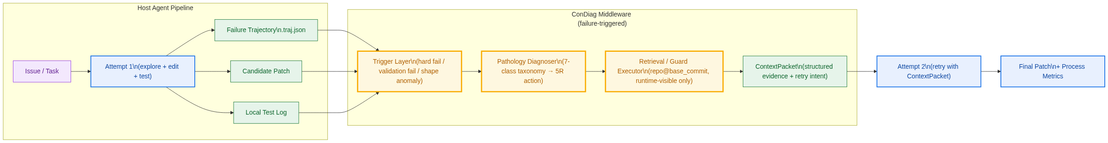
Figure 1: ConDiag in the agent repair pipeline. Inputs are the Host Agent’s failed trajectory, candidate patch, and local test log; outputs are a structured ContextPacket consumed by Attempt 2.

3.1 Position in the Pipeline
ConDiag is invoked after the Host Agent’s Attempt 1 ends in a detectable failure. Its outputs feed Attempt 2 of the same agent. The Host Agent’s prompt, tools, and model are untouched — ConDiag only controls the additional context and retry intent that the agent receives between attempts. This makes the middleware agent-agnostic.

3.2 5R Framework × 7-Class Pathology Taxonomy
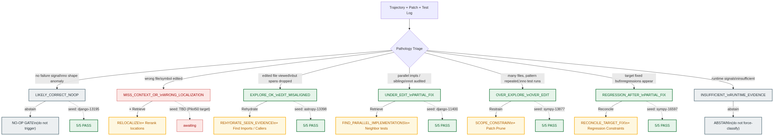
Figure 2: The 5R recovery actions (Relocalize, Retrieve, Rehydrate, Restrain, Reconcile) mapped onto the 7-class pathology taxonomy. Six of seven classes have seed cases; RELOCALIZE is the open slot to be filled by Pilot50 mining.
ConDiag maps each diagnosed failure onto one of five recovery actions:
- Relocalize — re-locate the edit target (stack-trace origin, error token).
- Retrieve — surface unseen context (parallel implementations, neighbor tests, sibling classes).
- Rehydrate — re-activate viewed-but-dropped evidence (viewed spans lost in the final patch).
- Restrain — collapse over-wide edits (scope guard + patch prune).
- Reconcile — coordinate the target fix with regression constraints.
Two classes (LIKELY_CORRECT_NOOP, INSUFFICIENT_RUNTIME_EVIDENCE) trigger abstain: ConDiag explicitly declines to act rather than force-classify.

3.3 Oracle → Runtime Proxy Mapping (key contribution)
The Pilot-5 analysis initially used file_cov, symbol_cov, EditLoc recall as trigger signals. These are oracle metrics — they require gold context to compute and therefore cannot be used at runtime without leakage. Table 1 captures the systematic translation we performed so that every ConDiag rule can be evaluated from runtime-visible facts alone.
Table 1: Oracle → Runtime proxy mapping (excerpt)
Oracle metric (offline only) | Runtime-visible proxy (ConDiag input)
file_cov < 0.3 | Long search history but issue-key symbol definition never viewed
symbol_cov = 0 | Edited symbol disjoint from issue / stack / failed-test symbols
EditLoc recall = 0 | Edited spans far from any high-value viewed span
file_precision < 0.2 | Many edited files lacking independent failure evidence
patch_files > 2×gold_files | changed_files ≥ K + same lexical pattern across files
line_cov low + precision high | Local test still failing + unedited sibling in same file
Cheap and strong runtime signals identified from case-bundle analysis:
- test_runs_count == 0 → strong OVER_EXPLORE signal
- git_checkout_count ≥ 2 → agent cycling, possible REGRESSION
- viewed_to_edited_ratio > 0.7 → OVER_EXPLORE; < 0.3 → MISS_CONTEXT
- repeated_pattern_count ≥ 5 → PATTERN_OVER_GENERALIZATION
The Leakage Guard module (leakage_guard.py) enforces the runtime/gold separation at the case-bundle schema level.

3.4 Three-Layer Trigger
ConDiag’s entry-point trigger has three layers, applied in order:
- Trigger-0 (hard failure) — timeout, format error, patch-apply failure, empty patch, runtime exception. ConDiag short-circuits to a generic diagnostic.
- Trigger-1 (runtime-visible validation failure) — agent-ran tests failed or ConDiag’s own runtime-visible local validation failed. Primary trigger. ConDiag runs “runtime-visible local validation”, never the official FAIL_TO_PASS oracle.
- Trigger-2 (patch-shape anomaly) — Scope Guard score ≥ 2 (see §4.2). Risk trigger; enters audit / guard mode without claiming the patch is wrong.

3.5 v0 Module Architecture
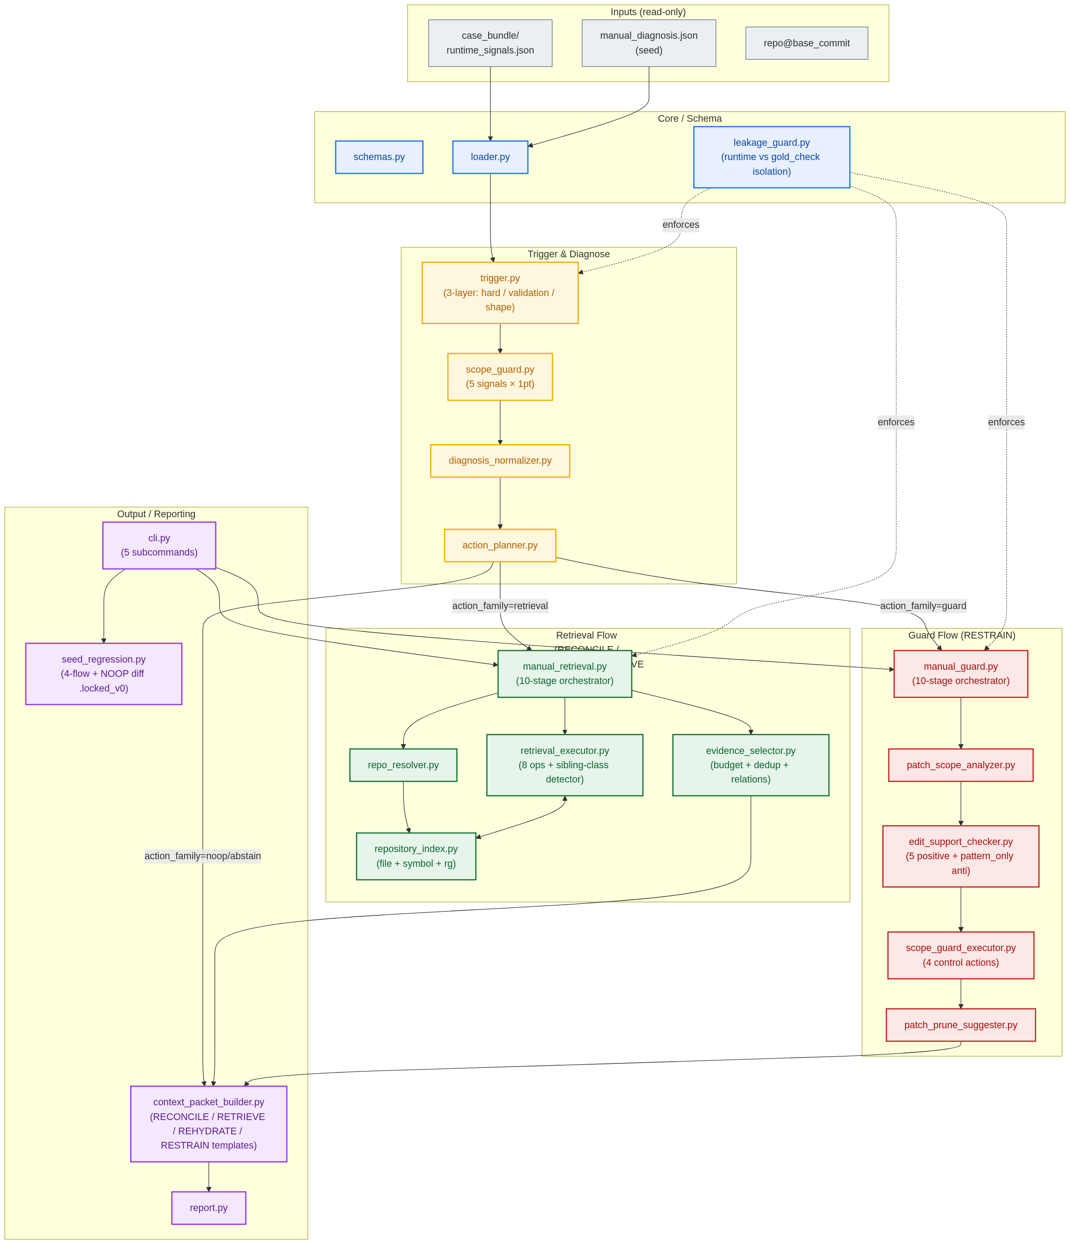
Figure 3: ConDiag v0 module architecture. 22 modules organized into five groups: Core/Schema, Trigger & Diagnose, Retrieval flow (4 actions), Guard flow (RESTRAIN), and Output/Reporting. Leakage Guard enforces runtime/gold separation across all retrieval and guard flows.
The full module inventory is in Appendix A.

4. v0 Implementation Status

4.1 Manual Recovery Subsystem: 5/5 PASS
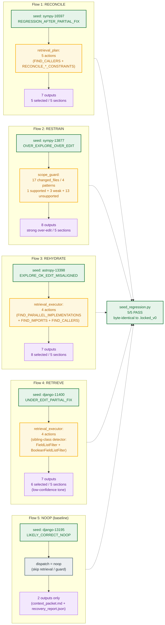
Figure 4: Four manual-seed recovery flows + one NO-OP baseline. Each flow is byte-identical to its .locked_v0 snapshot under seed_regression.py, confirming that ConDiag deterministically reproduces the intended ContextPacket for each pathology class.
What 5/5 PASS means:
- Given a human-authored manual_diagnosis.json seed, ConDiag runs the appropriate retrieval or guard flow and produces a ContextPacket matching the locked baseline byte-for-byte.
What it does not mean (and we are explicit about this):
- It does not prove that an auto-diagnoser can produce the seed.
- It does not prove that Attempt 2 actually resolves the task — that is Agent-Retry v0 (post-Pilot50 milestone).
- It does not measure context-F1 against gold (that is ContextBench’s job).

4.2 Scope Guard (RESTRAIN)
The Scope Guard scores each candidate patch on five binary signals:
scope_anomaly_score =
1 if changed_files ≥ 5
+ 1 if changed_lines ≥ 200
+ 1 if api_calls ≥ 80
+ 1 if repeated_edit_pattern detected
+ 1 if many edited files lack support from issue / stack / failed tests / viewed evidence
Score ≥ 2 → warning; ≥ 3 → strong over-edit. The thresholds are seeded from Pilot-5 and will be frozen after Pilot50.

4.3 Retrieval Executor
Eight operations, each other than RECONCILE_* is an executable repo probe against repo@base_commit:
Operation | Purpose
FIND_SYMBOL_DEFINITION | Resolve a short-name hint to a source location
FIND_PARALLEL_IMPLEMENTATIONS | Cross-file basename shape match + same-file sibling-class detector
FIND_NEIGHBOR_TESTS | Match failed-test concept to neighbor tests
FIND_IMPORTS | Locate import sites of an edited symbol
FIND_CALLERS | Locate call / decorator sites
REHYDRATE_SEEN_EVIDENCE | Re-attach viewed spans dropped from the final patch context
READ_DEPENDENCY_NEIGHBORHOOD | Read around an edited location
FIND_FAILED_TEST | Inspect a specific failing test’s source
RECONCILE_TARGET_FIX_WITH_REGRESSION_CONSTRAINTS is a synthesis action — it produces no retrieval candidates of its own, only restructures the ContextPacket to present both the target-fix evidence and the regression constraints.

4.4 Leakage Guard
Every case-bundle and manual_diagnosis.json is split into two halves at the schema level:
- runtime_signals — trajectory / patch / test-log derived facts. The only input to trigger, diagnoser, executor.
- gold_check — ContextBench metrics, gold patch shape, oracle pathology label. Marked allowed_for_runtime: false. Used only for offline analysis.
leakage_guard.py rejects any case-bundle whose runtime half overlaps the gold half.

5. Pilot50 Evaluation Plan
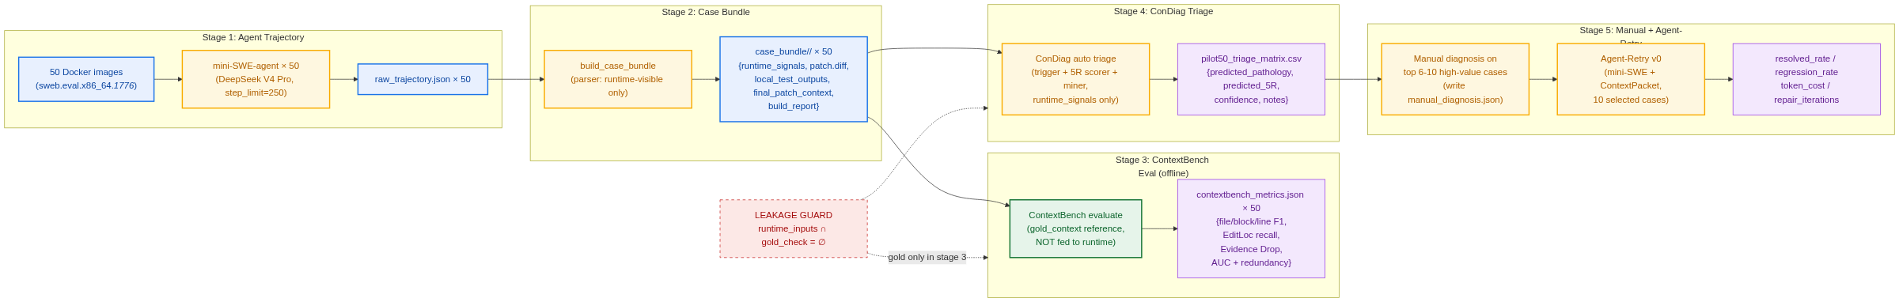
Figure 5: Pilot50 five-stage pipeline. Stages 1–4 run on every instance; Stage 5 selects 6–10 high-value cases for manual diagnosis and Agent-Retry v0. The red dashed boundary marks the strict runtime/gold isolation: ContextBench gold metrics appear only in Stage 3 and never feed back into Stage 4 triage.

5.1 Configuration
50 ContextBench-Verified instances drawn from the 500-instance Lite split, stratified across pathology categories:
Stratum | Count | Rationale
Django error-code / system-check / validation | 20 | RELOCALIZE mining (models.E###, SystemCheckError)
Django config / database / router / exception | 10 | Localization pathology
Non-Django Python (sympy / transformers / astropy / sklearn) | 15 | Taxonomy diversity
Local easy / likely-correct controls | 5 | NO-OP false-positive test

5.2 Three-Layer Analysis
- Auto triage (all 50). Run ConDiag trigger + 5R scorer + RELOCALIZE miner → produce pilot50_triage_matrix.csv. Answer four questions: Does ConDiag over-trigger? Does the 5R dispatch make sense? Are NO-OP cases correctly skipped? Can RELOCALIZE candidates be surfaced?
- Manual diagnosis (top 6–10). For each high-value case, author a manual_diagnosis.json and run the recovery flow. Goal: extend the 4-flow seed set into 15–20 manual recovery fixtures.
- Agent-Retry v0 (final). Pick 10 most-promising cases and re-run mini-SWE with ConDiag’s ContextPacket. Compare resolved / regression / token cost / repair iterations against Attempt 1.

5.3 Metrics
Primary (process-level, from ContextBench):
- Incremental Context F1 at file / block / line granularity
- Evidence Recovery: ConDiag-retrieved evidence hits Attempt-1 missed gold
- Evidence Drop Recovery: re-activated viewed spans reduce Evidence Drop
- Retrieved Context Size / Token Cost
- NO-OP False-Positive Rate on likely-correct controls
Secondary (outcome-level, for Agent-Retry v0):
- Resolved rate (FAIL_TO_PASS / PASS_TO_PASS)
- Regression rate (newly broken PASS_TO_PASS)
- Token cost / repair iterations

5.4 Evaluation-Only Isolation
ContextBench gold metrics appear only in Stage 3 (offline evaluation) and are physically unable to enter Stage 4 (ConDiag runtime triage) or Stage 5 (Agent retry). The case-bundle parser (condiag/tools/build_case_bundle.py) refuses to write any gold-derived field into runtime_signals.json.

6. Roadmap
Phase | Goal | Status
P0 | NO-OP Gate (do no harm on success) | ✅ 5/5 seed PASS
P1 | RELOCALIZE seed + flow | ⏳ Pending Pilot50 mining
P2 | REHYDRATE + Scope Guard | ✅ 5/5 seed PASS
P3 | Sibling / Parallel Audit (RETRIEVE) | ✅ 5/5 seed PASS
P4 | REGRESSION_AFTER_PARTIAL_FIX (RECONCILE) | ✅ 5/5 seed PASS
P5 | Auto-diagnoser (replace manual seed) | Post-Pilot50
P6 | Agent-Retry end-to-end resolved rate | Pilot50 Stage 5

7. Competitive Analysis
Table 2: ConDiag vs. related systems
Property | ConDiag | Agentless | AutoCodeRover | RAG-SWE
Trigger | Post-failure | Preemptive | Preemptive | Preemptive
Retrieval granularity | Pathology-aware | None | BM25 chunks | Embedding chunks
Output form | Structured ContextPacket | Localization list | Bug-locations + snippets | Chunk list
Evaluation | Outcome + process | Outcome only | Outcome only | Outcome only
Integration | Decoupled middleware | Standalone | Standalone | Standalone
Pathology-awareness | 5R × 7 classes | None | None | None

8. Open Questions & Risks
- Auto-diagnoser is unbuilt. All current seeds are human-authored. The risk is that pathology classification from runtime signals is too noisy without gold features. Pilot50 triage matrix will answer this.
- RELOCALIZE seed is missing. Pilot-5 had no pure RELOCALIZE case. If Pilot50 also fails to surface one, the 5R framework has a gap.
- Recovery execution ≠ repair rate. Passing seed regression proves ConDiag can produce the intended ContextPacket. Whether Attempt 2 actually resolves more tasks is Agent-Retry v0 — currently unbuilt.
- Scale. 50 instances may be too few to freeze trigger thresholds. We may need to extend to 100+ before publishing.

Appendix A: Module Inventory
22 modules under ~/condiag/condiag/, grouped per Figure 3:
Core / Schema. schemas.py, loader.py, leakage_guard.py.
Trigger & Diagnose. trigger.py, scope_guard.py, diagnosis_normalizer.py, action_planner.py.
Retrieval flow. repo_resolver.py, repository_index.py, retrieval_executor.py, evidence_selector.py, manual_retrieval.py.
Guard flow. patch_scope_analyzer.py, edit_support_checker.py, scope_guard_executor.py, patch_prune_suggester.py, manual_guard.py.
Output / Reporting. context_packet_builder.py, report.py, cli.py, seed_regression.py.
Tools (under condiag/tools/). build_case_bundle.py, find_relocalize_candidates.py, parsers/{base,common,miniswe}.py.

Appendix B: 5R Action Verbs
- Relocalize. TRACE_ERROR_ORIGIN, FIND_SYMBOL_DEFINITION, RERANK_LOCATIONS.
- Retrieve. FIND_PARALLEL_IMPLEMENTATIONS, FIND_NEIGHBOR_TESTS, FIND_IMPORTS, FIND_CALLERS, READ_DEPENDENCY_NEIGHBORHOOD, FIND_FAILED_TEST.
- Rehydrate. REHYDRATE_SEEN_EVIDENCE.
- Restrain. SCOPE_CONSTRAIN, PATCH_PRUNE_CANDIDATES, RUN_RUNTIME_VISIBLE_VALIDATION.
- Reconcile. RECONCILE_TARGET_FIX_WITH_REGRESSION_CONSTRAINTS.

Appendix C: References
- ContextBench: A Process-Level Benchmark for Context Engineering in Repository-Level Program Repair (2026).
- SWE-Bench Verified (princeton-nlp/SWE-Bench_Verified), 500-instance Lite split.
- Yang et al., SWE-agent: Agent Computer Interfaces Enable Software Engineering Language Models (2024).
- Xia et al., Agentless: Demystifying LLM-based Software Engineering Agents (2024).
- Zhang et al., AutoCodeRover: Autonomous Program Improvement (2024).
- RAG-SWE retrieval-augmented SWE pipeline variants (various, 2024–2025).

