**LCMR1 Promotes Large-cell Lung Cancer Proliferation and Metastasis through Downregulation of HLA Coding Genes**

分析流程: (我是把原始.SRA檔轉成.FASTQ丟上GALAXY用作業4流程跑)

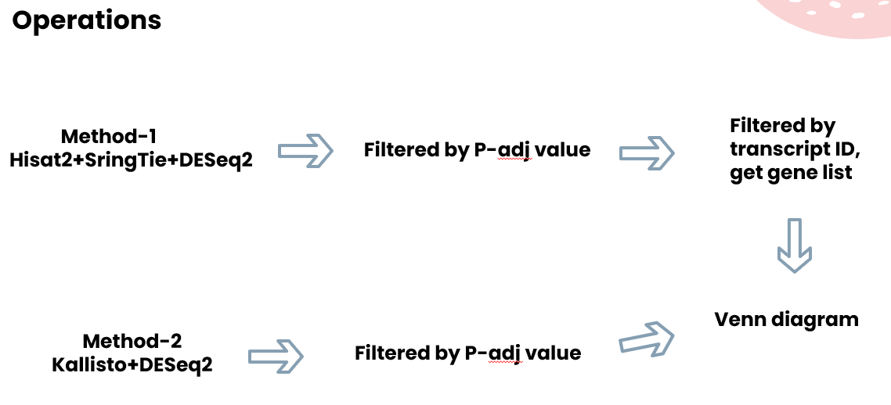

How many transcripts are collected after StringTie merge?

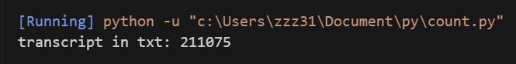

How many transcripts are differentially expressed in Method1? (p-adj-value<0.01)



How many transcripts are differentially expressed in Method2? (p-adj-value<0.01)



How many genes are commonly reported differential by these two methods?

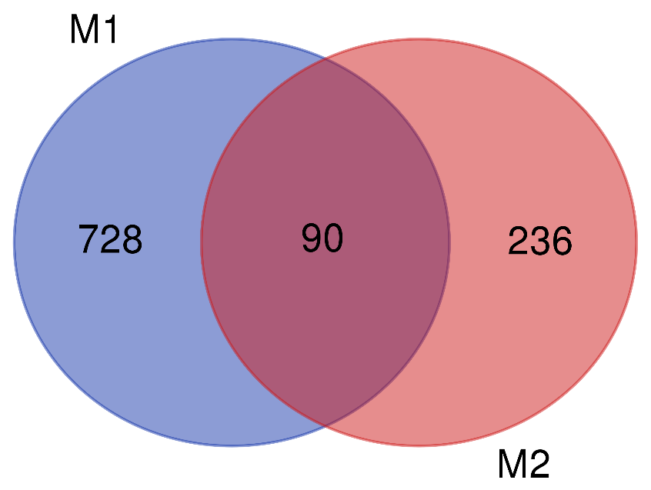

M1:方法一(Hisat2 + StringTie + DESeq2)M2:方法二(Kallisto+DESeq2)

詳細: