

Product Management Essentials course

Product Idea Workbook

By Pranav Srusti

Table of Contents

Product Management Essentials I
Product Idea Brief 3
1. Customer Problem Space 4
2. Market Space 5
3. Solution Space 6
4. Customer Value Space 7
Appendix 8

Product Idea Brief

[ this section is to be completed at the end of the course]

1. Customer Problem Space

1. Fertile Land: Personal Nutrition

2. Actor: Diet tracker

3. Job To Be Done: Monitor nutrient intake

4. Outcomes:
- Nutrient Deficiency Rate (Source: CDC National Health and Nutrition Examination Survey [NHANES] / CDC Nutrition Report)
- Actual Outcome: Average nutrient deficiency risk rate among users is 31.0% (at risk of at least one micronutrient deficiency or anemia).
- Desired Outcome: Average nutrient deficiency rate among users is 10.0%.
- Health Goal Completion Rate (Source: Digital Health & Mobile Wellness Industry Benchmarks / App Retention Data)
- Actual Outcome: Average health goal completion rate is 22.0%.
- Desired Outcome: Average health goal completion rate is 65.0%.
- Diet Consistency Rate (Source: Digital Nutrition Adherence & Food Logging Analytics)
- Actual Outcome: Average diet consistency rate is 35.0% of days meeting targets.
- Desired Outcome: Average diet consistency rate is 75.0% of days meeting targets.
- Time to Identify Nutrient Gap (Source: Routine Primary Care Preventative Diagnostics vs. Continuous Digital Tracking)
- Actual Outcome: Average time to detect a nutrient gap after it begins is 180 days (aligned with standard bi-annual/annual checkups).
- Desired Outcome: Average time to detect a nutrient gap after it begins is 14 days.

Outcome | Measurements
Nutrient Deficiency Rate | % of users whose 30-day rolling logged intake falls below the RDA/AI threshold (NIH/USDA reference values) for one or more key micronutrients, as flagged by the app's nutrient-analysis engine
Health Goal Completion Rate | (# users whose tracked metric crosses their self-set goal threshold within their chosen timeframe) ÷ (total users who set a goal)
Diet Consistency Rate | (# logged days within ±10% of the user's personalized daily nutrient/calorie target) ÷ (total logged days), rolling 30-day window
Time to Identify Nutrient Gap | Days between estimated onset (first day intake trends below RDA threshold for 7+ consecutive days) and the day the app flags the gap to the user
Sources:
Outcome 2 (Health Goal Completion): Source → Informed by general digital-health app engagement/retention patterns; no single authoritative published figure exists for this specific metric.
Outcome 3 (Diet Consistency): Source → Informed by typical self-reported food-logging adherence patterns observed in consumer nutrition apps; no single authoritative published figure exists.
Outcome 4 (Time to Identify Nutrient Gap): Source → Benchmarked against the standard U.S. annual/bi-annual preventive checkup interval (the typical point at which a clinician would catch a nutrient deficiency via bloodwork).

5. Customer Journey Map
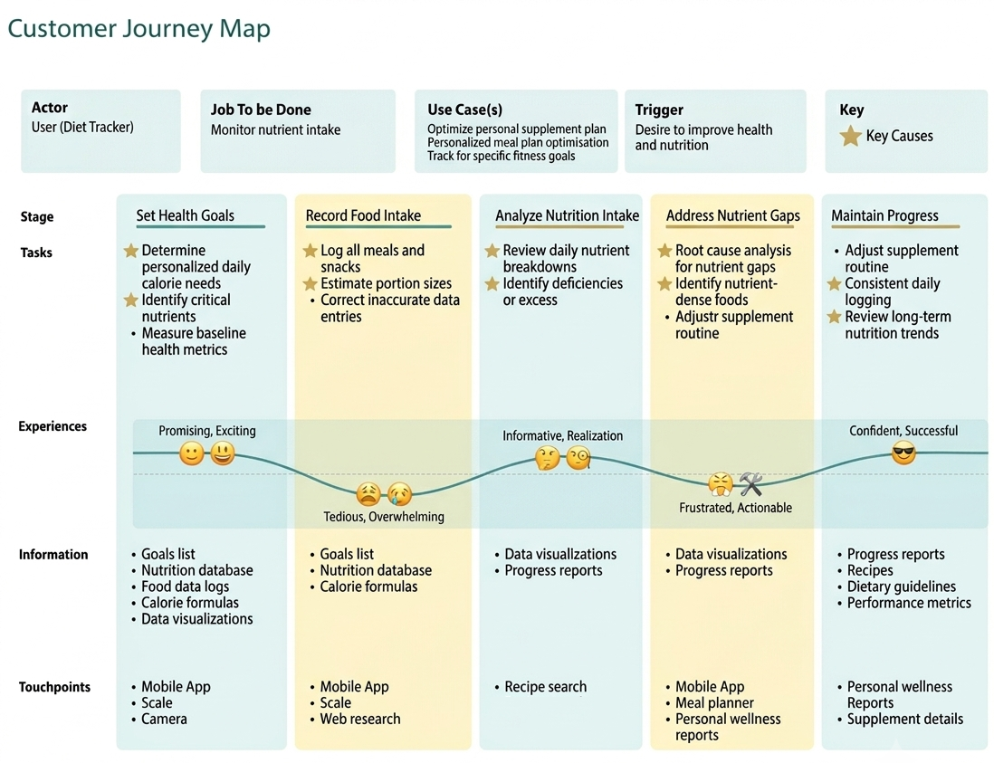

6. Problem

- Gap: The baseline risk of micronutrient deficiency for individual dietary tracking users stands at 31.0%, whereas the targeted baseline is 10.0%, representing a disparity of 21.0 percentage points. The objective of this solution is to address and bridge this variance.

- Causes
- Apps report raw nutrient totals (grams, %DV) without translating them into "why" a gap exists or "what to eat" to fix it — no root-cause analysis step.
- Nutrient shortfalls build up silently over weeks; nothing in the app proactively surfaces a trend until the user manually reviews breakdowns.
- Portion-size estimation is manual and error-prone, so logged intake often doesn't reflect actual intake, delaying accurate detection.
- Detection today effectively depends on an annual/bi-annual clinical checkup (bloodwork) rather than continuous tracking, so the lag between onset and detection (180 days) is driven by the healthcare cadence, not the app.

7. Use Cases
- Weight Management
The actor tracks nutrient intake while actively working toward a weight-loss or weight-gain goal.
- Chronic Disease Management
The actor tracks nutrient intake to manage a diagnosed condition (e.g., diabetes, hypertension, kidney disease) under medical guidance.
- Athletic Performance
The actor tracks nutrient intake to support training, recovery, and competition goals.
- Wellness Maintenance
The actor tracks nutrient intake with no specific medical or performance goal, simply to maintain a balanced, healthy diet day-to-day

8. Problem Sizing
- Per instance: Each time a nutrient gap occurs, it stays undetected for 166 extra days (180 days actual vs. 14 days desired).
- Annualized per actor: 166 days × 31% probability of occurrence ≈ 51 expected undetected-risk days/actor/year (vs. a desired 14 days × 10% = 1.4 days) -> a net gap of ~50 excess days per actor per year.
- Total impact, annually: ~50 days × ~55M actors = 2.75 billion excess undetected-deficiency-risk days across the U.S. tracking population per year. In headcount terms (applying the 21-percentage-point gap directly to the actor base), 11.5 million U.S. adults per year are at risk of a deficiency that faster detection could catch far sooner.
Assumptions/logic: Actor population is U.S. adults who actively use a nutrition-tracking app, estimated at about 55 million (Gallup 2025: 19% of U.S. adults currently use a mobile health app, approximately 49M of a roughly 258M adult population, cross-checked against an independent industry estimate of 52 to 58M active U.S. nutrition-app users). The JTBD (monitor nutrient intake) is continuous rather than a discrete per-occasion task, so "frequency" is modeled as the annual probability of a deficiency episode occurring. This follows the probabilistic-gap sizing method covered in Session 5 (slide 33), since the outcome gap here is a chance of occurrence rather than a fixed per-instance amount.

9. Problem Category
Nutrient Gap Detection problem

10. Problem Statement
U.S. adults who track their nutrition (Diet Trackers) want to catch a nutrient deficiency within about 14 days of it starting, but currently face an average detection time of 180 days, a 166-day gap, putting an estimated 31% of the approximately 55 million U.S. actors at risk of an undetected deficiency each year, roughly 11.5 million people. This is primarily due to tracking apps reporting raw nutrient totals without root-cause analysis or corrective guidance, leaving detection to depend on the next annual checkup. Addressing this would cut the deficiency-risk rate toward the desired 10% and return an estimated 2.75 billion excess undetected-risk days to this population annually.

2. Market Space

1. Overall Market
- Name: U.S. Personal Nutrition and Diet-Tracking market
- No. Actors: approximately 55 million U.S. adults (same population as above, since it matches the Actor)
- Trends: Growing. The calorie and nutrition-tracking app market has grown at roughly a 13 to 15% CAGR since 2018, accelerated by a broader preventive healthcare shift (CDC-cited data indicates over half of U.S. adults now proactively track diet and nutrition) and by AI-driven personalization and wearable integration pulling in new users.

2. Total Addressable Market (TAM)
[Do NOT complete this part until the last Product Assignment of this course.]

3. Market Segmentation

Variable | Values
Primary Health Goal | Weight management, Chronic-disease prevention/management, Athletic/performance optimization, General wellness
Age Group | 18 to 29, 30 to 44, 45 to 59, 60 and older
Tracking Engagement Level | Consistent daily logger, Intermittent/casual logger, Wearable-integrated automatic tracker

4. Target Market Profiles
Chronic-Condition Preventers
- Variables/Values: Primary Goal = Chronic-disease prevention/management, Age 45 to 59
- No. Actors: approximately 11M (about 20% of the 55M market, author's estimate, no direct source breaks the market down this way)
- Growth: Fast (aging population plus CDC-documented shift toward proactive preventive tracking)
- Reasoning: This segment has the highest health stakes from an undetected nutrient gap, making faster detection especially valuable to them, a strong early target.
Performance Optimizers
- Variables/Values: Primary Goal = Athletic/performance optimization, Age 18 to 29, Wearable-integrated automatic tracker
- No. Actors: approximately 8M (about 15% of the 55M market, author's estimate)
- Growth: Steady to fast (young, tech-forward, willing to pay for precision tools)
- Reasoning: Highly engaged, data-hungry users who already log consistently, likely early adopters and premium payers for a root-cause/gap-detection feature.
Casual Wellness Trackers
- Variables/Values: Primary Goal = General wellness/weight management, Age 30 to 44, Intermittent/casual logger
- No. Actors: approximately 19M (about 35% of the 55M market, author's estimate, and the largest segment)
- Growth: Steady
- Reasoning: The largest segment by size, representing the mainstream market opportunity, even though lower average engagement means detection speed matters even more for them.

5. Competition

6. Positioning Analysis

- Current State Positioning Map

- Future State Positioning Map

- Position-to-Own

7. Market Focus Decision

3. Solution Space

1. MVP Product Concept Outline

2. User Views

3. Functional Requirements

4. Context View

5. Non-Functional Requirements

4. Customer Value Space

1. Product Features and Benefits

2. Pricing Model

3. Customer Cost Items

4. Customer Value Proposition Evaluation

Appendix

[items included here, as needed, with the details to complement or support the above work.]

